

Final Report

Utilisation analysis of antihypertensives
University of South Australia
Quality Use of Medicines and Pharmacy Research Centre

Prepared By: Professor Nicole Pratt, Associate Professor Lisa Kalisch Ellett, Dr Svetla Gadzhanova, Dr Anna Kemp-Casey, Dr Imaina Widagdo

Date prepared: 21/11/2024

Contents
Executive Summary 5
Introduction 7
Fixed dose combination antihypertensives on the PBS 8
PBAC recommendation and TGA indications 9
PBS listing and restrictions for two component FDC antihypertensive products 9
Clinical guideline recommendations 10
Methods 12
Data source: 12
Medicines 12
Prevalence 12
Incidence 12
Concurrent antihypertensive medicine use 12
Potential underuse of fixed dose combinations 12
Treatment initiation by type of product 13
Persistence and adherence to antihypertensive therapies 13
Factors influencing use of fixed dose combinations 15
Concordance with guidelines 15
Results and Discussion 16
Prescriptions dispensed 16
Prevalent use 18
Incident use 19
Concurrent use of antihypertensives 20
Potential underuse of FDC 23
Treatment initiation by type of product 25
Persistence and adherence to antihypertensive 28
Adherence to antihypertensive therapy 32
Demographic factors influencing use of FDCs 32
Concordance with guidelines 34
Costings 36
Background: 36
Aim 36
Method 36
Results 38
Literature review 40
Evaluating initiation of antihypertensive therapy with sequential stepped-up multiple products (standard care) versus low dose two-component FDC: A narrative review 40
Background 40
Methods 40
Results 40
Discussion 43
References 45
List of figures 47
Appendices 48
Appendix 1: PBS medicines included in the hypertension analysis 48
Appendix 2. Literature search strategies 61

Glossary
ACE: angiotensin-converting enzyme inhibitor
CCB: calcium channel blocker
ARB: angiotensin II receptor blocker
BB: beta blocker
FDC: Fixed dose combination
PBAC: Pharmaceutical Benefits Advisory Committee
PBS: Pharmaceutical Benefits Scheme

Executive Summary

The aim of this report is to quantify the potential underuse of Fixed-Dose Combination (FDC) antihypertensives among individuals using multiple antihypertensive classes. Currently, Pharmaceutical Benefits Scheme (PBS) only lists one low-dose FDC product without restriction, the remaining FDCs are restricted for use only when blood pressure is not adequately controlled by a single class, and it is possible that this is contributing to underuse of FDCs in the population.

The absolute number of people dispensed antihypertensive increased between 2013 and 2023; from 3.4 million in July 2013 to 4.3 million in July 2023, however, the rate of use in the population remained relatively constant (190 and 200 per 1000 of the Australian adult population respectively). In July 2023, half of the antihypertensive prevalent population were dispensed multiple classes of antihypertensives. Among those dispensed multiple antihypertensive classes, 60% were dispensed at least one FDC. This equates to a ratio of use of multiple single-class products compared to FDC of approximately 1 : 1.4. However, when considering only those people who were dispensed combinations that are available in FDC form, the ratio improved to approximately 1 : 3 (i.e., 75% use FDC among those using multiple classes available in FDC form).

There has been a substantial shift in the type of FDC antihypertensive products dispensed between 2013 and 2023. The proportion of individuals using FDCs containing a calcium channel blocker (CCB) with either an angiotensin-converting enzyme (ACE) inhibitor or an angiotensin II receptor blocker (ARB) has risen steadily. Specifically, the percentage of users dispensed FDCs containing CCB with either ACE or ARB increased from 7% to 14%. In contrast, the percentage of users dispensed FDCs containing thiazides with either ACE or ARB has decreased. The most notable decline was for ARB-thiazide combinations, which declined from 17% to 11%. Use of FDC ACE-thiazide was much lower overall and use also declined from 5% to 2%. These trends may reflect changes in comorbidity patterns over time, which in turn influence prescribing practices. In 2023, the distribution of use of FDC products among those using FDC was 44% for thiazides with ARB or ACE, 48% for CCBs with ARB or ACE and 8% for ARB with CCB and thiazide.

Across the study period (2013-2023), the population who commence treatment with antihypertensives has remained stable at less than 1% of all people dispensed antihypertensives per month with 90% commenced on a single class only in the first month of treatment and 10% were dispensed two or more classes of antihypertensives in their first month of treatment. Of those initiated on multiple classes, 40% were initiated on FDC and 60% were dispensed multiple single-agent products.

This report has estimated the potential savings for consumers and government from allowing use of FDCs at treatment initiation. To estimate the eligible population who would commence antihypertension treatment with a FDC, should PBS restriction permit, we determined first, the population who initiate treatment with a single agent product who subsequently added another class within 12 weeks and second, the population who initiate two single agent products. Of those that commenced antihypertension treatment with a single class, 8% subsequently added another class within the first 12 weeks. Of these, 37.5% switched to FDC while 65.5% added another single-agent product. Assuming those that added another single-agent product within 12 weeks of commencing a single-agent product would instead commence antihypertensive treatment with an FDC, we estimated that 11,408 people in Year 1 would initiate FDC. Assuming that the 60% who initiated multiple single agents would have instead initiated FDC we estimate that this would equate to a population of 21,730 patients who would be eligible to commence FDC in Year 1. Additionally, we estimate that persistence to multiple treatment after commencement would be 38% at year 1, 30% at year 2, 23% at year 3, 20% at year 4, and 20% at year 5.

Overall, we estimated that allowing FDC at antihypertensive treatment commencement would save consumers $2.4 million in Year 1 (assuming no safety net dispensings) or $1.9 million in Year 1 (weighted by general and safety net prescriptions) and $25.7 million and $20.5 million in total over 6 years respectively (Table ES.1). Cost savings to the PBS were estimated to be $17.9 million in total over 6 years. Cost savings were driven by a reduction in prescriptions which was estimated to be between 2 to 3 less prescriptions per annum for those dispensed thiazides with ARB or ACE and between 8 and 9 prescriptions less for those on CCB with ACE or ARB.

Table ES.1: Estimated cost savings if patients were permitted to initiate an antihypertensive FDC
Year | Total consumer savings (no safety net) | Total consumer savings (including safety net) | PBS savings
Year 1 | $2,379,159 | $1,902,085 | $1,660,789
Year 2 | $3,342,718 | $2,672,430 | $2,333,408
Year 3 | $4,140,034 | $3,309,866 | $2,889,980
Year 4 | $4,790,742 | $3,830,092 | $3,344,211
Year 5 | $5,362,596 | $4,287,277 | $3,743,398
Year 6 | $5,671,174 | $4,533,978 | $3,958,803
Total | $25,686,422 | $20,535,728 | $17,930,589

A review of literature found no systematic reviews of studies specifically comparing the safety and effectiveness of commencing antihypertensive treatment with standard care (monotherapy followed by add-on therapy) with commencing low dose FDC therapy. Individual studies of FDC as first line antihypertensive treatment have found that initiating antihypertensive treatment with a low dose FDC was associated with a more rapid reduction in BP in the short term which may be associated with long-term cardiovascular benefits. However, due to the rapid reduction in BP, FDC may be associated with an increased risk of hypotension and falls, particularly in older patients, which requires careful consideration.

As international guidelines recommend starting low dose two-component FDC in most hypertensive patients the PBAC might consider removing restrictions to allow low dose FDC to be used at initiation. The impact of this change in restriction could result in cost savings to consumers and the PBS.

Introduction
A variety of antihypertensives are subsidised on the PBS, including diuretics, medicines affecting the renin-angiotensin-aldosterone system, beta-blockers, calcium channel blockers and other antihypertensives. Historically, hypertension was treated with a single agent, however, in 2000 guidelines began recommending add on therapy where treatment targets were not met with single agents.

Australian clinical guidelines generally recommend that patients commence antihypertensive treatment with a single-class medicine at a low dose and then add a second drug at a low dose before titrating up the doses.^{1,2} The Heart Foundation Guidelines note that 50-70% of patients will require treatment with more than one antihypertensive. Further, cumulative data from clinical trials indicates that around 25% of patients will require triple therapy to achieve adequate blood pressure (BP) control.3 Given the large proportion of patients requiring more than one antihypertensive, FDCs have been developed to provide multiple medicines in a single product, with the aim to improve adherence to recommended therapy while minimising tablet burden.
Currently, the PBS only lists one low-dose FDC product without restriction, the remaining FDCs are restricted for use only when BP is not adequately controlled by a single class. It is possible that these restrictions are contributing to the potential underuse of FDCs particularly if patients are commencing antihypertensive therapy with multiple single-class medicines and not being switched to a FDC once their medicine regimen is stable. The PBS restrictions preventing therapy initiation with an FDC may be inconsistent with recommendations in clinical guidelines that FDCs may be used at therapy initiation for most hypertension patients and particularly in the younger population or those at high cardiovascular risk.
PBS data, considered by the PBAC in September 2023, indicated that there was a 2 : 1 ratio of the use of angiotensin-converting enzyme inhibitors (ACEs) and angiotensin II receptor blockers (ARBs) in single-class form compared to use in FDCs. Given the numerous antihypertensive FDCs available through the PBS, the ratio of dispensing of single-class antihypertensive medicines to FDCs was expected to be close to 1 : 1. These usage patterns indicated potential underuse of antihypertensive FDCs.
In September 2023, the Pharmaceutical Benefits Advisory Committee (PBAC) recommended that the Department undertake a research project on the use of antihypertensive medicines supplied through the PBS, focusing on quantifying the potential underuse of FDCs versus two or more single-class products. This research project was to include an analysis on the potential savings to the PBS and consumers from addressing any underuse of FDCs and synthesise the evidence from published systematic reviews regarding the comparative effectiveness of commencing low dose FDC therapy with ‘standard care’ (i.e., low dose monotherapy, followed by adding a second low dose therapy, then titrating up the doses).
Specifically, this project was to perform the following activities:
Stage 1: A patient-level analysis of the utilisation of antihypertensive medicines, focusing on quantifying the potential underuse of FDCs, and initiation of antihypertensive therapy with two or more single-class products.
Stage 2: Quantification of the potential savings to the PBS and consumers from addressing any underuse of FDCs.
Stage 3: An overview of high-quality systematic reviews and/or meta-analyses on commencing antihypertensive therapy with standard care (monotherapy and adding-on additional medications as needed) versus multiple therapies as an FDC.

Fixed dose combination antihypertensives on the PBS

The fixed dose antihypertensive combinations available on the PBS are listed in table 1.

Table 1. Available FDC antihypertensives as at July 2024
- ACE combination
Type of combination | Restriction on initiation | Low dose strength available | 60-day item | CHD indication
Enalapril + HCT | Yes | No | Yes | No
Enalapril + Lercanidipine | Yes | No | Yes | No
Perindopril + Indapamide | Yes (except 2.5mg/0.625mg) | Yes | Yes | No
Perindopril + Amlodipine | Yes | Yes | Yes | Yes
Quinapril + HCT | Yes | Yes | No | No
Ramipril + Felodipine | Yes | Yes | Yes | No
Trandolapril + Verapamil | Yes | No | Yes | No
- ARB combination
Type of combination | Restriction on initiation | Low dose strength available | 60-day item | CHD indication
Candesartan + HCT | Yes | Yes | Yes | No
Eprosartan + HCT | Yes | No | Yes | No
Irbesartan + HCT | Yes | Yes | Yes | No
Olmesartan + HCT | Yes | Yes | Yes | No
Olmesartan + Amlodipine | Yes | Yes | Yes | No
Telmisartan + HCT | Yes | Yes | Yes | No
Telmisartan + Amlodipine | Yes | Yes | Yes | No
Valsartan + HCT | Yes | Yes | Yes | No
Valsartan + Amlodipine | Yes | Yes | Yes | No
- Diuretic combination
Type of combination | Restriction on initiation | Low dose strength available | 60-day item | CHD indication
Amiloride + HCT | No | No | Yes | No
- Triple combination
Type of combination | Restriction on initiation | Low dose strength available | 60-day item | CHD indication
Olmesartan + Amlodipine + HCT | Yes | Yes | Yes | No
Amlodipine + Valsartan + HCT | Yes | Yes | Yes | No
- Antihypertensive and statin combination
Type of combination | Restriction on initiation | Low dose strength available | 60-day item | CHD indication
Amlodipine + Atorvastatin | No | Yes | Yes | No
Abbreviations: CHD – Coronary heart disease; HCT – Hydrochlorothiazide.
Notes:
Fosinopril + HCT was available on the PBS but was delisted, with the last formulation delisted in September 2024.
HCT + Triamterene was available on the PBS but was delisted in August 2019.

PBAC recommendation and TGA indications
The PBS listings for FDC antihypertensive therapies align with the TGA-registered indications.

The PBAC has generally recommended the listing of two component FDC antihypertensive therapies on a cost-minimisation basis. The PBAC noted that there is insufficient evidence to suggest that the combination products significantly improve patient compliance, efficacy, or reduce toxicity compared to alternative therapies for some patients.

PBS listing and restrictions for two component FDC antihypertensive products

Restriction conditions:
- All two component FDCs except for perindopril/indapamide 2.5mg/0.625mg and amiloride/hydrochlorothiazide are restricted for use in patients who are stabilised on at least one of the active ingredients. A “not for initiation” description was added to the restriction in 2014. Perindopril/indapamide 2.5mg/0.625mg is unrestricted on the PBS.
- ACE/ARB + CCB: only perindopril/amlodipine has a restriction indication for both stable hypertension or coronary heart disease.

Delisting:
- Fosinopril + hydrochlorothiazide 10mg/12.5mg strength was delisted in December 2016, 20mg/12.5mg strength was delisted in September 2024.
- Hydrochlorothiazide + triamterene was delisted in August 2019.

A 60-day item for antihypertensive prescriptions was first available in September 2023. The majority of two component FDCs have a 60-day prescription item, except for quinapril + hydrochlorothiazide (all strengths).

Anomalies in strength availability:
- Olmesartan + amlodipine 20mg/10mg strength is not available on the PBS. The available strengths on the PBS are: 20mg/5mg, 40mg/5mg, 40mg/10mg.

Clinical guideline recommendations
Australian clinical guidelines (2023 Therapeutic Guideline and 2016 Heart Foundation Guideline) recommend starting antihypertensive treatment with either a single medicine at a low/moderate dose and adding a second medicine if needed, or starting with two drugs concurrently at low doses, particularly for patients with high cardiovascular (CV) risk (Figure 1). The Heart Foundation guidelines recommend considering initiation of combination therapy in patients with very high baseline BP (BP >20 mmHg systolic and >10 mmHg diastolic). Potential benefits cited include more rapid BP reduction, reduced drug and dosage changes with benefits to adherence, and reductions in clinical inertia (2016 Heart Foundation Guideline). ^{1,2} These guidelines do not specifically mention the use of FDCs. FDCs are single dosage forms containing two or more different active ingredients.
International guidelines such as the 2020 International Society of Hypertension (ISH) guideline and the 2023 European Society of Hypertension (ESH) guideline recommend starting antihypertensive treatment with a two-component low dose FDC (that is, an FDC with two active ingredients both in low doses) for most patients, except in frail and very old patients for whom low dose monotherapy is recommended.^{3,4} Guidelines suggest that starting two drugs at low dose is a reasonable approach in most patients but especially those with high CV risk or particularly elevated BP (Table 2).

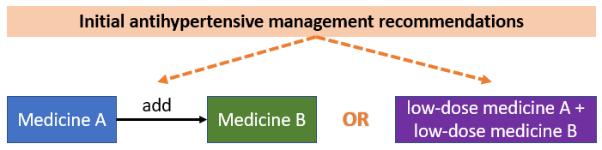
Figure 1. Initial antihypertensive management in Australian clinical guidelines

Table 2. Comparison of international guidelines
Treatment recommendations criteria | 2024 European Society of Cardiology (ESC) Hypertension Guidelines | 2020 International Society of Hypertension (ISH) Global Hypertension Practice Guidelines | 2019 National Institute for Health and Care Excellence (NICE) Hypertension Guidelines
When to start medicine treatment? | Initiate at BP ≥ 140/90 mmHg; lower threshold for high-risk populations (≥ 130/80 mmHg) | Initiate at BP ≥ 130/85 mmHg in patients with CVD or high risk; otherwise, ≥ 140/90 mmHg | Initiate at BP ≥ 135/85 for under 80 with risk factors; at 150/95 mmHg for patients under 40; or > 150/90 mmHg for patients 80 and older
Medicine class of choice for initiation | ACE, ARB, dihydropyridine CCB, or thiazide-like diuretic | ACE, ARB, CCB, or thiazide diuretic | ACE, ARB, CCB, or thiazide-like diuretic (based on age and ethnicity)
Recommendations for starting on single class (monotherapy) | Monotherapy recommended for patients with mild hypertension (BP between 120/70 and 139/89), particularly in people ≥85 yrs | Monotherapy recommended for low risk grade 1 hypertension (BP ≥ 130/85), or ≥80 yrs, or frail | Monotherapy recommended as treatment initiation for all hypertensive patients
Recommendations for starting on 2 classes | Recommended | Recommended | Not recommended
Option for gradual addition of classes | No,  recommends starting with two agents for most patients unless they are older or frail | No,  recommends starting with two agents for most patients unless they are older or frail | Yes,  recommends starting with a single agent and gradually adding another if needed
Abbreviations: BP: blood pressure; CVD: cardiovascular disease; ACE: angiotensin converting enzyme inhibitor ; ARB: angiotensin receptor blocker; CCB: calcium channel blocker

Methods

Data source:
Data from the PBS 10% sample were used for this analysis.

Medicines
The medicines included in the hypertension analyses are detailed in Appendix 1 and included medicines affecting the renin-angiotensin-aldosterone system, calcium channel blockers, beta-blockers, low ceiling diuretics, potassium sparing diuretics and other antihypertensives (clonidine, prazosin, and methyldopa). We excluded injectable preparations and any antihypertensive that was restricted to an indication other than hypertension. High ceiling diuretics were excluded as they are predominantly used for oedema.

Prevalence
Prevalence was calculated as the monthly number of people who were dispensed any antihypertensive medicine from Appendix 1 from 2013 to 2023.

We also reported prevalence by medicine class. Population estimates were based on the estimated Australian resident population at 30 June in the respective year as reported by the Australian Bureau of Statistics.

Incidence
Incidence was calculated as the yearly number of people who initiated any medicine from Appendix 1 between 2013 and 2023, where incident use was defined as no dispensings of any of the medicines previously with a look-back period to 2012 (i.e., minimum 12 months).

Concurrent antihypertensive medicine use
To determine the number of medicines a person was supplied concurrently, we included all persons dispensed at least one antihypertensive during the period January 2013 to December 2023 (see Appendix 1 for a list of the PBS item codes used). We used estimates of standard coverage days (SCD) (including adjustment for 60-day dispensings where appropriate) to determine the estimated length of exposure. People were considered as exposed to an antihypertensive in a month if they were dispensed a medicine in that month or had a dispensing in a period of time prior to that month which would have sufficient tablets dispensed such that the person would still be using that medicine in the current month (based on the estimated SCD). SCD is calculated based on the estimated dispensing interval for each relevant PBS item at population level. Further details of the methods are included with the individual analyses.

Potential underuse of fixed dose combinations
To determine if there was potential underuse of FDCs, we identified the population of patients who were dispensed products from multiple different antihypertensive classes in the same calendar month. From this population we stratified patients into two groups:
- those dispensed at least one FDC in their regimen (noting that these patients may have been dispensed other single-class products as well)
- those who did not have an FDC in their regimen.
Since not all combinations of antihypertensive classes have an available FDC, and considering the interchangeability of drugs within and between classes (e.g., ACE and ARB), we calculated the proportion of FDC use among users whose class combinations had an available FDC in 2023. Appendix 1 provides the combinations of classes with available FDCs.
In this analysis we considered FDC of amlodipine and atorvastatin as a single amlodipine (single CCB). When considering the underuse of FDC, people dispensed a single-class antihypertensive and also dispensed an FDC containing antihypertensive and statin were not considered eligible to switch to a two-component antihypertensive FDC as there would be no cost benefit to the PBS or to the patient. The number of patients in this scenario is relatively low. Patients on amlodipine and atorvastatin as FDC and on two other single ingredient products may be eligible for a triple FDC and separate statin. These patients have three scripts and could reduce to two scripts with a triple FDC. These people are included in the analysis. Some patients may be on a FDC and another single product from the same class. In this case, we will consider a patient is receiving a FDC for the purpose of this analysis, however, both products from the same class will be included in any cost analysis. Some patients may be on a FDC and a single product from another class (i.e., a different class than the two classes in the FDC). In this case we will consider a patient is receiving an FDC.

Treatment initiation by type of product
To determine the potential under-use of FDCs at treatment initiation we calculated the trends over time in the number of people who commenced treatment with antihypertensives. To determine those who commenced antihypertensive treatment, we identified the first month each patient was ever dispensed an antihypertensive medicine. We then considered the number of different classes of antihypertensives they were dispensed in that month. We considered patients who had medicine dispensed from one class only to be receiving monotherapy, while those dispensed medicines from multiple different classes were further stratified according to whether or not an FDC product was part of the regimen. Those commencing antihypertensive treatment were defined as those who received their first ever antihypertensive any time from 2013 with a look back period to 2012.
Among the proportion of patients who initiated a medicine from only one class of antihypertensive in 2023, we determined the number of people who added a second class either as another single-agent product of as an FDC within 12 weeks, stopped treatment, or continued on a single antihypertensive class product. In the primary analysis, patients were censored at 12 weeks (or at 31st December 2023) if they were still on single class. Patients were considered to have stopped treatment if they had a gap of longer than 3 times the standard coverage days where the start of the gap commenced in the first 12 weeks. Patients were considered to have “added” to the initial single class regimen if there was more than 60 days overlap in treatment. Those with less than 60 days overlap or less than a 90-day gap between exposure periods were considered to have switched to another class but remained on single class.
The outcomes of this analysis were 1) time to addition of another class (no FDC), or 2) addition of another class as FDC, or 3) cessation of treatment. Cumulative incidence functions were generated to determine the proportion who had experienced each outcome by 12 weeks. As a sensitivity analysis we also considered a 12-month follow-up time.

Persistence and adherence to antihypertensive therapies

To determine persistence and adherence to antihypertensive therapy amongst naïve patients initiating antihypertensive monotherapy versus multiple therapies we identified patients with a first ever (index) antihypertensive class of medicines between 1 Jan 2015 and 31 Dec 2019. We followed patients for 4 years to determine persistence and adherence to therapy. The analysis was conducted at the class level of antihypertensives.

Treatment regimens for each patient who had antihypertensive prescriptions dispensed were determined. Duration of use of a medicine was determined using the date of supply and the estimated prescription duration. The estimated prescription duration was based on medicine specific SCDs calculated from the data at the PBS item code level and defined as the time period (days) within which 75% of prescriptions for that medicine was refilled. SCDs accounted for the 60-day dispensing rule. It was assumed that a person continued to use a medicine from the supply date for the prescription duration. A break (long gap) in treatment was defined as a gap of two or more SCDs (i.e., the patient had not received re-supply at two consecutive expected refill dates). If multiple prescriptions of the same medication (but not the same strength) were supplied on the same day, it was assumed that these were necessary for dose escalation and the coverage period was not extended. If the multiple prescription of the same medication and the same strength were supplied on the same day (for example original and repeat prescriptions were supplied under Regulation 24 on the same day), then this was assumed to extend the coverage period (i.e., end of coverage period = supply date + number of prescriptions on the same day x SCD). Once medication episodes for each patient and each medicine were determined for every week, then regimens of monotherapy and co-administration were calculated.

Persistence (duration) to first treatment episode with index class(es) was defined as time from initiation of the index class(es) to its discontinuation, either due to switch or cessation (whichever occurred first):
- switch was defined as change to another class(es) of antihypertensive where there was also cessation of the initial class(es),
- cessation was defined as a long gap in therapy - gaps larger than two or more SDCs were considered to represent cessation.

Based on the definition for a switch, the addition of an antihypertensive class to the index therapy was considered as continuation as long as the index class(es) was also continued. Only change to therapy that did not include the index class(es) was considered as a switch. A gap of 2 or more SCDs was imposed to avoid misclassifying those who have short breaks between dispensing, which may occur when patients have accumulated surplus medicine or have a break due to hospitalisation or overseas travel.

Examples for mono therapy, FDC and separate agent combination:
Continuation of index therapy:
Index ACE ACE +/- anything else;
Index ACE_CCB_FDC ACE_CCB_FDC +/- anything else;
Index ACE + CCB ACE + CCB +/- anything else;
Switch from index therapy:
Index ACE anything else but no ACE;
Index ACE_CCB_FDC anything else but no ACE_CCB_FDC;
Index ACE + CCB anything else but no ACE + CCB;

Persons were followed up until cessation, switching therapy, or end of study (death data was not available). Persons who ceased or switched therapy before the end of the study were reported as “event” persons, while those who continued therapy with the index therapy at the end of study were reported as “censored” persons.

The duration of the index episode was stratified by the type of the index therapy, namely monotherapies, FDCs and combinations of separate agents. Median duration of the index therapy was reported using Kaplan Meier methods. Time to discontinuation of index therapy was compared between groups using Cox proportional hazards models adjusted for age at initiation and gender.

Additionally, overall duration was determined as time from index therapy to last episode with any antihypertensive therapy.

Adherence was measured as the proportion of days covered (PDC) from initiation of a class(es) to last dispensing for that class(es) – the time between the first and last dispensing was divided by the sum of all prescriptions’ coverage in that period. PDC of 80% or greater was used as the cut-point to define good adherence.

Factors influencing use of fixed dose combinations
Factors associated with the use of FDCs were explored in both the incident users of antihypertensives and the prevalent population in July 2023. We examined demographic characteristics including age and gender according to the regimen of antihypertensive treatments used, i.e., monotherapy, use of at least one FDC, or use of multiple single class products.

Concordance with guidelines
We examined the concordance of use of antihypertensive treatments to current clinical guidelines. Specifically, we considered potential quality use of medicines issues, including use of ACEs in combination with ARBs. We describe treatment pattern concordance with recommended guidelines and best practice. The following Australian guidelines were considered: Heart Foundation guidelines, Therapeutic Guidelines, and the Australian Medicines Handbook (AMH).^{1,2,5}
Antihypertensive medicines were grouped into first-line and second-line; first-line therapies included ACEs or ARBs, CCBs (dihydropyridines), and thiazide diuretics. Second-line therapies include BBs, other antihypertensives (e.g., alpha blockers), CCBs (non-dihydropyridines), and potassium-sparing diuretics.
In practice, the selection of antihypertensive medicine is often based on BP levels and the presence of other coexisting conditions to assess the risk and benefit of treatment. We examined the use of antihypertensive medications, particularly concerning the risk of adverse events for specific patient populations as described in the guidelines.
The following indicators were examined:
- use of antihypertensives combination to avoid: ACE in combination with ARB, or non- dihydropyridine CCB with BB; and
- use of antihypertensives with unfavourable and favourable effects by presence of comorbid conditions.
Comorbid conditions of interest were identified using a modified version of the available Rx-Risk comorbidity index.⁶ The conditions examined in this analysis include: atrial fibrillation (AF), diabetes, airways disease, chronic kidney disease (CKD), heart failure (HF), and angina.

Results and Discussion

Prescriptions dispensed

In 2023, there were almost 59 million prescriptions dispensed for antihypertensive agents. Most prescriptions were for the renin-angiotensin-aldosterone system (ACE or ARB) medicines, calcium channel blockers or beta-blockers (Figure 2).

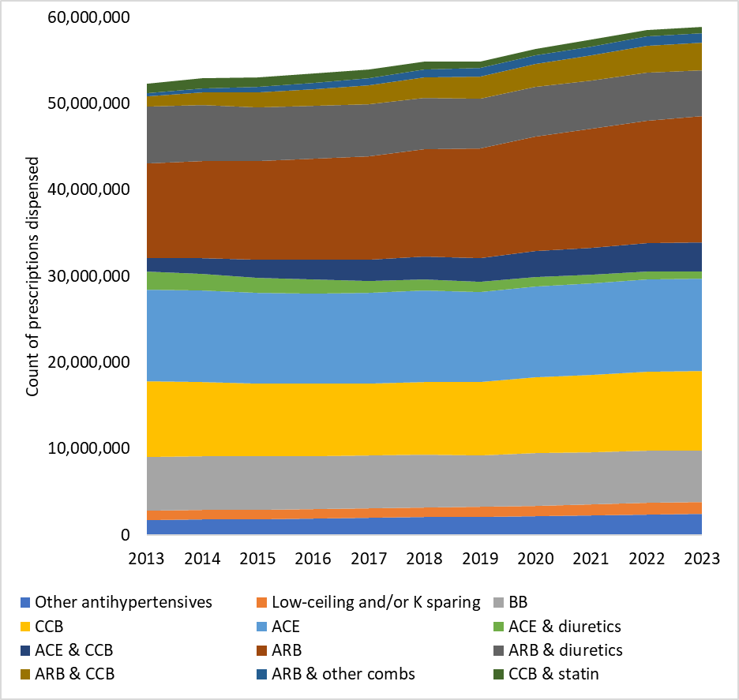
Figure 2. Number of antihypertensive prescriptions dispensed annually by class

With regards to FDCs, use of renin-angiotensin medicines in combination with diuretics is decreasing and being replaced by renin-angiotensin medicines in combination with calcium channel blockers (Figure 3).

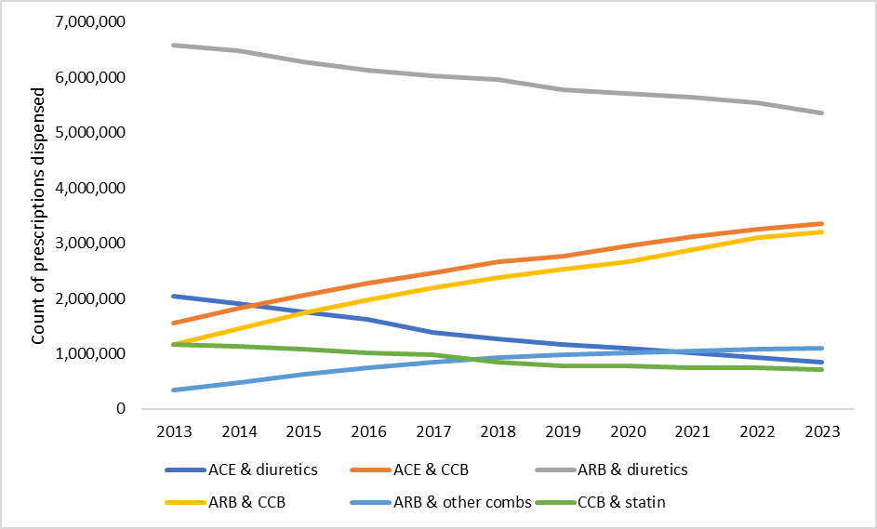
Figure 3. Number of FDC antihypertensive prescriptions dispensed annually by class

Prevalent use
Overall, the annual number of people dispensed at least one antihypertensive medicine has increased over time; however, the rate remained relatively constant, from 4 million (17.4% of the Australian population) in 2013 to 5 million (19%) in 2023 (Figure 4).

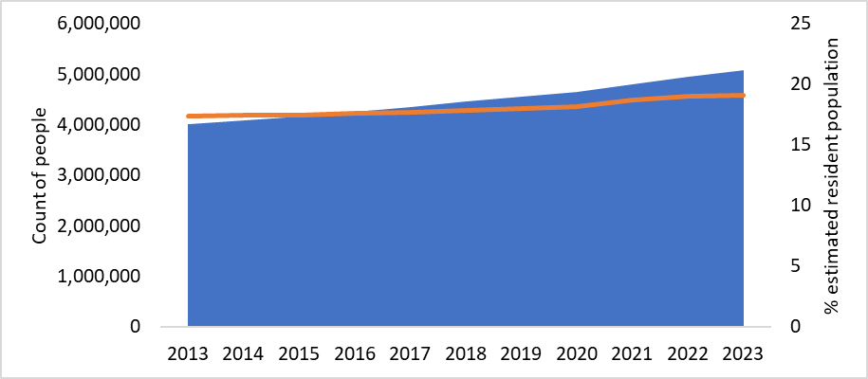
Figure 4. Number of people dispensed at least one antihypertensive per year and the population prevalence as a proportion of the Estimated Resident Population (ERP) as at June of the corresponding year

Most people are receiving single agent products from the renin-angiotensin-aldosterone system (ACE or ARB), calcium channel blockers or beta-blockers (Figure 5).
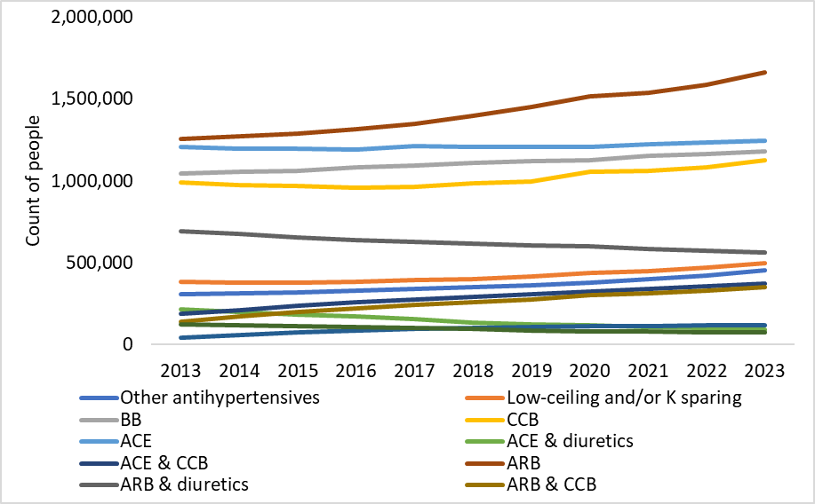
Figure 5. Number of people dispensed at least one antihypertensive product annually by class

The number of people supplied FDCs is presented in figure 6. Similar to the pattern observed in figure 3, use of renin-angiotensin medicines in combination with diuretics is decreasing and being replaced by renin-angiotensin medicines in combination with calcium channel blockers.

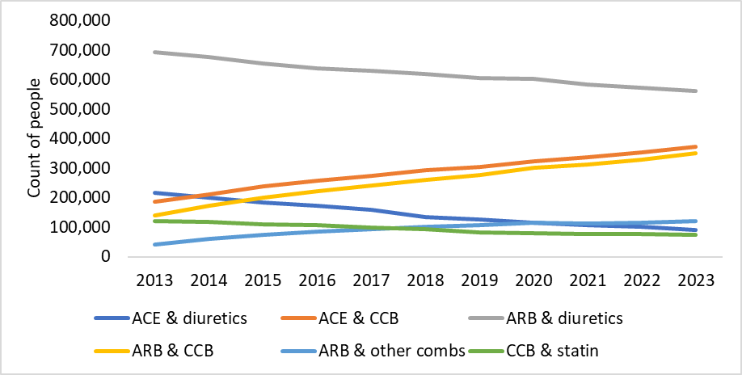
Figure 6. Number of people dispensed at least one FDC annually by class

Incident use
There are approximately 400,000 persons incident to an antihypertensive each year. Analysis of the incident users by class is shown in figure 7. A rise in incident use of “other antihypertensives” is apparent, which is due to use of clonidine likely for indications other than hypertension. All other classes are relatively stable.

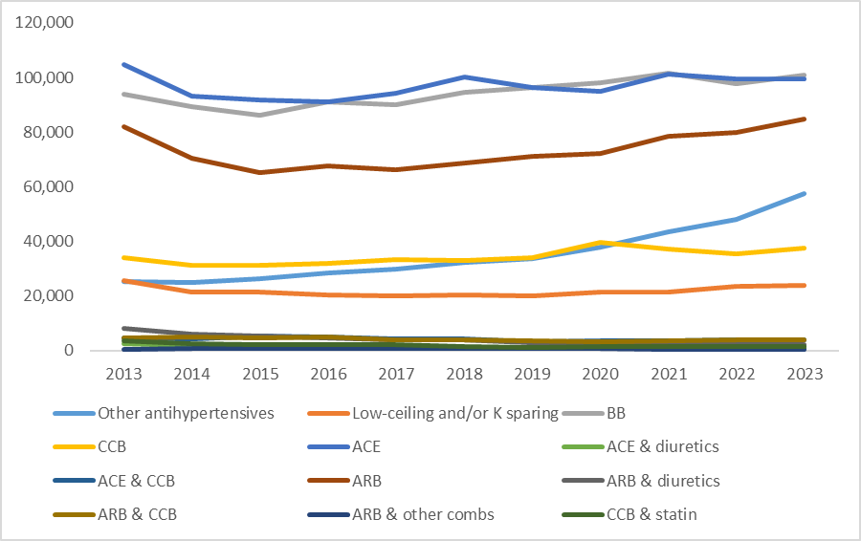
Figure 7. Number of people incident to an antihypertensive annually by class

Incident use of FDCs represents only a small proportion of the overall incident antihypertensive user market and is presented in figure 8. Incident use of angiotensin-renin system medicines in combination with diuretics is declining.

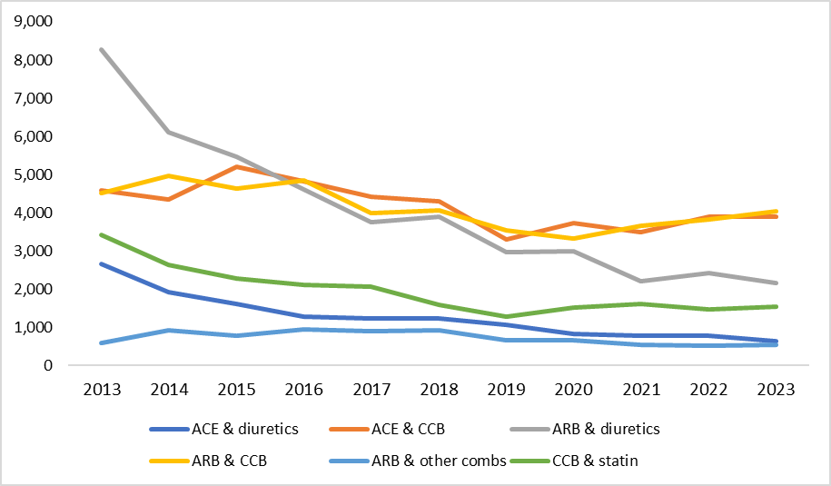
Figure 8. Number of people incident to FDCs annually by class

Concurrent use of antihypertensives

This section of the report examines how many antihypertensives a person is dispensed concurrently and was limited to the population aged 18 years and over. Standard coverage days were used to estimate overlap of prescriptions enabling concurrent use to be determined. Figure 9 shows that half the population are managed on a single antihypertensive, 35% use two concurrently and 15% use three or more concurrently.

Figure 9. Proportion of people dispensed antihypertensive medicines by month according to whether they were dispensed medicines from only one class or from multiple different classes
Among those dispensed only a single antihypertensive class, the number of people with at least one dispensing of ARB or BB increased over the study period (Figure 10), while the number of people dispensed a single-class ACE remained stable. There has been a small increase in the number of people dispensed at least one single-agent CCB from 2020. The proportion of use of single-class products among all antihypertensive users has remained relatively constant. For example, with the proportion of use of ARB accounted for 30% of use in July 2013 and 32% of use in July 2023. The percentage of singe-class BB users remained constant at 26%, however, the percentage of single class ACE users declined from 28% in July 2013 to 24% in 2023. Use of thiazides as a single-class antihypertensive remains low.

% of users
Number of people
Figure 10. Number of people supplied a single-class antihypertensive, by class and the proportion of use

Among the FDCs (Figure 11), the most commonly dispensed were those containing an ARB with a thiazide; however, the number and proportion of people dispensed this FDC declined over the study period. There has been an increase in the number and proportion of people dispensed FDCs containing CCB with either ARB or ACE. The number of people dispensed an FDC containing an ACE with a thiazide is low and use has declined. The number of people dispensed an ARB with CCB and thiazide FDC is low but use is increasing. In 2023, the distribution of use of FDC products among those using FDC was 38% for thiazides with ARB, 6% for thiazides with ACE, 25% for CCBs with ACE, 23% with CCBs with ARB and 8% for ARB with CCB and thiazide.
% of users
Number of people
Figure 11. Number of people supplied FDC antihypertensives, by class and the proportion of use.

Potential underuse of FDC
In this section of the report we quantify the potential underuse of FDCs among those dispensed antihypertensive medicines from multiple classes in persons 18 years and over.

We identified the population of patients who were dispensed products from multiple different antihypertensive classes in the same calendar month. From this population we stratified patients into two groups:
- those dispensed at least one FDC in their regimen (noting that these patients may have been dispensed other single-class products as well)
- those who did not have an FDC in their regimen

The proportion of use of FDCs among all prevalent users of multiple antihypertensive classes
When stratified by the number of classes dispensed to an individual person in a month, the proportion of use of FDC was approximately 55% among those dispensed medicines from two different classes (ratio of use of multiple single-class products to FDC products 1 : 1) and approximately 75% among those using three or more classes (ratio of use of multiple single-class products to FDC products 1 : 3) (Figure 12).

Figure 12. Proportion of patients dispensed at least one FDC, stratified by the number of multiple classes dispensed
In this analysis, we only considered antihypertensive users who were dispensed multiple classes in 2023 that could have used at least one FDC product, ACE and CCB, ARB and CCB, ACE and thiazide, and ARB and thiazide (Appendix 1).

Potential population who could be switched to FDC
In 2023, there were approximately 2.1 million users of antihypertensives dispensed multiple classes. Among these there were 1.4 million who were dispensed multiple classes of antihypertensives that are available in combination in FDC form, of which, the proportion of use of FDC remained relatively stable between 2013-2023 at approximately 75% (ratio of use of multiple single-class products to FDC products 1 : 3) (Figure 13).

Figure 13. Proportion of people dispensed at least one FDC among those who use multiple single ingredient products that have an equivalent FDC product available that contained the same combination of classes
In 2023, approximately 25% of the prevalent population on a combination of multiple antihypertensive classes that are available in FDC form (378,000 in the Australian population) could have used at least one FDC.

Treatment initiation by type of product

Number of initiators of antihypertensives every month, based on the first month that an antihypertensive was ever dispensed for a patient
Over the study period (2013 to 2023), on average, 0.8% of monthly antihypertensive users were newly commenced on treatment. In 2023, the total number of new users of antihypertensive treatment was approximately 3,000 people per month in the PBS10% data (Figure 14) or 30,000 Australians. The majority (90%) were initiated on a single class of antihypertensive, 9% were initiated on two classes, and 1% were initiated on three or more classes.

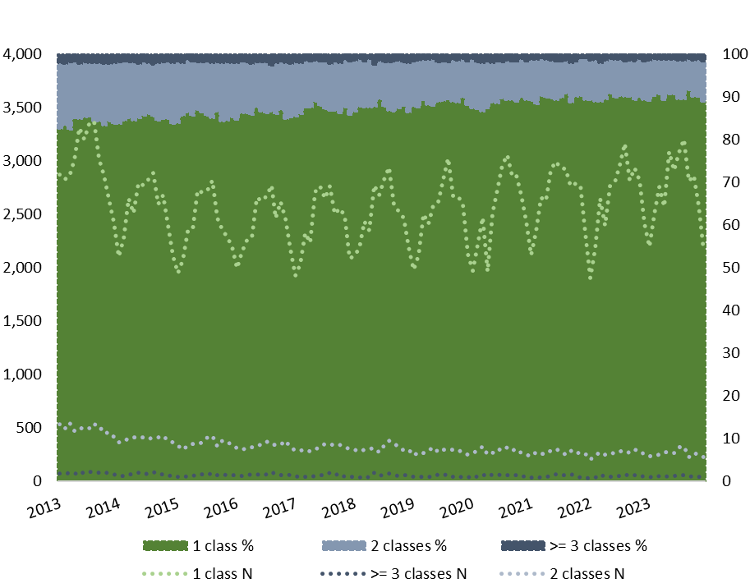
% of users
Number of people (10% sample)
Figure 14. Number and percent of people initiated on antihypertensive treatment by the number of classes dispensed
Among those initiated on a single class of antihypertensives, the trends in the class dispensed remained relatively stable over the study period (Figure 15). In July 2023, antihypertensive agents acting on the renin-angiotensin system (WHO ATC C09) which include ACE and ARB classes were used by 57% of the single-class users, and BBs (WHO ATC C07) were used by 31% of new users. Our findings on the use of BBs as initial therapy align with a recent US large database study, which found that BBs are still commonly used as an initial therapy for hypertension despite the American College of Cardiology and American Heart Association no longer recommending them as first-line treatment for patients with uncomplicated hypertension.⁷ Similarly, in Australia, the Heart Foundation guideline, does not recommend the use of BBs as first-line therapy for patients with uncomplicated hypertension.^{1,2} However, both US and Australian guidelines recommend the use of BBs in patients with a history of heart failure, myocardial infarction or angina. Additionally, antihypertensives are also commonly used in patients without high BP, such as those with a history of myocardial infarction. Therefore, this analysis should be interpreted with caution, considering the broader clinical context in which antihypertensives are prescribed.
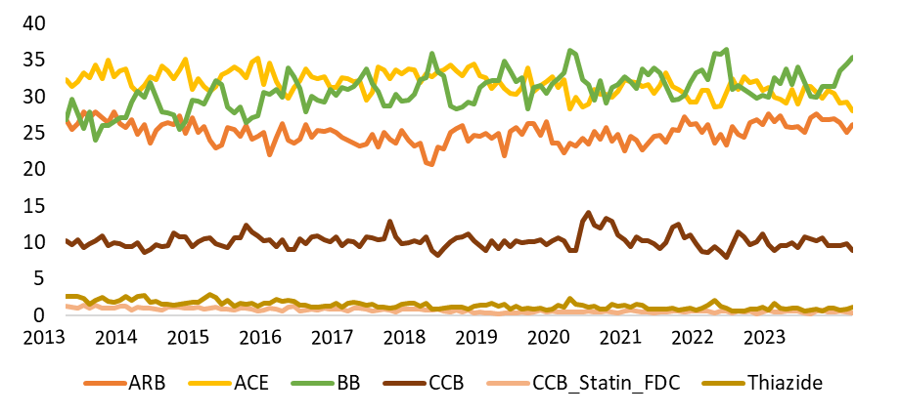
Figure 15. Monthly proportion of single class initiators by class dispensed, 2013 to 2023
There was only a small group of people (9%) who were dispensed two classes of antihypertensives in the first month of treatment (average 300 per month in the PBS 10% sample dataset, or approximately 3000 in the Australian population). The proportion of people dispensed multiple classes in FDC at therapy initiation declined over the study period from 60% in 2013 to 40% by the end of 2023 (Figure 16). This is may be due to the change in the clinical criteria for the PBS restriction of FDC in 2014 that specifically indicated that FDC products must not be for the initiation of antihypertensive therapy, or may be a result of changing treatments patterns, such as reduced use of thiazides with ACE/ARB and increasing use of CCB with ACE/ARB, for which there are fewer available FDCs on the PBS.

Figure 16. Proportion of people initiated on FDC among those dispensed two classes of antihypertensive

The proportion of patients who subsequently had a second antihypertensive from a different class, either as a single product or as a FDC, after initiation of monotherapy
In the following analysis we considered all new users of antihypertensive therapy in 2023. In this analysis day 0 is considered the first day of dispensing of any antihypertensive for those patients.

In 2023, there were 35,334 people in the PBS 10% sample dataset (353,340 in the Australian population) who commenced antihypertensive treatment. Of these 90% were dispensed a single product only on the first day (318,006 in the Australian population).

Of those dispensed a single product only on the first day:
- 5% added another single product within 12 weeks
- 3% switched to a FDC within 12 weeks
- 17% stopped all antihypertensive treatment within 12 weeks
- 75% remained on monotherapy (single class antihypertensive).
Overall, 8% of all patients who commence antihypertensive treatment with a single class were considered for the costings as ‘eligible’ to initiate an FDC at treatment commencement.

If we consider the population that initiate monotherapy in 2023, there are 30% that initiate on a beta-blocker (BB). Since there are no FDC products containing BBs on the PBS, the population who initiate BBs were excluded from the population of people who could potentially initiate an FDC at hypertension treatment initiation. After excluding those who initiate BBs, there were 222,604 people in the Australian population that initiate on an ACE, ARB, CCB or thiazide. If we assume that 8% of those people could have initiated an FDC at antihypertension treatment initiation, this would equate to 17,808 people. Of these, a difference in costs of treatment would only be realised for those who commence 2 multiple single-agent products rather than a FDC, as those who escalate treatment to a FDC would not incur any reduction in prescriptions or copayments. Of the 8% who escalate treatment, 62.5% added another single-agent product, 11,130 patients, and were included in the costings.

Using a 12-month follow-up time, the proportion of patients dispensed a single product only on the first day who subsequently added another single product was 11.4%, the proportion who switched to a FDC was 7.3%, and 54% stopped antihypertensive treatment. Overall, it was estimated that 18.7% of people who initiated antihypertensive treatment in 2023, or 41,627 people in the Australian population, may have started a FDC at hypertension treatment initiation if the PBS restriction allowed.

In this analysis we found that of the population who commence antihypertensive therapy the majority initiate a single agent (90%). Very few initiate multiple classes (10%) and of these, less than half initiate a FDC.

In 2023, of the approximately 353,340 people in Australia who commenced antihypertensive therapy, 17% (60,800 people) were on multiple antihypertensive therapies by 12 weeks, and around 27% (94,800 people) were on multiple antihypertensive therapies by one year.

Persistence and adherence to antihypertensive

This section of the report examines persistence and adherence to antihypertensive therapy amongst naïve patients initiating antihypertensive monotherapy versus multiple therapies. The analysis was conducted at the class level of antihypertensives. Patients who initiated on beta-blockers or ‘other’ antihypertensives were excluded.

Persistence to index therapy

There were 155,554 people who initiated antihypertensive therapy between 1 Jan 2015 and 31 Dec 2019. The median time to discontinuation of index therapy due to a switch or cessation was 10 months for those on monotherapy, while it was 4 months for those initiated on ACE or ARB in combinations at treatment commencement (Figure 17 and Table 3). Persistence to index therapy at 4 years was 29% for monotherapies and 17% for ACE/ARB combination therapies (Table 3). Compared to those on combination treatment those initiated on monotherapy had a longer time to discontinuation (HR 0.71 95% CI 0.69-0.72).

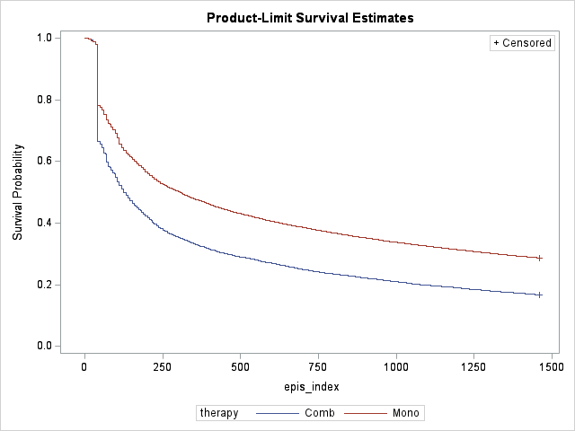
Figure 17. Time to discontinuation of index therapy, monotherapy vs ACE/ARB combinations (pooled)

Table 3. Persistence to index therapy after treatment commencement by regimen initiated
Regimen at hypertension treatment commencement | Number of patients | Percent on therapy at 4 years | Median duration | 95% CI
Monotherapy (ACE/ARB/CCB/Thiazide) | 102,174 | 28.7% | 306 days | (299; 313)
Combinations  (ACE/ARB as FDC or as separate agents) | 9,966 | 16.7% | 125 days | (123; 132)

When stratified by the type of index monotherapy, people initiated on ARB had the longest median duration on index therapy (1.5 years), followed by ACE monotherapy initiators with median duration (11 months) (Figure 17 and Table 4). Persistence to index monotherapy at 4 years was 36% for ARB and 29% for ACE (Table 4).

Table 4. Persistence to index therapy after hypertension treatment commencement by class for those on mono-therapy
Class | Number of patients | Percent on index therapy at 4 years | Mean duration | 95% CI
ACE | 48,422 | 28.5% | 321 days | (314; 335)
ARB | 34,785 | 36.4% | 559 days | (538; 580)
CCB | 15,643 | 17.3% | 118 days | (111; 125)
Thiazide | 3,324 | 4.0% | 111 days | (109; 115)

Duration on index therapy for people on separate agent combinations and FDC at antihypertensive treatment initiation are shown in Figure 18. Mean duration of persistence to index therapy was approximately 3 months for separate agent combinations and 5 months for FDC (Table 5).

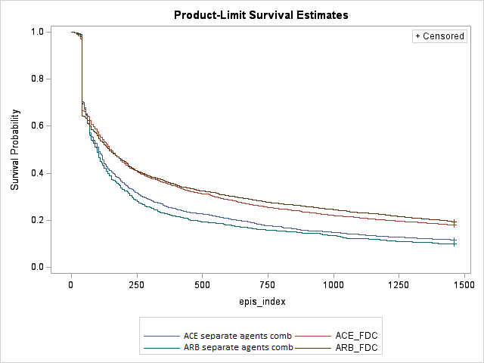
Figure 18. Time to discontinuation of index combination therapy, by type of combination therapy

Table 5. Persistence to index therapy after hypertension treatment commencement by class for those on multiple classes either as multiple single agents or as FDC
Class | Number of patients | Percent on index therapy at 4 years | Mean duration | 95% CI
FDC including ACE | 2,862 | 18.0% | 153 | (139; 167)
Separate agent combinations including ACE | 1,773 | 11.6% | 104 | (97; 117)
FDC including ARB | 4,260 | 19.5% | 146 | (132; 160)
Separate agent combinations including ARB | 1,071 | 10.0% | 97 | (83; 104)

The unadjusted and adjusted hazard ratios (HRs) for persistence to first episode with index therapy are shown in Table 6, demonstrating age and gender had little impact on time to discontinuation of first episode of therapy.

Table 6. Unadjusted and adjusted Cox proportional hazard ratios (HF) for persistence to index antihypertensive therapy
Comparison | Unadjusted HR  (95% CI) | p- value | Adjusted HR  (95% CI) | p-value
Mono therapies vs Combinations | 0.693 (0.678; 0.708) | <0.0001 | 0.701 (0.685; 0.717) | <0.0001
ACE mono vs ARB mono | 1.230 (1.209; 1.250) | <0.0001 | 1.235 (1.214; 1.256) | <0.0001
CCB mono vs ARB mono | 1.787 (1.748; 1.826) | <0.0001 | 1.773 (1.734; 1.812) | <0.0001
Thiazides mono vs ARB mono | 2.275 (2.259; 2.435) | <0.0001 | 2.265 (2.182; 2.352) | <0.0001
ACE separate agent comb vs ACE_FDC | 1.248 (1.143; 1.299) | <0.0001 | 1.240 (1.163; 1.322) | <0.0001
ARB separate agent comb vs ARB_FDC | 1.345 (1.243; 1.434) | <0.0001 | 1.367 (1.272; 1.468) | <0.0001
Note: Adjusted for age and gender at initiation

Persistence to any antihypertensive therapy

Overall, persistence to any antihypertensive therapy was similar between those initiated on combination treatment or monotherapy (Figure 19, Table 7).

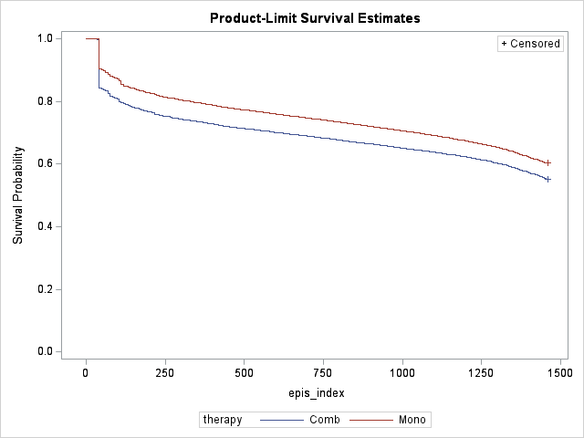
Figure 19. Persistence to any antihypertensive therapy after treatment commencement by regimen

Table 7. Persistence to any therapy after treatment commencement by regimen initiated
Class | Number of patients | Percent on any therapy at 4 years | Median duration
Monotherapy (ACE/ARB/CCB/Thiazides) | 102,174 | 60.0% | >4 years
Combinations  (ACE/ARB as FDC or as separate agents) | 9,966 | 55.3% | > 4 years

Adherence to antihypertensive therapy
Adherence was measured as the proportion of days covered (PDC) from initiation of a class(es) to last dispensing for that class(es). The results are presented in Table 8 and show good adherence for all therapies (80% or greater PDC was used as a cut-point to indicate good adherence).

Table 8. Adherence to antihypertensive therapy
Type of index therapy | Adherence
ACE and thiazide as multiple single agents | 87%
ACE monotherapy | 85%
ACE/thiazide as FDC | 85%
ACE and CCB as multiple single agents | 84%
ACE/CCB as FDC | 83%
ARB/CCB as FDC | 83%
ARB/thiazide as FDC | 83%
ARB and thiazide as multiple single agents | 83%
ARB monotherapy | 82%
ARB and CCB as multiple single agents | 82%
CCB monotherapy | 79%
Thiazide monotherapy | 79%

Demographic factors influencing use of FDCs
In this section of the report, we examine the impact of demographic factors on antihypertensive use.
Among initiators of antihypertensives, the proportion of females was highest in monotherapy initiators and lowest in those initiating multiple classes (Table 9). Compared to the monotherapy initiators, those initiating multiple single-class products were older, while the majority of those initiating FDC were in the 45-to-65-year age group. This may reflect the availability of low dose FDC products through the PBS and the recommendations for starting antihypertensive therapy in older individuals which include starting at low doses and titrating slowly to minimise adverse effects. Furthermore, if the initial treatment response to monotherapy is inadequate, guidelines recommend considering alternative drug classes or investigate secondary causes before adding another class of antihypertensive.⁵

Table 9. Demographic characteristics of people who initiated hypertension treatment in 2023 stratified by the initiating regimen
 | Monotherapy  (N=32,705) |  | Multiple single-class products  (N=1,309) |  | At least one FDC  (N=1,320) |  | p-value
Demographic characteristic | N | % | N | % | N | %
Female | 16,779 | 51.3 | 478 | 36.5 | 546 | 41.4 | <0.0001
Age: 18-44 | 9,785 | 29.9 | 265 | 20.2 | 333 | 25.2 | <0.0001
Age: 45-64 | 14,083 | 43.1 | 582 | 44.5 | 658 | 49.8 | <0.0001
Age: 65-74 | 5,643 | 17.3 | 293 | 22.4 | 224 | 17.0 | <0.0001
Age: 75-84 | 2,662 | 8.1 | 130 | 9.9 | 84 | 6.4 | <0.0001
Age: 85+ | 532 | 1.6 | 39 | 3 | 21 | 1.6 | <0.0001
Among the prevalent users, the proportion of females was highest in those dispensed only a single class in 2023 and lowest in those dispensed multiple classes (Table 10). Compared to the prevalent monotherapy group, those using multiple single-class products were older. The use of FDC is infrequent in the older age groups.

Table 10. Demographic characteristics of the antihypertensive users with at least one hypertension treatment in July 2023 stratified by the regimen
 | Monotherapy  (N=214,689) |  | Multiple single-class products  (N=88,276) |  | At least one FDC  (N=126,277) |  | p-value
Demographic characteristic | N | % | N | % | N | %
Female | 110,411 | 52.1 | 42,940 | 20.2 | 58,752 | 27.7 | <0.0001
Age: 18-44 | 31,600 | 14.7 | 6810 | 7.7 | 14,745 | 11.7 | <0.0001
Age: 45-64 | 106,810 | 49.8 | 40,680 | 46.1 | 73,016 | 57.8 | <0.0001
Age: 65-74 | 52,492 | 24.5 | 27,847 | 31.5 | 30,416 | 24.1 | <0.0001
Age: 75-84 | 21,407 | 10.0 | 11,917 | 13.5 | 7735 | 6.1 | <0.0001
Age: 85+ | 2380 | 1.1 | 1022 | 1.2 | 365 | 0.3 | <0.0001

Among the initiators of antihypertensive treatment, those initiating FDC are younger and more likely to be male than compared to those initiated on monotherapy. For the prevalent population, those dispensed FDC are more likely to be male and less likely to be in the older age groups. This suggests that the population likely to initiate FDC at treatment initiation should the PBS restrictions allow this, would likely be in the younger age groups, consistent with guideline recommendations.

Concordance with guidelines
In this section we examined the concordance of use of antihypertensive treatments to current clinical guidelines. Specifically, we considered potential quality use of medicines issues, including use of ACE in combination with ARB. We describe treatment pattern concordance with recommended guidelines and best practice. The following Australian guidelines were considered: Heart Foundation guidelines, Therapeutic Guidelines, and the Australian Medicines Handbook (AMH).^{1,2,5}
Use of antihypertensive combinations to avoid: ACE in combination with ARB, or non-dihydropyridine CCB and BB
Among antihypertensive users in July 2023, the proportion of people with significant interactions was very low, with concomitant use of ACE and ARB at 0.3%, and non-dihydropyridine CCB and BB at 0.2%. These combinations could reflect a transition between antihypertensive regimens or, in some cases, intentional use. While the combination of ACE and ARB can increase the risk of renal impairment, there are specific clinical scenarios where their combined use may be warranted. The concurrent use of non-dihydropyridine CCBs and BBs carries a risk of bradycardia and heart block, necessitating careful patient monitoring.
Use of antihypertensives with unfavourable and favourable effects by presence of comorbid conditions
In July 2023, diabetes was the most common comorbidity among antihypertensive users, affecting 20.7% of the population dispensed at least one antihypertensive, followed by airways disease and atrial fibrillation (AF). FDC use was highest among those with diabetes (32% of those with diabetes), which may be partly attributable to their younger age (median age 69 years), compared to the other comorbidity cohorts (Table 11).

Table 11. Characteristics of antihypertensive users in July 2023 by comorbidity as measured by the RxRisk categories (based on PBS 10% sample, not adjusted to Australian population numbers)
Characteristics | Comorbid condition
Characteristics | AF | Diabetes | Airways disease | CKD | HF | Angina
N (% of all anti-hypertensive users) | 42,903  (9.9%) | 88,752 (20.7%) | 53,365 (12.4%) | 1,689 (0.4%) | 30,904 (7.2%) | 11,740 (2.7%)
Median age (range) | 77 (70-84) | 69 (60-77) | 72 (63-79) | 73 (60-82) | 73 (64-81) | 76 (68-84)
Male N (%) | 23,953  (55.8%) | 50,731 (57.2%) | 23,158 (43.4%) | 964  (57.1%) | 19,109 (61.8%) | 6,829 (58.2%)
N used at least 1 FDC (% of comorbid users) | 8,322  (19.4%) | 27,929 (31.5%) | 14,347 (26.9%) | 167 (9.9%) | 2,962 (9.6%) | 1,940 (16.5%)
1 antihypertensive class  (% of comorbid users) | 17,287  (40.3%) | 34,912 (39.3%) | 24,549 (46.0%) | 586  (34.7%) | 7,625 (24.7%) | 4,109 (35.0%)
2 antihypertensive classes  (% of comorbid users) | 15,225  (35.5%) | 31,731 (35.8%) | 19,350 (36.3%) | 577  (34.2%) | 12,581 (40.7%) | 4,540 (38.7%)
≥3 antihypertensive classes  (% of comorbid users) | 10,391  (24.2%) | 22,109 (24.9%) | 9,466  (17.7%) | 526  (31.1%) | 10,698 (34.6%) | 3,091 (26.3%)
In terms of quality use of medicines by comorbidity, the analysis showed varying degrees of alignment to recommended antihypertensive therapies (Table 12). For example, among those with AF, 86% were dispensed the preferred antihypertensive agents (ACE, ARBs, or non-dihydropyridine CCBs) which aligns with clinical guidelines. However, for users with diabetes, where caution is advised on the use of BBs and thiazides due to potential adverse effects on glucose metabolism, our analysis found that 32% and 20% were dispensed these agents, respectively. In those with airways disease, one in four were dispensed selective BBs. Selective BBs should be used with caution in those with airways disease due to the high risk of bronchospasm. Additionally, 3% of those with airways disease were taking contraindicated non-selective BBs. Among those with chronic kidney disease (CKD), only 53% were using the preferred antihypertensive agents (ACE or ARB). While this relatively low use of ACE or ARB suggests room for improvement in optimising renal protection and reducing CV risk, it is important to note that some patients may be unable to use ACE or ARB due to contraindications or adverse effects.

Table 12. Use of antihypertensives with favourable and unfavourable effects by presence of comorbid conditions (based on the PBS 10% sample)
Co-morbid condition | Total no. of patients  (% all users) | Favourable effects  (recommended) | Unfavourable effects  (potentially harmful)
Co-morbid condition | Total no. of patients  (% all users) | Favourable effects  (recommended) | Caution agents | Contraindicated agents
AF | 42,903  (9.9%) | Use of ACE/ARB/BB/  Diltiazem/Verapamil:  37,075 (86%) | N/A | N/A
Diabetes | 88,752  (20.7%) | N/A | Use of BB:  27,968 (32%)  Use of thiazide:  17,363 (20%) | N/A
Airways disease | 53,365  (12.4%) | N/A | Use of selective BB:  13,344 (25%) | Use of non-selective BB:  1,721 (3%)
CKD | 1,689  (0.4%) | Use of ACE/ARB:  897 (53.1%) | N/A | N/A

Costings

Background:
Given the substantial use of antihypertensives through the PBS, FDC underuse may have significant cost impacts to Government and consumers, as FDCs often have similar prices to the single-class medicines there would be additional costs if the individual components are dispensed rather than the FDC. For example, at 1 September 2024, the PBS dispensed price for maximum quantity (DPMQ) of telmisartan 40 mg was $16.17, amlodipine 5 mg was $15.17, and telmisartan 40 mg + amlodipine 5 mg FDC was $16.60, an increased cost of $15.74 if the individual components are dispensed rather than the FDC. In the previous analysis we identified that among the prevalent population the ratio of single agent products to FDC among those for which an FDC equivalent is available was 1 : 3. This suggests that where patients are dispensed multiple classes of medicines that are available as FDC products the majority of patients receive FDC. However, it is possible that the 25% who are dispensed multiple single class products could be reduced if patients were permitted to initiate FDC at hypertension treatment commencement.
In this analysis we estimate the cost to the patient and to the PBS if FDC products were available at hypertension treatment commencement. Additionally, we estimate total cost to the patient and to the PBS if all patients on multiple single agent products, for which there is an equivalent FDC available, were to switch to FDC.

Aim
To determine the potential savings to the PBS and consumers from addressing any underuse of antihypertensive FDCs due to PBS restriction.

Method
In this analysis we estimate that the underuse of FDCs may be associated with the PBS restriction that requires patients to initiate a single-agent product at antihypertensive treatment commencement and then step up treatment. We estimate the population that would be using FDCs if PBS restrictions were lifted.
To determine the population who would be eligible to initiate FDC at treatment commencement we used the following approach. First, we considered the population that initiated a second single-agent product from another class within 3 months of antihypertension treatment commencement with a single product. Secondly, we considered those patients who commenced on multiple single agent products at antihypertensive treatment initiation.
In Stage 1 of this analysis, we identified that 90% of patients commence antihypertensive treatment with a single-agent and of these 8% add a second product from a different class. Among those who added a second product, 62.5% added a second single-class product and 37.5% added an FDC. We assume that those who added an FDC would have no difference in their co-payment cost had they started a FDC at commencement, hence these patients are not included in the costing analysis.
In addition, we included in the eligible population those that initiated multiple single agents at treatment initiation. In Stage 1 of this analysis, we identified that 10% of patients commence antihypertensive treatment with multiple classes, and of these 60% initiate multiple single agents.
Therefore, we consider that the eligible population who would initiate an FDC at commencement of antihypertensive treatment if PBS restrictions permitted would include: 1) individuals who initiated a single product and added a second class of antihypertensive as either another single agent or a FDC within 90 days and 2) individuals who initiated multiple single agents at treatment commencement.
Next, to determine the prevalent (continuing incident) population who would have persisted to use multiple products, we estimated the number of individuals who initiated treatment with multiple products and continued using multiple products over time. The estimation process was informed by the persistence analysis, which examined how long patients remained on their multiple-product regimen without discontinuation. The persistence analysis provided insights into the proportion of patients who maintained their multi-product regimen over various timeframes (Figure 18). Using this model, we estimated that 38% of those who initiated multiple treatments would be persistent at year 1, 30% at year 2, 23% at year 3, 20% at year 4, and 20% at year 5.
We estimated that the size of the population would increase marginally by 2.5% every year, based on the previous yearly increase in the population.
For both the incident and prevalent (continuing incident) eligible populations, we assumed that the distribution of FDC products is equivalent to the distribution of FDC among the prevalent population in 2023. We also consider that the proportion of general and concessional patients will be similar to the prevalent population (i.e., 40% general and 60% concessional).
The average weighted price for each single agent product and FDC is estimated based on 2023 prices for both the consumer and the PBS and the average number of prescriptions per year is also estimated from the PBS 10% sample dataset.
The average script reduction if patients are to use FDC from treatment commencement rather than a single product at initiation and stepping up to two single agent products is estimated as the average number of scripts for the multiple single products minus the average number of FDC scripts.
The cost difference per script between dispensing two single-agent products compared to FDC is estimated as the total cost of the two single ingredients products minus the cost of the equivalent FDC for both the general and concessional patients and for consumers and the PBS.
The total cost savings per year were calculated as the cost saving per prescription multiplied by the average script reduction if patients use only FDC. For this analysis the maximum cost for concessional patients is calculated as the total cost assuming no safety net scripts and the actual cost calculation is calculated as the total cost assuming the distribution of safety net scripts based on the PBS10% sample dataset. Premium brand surcharges and the $1 concessional patient discount are not accounted for in this analysis. Additionally, as the DPMQ represents the maximum dispensing charge, consumers may pay less than the listed DPMQ amount. The general beneficiaries’ cost is estimated from DPMQ in 2023.
Lastly, the total savings to general and concessional patients for both the consumer and the PBS are calculated as the sum across all FDC products of the estimated population who would commence FDC at treatment initiation multiplied by the average cost savings per year.

Results

In Stage 1 of this report, we estimated that 8% of those who commence antihypertensive treatment with a single medicine class escalated treatment with another antihypertensive class within 12 weeks, and of these 37.5% switched to FDC while 65.5% added another single-agent product. If we consider antihypertensive monotherapy initiators who escalated treatment by adding another single ingredient product rather than an FDC within 12 weeks could have instead been initiated on an FDC, this equates to a potential population of people who could initiate FDCs in Year 1 of 11,408 people (Table 12). For the 6,845 people who switch to an FDC product from a single-agent product we assume no net cost impact if they were to have commenced a FDC at treatment initiation. Therefore, these patients are not included further in this analysis.

Next, we consider the 10% of patients who were commenced on multiple classes of antihypertensives at treatment commencement. Of these 40% initiated FDC and 60% initiated multiple single agents. Assuming that the 60% who initiated multiple single agents would have instead initiated FDC we estimate that this would equate to a population of 21,730 patients who would be eligible to commence FDC in Year 1 (Table 12). Therefore, we estimate that the population of patients who would commence FDC if permitted would be 33,139 patients in Year1 (Table 13). In Year 2 we estimated 46,560 eligible population, including 12,593 estimated persistent multiple product users who could potentially switch to FDC.

Table 13. Estimated population underusing FDCs if PBS restrictions were removed
Population Group | 2023 | Year 1 estimate | Year 2 estimate | Assumption
All new users | 353,340 | 362,174 | 371,228 | ↑ 2.5% yearly
Monotherapy (90%) - A | 318,006 | 325,956 | 334,105
ACE/ARB/CCB/Thiazide (70% of A) - B | 222,604 | 228,169 | 233,874
Added another class in 90 days (8% of B) - C | 17,808 | 18,524 | 18,710
Multiple class (10%) - D | 35,334 | 36,217 | 37,123
Not FDC (60% of D) – E | 21,200 | 21,730 | 22,274
Potential underuse population: Commenced on single product then add another class (not in FDC) within 90 days - F | 11,130 | 11,408 | 11,694 | 62.5% of C
Potential underuse population: Prevalent (persistent users) who initiated on multiple products - G |  |  | 12,593 | Persistence model
Total potential underuse population who could switch to FDC (E + F + G) |  | 33,139 | 46,560
Notes: sum may differ due to rounding

Assuming that the distribution of use of FDC products among these patients would be similar to the distribution of FDC among the prevalent population in 2023 we estimated that in Year 1 consumers would save $2.4 million (assuming no safety net dispensings) or $1.9 million (weighted by general and safety net prescriptions) and $25.7 million and $20.5 million in total over six years respectively (Table 14). Cost savings to the PBS were estimated to be $1.7 million in Year 1 to $3.9 million by Year 6 and a total cost saving of $17.9 million over 6 years. Cost savings were driven by a reduction in prescriptions which is estimated to be between 2 to 3 less prescriptions per year for those dispensed thiazides with ARB or ACE and between 8 and 9 prescriptions less per year for those on CCB with ACE or ARB.

Table 14. Estimated cost savings if patients were permitted to initiate an antihypertensive FDC
Year | Total consumer savings (no safety net) | Total consumer savings (including safety net) | PBS savings
Year 0 | $2,321,131 | $1,855,693 | $1,620,282
Year 1 | $2,379,159 | $1,902,085 | $1,660,789
Year 2 | $3,342,718 | $2,672,430 | $2,333,408
Year 3 | $4,140,034 | $3,309,866 | $2,889,980
Year 4 | $4,790,742 | $3,830,092 | $3,344,211
Year 5 | $5,362,596 | $4,287,277 | $3,743,398
Year 6 | $5,671,174 | $4,533,978 | $3,958,803
Total (Year 1-6) | $25,686,422 | $20,535,728 | $17,930,589
Note: Yearly projections are based on the proportion of people in 2023 (Year 0) estimated to be underusing FDCs (Table 12)

The estimated total cost savings for patients should they initiate with FDC at antihypertensive treatment initiation, among the population likely to be eligible, was estimated to be $20.5 million to $25.7 million, while the cost saving to the PBS was estimated to be $17.9 million over 6 years. Cost savings are driven by a reduction in prescriptions which is estimated to be between 2 to 3 less prescriptions for those dispensed thiazides with ARB or ACE and between 8 and 9 prescriptions for those on CCB with ACE or ARB.

Literature review

Evaluating initiation of antihypertensive therapy with sequential stepped-up multiple products (standard care) versus low dose two-component FDC: A narrative review

Background
This narrative review aims to summarise the comparative safety and effectiveness of initiating antihypertensive treatment with ‘standard care’ (i.e., low dose monotherapy, followed by adding a second low dose therapy, then titrating up the doses) versus commencing low dose two-component FDC therapy.

Methods
A literature search was conducted using MEDLINE and EMBASE databases. A purposive search strategy was conducted to identify systematic reviews or meta-analyses comparing safety and effectiveness associated with initiation of a standard care regimen versus low dose two-component FDC. Search terms relating to fixed-dose combination, individual formulation, meta-analysis, and systematic review were applied. Appendix 2 provides a detailed description of the search strategy. We limited inclusion to studies where the population were incident users of antihypertensives comparing standard care to FDC therapy, and where the study design was a systematic review or meta-analysis. Studies were excluded if they only involved monotherapy without the addition of a second drug or if they compared the use of FDCs with a placebo. The search was limited to literature published between 2012 and 2024 to ensure that results are relevant to current clinical practice.

Results
The database search initially identified 288 articles. After removing duplicates, we screened the titles and abstracts of 195 articles. We assessed the eligibility of 44 articles which were relevant after the title and abstract review stage; however, none of these systematic reviews or meta-analyses met our inclusion criteria. A review of the reference list of these studies was therefore conducted to identify relevant randomised controlled trials on the topic. We identified two randomised controlled trials: one from Canada - Simplified Treatment Intervention to Control Hypertension (STITCH) trial (Feldman et al., 2009) and one from the United Kingdom - Prevention and Treatment of Hypertension With Algorithm-based Therapy (PATHWAY) trial (Macdonald et al., 2017).^{8,9} Both trials compared standard care with a low dose two-component FDC at hypertension treatment initiation. Table 15 provides a summary of the characteristics of the studies included in this review.

Table 15. Randomised-controlled trial study characteristics
Author  (Trial name) - country | N | Age – mean (SD) | Initial BP | Antihypertensive regimen comparison | Trial duration | Potential bias
Feldman et al 2009⁸ (Simplified Treatment Intervention to Control Hypertension (STITCH)) - Canada | 2048 | 61.3 (8.9) | ≥140/90 mmHg for patients without diabetes mellitus or ≥130/80 mmHg for patients with diabetes mellitus | Standard care:  As per 2007 Canadian Hypertension Education Program (CHEP) guideline – initial monotherapy then add-on (N= 1246)  vs  Low dose two-component FDC:  As per STITCH algorithm – initial low dose two-component FDCs including combination of ACE+diuretics or ARB+diuretics (N= 802) | 6 months | Selection bias:  Young participants and inclusion of new and prevalent antihypertensive users  Funding bias:  Pfizer funded study
Macdonald et al 2017⁹ (Prevention and Treatment of Hypertension With Algorithm-based Therapy (PATHWAY) trial) – United Kingdom | 605 | 54.2 (8.1) | >150/90 or <200 /120 | Standard care:  - Losartan then hydrochlorothiazide (HCT) then switches to losartan+HCT in FDC form (N= 150)  - HCT then losartan then switches to losartan+HCT in FDC form (N= 151)  vs  Low dose two-component FDC:  Losartan+HCT FDC (N= 304) | 1 year | Selection bias:  Young participants and inclusion of new and prevalent antihypertensive users  Funding bias:  Authors have pharmaceutical affiliations and provision of study drug by pharmaceutical company

Both studies included a mix of incident users and prevalent users, 49% of participants in the STITCH trial and 56% in the PATHWAY trial were prevalent users. There was no washout period prior to inclusion in the STITCH trial. In the PATHWAY trial, there was a 4-week placebo run-in period used as a washout regimen.

Effectiveness
The target BP level in both trials was <140/90. The STITCH trial found that at 6 months 65% of those in the initial low dose two-component FDC group achieved target BP compared to 53% in the standard care group (between-group difference: 12.1%, 95% confidence interval (CI): 1.5-22.4%, p= 0.026).⁸ At 6 months, only 16.8% of the standard care group were on dual therapy.⁸
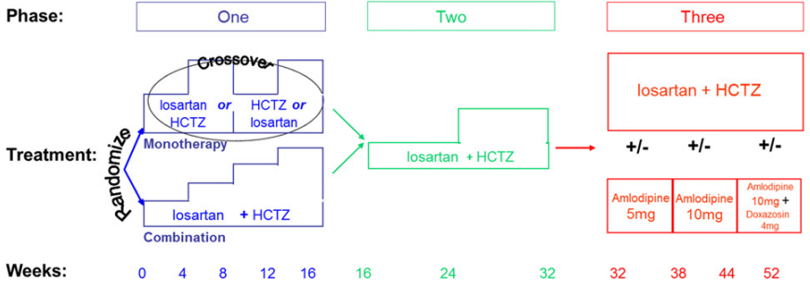
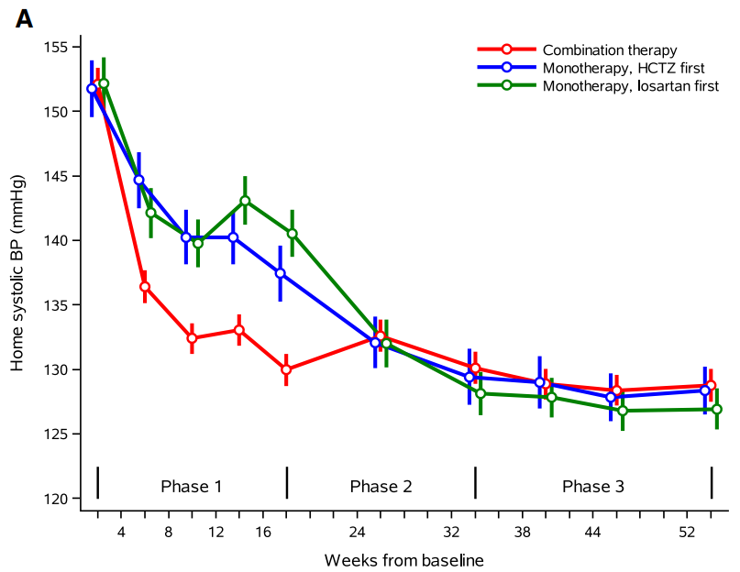
In the PATHWAY trial, after 16 weeks of study treatment, 75% of those in the initial low dose two-component FDC group achieved target BP compared to 40% who started on standard care (p <0.001).⁹ However, at the end of week 32 similar proportions achieved the target BP (76% in low dose two-component FDC group and 78% in standard care group). At 32 weeks, the duration on dual therapy was 32 weeks for low dose two-component FDC group and 28 weeks for standard care group.⁹ Figure 20 shows the average reduction in BP throughout the PATHWAY trial study periods. The group that initiated treatment with a low dose two-component FDC showed a more rapid and steep decrease in BP.
Figure 20. PATHWAY study design and BP reduction results
Safety
The STITCH trial reported seven serious adverse events: three deaths in the standard care group and four undocumented events in the low dose two-component FDC group, and three episodes of drug intolerance (all in the low dose two-component FDC group).⁸
The PATHWAY trial found a higher reporting of hypotension symptoms in the two-component low dose FDC group at the end of 16 weeks study period, with 25% reporting hypotension symptoms compared to 14% in the monotherapy first group (p <0.001).⁹

Discussion
We did not find any systematic reviews or meta-analyses comparing initial antihypertensive treatment using the standard care approach versus starting with a low dose two-component FDC. This is because use of FDC as combination therapy was not specifically stated in many studies (that is, it was unclear whether study participants used FDC or multiple single-class products) and many studies included comparisons with placebo or monotherapy only. For example, Salam et al. (2019) reviewed the initiation of two-component combination therapy but did not specify whether participants used FDC or multiple single-class products in their inclusion criteria.¹⁰ Additionally, they considered the standard care approach, where one medicine is initially used and then another is added, as treatment intensification and excluded it from their review.
The STITCH and PATHWAY trials included in this review each used a different definition of standard care. In the STITCH trial, standard care involved starting with one medicine, increasing the dose to the standard recommended dose level, and then adding another medicine if needed.¹¹ In the PATHWAY trial, standard care included starting with one medicine, switching to a different medicine, and then using an FDC product combining the two medicines. This variation in the definition of standard care could potentially contribute to the absence of identification of suitable meta-analyses in our database search, as it is difficult to meta-analyse the results of individual studies with such heterogeneous designs.
The target BP level in both the STITCH and PATHWAY trials was <140/90 mm Hg, therefore, the findings from these trials may not be applicable to individuals aged 65 years and older. The AMH Aged Care Companion 2022 suggests that a higher BP target of less than 150/90 mmHg is acceptable for individuals aged 65 years and older.¹² This is because, as people age, there are natural changes in the cardiovascular system. Blood vessels may become stiffer and become less responsive to medicines.
Both trials showed immediate BP target achievement within the 6 months study period. Early and rapid BP control provides significant clinical benefits. For example, achieving BP control within six months is associated with reduced stroke incidence, while delayed responders have higher rates of CV disease, coronary artery disease, and heart failure. Additionally, early BP lowering significantly reduces fatal and non-fatal strokes, total CV events, and mortality.¹³
The PATHWAY trial reported safety concerns, particularly the incidence of hypotension. By the end of 16 weeks, 25% of patients in the low dose two-component FDC experienced hypotension symptoms, compared to 13.6% in the standard care group (p < 0.001).⁹ This indicates that while FDCs are effective in achieving rapid BP control, they also pose a higher risk of hypotension.
Additionally, since both trials included previously treated patients (49% and 56%, in STITCH and PATHWAY trials respectively), the results may underestimate the incidence of adverse effects and overestimate the BP reduction effect. Adverse effects most commonly occur during the initial intake of medicine meaning that prevalent users are both less likely to experience adverse effects, and if they have experienced them, are more likely to tolerate them as they have remained on therapy. In addition, previously treated patients might experience cumulative beneficial effects of the medicine meaning that BP targets are more likely to be met in these patients. Therefore, these results from the STITCH and PATHWAY trials may not accurately reflect the effects of newly starting antihypertensives using standard care or low dose two-component FDC.
The use of multiple antihypertensive medications in the older population is associated with an increased risk of injurious falls, primarily due to their effects on BP and orthostasis.¹⁴ Research shows that moderate to high doses of antihypertensives are associated with a 30% to 40% increased risk of serious falls.¹⁴ This risk is particularly pronounced within the first few weeks of initiating therapy, likely due to acute changes in BP and potential urinary symptoms from diuretics.¹⁵ The impact on fall risk does not appear to differ significantly across different classes of antihypertensive drugs. However, combining these medications can result in substantial BP reductions, increasing the likelihood of falls.
Despite the lack of systematic reviews on the efficacy of initiating first line hypertension therapy with FDC, the European Society of Hypertension (ESH) has rated the reliability of evidence as level B, signifying a moderate level of evidence or evidence with some uncertainty. The 'class of recommendation' (CoR), on the other hand, was designated as level I, indicating a strong agreement between the experts where the benefits of the therapy clearly outweigh the potential risks.⁴
Systematic reviews and meta-analyses have found that, in general, use of FDC improves patient adherence particularly among those with hypertension.^{16,17} Australian studies found that while FDCs may slightly improve persistence with the initial therapy, they have limited impact on overall adherence and long-term persistence in lipid-lowering therapy. Prior treatment experience plays a more significant role in promoting persistence than FDC use.¹⁸⁻²⁰
A Canadian study examined the effectiveness of initiating antihypertensive therapy with FDC in a large linked clinical and administrative data of 13,350 people aged 66 years older.²¹ The study found that initiating FDC as first-line was associated with a significantly lower rate of the composite outcome of death or hospitalisation for heart attack, heart failure, or stroke, compared with initiating multiple first-line medicines in multiple products (3.4 versus 3.9 events per 100 person-years respectively; hazard ratio: 0.89, 95% CI 0.81–0.97, p < 0.01).²¹ While it is not possible to directly associate treatment with these outcomes in this observational study, it is possible that the benefits of FDC observed compared to use of multiple single products is related to a better treatment adherence in the FDC groups.¹⁶
In terms of long-term persistence, an Australian study using PBS data found that FDCs seem better for long-term persistence with the same treatment combinations, but separate pills have a slight advantage for overall antihypertensive therapy 4-year persistence (59% for ARB and 57% for ACE as separate pills, compared to 55% for both ACE and ARB as FDC).²²
In summary, there is limited evidence on the risks and benefits of initiating antihypertensive using standard care versus using low dose two-component FDC. Most of the existing evidence compares monotherapy or placebo with dual combination (in FDC or in multiple single products) as initial treatment or comparing use of multiple single products and FDC in prevalent users.
Conclusion
Overall, there is limited evidence on the comparative safety and effectiveness of initiating antihypertensive treatment with standard care versus commencing low dose two-component FDC therapy. Available studies indicate that initiating antihypertensive treatment with a low dose FDC offers a more rapid BP control in the short term, which is associated with long-term cardiovascular benefits.^{8,9} However, due to the rapid BP reduction, FDC may be associated with an increased risk of hypotension and falls, particularly in older patients, which requires careful consideration. International guidelines recommend starting low dose two-component FDC in most hypertensive patients. However, as shown in tables 8 and 9, Australian prescribers are already using FDCs sparingly in older adults, reflecting adherence to clinical recommendations to start antihypertensives cautiously in this population. The PBAC might consider removing PBS restrictions that prevent FDC at first-line and allowing low dose FDC to be used at initiation.

References

1. Guideline for the diagnosis and management of hypertension in adults – 2016. National Heart Foundation of Australia; 2016. 1 May 2024,
2. Guidelines T, ed. Hypertension and Blood Pressure Reduction. Therapeutic Guidelines; 2023. Accessed 1 May 2024.
3. Unger T, Borghi C, Charchar F, et al. 2020 International Society of Hypertension global hypertension practice guidelines. Hypertension. 2020;75(6):1334-1357.
4. Mancia G, Kreutz R, Brunström M, et al. 2023 ESH Guidelines for the management of arterial hypertension The Task Force for the management of arterial hypertension of the European Society of Hypertension: Endorsed by the International Society of Hypertension (ISH) and the European Renal Association (ERA). Journal of hypertension. 2023;41(12):1874-2071.
5. Australian Medicines Handbook. Australian Medicines Handbook Pty Ltd.; 2024.
6. Pratt NL, Kerr M, Barratt JD, et al. The validity of the Rx-Risk Comorbidity Index using medicines mapped to the Anatomical Therapeutic Chemical (ATC) Classification System. BMJ Open. Apr 13 2018;8(4):e021122. doi:10.1136/bmjopen-2017-021122
7. Chan You S, Krumholz HM, Suchard MA, et al. Comprehensive Comparative Effectiveness and Safety of First-Line β-Blocker Monotherapy in Hypertensive Patients. Hypertension. 2021;77(5):1528-1538. doi:doi:10.1161/HYPERTENSIONAHA.120.16402
8. Feldman RD, Zou GY, Vandervoort MK, Wong CJ, Nelson SA, Feagan BG. A simplified approach to the treatment of uncomplicated hypertension: a cluster randomized, controlled trial. hypertension. 2009;53(4):646-653.
9. MacDonald TM, Williams B, Webb DJ, et al. Combination therapy is superior to sequential monotherapy for the initial treatment of hypertension: a double‐blind randomized controlled trial. Journal of the American Heart Association. 2017;6(11):e006986.
10. Salam A, Kanukula R, Atkins E, et al. Efficacy and safety of dual combination therapy of blood pressure-lowering drugs as initial treatment for hypertension: a systematic review and meta-analysis of randomized controlled trials. Journal of hypertension. 2019;37(9):1768-1774.
11. Khan NA, Hemmelgarn B, Padwal R, et al. The 2007 Canadian Hypertension Education Program recommendations for the management of hypertension: Part 2–therapy. Canadian Journal of Cardiology. 2007;23(7):539-550.
12. AMH Aged Care Companion Australian Medicines Handbook Pty Ltd.; 2022.
13. Volpe M, Gallo G, Tocci G. Is early and fast blood pressure control important in hypertension management? International Journal of Cardiology. 2018;254:328-332.
14. Tinetti ME, Han L, Lee DS, et al. Antihypertensive medications and serious fall injuries in a nationally representative sample of older adults. JAMA internal medicine. 2014;174(4):588-595.
15. Butt DA, Mamdani M, Austin PC, Tu K, Gomes T, Glazier RH. The risk of hip fracture after initiating antihypertensive drugs in the elderly. Archives of internal medicine. 2012;172(22):1739-1744.
16. Baumgartner A, Drame K, Geutjens S, Airaksinen M. Does the polypill improve patient adherence compared to its individual formulations? A systematic review. Pharmaceutics. 2020;12(2):190.
17. Wei Q, Zhou J, Li H, et al. Medication adherence with fixed-dose versus free-equivalent combination therapies: Systematic review and meta-analysis. Frontiers in pharmacology. 2023;14:1156081.
18. Bartlett LE, Pratt N, Roughead EE. Does tablet formulation alone improve adherence and persistence: a comparison of ezetimibe fixed dose combination versus ezetimibe separate pill combination? British Journal of Clinical Pharmacology. 2017;83(1):202-210.
19. Bartlett LE, Pratt N, Roughead EE. Does a fixed-dose combination of amlodipine and atorvastatin improve persistence with therapy in the Australian population? Current Medical Research and Opinion. 2018;34(2):305-311.
20. Bartlett LE, Pratt NL, Roughead EE. Prior experience with cardiovascular medicines predicted longer persistence in people initiated to combinations of antihypertensive and lipid-lowering therapies: findings from two Australian cohorts. Patient preference and adherence. 2018:835-843.
21. Verma AA, Khuu W, Tadrous M, Gomes T, Mamdani MM. Fixed-dose combination antihypertensive medications, adherence, and clinical outcomes: A population-based retrospective cohort study. PLoS Med. Jun 2018;15(6):e1002584. doi:10.1371/journal.pmed.1002584
22. Gadzhanova S, Roughead EE, Bartlett LE. Long-term persistence to mono and combination therapies with angiotensin converting enzymes and angiotensin II receptor blockers in Australia. European journal of clinical pharmacology. 2016;72:765-771.

List of figures

Figure 1. Initial antihypertensive management in Australian clinical guidelines 10
Figure 2. Number of antihypertensive prescriptions dispensed annually by class: PBS 10% sample 16
Figure 3. Number of fixed dose combination antihypertensive prescriptions dispensed annually by class: PBS 10% sample 17
Figure 4. Number of people dispensed at least one antihypertensive per year and the population prevalence as a proportion of the Estimated Resident Population (ERP) as at June of the corresponding year 18
Figure 5. Number of persons dispensed at least one antihypertensive product annually by class: PBS 10% sample 18
Figure 6. Number of persons dispensed at least one fixed dose combination product annually by class: PBS 10% sample 19
Figure 7. Number of persons incident to an antihypertensive annually by class: PBS 10% sample 19
Figure 8. Number of persons incident to fixed dose antihypertensive products annually by class: PBS 10% sample 20
Figure 9. Proportion of people dispensed antihypertensive medicines by month according to whether they were dispensed medicines from only one class or from multiple different classes 20
Figure 10. Number of people supplied a single-class antihypertensive, by class and the proportion of use 21
Figure 11. Number of people supplied FDC antihypertensives, by class and the proportion of use. 22
Figure 12. Proportion of patients dispensed at least one FDC, stratified by the number of multiple classes dispensed 23
Figure 13. Proportion of people dispensed at least one FDC among those who use multiple single ingredient products that have an equivalent FDC product available that contained the same combination of classes 24
Figure 14. Number and percent of people initiated on antihypertensive treatment by the number of classes dispensed 25
Figure 15. Monthly proportion of single class initiators by class dispensed, 2013 to 2023 26
Figure 16. Proportion of people initiated on FDC among those dispensed two classes of antihypertensive 26
Figure 17. Time to discontinuation of index therapy, mono vs ACE/ARB combinations (pooled) 28
Figure 18. Time to discontinuation of index combination therapy, by type of combination therapy 29
Figure 19. Persistence to any antihypertensive therapy after treatment commencement by regimen 31
Figure 20. PATHWAY study design and blood pressure reduction results 42

Appendices

Appendix 1: PBS medicines included in the hypertension analysis
Item code | ATC 2 | ATC 4 | ATC code | Generic name | Form and strength
01629R | C02 | C02AB | C02AB01 | METHYLDOPA | Tablet 250mg
13548C | C02 | C02AC | C02AC01 | CLONIDINE | clonidine hydrochloride 150 microgram tablet, 100
13578P | C02 | C02AC | C02AC01 | CLONIDINE | clonidine hydrochloride 100 microgram tablet, 100
03141H | C02 | C02AC | C02AC01 | CLONIDINE | Tablet 150ug
03145M | C02 | C02AC | C02AC01 | CLONIDINE | Tablet 100ug
13552G | C02 | C02AC | C02AC05 | MOXONIDINE | moxonidine 400 microgram tablet, 30
13579Q | C02 | C02AC | C02AC05 | MOXONIDINE | moxonidine 200 microgram tablet, 30
09019Q | C02 | C02AC | C02AC05 | MOXONIDINE | Tablet 200mg 30
09020R | C02 | C02AC | C02AC05 | MOXONIDINE | Tablet 400mg 30
13367M | C02 | C02CA | C02CA01 | PRAZOSIN | prazosin 5 mg tablet, 100
13400G | C02 | C02CA | C02CA01 | PRAZOSIN | prazosin 2 mg tablet, 100
13553H | C02 | C02CA | C02CA01 | PRAZOSIN | prazosin 1 mg tablet, 100
01478T | C02 | C02CA | C02CA01 | PRAZOSIN HYDROCHLORIDE | Tablet 5mg (base)
01479W | C02 | C02CA | C02CA01 | PRAZOSIN HYDROCHLORIDE | Tablet 1mg (base)
01480X | C02 | C02CA | C02CA01 | PRAZOSIN HYDROCHLORIDE | Tablet 2mg (base)
01639G | C02 | C02DB | C02DB02 | HYDRALAZINE HYDROCHLORIDE | Tablet 50mg
01640H | C02 | C02DB | C02DB02 | HYDRALAZINE HYDROCHLORIDE | Tablet 25mg
02313R | C02 | C02DC | C02DC01 | MINOXIDIL | Tablet 10mg
01106F | C03 | C03AA | C03AA01 | BENDROFLUAZIDE | Tablet 5mg
13409R | C03 | C03AA | C03AA03 | HYDROCHLOROTHIAZIDE | hydrochlorothiazide 25 mg tablet, 100
01484D | C03 | C03AA | C03AA03 | HYDROCHLOROTHIAZIDE | Tablet 25mg
01485E | C03 | C03AA | C03AA03 | HYDROCHLOROTHIAZIDE | Tablet 50mg
01187L | C03 | C03AA | C03AA04 | CHLOROTHIAZIDE | Tablet 500mg
13500M | C03 | C03BA | C03BA04 | CHLORTALIDONE | chlortalidone 25 mg tablet, 50
01585K | C03 | C03BA | C03BA04 | CHLORTALIDONE | Tablet 25mg
13378D | C03 | C03BA | C03BA11 | INDAPAMIDE | indapamide hemihydrate 2.5 mg tablet, 90
13475F | C03 | C03BA | C03BA11 | INDAPAMIDE | indapamide hemihydrate 1.5 mg modified release tablet, 90
02436F | C03 | C03BA | C03BA11 | INDAPAMIDE | Tablet 2.5mg 90
08532C | C03 | C03BA | C03BA11 | INDAPAMIDE | Tablet 1.5mg (sustained release) 90
13503Q | C03 | C03DA | C03DA01 | SPIRONOLACTONE | spironolactone 25 mg tablet, 100
02339D | C03 | C03DA | C03DA01 | SPIRONOLACTONE | Tablet 25mg
02340E | C03 | C03DA | C03DA01 | SPIRONOLACTONE | Tablet 100mg
03109P | C03 | C03DB | C03DB01 | AMILORIDE HYDROCHLORIDE | Tablet 5mg
13410T | C03 | C03EA | C03EA01 | AMILORIDE + HYDROCHLOROTHIAZIDE | amiloride hydrochloride dihydrate 5 mg + hydrochlorothiazide 50 mg tablet, 50
01280J | C03 | C03EA | C03EA01 | HYDROCHLOROTHIAZIDE with TRIAMTERE | Tablet 25mg-50mg 100
01486F | C03 | C03EA | C03EA01 | HYDROCHLOROTHIAZIDE with AMILORIDE | Tablet 50mg-5mg
02942W | C07 | C07AA | C07AA02 | OXPRENOLOL HYDROCHLORIDE | Tablet 20mg
02961W | C07 | C07AA | C07AA02 | OXPRENOLOL HYDROCHLORIDE | Tablet 40mg
12224J | C07 | C07AA | C07AA03 | PINDOLOL | pindolol 5 mg tablet, 100
03062E | C07 | C07AA | C07AA03 | PINDOLOL | Tablet 5mg
03065H | C07 | C07AA | C07AA03 | PINDOLOL | Tablet 15mg
13386M | C07 | C07AA | C07AA05 | PROPRANOLOL | propranolol hydrochloride 10 mg tablet, 100
13542R | C07 | C07AA | C07AA05 | PROPRANOLOL | propranolol hydrochloride 40 mg tablet, 100
02565B | C07 | C07AA | C07AA05 | PROPRANOLOL HYDROCHLORIDE | Tablet 10mg
02566C | C07 | C07AA | C07AA05 | PROPRANOLOL HYDROCHLORIDE | Tablet 40mg
02899N | C07 | C07AA | C07AA05 | PROPRANOLOL HYDROCHLORIDE | Tablet 160mg
13541Q | C07 | C07AB | C07AB02 | METOPROLOL TARTRATE | metoprolol tartrate tablet 100 mg, 60
13598Q | C07 | C07AB | C07AB02 | METOPROLOL TARTRATE | metoprolol tartrate tablet 50 mg, 100
01324Q | C07 | C07AB | C07AB02 | METOPROLOL TARTRATE | Tablet 50mg
01325R | C07 | C07AB | C07AB02 | METOPROLOL TARTRATE | Tablet 100mg
13600T | C07 | C07AB | C07AB03 | ATENOLOL | atenolol 50 mg/10 ml oral liquid, 300 ml
02243C | C07 | C07AB | C07AB03 | ATENOLOL | Oral solution 50 mg in 10 mL, 300 mL
13540P | C07 | C07AB | C07AB03 | ATENOLOL | atenolol 50 mg tablet, 30
01081X | C07 | C07AB | C07AB03 | ATENOLOL | Tablet 50mg
01566K | C07 | C07AG | C07AG01 | LABETALOL HYDROCHLORIDE | Tablet 100mg
01567L | C07 | C07AG | C07AG01 | LABETALOL HYDROCHLORIDE | Tablet 200mg
13532F | C08 | C08CA | C08CA01 | AMLODIPINE | amlodipine 5 mg tablet, 30
13562T | C08 | C08CA | C08CA01 | AMLODIPINE | amlodipine 10 mg tablet, 30
01343Q | C08 | C08CA | C08CA01 | AMLODIPINE | Tablet 5mg (base) maleate salt 30
01345T | C08 | C08CA | C08CA01 | AMLODIPINE | Tablet 10mg (base) maleate salt 30
02751T | C08 | C08CA | C08CA01 | AMLODIPINE | Tablet 5mg (base) besylate salt 3 0
02752W | C08 | C08CA | C08CA01 | AMLODIPINE | Tablet 10mg (base) besylate salt 30
04985J | C08 | C08CA | C08CA01 | AMLODIPINE | Tablet 5mg (base) besylate salt 3 0
04986K | C08 | C08CA | C08CA01 | AMLODIPINE | Tablet 10mg (base) besylate salt 30
08923P | C08 | C08CA | C08CA01 | AMLODIPINE | Tablet 5mg (base) besylate salt 30
08924Q | C08 | C08CA | C08CA01 | AMLODIPINE | Tablet 10mg (base) besylate salt 30
13377C | C08 | C08CA | C08CA02 | FELODIPINE | felodipine 2.5 mg modified release tablet, 30
13531E | C08 | C08CA | C08CA02 | FELODIPINE | felodipine 10 mg modified release tablet, 30
13561R | C08 | C08CA | C08CA02 | FELODIPINE | felodipine 5 mg modified release tablet, 30
02361G | C08 | C08CA | C08CA02 | FELODIPINE | Tablet 2.5mg (extended release)
02366M | C08 | C08CA | C08CA02 | FELODIPINE | Tablet 5mg (extended release)
02367N | C08 | C08CA | C08CA02 | FELODIPINE | Tablet 10mg (extended release)
13376B | C08 | C08CA | C08CA05 | NIFEDIPINE | nifedipine 60 mg modified release tablet, 30
13502P | C08 | C08CA | C08CA05 | NIFEDIPINE | nifedipine 30 mg modified release tablet, 30
01694E | C08 | C08CA | C08CA05 | NIFEDIPINE | Tablet 10mg 60
01695F | C08 | C08CA | C08CA05 | NIFEDIPINE | Tablet 20mg 60
01906H | C08 | C08CA | C08CA05 | NIFEDIPINE | Tablet 30mg (controlled release) 30
01907J | C08 | C08CA | C08CA05 | NIFEDIPINE | Tablet 60mg (controlled release) 30
04961D | C08 | C08CA | C08CA05 | NIFEDIPINE | Tablet 20mg (controlled release) 30
04973R | C08 | C08CA | C08CA05 | NIFEDIPINE | Tablet 30mg (controlled release) 30
04974T | C08 | C08CA | C08CA05 | NIFEDIPINE | Tablet 60mg (controlled release) 30
08610E | C08 | C08CA | C08CA05 | NIFEDIPINE | Tablet 20mg (controlled release) 30
08925R | C08 | C08CA | C08CA05 | NIFEDIPINE | Tablet 30mg (controlled release) 30
08926T | C08 | C08CA | C08CA05 | NIFEDIPINE | Tablet 60mg (controlled release) 30
08938K | C08 | C08CA | C08CA05 | NIFEDIPINE | Tablet 20mg (controlled release) 30
13411W | C08 | C08CA | C08CA13 | LERCANIDIPINE | lercanidipine hydrochloride 10 mg tablet, 28
13412X | C08 | C08CA | C08CA13 | LERCANIDIPINE | lercanidipine hydrochloride 20 mg tablet, 28
04959B | C08 | C08CA | C08CA13 | LERCANIDIPINE | Tablet 20mg 30
04960C | C08 | C08CA | C08CA13 | LERCANIDIPINE | Tablet 10mg 30
08534E | C08 | C08CA | C08CA13 | LERCANIDIPINE | Tablet 10mg 30
08679T | C08 | C08CA | C08CA13 | LERCANIDIPINE | Tablet 20mg 30
08939L | C08 | C08CA | C08CA13 | LERCANIDIPINE | Tablet 10mg 30
08940M | C08 | C08CA | C08CA13 | LERCANIDIPINE | Tablet 20mg 30
02206D | C08 | C08DA | C08DA01 | VERAPAMIL HYDROCHLORIDE | Capsule 160mg (sustained release)
02207E | C08 | C08DA | C08DA01 | VERAPAMIL HYDROCHLORIDE | Capsule 240mg (sustained release)
02208F | C08 | C08DA | C08DA01 | VERAPAMIL HYDROCHLORIDE | Capsule 180mg (sustained release)
13408Q | C08 | C08DA | C08DA01 | VERAPAMIL | verapamil hydrochloride 240 mg modified release tablet, 30
13434C | C08 | C08DA | C08DA01 | VERAPAMIL | verapamil hydrochloride 180 mg modified release tablet, 30
13530D | C08 | C08DA | C08DA01 | VERAPAMIL | verapamil hydrochloride 80 mg tablet, 100
01241H | C08 | C08DA | C08DA01 | VERAPAMIL HYDROCHLORIDE | Tablet 240mg (sustained release)
01248Q | C08 | C08DA | C08DA01 | VERAPAMIL HYDROCHLORIDE | Tablet 40mg
01250T | C08 | C08DA | C08DA01 | VERAPAMIL HYDROCHLORIDE | Tablet 80mg
01253Y | C08 | C08DA | C08DA01 | VERAPAMIL HYDROCHLORIDE | Tablet 160mg
01254B | C08 | C08DA | C08DA01 | VERAPAMIL HYDROCHLORIDE | Tablet 120mg
01312C | C08 | C08DB | C08DB01 | DILTIAZEM HYDROCHLORIDE | Capsule 180mg controlled delivery
01313D | C08 | C08DB | C08DB01 | DILTIAZEM HYDROCHLORIDE | Capsule 240mg controlled delivery
08480H | C08 | C08DB | C08DB01 | DILTIAZEM HYDROCHLORIDE | Capsule 360mg controlled delivery 30
01335G | C08 | C08DB | C08DB01 | DILTIAZEM HYDROCHLORIDE | Tablet 60mg
08760C | C09 | C09AA | C09AA01 | CAPTOPRIL | Oral solution 5mg per mL 95mL
90674H | C09 | C09AA | C09AA01 | CAPTOPRIL | Oral solution 5mg per mL 95mL
01147J | C09 | C09AA | C09AA01 | CAPTOPRIL | Tablet 12.5mg
01148K | C09 | C09AA | C09AA01 | CAPTOPRIL | Tablet 25mg
01149L | C09 | C09AA | C09AA01 | CAPTOPRIL | Tablet 50mg
13369P | C09 | C09AA | C09AA02 | ENALAPRIL | enalapril maleate 5 mg tablet, 30
13401H | C09 | C09AA | C09AA02 | ENALAPRIL | enalapril maleate 20 mg tablet, 30
13465Q | C09 | C09AA | C09AA02 | ENALAPRIL | enalapril maleate 10 mg tablet, 30
01368B | C09 | C09AA | C09AA02 | ENALAPRIL MALEATE | Tablet 10mg
01369C | C09 | C09AA | C09AA02 | ENALAPRIL MALEATE | Tablet 20mg
01370D | C09 | C09AA | C09AA02 | ENALAPRIL MALEATE | Tablet 5mg
04990P | C09 | C09AA | C09AA02 | ENALAPRIL MALEATE | Tablet 5mg
04991Q | C09 | C09AA | C09AA02 | ENALAPRIL MALEATE | Tablet 10mg
04992R | C09 | C09AA | C09AA02 | ENALAPRIL MALEATE | Tablet 20mg
08913D | C09 | C09AA | C09AA02 | ENALAPRIL MALEATE | Tablet 5mg
08914E | C09 | C09AA | C09AA02 | ENALAPRIL MALEATE | Tablet 10mg
08915F | C09 | C09AA | C09AA02 | ENALAPRIL MALEATE | Tablet 20mg
04970N | C09 | C09AA | C09AA02 | ENALAPRIL MALEATE | Wafer 5mg 30
04971P | C09 | C09AA | C09AA02 | ENALAPRIL MALEATE | Wafer 10mg 30
04972Q | C09 | C09AA | C09AA02 | ENALAPRIL MALEATE | Wafer 20mg 30
08342C | C09 | C09AA | C09AA02 | ENALAPRIL MALEATE | Wafer 5mg
08343D | C09 | C09AA | C09AA02 | ENALAPRIL MALEATE | Wafer 10mg 30
08344E | C09 | C09AA | C09AA02 | ENALAPRIL MALEATE | Wafer 20mg 30
08927W | C09 | C09AA | C09AA02 | ENALAPRIL MALEATE | Wafer 5mg 30
08929Y | C09 | C09AA | C09AA02 | ENALAPRIL MALEATE | Wafer 20mg 30
08928X | C09 | C09AA | C09AA02 | ENALAPRIL MALEATE | Wafer 10 mg
13402J | C09 | C09AA | C09AA03 | LISINOPRIL | lisinopril 20 mg tablet, 30
13583X | C09 | C09AA | C09AA03 | LISINOPRIL | lisinopril 5 mg tablet, 30
13584Y | C09 | C09AA | C09AA03 | LISINOPRIL | lisinopril 10 mg tablet, 30
02456G | C09 | C09AA | C09AA03 | LISINOPRIL | Tablet 5mg 30
02457H | C09 | C09AA | C09AA03 | LISINOPRIL | Tablet 10mg 30
02458J | C09 | C09AA | C09AA03 | LISINOPRIL | Tablet 20mg 30
13371R | C09 | C09AA | C09AA04 | PERINDOPRIL | perindopril erbumine 4 mg tablet, 30
13372T | C09 | C09AA | C09AA04 | PERINDOPRIL | perindopril erbumine 8 mg tablet, 30
13404L | C09 | C09AA | C09AA04 | PERINDOPRIL | perindopril erbumine 2 mg tablet, 30
13494F | C09 | C09AA | C09AA04 | PERINDOPRIL | perindopril arginine 2.5 mg tablet, 30
13555K | C09 | C09AA | C09AA04 | PERINDOPRIL | perindopril arginine 10 mg tablet, 30
13585B | C09 | C09AA | C09AA04 | PERINDOPRIL | perindopril arginine 5 mg tablet, 30
03050M | C09 | C09AA | C09AA04 | PERINDOPRIL | Tablet 2mg (erbumine) 30
03051N | C09 | C09AA | C09AA04 | PERINDOPRIL | Tablet 4mg (erbumine) 30
08704D | C09 | C09AA | C09AA04 | PERINDOPRIL | Tablet 8mg (erbumine) 30
09006B | C09 | C09AA | C09AA04 | PERINDOPRIL | Tablet 2.5mg (arginine) 30
09007C | C09 | C09AA | C09AA04 | PERINDOPRIL | Tablet 5mg (arginine) 30
09008D | C09 | C09AA | C09AA04 | PERINDOPRIL | Tablet 10mg (arginine) 30
13405M | C09 | C09AA | C09AA05 | RAMIPRIL | ramipril 2.5 mg capsule, 30
13430W | C09 | C09AA | C09AA05 | RAMIPRIL | ramipril 10 mg capsule, 30
13431X | C09 | C09AA | C09AA05 | RAMIPRIL | ramipril 1.25 mg capsule, 30
13556L | C09 | C09AA | C09AA05 | RAMIPRIL | ramipril 5 mg capsule, 30
01944H | C09 | C09AA | C09AA05 | RAMIPRIL | Capsule 1.25mg 28
01945J | C09 | C09AA | C09AA05 | RAMIPRIL | Capsule 2.5mg 28
01946K | C09 | C09AA | C09AA05 | RAMIPRIL | Capsule 5.0mg 28
04962E | C09 | C09AA | C09AA05 | RAMIPRIL | Capsule 10mg 30
08470T | C09 | C09AA | C09AA05 | RAMIPRIL | Capsule 10mg 30
08937J | C09 | C09AA | C09AA05 | RAMIPRIL | Capsule 10mg 30
09120B | C09 | C09AA | C09AA05 | RAMIPRIL | Capsule 1.25mg 30
09121C | C09 | C09AA | C09AA05 | RAMIPRIL | Capsule 2.5mg 30
09122D | C09 | C09AA | C09AA05 | RAMIPRIL | Capsule 5.0mg 30
08668F | C09 | C09AA | C09AA05 | RAMIPRIL | Pack 7 Tabs 2.5mg 21 tabs 5mg and 10 caps 10mg
04954R | C09 | C09AA | C09AA05 | RAMIPRIL | Pack 7 Tabs 2.5mg 21 tabs 5mg and 10 caps 10mg
08948Y | C09 | C09AA | C09AA05 | RAMIPRIL | Pack 7 Tabs 2.5mg 21 tabs 5mg and 10 caps 10mg
13368N | C09 | C09AA | C09AA05 | RAMIPRIL | ramipril 10 mg tablet, 30
13466R | C09 | C09AA | C09AA05 | RAMIPRIL | ramipril 2.5 mg tablet, 30
13526X | C09 | C09AA | C09AA05 | RAMIPRIL | ramipril 5 mg tablet, 30
13582W | C09 | C09AA | C09AA05 | RAMIPRIL | ramipril 1.25 mg tablet, 30
01316G | C09 | C09AA | C09AA05 | RAMIPRIL | Tablet 10mg 30
04951N | C09 | C09AA | C09AA05 | RAMIPRIL | Tablet 1.25mg 30
04952P | C09 | C09AA | C09AA05 | RAMIPRIL | Tablet 5mg 30
04953Q | C09 | C09AA | C09AA05 | RAMIPRIL | Tablet 2.5mg 30
08945T | C09 | C09AA | C09AA05 | RAMIPRIL | Tablet 1.25mg 30
08946W | C09 | C09AA | C09AA05 | RAMIPRIL | Tablet 2.5mg 30
08947X | C09 | C09AA | C09AA05 | RAMIPRIL | Tablet 5mg 30
01968N | C09 | C09AA | C09AA06 | QUINAPRIL | Tablet 5mg (as hydrochloride) 30
01969P | C09 | C09AA | C09AA06 | QUINAPRIL | Tablet 10mg (as hydrochloride) 30
01970Q | C09 | C09AA | C09AA06 | QUINAPRIL | Tablet 20mg (as hydrochloride) 30
01182F | C09 | C09AA | C09AA09 | FOSINOPRIL | Tablet 10mg 30
01183G | C09 | C09AA | C09AA09 | FOSINOPRIL | Tablet 20mg
04993T | C09 | C09AA | C09AA09 | FOSINOPRIL | Tablet 10mg 30
04994W | C09 | C09AA | C09AA09 | FOSINOPRIL | Tablet 20mg
08916G | C09 | C09AA | C09AA09 | FOSINOPRIL | Tablet 10mg 30
08917H | C09 | C09AA | C09AA09 | FOSINOPRIL | Tablet 20mg 30
13403K | C09 | C09AA | C09AA10 | TRANDOLAPRIL | trandolapril 2 mg capsule, 28
13429T | C09 | C09AA | C09AA10 | TRANDOLAPRIL | trandolapril 1 mg capsule, 28
13467T | C09 | C09AA | C09AA10 | TRANDOLAPRIL | trandolapril 4 mg capsule, 28
13554J | C09 | C09AA | C09AA10 | TRANDOLAPRIL | trandolapril 500 microgram capsule, 28
02791X | C09 | C09AA | C09AA10 | TRANDOLAPRIL | Capsule 500ug
02792Y | C09 | C09AA | C09AA10 | TRANDOLAPRIL | Capsule 1mg
02793B | C09 | C09AA | C09AA10 | TRANDOLAPRIL | Capsule 2mg
08758Y | C09 | C09AA | C09AA10 | TRANDOLAPRIL | Capsule 4mg 28
13439H | C09 | C09BA | C09BA02 | ENALAPRIL + HYDROCHLOROTHIAZIDE | enalapril maleate 20 mg + hydrochlorothiazide 6 mg tablet, 30
08477E | C09 | C09BA | C09BA02 | ENALAPRIL with HYDROCHLOROTHIAZIDE | Tablet 20mg-6mg
13413Y | C09 | C09BA | C09BA04 | PERINDOPRIL + INDAPAMIDE | perindopril arginine 2.5 mg + indapamide hemihydrate 625 microgram tablet, 30
13476G | C09 | C09BA | C09BA04 | PERINDOPRIL + INDAPAMIDE | perindopril erbumine 4 mg + indapamide hemihydrate 1.25 mg tablet, 30
13506W | C09 | C09BA | C09BA04 | PERINDOPRIL + INDAPAMIDE | perindopril arginine 5 mg + indapamide hemihydrate 1.25 mg tablet, 30
02190G | C09 | C09BA | C09BA04 | PERINDOPRIL with INDAPAMIDE | Tablet 2.5mg (arginine)-0.625mg 30
02845R | C09 | C09BA | C09BA04 | PERINDOPRIL with INDAPAMIDE | Tablet 5mg (arginine)-1.25mg 30
08449Q | C09 | C09BA | C09BA04 | PERINDOPRIL with INDAPAMIDE | Tablet 4mg (erbumine)-1.25mg 30
08589C | C09 | C09BA | C09BA06 | QUINAPRIL with HYDROCHLOROTHIAZIDE | Tablet 10mg(base) / 12.5mg 30
08590D | C09 | C09BA | C09BA06 | QUINAPRIL with HYDROCHLOROTHIAZIDE | Tablet 20mg(base) / 12.5mg 30
08400D | C09 | C09BA | C09BA09 | FOSINOPRIL with HYDROCHLOROTHIAZID | Tablet 10mg-12.5mg
08401E | C09 | C09BA | C09BA09 | FOSINOPRIL with HYDROCHLOROTHIAZID | Tablet 20mg-12.5mg
13477H | C09 | C09BB | C09BB02 | LERCANIDIPINE + ENALAPRIL | lercanidipine hydrochloride 10 mg + enalapril maleate 20 mg tablet, 28
13507X | C09 | C09BB | C09BB02 | LERCANIDIPINE + ENALAPRIL | lercanidipine hydrochloride 10 mg + enalapril maleate 10 mg tablet, 28
09144G | C09 | C09BB | C09BB02 | ENALAPRIL and LERCANIDIPINE | Tablet 10mg-10mg 30
09145H | C09 | C09BB | C09BB02 | ENALAPRIL and LERCANIDIPINE | Tablet 10mg-20mg 30
13381G | C09 | C09BB | C09BB04 | PERINDOPRIL + AMLODIPINE | perindopril arginine 5 mg + amlodipine 10 mg tablet, 30
13382H | C09 | C09BB | C09BB04 | PERINDOPRIL + AMLODIPINE | perindopril arginine 10 mg + amlodipine 10 mg tablet, 30
13478J | C09 | C09BB | C09BB04 | PERINDOPRIL + AMLODIPINE | perindopril arginine 10 mg + amlodipine 5 mg tablet, 30
13508Y | C09 | C09BB | C09BB04 | PERINDOPRIL + AMLODIPINE | perindopril arginine 5 mg + amlodipine 5 mg tablet, 30
09346X | C09 | C09BB | C09BB04 | PERINDOPRIL and AMLODIPINE | Tablet 5mg-5mg 30
09347Y | C09 | C09BB | C09BB04 | PERINDOPRIL and AMLODIPINE | Tablet 5mg-10mg 30
09348B | C09 | C09BB | C09BB04 | PERINDOPRIL and AMLODIPINE | Tablet 10mg-5mg 30
09349C | C09 | C09BB | C09BB04 | PERINDOPRIL and AMLODIPINE | Tablet 10mg-10mg 30
13534H | C09 | C09BB | C09BB05 | RAMIPRIL + FELODIPINE | ramipril 5 mg + felodipine 5 mg modified release tablet, 30
13563W | C09 | C09BB | C09BB05 | RAMIPRIL + FELODIPINE | ramipril 2.5 mg + felodipine 2.5 mg modified release tablet, 30
02626F | C09 | C09BB | C09BB05 | RAMIPRIL and FELODIPINE | Tablet 2.5mg-2.5mg 30
02629J | C09 | C09BB | C09BB05 | RAMIPRIL and FELODIPINE | Tablet 5mg-5mg 30
13591H | C09 | C09BB | C09BB10 | TRANDOLAPRIL + VERAPAMIL | trandolapril 4 mg + verapamil hydrochloride 240 mg modified release tablet, 28
13594L | C09 | C09BB | C09BB10 | TRANDOLAPRIL + VERAPAMIL | trandolapril 2 mg + verapamil hydrochloride 180 mg modified release tablet, 28
02857J | C09 | C09BB | C09BB10 | TRANDOLAPRIL and VERAPAMIL | Tablet 4mg-240mg (sustained release) 28
09387C | C09 | C09BB | C09BB10 | TRANDOLAPRIL and VERAPAMIL | Tablet 2mg-180mg (sustained release) 28
05452Y | C09 | C09CA | C09CA01 | LOSARTAN | Tablet containing losartan potassium 25mg 30
08203R | C09 | C09CA | C09CA01 | LOSARTAN | Tablet 50mg
96571Q | C09 | C09CA | C09CA01 | LOSARTAN POTASSIUM | Tablet 50mg
96634B | C09 | C09CA | C09CA01 | LOSARTAN POTASSIUM | Tablet 50mg
05491B | C09 | C09CA | C09CA02 | EPROSARTAN | Tablet 600mg (base) 28
08396X | C09 | C09CA | C09CA02 | EPROSARTAN | Tablet 300mg (base) 56
08397Y | C09 | C09CA | C09CA02 | EPROSARTAN | Tablet 400mg (base) 56
08447N | C09 | C09CA | C09CA02 | EPROSARTAN | Tablet 600mg (base) 28
08951D | C09 | C09CA | C09CA02 | EPROSARTAN | Tablet 400mg (base) 56
13383J | C09 | C09CA | C09CA03 | VALSARTAN | valsartan 320 mg tablet, 28
13414B | C09 | C09CA | C09CA03 | VALSARTAN | valsartan 80 mg tablet, 28
13566B | C09 | C09CA | C09CA03 | VALSARTAN | valsartan 160 mg tablet, 28
09368C | C09 | C09CA | C09CA03 | VALSARTAN | Tablet 40mg 28
09369D | C09 | C09CA | C09CA03 | VALSARTAN | Tablet 80mg 28
09370E | C09 | C09CA | C09CA03 | VALSARTAN | Tablet 160mg 28
09371F | C09 | C09CA | C09CA03 | VALSARTAN | Tablet 320mg 28
13380F | C09 | C09CA | C09CA04 | IRBESARTAN | irbesartan 150 mg tablet, 30
13435D | C09 | C09CA | C09CA04 | IRBESARTAN | irbesartan 75 mg tablet, 30
13564X | C09 | C09CA | C09CA04 | IRBESARTAN | irbesartan 300 mg tablet, 30
08246B | C09 | C09CA | C09CA04 | IRBESARTAN | Tablet 75mg
08247C | C09 | C09CA | C09CA04 | IRBESARTAN | Tablet 150mg
08248D | C09 | C09CA | C09CA04 | IRBESARTAN | Tablet 300mg
13436E | C09 | C09CA | C09CA06 | CANDESARTAN | candesartan cilexetil 8 mg tablet, 30
13438G | C09 | C09CA | C09CA06 | CANDESARTAN | candesartan cilexetil 32 mg tablet, 30
13565Y | C09 | C09CA | C09CA06 | CANDESARTAN | candesartan cilexetil 16 mg tablet, 30
13592J | C09 | C09CA | C09CA06 | CANDESARTAN | candesartan cilexetil 4 mg tablet, 30
08295N | C09 | C09CA | C09CA06 | CANDESARTAN | Tablet 4mg 30
08296P | C09 | C09CA | C09CA06 | CANDESARTAN | Tablet 8mg 30
08297Q | C09 | C09CA | C09CA06 | CANDESARTAN | Tablet 16mg 30
08889W | C09 | C09CA | C09CA06 | CANDESARTAN | Tablet 32mg 30
08997M | C09 | C09CA | C09CA06 | CANDESARTAN | Tablet 8mg 30
08998N | C09 | C09CA | C09CA06 | CANDESARTAN | Tablet 16mg 30
08999P | C09 | C09CA | C09CA06 | CANDESARTAN | Tablet 32mg 30
13437F | C09 | C09CA | C09CA07 | TELMISARTAN | telmisartan 40 mg tablet, 28
13593K | C09 | C09CA | C09CA07 | TELMISARTAN | telmisartan 80 mg tablet, 28
05494E | C09 | C09CA | C09CA07 | TELMISARTAN | Tablet 40mg 28
05495F | C09 | C09CA | C09CA07 | TELMISARTAN | Tablet 80mg 28
08355R | C09 | C09CA | C09CA07 | TELMISARTAN | Tablet 40mg
08356T | C09 | C09CA | C09CA07 | TELMISARTAN | Tablet 80mg
13505T | C09 | C09CA | C09CA08 | OLMESARTAN | olmesartan medoxomil 20 mg tablet, 30
13533G | C09 | C09CA | C09CA08 | OLMESARTAN | olmesartan medoxomil 40 mg tablet, 30
02147B | C09 | C09CA | C09CA08 | OLMESARTAN MEDOXOMIL | Tablet 20mg 30
02148C | C09 | C09CA | C09CA08 | OLMESARTAN MEDOXOMIL | Tablet 40mg 30
05492C | C09 | C09CA | C09CA08 | OLMESARTAN MEDOXOMIL | Tablet 20mg 30
05493D | C09 | C09CA | C09CA08 | OLMESARTAN MEDOXOMIL | Tablet 40mg 30
08624X | C09 | C09DA | C09DA02 | EPROSARTAN with HYDROCHLOROTHIAZID | Tablet 600mg (base) -12.5mg 28
13393X | C09 | C09DA | C09DA03 | VALSARTAN + HYDROCHLOROTHIAZIDE | valsartan 80 mg + hydrochlorothiazide 12.5 mg tablet, 28
13453C | C09 | C09DA | C09DA03 | VALSARTAN + HYDROCHLOROTHIAZIDE | valsartan 160 mg + hydrochlorothiazide 25 mg tablet, 28
13455E | C09 | C09DA | C09DA03 | VALSARTAN + HYDROCHLOROTHIAZIDE | valsartan 320 mg + hydrochlorothiazide 25 mg tablet, 28
13517K | C09 | C09DA | C09DA03 | VALSARTAN + HYDROCHLOROTHIAZIDE | valsartan 320 mg + hydrochlorothiazide 12.5 mg tablet, 28
13606D | C09 | C09DA | C09DA03 | VALSARTAN + HYDROCHLOROTHIAZIDE | valsartan 160 mg + hydrochlorothiazide 12.5 mg tablet, 28
09372G | C09 | C09DA | C09DA03 | VALSARTAN with HYDROCHLOROTHIAZIDE | Tablet 80mg-12.5mg 28
09373H | C09 | C09DA | C09DA03 | VALSARTAN with HYDROCHLOROTHIAZIDE | Tablet 160mg-12.5mg 28
09374J | C09 | C09DA | C09DA03 | VALSARTAN with HYDROCHLOROTHIAZIDE | Tablet 160mg-25mg 28
09481B | C09 | C09DA | C09DA03 | VALSARTAN with HYDROCHLOROTHIAZIDE | Tablet 320mg-12.5mg 28
09482C | C09 | C09DA | C09DA03 | VALSARTAN with HYDROCHLOROTHIAZIDE | Tablet 320mg-25mg 28
13446Q | C09 | C09DA | C09DA04 | IRBESARTAN + HYDROCHLOROTHIAZIDE | irbesartan 300 mg + hydrochlorothiazide 25 mg tablet, 30
13545X | C09 | C09DA | C09DA04 | IRBESARTAN + HYDROCHLOROTHIAZIDE | irbesartan 300 mg + hydrochlorothiazide 12.5 mg tablet, 30
13572H | C09 | C09DA | C09DA04 | IRBESARTAN + HYDROCHLOROTHIAZIDE | irbesartan 150 mg + hydrochlorothiazide 12.5 mg tablet, 30
02136K | C09 | C09DA | C09DA04 | IRBESARTAN with HYDROCHLOROTHIAZID | Tablet 300mg-25mg 30
08404H | C09 | C09DA | C09DA04 | IRBESARTAN with HYDROCHLOROTHIAZID | Tablet 150mg-12.5mg 30
08405J | C09 | C09DA | C09DA04 | IRBESARTAN with HYDROCHLOROTHIAZID | Tablet 300mg-12.5mg 30
13391T | C09 | C09DA | C09DA06 | CANDESARTAN + HYDROCHLOROTHIAZIDE | candesartan cilexetil 16 mg + hydrochlorothiazide 12.5 mg tablet, 30
13392W | C09 | C09DA | C09DA06 | CANDESARTAN + HYDROCHLOROTHIAZIDE | candesartan cilexetil 32 mg + hydrochlorothiazide 25 mg tablet, 30
13452B | C09 | C09DA | C09DA06 | CANDESARTAN + HYDROCHLOROTHIAZIDE | candesartan cilexetil 32 mg + hydrochlorothiazide 12.5 mg tablet, 30
08504N | C09 | C09DA | C09DA06 | CANDESARTAN with HYDROCHLOROTHIAZI | Tablet 16mg-12.5mg 30
09314F | C09 | C09DA | C09DA06 | CANDESARTAN with HYDROCHLOROTHIAZI | Tablet 32mg-12.5mg 30
09315G | C09 | C09DA | C09DA06 | CANDESARTAN with HYDROCHLOROTHIAZI | Tablet 32mg-25mg 30
13546Y | C09 | C09DA | C09DA07 | TELMISARTAN + HYDROCHLOROTHIAZIDE | telmisartan 40 mg + hydrochlorothiazide 12.5 mg tablet, 28
13574K | C09 | C09DA | C09DA07 | TELMISARTAN + HYDROCHLOROTHIAZIDE | telmisartan 80 mg + hydrochlorothiazide 12.5 mg tablet, 28
13607E | C09 | C09DA | C09DA07 | TELMISARTAN + HYDROCHLOROTHIAZIDE | telmisartan 80 mg + hydrochlorothiazide 25 mg tablet, 28
08622T | C09 | C09DA | C09DA07 | TELMISARTAN with HYDROCHLOROTHIAZI | Tablet 40mg-12.5mg 28
08623W | C09 | C09DA | C09DA07 | TELMISARTAN with HYDROCHLOROTHIAZI | Tablet 80mg-12.5mg 28
09381R | C09 | C09DA | C09DA07 | TELMISARTAN with HYDROCHLOROTHIAZI | Tablet 80mg-25mg 28
13447R | C09 | C09DA | C09DA08 | OLMESARTAN + HYDROCHLOROTHIAZIDE | olmesartan medoxomil 20 mg + hydrochlorothiazide 12.5 mg tablet, 30
13601W | C09 | C09DA | C09DA08 | OLMESARTAN + HYDROCHLOROTHIAZIDE | olmesartan medoxomil 40 mg + hydrochlorothiazide 12.5 mg tablet, 30
13602X | C09 | C09DA | C09DA08 | OLMESARTAN + HYDROCHLOROTHIAZIDE | olmesartan medoxomil 40 mg + hydrochlorothiazide 25 mg tablet, 30
02161R | C09 | C09DA | C09DA08 | OLMESARTAN with HYDROCHLOROTHIAZID | Tablet 20mg 12.5mg 30
02166B | C09 | C09DA | C09DA08 | OLMESARTAN with HYDROCHLOROTHIAZID | Tablet 40mg 12.5mg 30
02170F | C09 | C09DA | C09DA08 | OLMESARTAN with HYDROCHLOROTHIAZID | Tablet 40mg 25mg 30
13389Q | C09 | C09DB | C09DB01 | AMLODIPINE + VALSARTAN | amlodipine 10 mg + valsartan 320 mg tablet, 28
13421J | C09 | C09DB | C09DB01 | AMLODIPINE + VALSARTAN | amlodipine 5 mg + valsartan 80 mg tablet, 28
13454D | C09 | C09DB | C09DB01 | AMLODIPINE + VALSARTAN | amlodipine 10 mg + valsartan 160 mg tablet, 28
13516J | C09 | C09DB | C09DB01 | AMLODIPINE + VALSARTAN | amlodipine 5 mg + valsartan 160 mg tablet, 28
13604B | C09 | C09DB | C09DB01 | AMLODIPINE + VALSARTAN | amlodipine 5 mg + valsartan 320 mg tablet, 28
05459H | C09 | C09DB | C09DB01 | AMLODIPINE and VALSARTAN | Tablet 5mg as (besylate)-320mg 28
05460J | C09 | C09DB | C09DB01 | AMLODIPINE and VALSARTAN | Tablet 10mg as (besylate)-320mg 28
09375K | C09 | C09DB | C09DB01 | AMLODIPINE and VALSARTAN | Tablet 5mg as (besylate)-80mg 28
09376L | C09 | C09DB | C09DB01 | AMLODIPINE and VALSARTAN | Tablet 5mg as (besylate)-160mg 28
09377M | C09 | C09DB | C09DB01 | AMLODIPINE and VALSARTAN | Tablet 10mg as (besylate)-160mg 28
13449W | C09 | C09DB | C09DB02 | OLMESARTAN + AMLODIPINE | olmesartan medoxomil 20 mg + amlodipine 5 mg tablet, 30
05292M | C09 | C09DB | C09DB02 | OLMESARTAN with AMLODIPINE | Tablet containing olmesartan medoxomil 20mg with amlodipine 5mg (as
05293N | C09 | C09DB | C09DB02 | OLMESARTAN with AMLODIPINE | Tablet containing olmesartan medoxomil 40mg with amlodipine 5mg (as
05294P | C09 | C09DB | C09DB02 | OLMESARTAN with AMLODIPINE | Tablet containing olmesartan medoxomil 40mg with amlodipine 10mg (as
13450X | C09 | C09DB | C09DB04 | TELMISARTAN + AMLODIPINE | telmisartan 80 mg + amlodipine 5 mg tablet, 28
13451Y | C09 | C09DB | C09DB04 | TELMISARTAN + AMLODIPINE | telmisartan 80 mg + amlodipine 10 mg tablet, 28
13483P | C09 | C09DB | C09DB04 | TELMISARTAN + AMLODIPINE | telmisartan 40 mg + amlodipine 5 mg tablet, 28
13515H | C09 | C09DB | C09DB04 | TELMISARTAN + AMLODIPINE | telmisartan 40 mg + amlodipine 10 mg tablet, 28
08978M | C09 | C09DB | C09DB04 | TELMISARTAN and AMLODIPINE | Tablet 40mg-5mg (as besylate) 28
08979N | C09 | C09DB | C09DB04 | TELMISARTAN and AMLODIPINE | Tablet 40mg-10mg (as besylate) 28
08980P | C09 | C09DB | C09DB04 | TELMISARTAN and AMLODIPINE | Tablet 80mg-5mg (as besylate) 28
08981Q | C09 | C09DB | C09DB04 | TELMISARTAN and AMLODIPINE | Tablet 80mg-10mg (as besylate) 28
13390R | C09 | C09DX | C09DX01 | AMLODIPINE + VALSARTAN + HYDROCHLOROTHIAZIDE | amlodipine 10 mg + valsartan 160 mg + hydrochlorothiazide 25 mg tablet, 28
13448T | C09 | C09DX | C09DX01 | AMLODIPINE + VALSARTAN + HYDROCHLOROTHIAZIDE | amlodipine 5 mg + valsartan 160 mg + hydrochlorothiazide 12.5 mg tablet, 28
13514G | C09 | C09DX | C09DX01 | AMLODIPINE + VALSARTAN + HYDROCHLOROTHIAZIDE | amlodipine 10 mg + valsartan 160 mg + hydrochlorothiazide 12.5 mg tablet, 28
13573J | C09 | C09DX | C09DX01 | AMLODIPINE + VALSARTAN + HYDROCHLOROTHIAZIDE | amlodipine 10 mg + valsartan 320 mg + hydrochlorothiazide 25 mg tablet, 28
13603Y | C09 | C09DX | C09DX01 | AMLODIPINE + VALSARTAN + HYDROCHLOROTHIAZIDE | amlodipine 5 mg + valsartan 160 mg + hydrochlorothiazide 25 mg tablet, 28
05285E | C09 | C09DX | C09DX01 | AMLODIPINE with VALSARTAN and HYDR | Tablet 5mg (as besylate)-160mg-12.5mg
05286F | C09 | C09DX | C09DX01 | AMLODIPINE with VALSARTAN and HYDR | Tablet 5mg (as besylate)-160mg-25mg
05287G | C09 | C09DX | C09DX01 | AMLODIPINE with VALSARTAN and HYDR | Tablet 10mg (as besylate)-160mg-12.5mg
05288H | C09 | C09DX | C09DX01 | AMLODIPINE with VALSARTAN and HYDR | Tablet 10mg (as besylate)-160mg-25mg
05289J | C09 | C09DX | C09DX01 | AMLODIPINE with VALSARTAN and HYDR | Tablet 10mg (as besylate)-320mg-25mg
13481M | C09 | C09DX | C09DX03 | OLMESARTAN + AMLODIPINE + HYDROCHLOROTHIAZIDE | olmesartan medoxomil 20 mg + amlodipine 5 mg + hydrochlorothiazide 12.5 mg tablet, 30
13482N | C09 | C09DX | C09DX03 | OLMESARTAN + AMLODIPINE + HYDROCHLOROTHIAZIDE | olmesartan medoxomil 40 mg + amlodipine 10 mg + hydrochlorothiazide 12.5 mg tablet, 30
13512E | C09 | C09DX | C09DX03 | OLMESARTAN + AMLODIPINE + HYDROCHLOROTHIAZIDE | olmesartan medoxomil 40 mg + amlodipine 5 mg + hydrochlorothiazide 25 mg tablet, 30
13513F | C09 | C09DX | C09DX03 | OLMESARTAN + AMLODIPINE + HYDROCHLOROTHIAZIDE | olmesartan medoxomil 40 mg + amlodipine 5 mg + hydrochlorothiazide 12.5 mg tablet, 30
02836G | C09 | C09DX | C09DX03 | OLMESARTAN + AMLODIPINE + HYDROCHL | TABLET 40MG/5MG/12.5MG 30
02864R | C09 | C09DX | C09DX03 | OLMESARTAN + AMLODIPINE + HYDROCHL | TABLET 40MG/5MG/25MG 30
02880N | C09 | C09DX | C09DX03 | OLMESARTAN + AMLODIPINE + HYDROCHL | TABLET 40MG/10MG/12.5MG 30
02953K | C09 | C09DX | C09DX03 | OLMESARTAN + AMLODIPINE + HYDROCHL | TABLET 40MG/10MG/25MG 30
10005N | C09 | C09DX | C09DX03 | OLMESARTAN + AMLODIPINE + HYDROCHL | TABLET 20MG/5MG/12.5MG 30
13384K | C10 | C10BX | C10BX03 | AMLODIPINE + ATORVASTATIN | amlodipine 10 mg + atorvastatin 20 mg tablet, 30
13415C | C10 | C10BX | C10BX03 | AMLODIPINE + ATORVASTATIN | amlodipine 5 mg + atorvastatin 40 mg tablet, 30
13479K | C10 | C10BX | C10BX03 | AMLODIPINE + ATORVASTATIN | amlodipine 10 mg + atorvastatin 10 mg tablet, 30
13536K | C10 | C10BX | C10BX03 | AMLODIPINE + ATORVASTATIN | amlodipine 10 mg + atorvastatin 40 mg tablet, 30
13567C | C10 | C10BX | C10BX03 | AMLODIPINE + ATORVASTATIN | amlodipine 5 mg + atorvastatin 20 mg tablet, 30
13596N | C10 | C10BX | C10BX03 | AMLODIPINE + ATORVASTATIN | amlodipine 5 mg + atorvastatin 10 mg tablet, 30
13597P | C10 | C10BX | C10BX03 | AMLODIPINE + ATORVASTATIN | amlodipine 5 mg + atorvastatin 80 mg tablet, 30
09049G | C10 | C10BX | C10BX03 | ATORVASTATIN and AMLODIPINE | Tablet 10mg (base) 5mg (base) 30
09050H | C10 | C10BX | C10BX03 | ATORVASTATIN and AMLODIPINE | Tablet 20mg (base) 5mg (base) 30
09051J | C10 | C10BX | C10BX03 | ATORVASTATIN and AMLODIPINE | Tablet 40mg (base) 5mg (base) 30
09052K | C10 | C10BX | C10BX03 | ATORVASTATIN and AMLODIPINE | Tablet 80mg (base) 5mg (base) 30
09053L | C10 | C10BX | C10BX03 | ATORVASTATIN and AMLODIPINE | Tablet 10mg (base) 10mg (base) 30
09054M | C10 | C10BX | C10BX03 | ATORVASTATIN and AMLODIPINE | Tablet 20mg (base) 10mg (base) 30
09055N | C10 | C10BX | C10BX03 | ATORVASTATIN and AMLODIPINE | Tablet 40mg (base) 10mg (base) 30
09056P | C10 | C10BX | C10BX03 | ATORVASTATIN and AMLODIPINE | Tablet 80mg (base) 10mg (base) 30

Appendix 2. Literature search strategies
Database: Ovid MEDLINE(R) ALL 1946 to May 24, 2024
# | Searches | Results
1 | ((one adj2 drug) or monotherapy or mono therapy or individual formulation* or free equivalent combination or FEC or free dose* combination or multipill or multi pill or pill burden*).ti,ab,kf. | 78097
2 | ((fixed adj2 combination) or fdc or fdcs or polypill* or poly pill* or dual combination or polypill or fixed dose or triple combination or quadpill or single pill or "one pill" or ((multi drug or multidrug or two drug or multiple drug*) adj2 (formulation or pill*))).ti,ab,kf. | 19512
3 | Meta-Analysis/ | 201170
4 | exp Meta-Analysis as Topic/ | 29851
5 | Systematic Review/ | 261631
6 | Systematic Reviews as Topic/ | 13224
7 | Review Literature as Topic/ | 10043
8 | Review/ and ((selection criteria or data extraction).ab. or (systematic or scoping or integrative or integrated or quantitative or rapid or mapping or umbrella or meta or mixed methods or living or realist or pragmatic).ti.) | 232255
9 | (meta analy* or metaanaly* or meta synthesis or metasynthesis or metaregression or meta regression or review of reviews or overview of reviews or evidence synthes* or knowledge synthes* or (research adj3 integrati*) or (pool adj3 (analy* or data)) or evidence report).ti,ab. | 323527
10 | ((systematic or scoping or integrative or integrated or quantitative or rapid or mapping or umbrella or meta or mixed methods or living or realist or pragmatic) adj2 (review* or overview or synthesis)).ti,ab. | 390524
11 | (cochrane or embase or cinahl or cinhal or science citation index or web of science or scopus or systematic search* or literature search* or reference list* or bibliograph* or handsearch* or hand search* or grey literature or gray literature or google scholar or relevant journals or following databases or manual search* or selection criteria).ab. | 397410
12 | or/3-11 | 706847
13 | Comment/ | 1035989
14 | Letter/ | 1254666
15 | Editorial/ | 692262
16 | or/13-15 | 2249093
17 | 12 not 16 | 685981
18 | 1 and 2 and 17 | 149
19 | limit 18 to yr="2012 -Current" | 105

Database: Embase Classic+Embase 1947 to 2024 May 24
# | Searches | Results
1 | free equivalent combination therapy/ | 1
2 | ((one adj2 drug) or monotherapy or mono therapy or individual formulation* or free equivalent combination or FEC or free dose* combination or multipill or multi pill or pill burden*).ti,ab,kf. | 139536
3 | or/1-2 | 139536
4 | fixed dose combination therapy/ | 18
5 | ((fixed adj2 combination) or fdc or fdcs or polypill* or poly pill* or dual combination or polypill or fixed dose or triple combination or quadpill or single pill or "one pill" or ((multi drug or multidrug or two drug or multiple drug*) adj2 (formulation or pill*))).ti,ab,kf. | 32602
6 | or/4-5 | 32602
7 | exp meta analysis/ | 318335
8 | "meta analysis (topic)"/ | 55952
9 | "systematic review"/ | 468527
10 | "systematic review (topic)"/ | 34950
11 | "review"/ and ((selection criteria or data extraction).ab. or (systematic or scoping or integrative or integrated or quantitative or rapid or mapping or umbrella or meta or mixed methods or living or realist or pragmatic).ti.) | 225328
12 | (meta analy* or metaanaly* or meta synthesis or metasynthesis or metaregression or meta regression or review of reviews or overview of reviews or evidence synthes* or knowledge synthes* or (research adj3 integrati*) or (pool adj3 (analy* or data)) or evidence report).ti,ab. | 407689
13 | ((systematic or scoping or integrative or integrated or quantitative or rapid or mapping or umbrella or meta or mixed methods or living or realist or pragmatic) adj2 (review* or overview or synthesis)).ti,ab. | 467578
14 | (cochrane or embase or cinahl or cinhal or science citation index or web of science or scopus or systematic search* or literature search* or reference list* or bibliograph* or handsearch* or hand search* or grey literature or gray literature or google scholar or relevant journals or following databases or manual search* or selection criteria).ab. | 499884
15 | or/7-14 | 994734
16 | note/ | 924360
17 | letter/ | 1241137
18 | editorial/ | 773886
19 | or/16-18 | 2937596
20 | 15 not 19 | 954834
21 | 3 and 6 and 20 | 269
22 | limit 21 to yr="2012 -Current" | 183

