Pharmaceutical Benefits Scheme
Post-market Review
The use of biologics in the treatment of severe CPP
Report to PBAC
Term of Reference 3
DRAFT REPORT

Contents
List of Tables 3
List of Figures 4
Abbreviations 5
Section 3: Term of Reference (ToR) 3 Prevalence and utilisation of PBS listed biologics for chronic plaque psoriasis (CPP) 7
3.1 Key findings for ToR 3 7
3.2 Review of epidemiological estimates of psoriasis 10
3.2.1 Prevalence of psoriasis in Australia 10
3.2.2 Incidence of psoriasis 13
3.2.3 Prevalence of CPP 14
3.2.4 Prevalence of psoriasis by site 15
3.2.5 Severity of psoriasis 17
3.2.6 Estimated prevalence of severe CPP in Australia psoriasis 19
3.2.7 Estimated prevalence of moderate-to-severe CPP in Australia psoriasis 20
3.2.8 Prevalence of psoriatic arthritis in patients with CPP 20
3.3 PBS utilisation of biologics for the treatment of severe CPP 22
3.3.1 Method 22
3.3.2 Results 26
3.4 Prior use of non-biologic treatments 40
3.5 Comparison of PBS utilisation of biologics with PBS restrictions, guidelines, and clinical evidence 41
3.5.1 Comparison of PBS utilisation with PBS restrictions 41
3.5.2 Comparison of PBS utilisation with clinical guidelines 41
3.5.3 Comparison of PBS utilisation with clinical evidence 41
References 44
Appendix A – ToR 3: Methods 48
Search strategy 48
Selection of studies 49
Appendix B – ToR 3: Epidemiology results 51
Risk of Bias 51
Study characteristics 54
Results 58
Appendix C – ToR 3: PBS utilisation analysis 59
Methods 59
Results 59
Persistence with first biologic for severe CPP on the PBS 59
Overall persistence on treatment with biologics 61
Treatment holidays from biologic treatment on the PBS 62
Switching between biologic medicines on the PBS 64

List of Tables
Table 1: Estimates of the prevalence of psoriasis in Australia 11
Table 2: Incidence of psoriasis per 100,000 patient-years 13
Table 3: Prevalence of CPP in psoriasis patients 14
Table 4: Incidence and prevalence of psoriasis by site in adults 16
Table 5: Severity of psoriasis in adults based on PASI or DLQI scores 18
Table 6: Prevalence of severe CPP in Australia 19
Table 7: Prevalence of psoriatic arthritis (key studies) 21
Table 8: Biologics and item codes used for the extraction of PBS/RPBS prescription data 23
Table 9: Standard prescription coverage days calculated from the prescription data 24
Table 10: Biologic expenditure for severe CPP 30
Table 11: Persistence with first biologic at 6, 12 and 18 months; n (%) of patients persisting with first biologic for severe CPP 31
Table 12: Treatment persistence with first biologic at 6, 12, and 18 months by biologic 32
Table 13: Treatment persistence with etanercept as a first biologic (adults vs. children) 34
Table 14: Persistence with biologics for severe CPP 35
Table 15: Patients with a continuing authority approval 35
Table 16: Median time spent on biologics prior to the treatment holiday and the median duration of the treatment holiday (sub-analysis: patients who had treatment holidays) 36
Table 17: Number of patients who had a treatment holiday from biologics 36
Table 18: Number (%) of patients who had a treatment holiday by biologic 37
Table 19: Number (%) of patients who switched between biologics for severe CPP 37
Table 20: Number of patients who switched between biologics for severe CPP; n (%) patients who switched between biologics for severe CPP 38
Table 21: Most common biologic sequences for CPP 40
Table 22: Continuation of first biologics compared with trial PASI 75 outcomes 42
Table 23: Risk of bias of included studies 51
Table 24: Study characteristics 54
Table 25: Prevalence of psoriatic arthritis (additional studies) 58

List of Figures
Figure 1: Cumulative incidence of psoriatic arthritis 22
Figure 2: Patient cohort flow diagram 24
Figure 3: New and prevalent patients receiving biologics for severe CPP 2013-2016 26
Figure 4: Patients receiving biologics for severe CPP by drug 27
Figure 5: Biologic prescriptions for severe CPP, 2013-2016 28
Figure 6: Utilisation by latitude for capital cities (age-adjusted) 29
Figure 7: Utilisation by major latitude for major centres (age-adjusted) 29
Figure 8: Market share of biologics by year (stacked) 31
Figure 9: Persistence with first biologic for severe CPP 32
Figure 10: Persistence with first biologic for severe CPP by biologic 33
Figure 11: Persistence with etanercept as a first biologic (adults vs. children) 34
Figure 12: Length of time spent on treatment with first biologic prior to switching to a different biologic 38
Figure 13: Length of time spent on treatment with first biologic prior to switching 39
Figure 14: Persistence with first biologic for severe CPP 59
Figure 15: Persistence with first biologic for severe CPP 60
Figure 16: Overall persistence with biologics for severe CPP 61
Figure 17: Time spent on treatment with biologics prior to treatment holiday 62
Figure 18: Time spent on treatment with biologics prior to treatment holiday by biologic 63
Figure 19: Length of time spent on treatment with first biologic prior to switching to a different biologic 64
Figure 20: Length of time spent on treatment with first biologic prior to switching to a different biologic by biologic 65

Abbreviations
Abbreviation | Full Name / Wording
ABS | Australian Bureau of Statistics
ACT | Australian Capital Territory
AS | Ankylosing spondylitis
BSA | Body surface area
CASPAR | The Classification Criteria for Psoriatic Arthritis
CI | Confidence interval
CPP | Chronic plaque psoriasis
DHS | Department of Human Services
DLQI | Dermatology Life Quality Index
DoH | Department of Health
EU | European Union
Excl | Excluding
LP | Lifetime prevalence
N/A | Not applicable
NHS | National Health Survey
NR | Not reported
NSW | New South Wales
NT | Northern Territory
PASI | Psoriasis Area and Severity Index
PASI 75 | 75% reduction in the Psoriasis Area and Severity Index
PBAC | Pharmaceutical Benefits Advisory Committee
PBS | Pharmaceuticals benefits scheme
PP | Point prevalence
PsA | Psoriatic arthritis
PsO | Psoriasis
Q | Quarter
QLD | Queensland
RA | Rheumatoid arthritis
SA | South Australia
SCD | Standard coverage days
TAS | Tasmania
TOR | Term of reference
UK | United Kingdom
USA | United States of America
WA | Western Australia
WHO | World Health Organisation
Yrs | Years

Section 3: Term of Reference (ToR) 3
Prevalence and utilisation of PBS listed biologics for chronic plaque psoriasis (CPP)
ToR 3: Review the utilisation of PBS biologics for the treatment of CPP and compare the patient response in practice to those observed in the clinical trial evidence considered by the PBAC. Compare the efficacy in practice among the listed biologics in terms of time on treatment and discontinuations from treatment.

3.1 Key findings for ToR 3

Estimating the prevalence of CPP
A review of Australian and international studies was conducted to estimate the prevalence of severe CPP and the proportions of CPP patients with psoriatic arthritis (PsA)
There was considerable uncertainty around the prevalence of severe CPP. The best estimate of the prevalence of psoriasis with a PASI greater than 15 in Australia was 19,223 people. However, the prevalence of severe CPP could range from 7,787 to 359,984 people. This was mostly due to the wide range of estimates for the proportion of psoriasis that is severe. There may be latitude-based differences in the prevalence of psoriasis in the Australian (and international) population;
There was also some variability in the estimates of the proportion of patients with PsA in patients with CPP. The best estimate of the prevalence of PsA using the Classification Criteria for Psoriatic Arthritis (CASPAR) criteria in patients with CPP was approximately 30%. However, the prevalence may be lower, because some population-based and general practice-based studies reported lower prevalence (around 11% to 15%).

Overall utilisation of PBS listed biologics for CPP
The utilisation of biologics for severe CPP was analysed using prescription data from the Department of Human Services Supplied Prescriptions Database for the period 1 July 2013 to 31 December 2016 based on the date of supply;
- The total number (prevalent) of patients being treated with biologics each quarter has nearly doubled in recent years, from 3,185 patients in the first quarter of 2014 to 5,144 patients in the last quarter of 2016;
- Across the state and territory capital cities there appeared to be a trend towards higher biologic utilisation in cities further south of the equator. For example, the rate of utilisation in Hobart was three times greater than Brisbane and twice the rate of Sydney. This was in line with the findings from the epidemiology estimates;
- Commonwealth expenditure has nearly doubled, from approximately $79 million in 2014 to approximately $121 million in 2016; and
- Prescriptions for ustekinumab accounted for over half of total expenditure and was the most commonly prescribed biologic between 2014 and 2016.

Treatment persistence and rates of switching amongst new users
Time-to-event analyses (survival analyses) were performed to understand the length of time patients spend on continuous treatment with biologics prior to discontinuing treatment or switching to a different biologic. These analyses were performed on a cohort of new users who had their first biologic dispensing for severe CPP between 1 July 2014 and 30 June 2015;
- The overall persistence rates with biologics were high, with 80% of new users remaining on continuous treatment with biologics for at least 18 months.
- Almost all patients (92%) who started biologic treatment received a continuing authority approval to continue biologic therapy with the same or a different biologic;
- Patients who initiated biologics with adalimumab and etanercept had higher rates of switching and lower rates of persistence than patients who initiated biologics with infliximab and ustekinumab;
- The frequency of treatment holidays from biologic medicines was rare, with only 5% of new users having had treatment holidays during the 18-month follow-up period;
- The rates of switching between biologics were high, with 22% of new users having switched biologics at 18 months follow-up; and
- Of the new users who switch biologics, most switched to secukinumab or ustekinumab.
The PBS prescription data does not contain clinical information about the reason a patient discontinues or recommences treatment. Therefore, it was not possible to determine why patients had taken a treatment holiday from the data. Treatment holidays could be due to sustained remission of CPP, drug toxicity or other reasons.
The extent to which current utilisation of biologics was consistent with the clinical guidelines and PBS restrictions could not be fully assessed with the available data. The majority of patients appeared to use biologics chronically. A very small number of patients used more than three biologics. However, this may not be outside the PBS restriction because patients are able to trial more than three biologics as long as they do not fail treatment with more than three biologics in a treatment cycle.

Comparison of utilisation with PBS restrictions, clinical evidence and practice
Continuation with biologics was high (80% at 18 months). This was broadly consistent with treatment guidelines that recommend continued treatment if an adequate response is achieved. The definition of an adequate response differed between the guidelines.
Continuation with adalimumab at 6 and 12 months was similar to PASI 75 response rates achieved in the clinical trials and cohort studies overall. However, continuation with ustekinumab and infliximab in the PBS data was much higher than the proportion of patients who achieved a PASI 75 response in the clinical studies at both 6 and 12 months. These results suggest that there could be some inappropriate use of these biologicals that falls outside the cost-effectiveness estimates used by PBAC for the decision on listing of these drugs. Continuation with etanercept was lower than the proportion of patients who achieved a PASI 75 response in the clinical trials.
The PBS restrictions allow patients to fail to achieve a PASI 75 response with three biologicals before they are deemed to have completed the PBS treatment cycle and are not eligible for PBS-subsidised biological treatment. However, a small proportion of patients (1%) used four or more PBS biologics over 18 months of follow-up.
Other aspects of biologic utilisation (use of prior therapies, use of co-administered methotrexate, achievement of response criteria) could not be compared to the PBS restrictions due to data limitations.
The best estimate of the prevalence of severe CPP in Australia was 19,223; however, only 5,144 patients were receiving PBS founded biologics.

Stakeholder views
Uptake and initiation of biologics
The stakeholder generally felt that biologics are not being over-utilised. Instead, there is likely to be a pool of people who have disease severe enough to treat, but who have not accessed biologics yet for a variety of reasons including awareness, access to specialists and issues with prior therapies. Patients using biologics in Australia may have had psoriasis for longer without treatment than those in clinical trial populations, and in effect, have worse psoriasis on commencement. This may influence continuation rates. Time to diagnosis could influence uptake rates, utilisation and outcomes. Patients who are difficult to diagnosis may end up with a late diagnosis and a treatment course dependant on comorbidities. Those with an early diagnosis may have a higher number of treatments over their disease course and improved management of comorbidities. Uptake was slow when biologics were first available as there was low uptake with prescribers initially hesitant to use them. Additionally, it takes a long time for patients to become eligible for biologics. They need to have a good relationship with their dermatologist, and it is hard both physically and emotionally. Stigma contributes to difficulties engaging with health care professionals. Uptake may be slowed by issues including access to dermatologists who are willing to prescribe biologics and other issues in the healthcare system.
Continuation of biologics
The retention rate of biologics is higher than predicted in studies. The real-life treatment goal is to maintain treatment effect and clinicians try to optimise patient outcomes.
Access to dermatologists
General practitioners are not well equipped to treat severe psoriasis, only prescribing topical therapy until referring to a dermatologist when required. Access to dermatologists is a limiting step for many patients. In Canberra and Adelaide, it can take three to four months to see a dermatologist and in rural Victoria patients may need to travel up to 6 hours to the nearest dermatology clinic. There are 14 dermatologists in Tasmania and only one or two prescribe biologics. Private dermatologists are expensive and hard to access. Additionally, not all dermatologists prescribe biologics. Some dermatologists then refer to other dermatologists who will prescribe biologics, increasing the costs and time for patients. Changing specialist demographics may improve this situation over time with younger dermatologists more aware of biologics through their training. It is not known whether the number of prescribers has changed over time and what the distribution of these practitioners is across Australia.

3.2 Review of epidemiological estimates of psoriasis
A systematic review was undertaken to identify estimates of the incidence and prevalence of severe CPP in Australia or estimates that may be applicable to the Australian context. The systematic review also aimed to identify any estimates published on the prevalence of patients with PsA within the patient population with CPP.
The literature review focussed on epidemiological estimates from Australia as well as the following: New Zealand, United Kingdom (UK), United States of America (USA), Canada, and Europe. Details of the methods for the systematic review are presented in Appendix A – ToR 3: Methods and the risk of bias of the included studies are presented in Appendix B – ToR 3: Epidemiology results.
The literature review did not identify estimates for the prevalence of severe CPP in Australia or overseas. Therefore, the prevalence of severe CPP had to be calculated using a number of estimates from different disease categories. The prevalence of severe CPP was calculated using i) the prevalence of psoriasis in Australia, ii) the prevalence of CPP in patients with psoriasis, and iii) the prevalence of severe psoriasis within the CPP population.

3.2.1 Prevalence of psoriasis in Australia
Three peer-reviewed publications were identified that reported estimates of the prevalence of psoriasis in Australia. (1-3) Grey literature searches identified The Australian Bureau of Statistics (ABS) National Health Surveys (NHS) as a source that also reported estimates of the prevalence of psoriasis. (4-6) Due to the availability of several Australian estimates of prevalence of psoriasis, estimates of prevalence from other countries were not presented in detail. The results from the three studies and the two most recent National Health Surveys are presented in Table 1.

Table 1: Estimates of the prevalence of psoriasis in Australia
Source | Study location and year | Sample size | Age | Diagnosis method | Response rate | Prevalence estimates  (95% CI) | Prevalence period
Quirk (1979) | Busselton, WA | 1,037 | Adults | Physician diagnosed | NR | 2.30% | PP
Kilkenny (1998) | Maryborough VIC 1996 | 416 | Adults  (18 yrs+) | Self-report | 94%ª | 4.5% (1.0, 7.9) | 2 weeks
 |  |  |  |  |  | 3.5% (0.9, 5.1) | 6 months^{b}
Plunkett (1999) | Maryborough VIC 1997-8 | 1,457 | 20 yrs+ | Dermatology registrar | 72.2% ª | All: 6.6% (5.4, 7.9)  Male: 8.9% (6.8, 11.0)  Female: 4.5% (3.2, 6.3) | PP
ABS NHS  (2011-12) | National | 20,426 |  | Self-report | 84.8%^{c} | National: 2.4% ^{d}  NSW: 2.2%  VIC: 2.9%  QLD: 2.2%  WA: 2.6%  SA: 2.5%  TAS: 3.0%  ACT: 2.4%  NT: 0.9% | LP
ABS NHS  (2014-15) | National | 19,259 |  | Self-report | 82.0% ^{c} | National: 2.6% ^{d}  NSW: 2.6%  VIC: 3.1%  QLD: 2.3%  WA: 1.9%  SA: 3.4%  TAS: 3.9%  ACT: 2.4%  NT: 1.1%^{e} | LP
ABS = Australian Bureau of Statistics; CI = confidence interval; LP = lifetime prevalence NHS = National Health Survey; NR = not reported; PP = point prevalence; VIC = Victoria; WA = Western Australia; yrs = years
ª Based on contacted participants
^{b} Excluding previous 2 weeks
^{c} Households
^{d} Percentages calculated using ABS population estimates during the review
^{e} Standard error of the estimate was 25-50%

The most recent estimates were from the ABS NHS in 2014-15. The ABS NHSs in 2011-12 and 2014-15 found self-reported prevalence of psoriasis to be 2.4% and 2.6%, respectively. (4, 5) Between the two surveys, prevalence also increased across almost all states and territories. The Australian Aboriginal and Torres Strait Islander Health Survey 2012-13 estimated that 9,200 Aboriginal or Torres Strait Islander people had psoriasis (6), equating to a prevalence of approximately 1.3%. (7)
The ABS NHSs consistently reported higher rates of psoriasis prevalence in the more southern states of Victoria and Tasmania. (4, 5) The analysis of biologic utilisation by capital cities and regional centres showed higher rates of biologic utilisation in more southern areas of Australia. This suggests there may be geographical variation in the prevalence of psoriasis or severe psoriasis in Australia. The three peer-reviewed studies of psoriasis prevalence were performed in lower latitudes of Australia and therefore may overestimate national prevalence.
The most recent peer-reviewed publication (Plunkett (1999) estimated the age and sex-adjusted prevalence of psoriasis to be 6.6%.(2) This was higher than the figures presented in earlier studies, as well as more recent estimates from the ABS NHSs.(1-5) The Plunkett (1999) study consisted of randomly selected participants who completed a questionnaire on whether they had or were treating a skin condition followed by an examination by dermatology registrars for skin conditions, including psoriasis. The study found 99 participants had psoriasis on clinical examination, although only 41 reported having psoriasis. Of a total 77 participants that reported having psoriasis, 36 (47%) did not have psoriasis on clinical examination. (2)
The measures of prevalence used in in Plunkett (1999) and Quirk (1979) differed from the measure used in Kilkenny, Stathakis, Jolley, and Marks (1998) and the ABS studies. Plunkett (1999) and Quirk (1979) measured point prevalence of medically diagnosed psoriasis at the time of the examination whereas Kilkenny (1998) and the ABS studies measured patient-reported psoriasis.(1-6) Kilkenny (1998) measured patient-reported psoriasis in the previous two weeks and patient-reported psoriasis in the previous six months excluding the previous two weeks. This difference of data collection may be important given that 47% of patients in Plunkett (1999) reported having psoriasis when they did not have it on clinical examination.(2)
There may have been a higher degree of responder bias with Plunkett (1999) than Kilkenny (1998). While both studies had a relatively high response rate, Kilkenny (1998) had a higher response rate than Plunkett (1999).(2, 3) Plunkett (1999) involved examination by a dermatology registrar. This may have resulted in higher participation by people with skin conditions. Additionally, Plunkett (1999) presented age and sex-adjusted prevalence that was adjusted for the population of Maryborough, Victoria. It was noted that age structure of Maryborough was older than that of the Australian population and that there was underrepresentation of younger participants. This may have affected the prevalence figure that was calculated. However, the authors noted that there was ‘no detectable trend in prevalence with age.’(2)

International estimates of the prevalence of psoriasis
Reviews of psoriasis epidemiology, such as Parisi (2013), Michalek, Loring, and John (2017) and the WHO Global Report on Psoriasis (2016) (informed by the systematic review by Michalek (2017)) reported Australia as having one of the highest prevalence of psoriasis based on the results of Plunkett (1999).(8-10) Higher rates of prevalence have been reported in a Norwegian cohort study which reported a prevalence of 11.4% for the population aged 30-79 years. (11) Danielsen (2013) found psoriasis was more commonly reported in more recent surveys in all age cohorts and also increased as the cohorts aged. The study measured self-reported psoriasis prevalence in participants from Tromso, a subarctic area of Norway. The study noted that estimates of prevalence from more southern areas of Norway have reported lower prevalence rates of psoriasis.(11)
The systematic review on the prevalence of psoriasis by Parisi (2013) noted that populations closer to the equator generally had lower reported prevalence of psoriasis. However, this pattern was not consistent. For example, within Europe, some Scandinavian and Southern European countries had higher reported prevalence than the UK. (8)
Parisi (2013) noted a number of other factors that affect the estimation of psoriasis prevalence. Studies estimating prevalence in adults report higher values than those examining the whole population. This may be relevant in consideration of the high prevalence figures presented in Danielsen (2013), which were based on people aged 30 years and older. Self-reported diagnoses typically results in higher rates compared to physician and dermatologist diagnosis.(8)
The results from the ABS NHSs demonstrated that Victoria and Tasmania have a higher prevalence of psoriasis than national estimates. If psoriasis is more common in more southern latitudes of Australia, then the estimates of prevalence from Kilkenny (1998) and Plunkett (1999) may overestimate national prevalence and it may be more appropriate to use ABS NHS estimates.

3.2.2 Incidence of psoriasis
Studies on the incidence of psoriasis are limited. The systematic review did not identify any Australian studies on the incidence of psoriasis. Table 2 presents the results of four studies on the age-specific incidence of psoriasis in adults and children from the United States of America (USA) and United Kingdom (UK).(12-15) Studies from the UK reported higher rates of incidence than the US studies.(8)
Table 2: Incidence of psoriasis per 100,000 patient-years
Age group (years) | USA  1970-1999 ª | UK  1996-7
0-17 | 40.8 | -
0-19 | - | 116
18-29 | 77.4 | 134
30-39 | 81.1 | 155
40-49 | 71.3 | 116
50-59 | 88.0 | 167
60-59 | 94.2 | 164
70-79 | 73.8 | 163
80+ | 51.4 | 100
All adults | 78.9 (75.0, 82.9) | -
Population prevalence | - | 1996-7: 140  2013: 129 (126, 133)
Source: Tollefson (2010); Icen (2009); Huerta (2007); Springate (2017)
ª Adjusted to US white 2000 population
Across all the four studies, children appear to have a lower incidence of psoriasis than adults.(12-15) In adults, there appear to be bimodal peaks in incidence around 30-39 years and again between 50-69 years.(8) It is believed this reflects two types of psoriasis: type I with early-onset disease and type II with late-onset disease. There was no clear trend for incidence by sex in adults.
Springate (2017) reported decreasing age-adjusted incidence from 1999 to 2013 in the UK.(15) However, the two US studies reported increasing incidence of psoriasis in adults and children (Icen, 2009; Tollefson, 2010) despite this trend in decreaseing age adjusted incedence. Given the international evidence, the incidence of psoriasis may also be increasing in Australia.

3.2.3 Prevalence of CPP
Data on the prevalence of the CPP subtype of psoriasis in the broader population with psoriasis were obtain from a number of sources and are presented in Table 3.
Table 3: Prevalence of CPP in psoriasis patients
Study | Study location (date) | Risk of bias | N | Proportion CPP
Adults
Icen (2009) (13) | USA  (1970-1999) | Low | 1,633 | 79%
Schafer (2011) (16) | Germany (2005) | Low | 24,509 | 58%
Merola (2016) (17) | USA (2005,2008) | Moderate | 3,825 | 57%
Baker (2013) (18) | Australia (2011) | Unclear | 228 ª | 77%
Mallbris (2005) (19) | Sweden (2001-3) | Unclear | 400 | 78%
Phan (2016) (20) | France (NR) | Low | 2,210 | 74%
Lopez (2015) (21) | Spain (2010-2011) | Low | 375 | 85%
Norris (2017) (22) | Australia (2008-2016) | High | 341 | 96%
Theodorakopoulou (2016) (23) | UK (2010-2012) | Low | 340 | 83%
Papadavid (2016) (24) | Greece (2011-2013) | Low | 278 | 86%
Papadavid (2017) (25) | Greece (2016) | Low | 146 | 94%
Rook’s Textbook of Dermatology 7th edition (26) | No study referenced | High | - | 90%
Children
Tollefson (2010) (12) | USA (1970-1999) | Low | 357 | 74%
Bonigen (2016) (27) | France (2012-2013) | Low | 312 | 64%
Pourchot 2017 (28) | France (2012-2013) | Low | 313 | 42%
Morris (2001) (29) | Sydney, Australia (1981-1995) | High^{b} | 1,262 | 34%
CPP = chronic plaque psoriasis; NR = not reported; UK = United Kingdom; USA = United States of America
ª The study had 330 participants. 35% of patients were unable to classify their psoriasis by sub-type.
^{b} The proportion of children aged less than 2 years (27%) was high.
The estimates of the prevalence of CPP in adults with psoriasis ranged from 57% to 96%. Two adult (Baker (2013) and Norris (2017)) and one paediatric (Morris (2001)) Australian studies were identified in the review.(18, 22, 29) Norris (2017) reported that 96% of psoriasis patients had CPP. Baker (2013) reported 77% of Australian patients with psoriasis had CPP. A number of biases in these studies affect their generalisability to the national setting. Norris (2017) was not considered to be representative of the broader Australian population with psoriasis because it was sourced from the Australasian Psoriasis Registry which only included patients who had started systemic therapy. Baker (2013) may not have recruited a representative sample due to recruitment through clinicians and a patient support group and the results were based on patient self-reporting.
Icen (2009) was a study on psoriasis epidemiology from the USA that examined clinical records in a region in the USA. It reported that 79% of patients with newly diagnosed psoriasis had CPP. This did not vary substantially during the three decades of the study, ranging from 77% in the 1970s to 81% in the 1980s. The figure reported by Icen (2009) appeared to be the most robust and applicable figure for the prevalence of CPP for adults with psoriasis that could be applicable to Australia, corroborated by the results of Baker (2013).(13, 18) Schafer (2011) could provide the lower estimate of CPP prevalence in Australia.
Numerous publications on psoriasis state that CPP accounts for 80-90% cases of psoriasis.(30-32) The estimate was frequently unreferenced. In some publications, Rook’s Textbook of Dermatology is referenced as the source of the estimate which states that 90% of psoriasis is CPP. The 7th edition of the textbook stated that, ‘[psoriasis variants that are not CPP] probably account for approximately 10% of all cases.’ No reference was provided that corroborated the estimate of 90%.(26)
Tollefson (2010) appeared to be the most applicable estimate for children and adolescents due to it including all paediatric psoriasis patients from a region in the USA.(12) Bonigen 2016 and Pourchot 2017 both reported on the French chi-Psocar study. However, they reported different estimates on the proportion of CPP.(27, 28) It was not clear why the proportions of patients with CPP was different in the two publications. The results of Morris (2001), although Australian, may be biased due to large number of children aged less than two years. This was not reflective of psoriasis incidence increasing with age.(8, 12) This may reflect general practitioners more frequently referring younger children to dermatologists due to the rarity of psoriasis in very young children. Children with atypical presentations of psoriasis would be referred to a dermatologist.

3.2.4 Prevalence of psoriasis by site
The reference group, at its first meeting, noted that psoriasis occurring in certain sites of the body differ in their ability to be treated with topical therapies. It was noted that psoriasis on the palms of hands and soles of feet do not respond as well to topical therapies due to greater thickness of skin on those sites. Similarly, topical treatments for nail psoriasis are ineffective due to disease being in the nail plate. Conversely, genital psoriasis cannot be treated with topical treatments due to inherent thinness of skin in the genital area, which may be further thinned by the use of potent corticosteroids.

Table 4 presents estimates of the prevalence of psoriasis by site affected. All studies, except Augustin (2008), reported data for all types of psoriasis.
Table 4: Incidence and prevalence of psoriasis by site in adults
Study | Study location and year | Risk of bias | N | Proportion of patients  (measure type)
Face
Icen (2009) (13) | USA (1970-1999) | Low | 1,633 | 10.8% (incidence)
Baker (2013) (18) | Australia (2011) | Unclear | 330 | 45% (prevalence)
Mallbris (2005) (19) | Sweden (2001-3) | Unclear | 400 | 17% (incidence)
Palm or sole
Icen (2009) (13) | USA (1970-1999) | Low | 1,633 | 3.3% (incidence)
Schafer (2011) (16) | Germany (2005) | Low | 24,509 | Psoriasis pustulosa palmoplantaris: 3.60%  (prevalent)
Baker (2013) (18) | Australia (2011) | Unclear | 330 | Hands: 39% (prevalence)
Mallbris (2005) (19) | Sweden (2001-3) | Unclear | 400 | 2% (incidence)
Merola (2016) (17) | USA (2005,2008) | Moderate | 3,825 | Palmar-plantar: 15% (prevalent)  Plaque + palm: 9%(prevalent)
Nail psoriasis
Icen (2009) (13) | USA (1970-1999) | Low | 1,633 | 14% (incidence)
Mallbris (2005) (19) | Sweden (2001-3) | Unclear | 400 | 12% (incidence)
Augustin (2008) (33) | Germany (2004-5) | Low | 1,511 | 48.1% (prevalent, CPP)  PASI ≤ 10: 41.3%  PASI 11-20: 54.2%  PASI > 20: 61.2%
Merola (2016) (17) | USA (2005,2008) | Moderate | 3,825 | Nail: 25% (prevalent)  Plaque + nail: 19% (prevalent)
Genital
Icen (2009) (13) | USA (1970-1999) | Low | 1,633 | Genital: 6.7%  Intergluteal/perianal: 10.0%  Groin: 3.1%  (incidence)
Baker (2013) (18) | Australia (2011) | Unclear | 330 | 31% (prevalence)
Meeuwis (2011) (34) | Various  Systematic review | Unclear | 9,983 | 29-40% of all psoriasis patients  Inverse psoriasis: 79.2%
PASI = Psoriasis Area and Severity Index; USA = United States of America
There were varying estimates for psoriasis by the site of the body affected. The Australian study by Baker (2013) reported substantially higher rates of psoriasis on the face and palm or sole than other studies. This may have been due to selection bias in Baker (2013). The survey was circulated through clinicians and Psoriasis Australia, which may have resulted in selection of patients with more severe and disabling forms of the disease. Conversely, many of the other studies were population based (Icen (2009)) or recruited through inclusion in other health-related databases or studies (Schafer (2011), Merola (2016)) and demonstrated much lower levels in these sites.
Psoriasis affecting the palm or sole was generally reported to occur in low numbers. Psoriasis of the face and nail appeared to be more common with 10-25% of people with psoriasis affected. However, Augustin (2008) reported a higher prevalence of nail psoriasis at 48%, with numerically higher rates with higher PASI scores.(33) Genital psoriasis also appeared to be relatively uncommon. The most reliable estimates were from Icen (2009) which reported that 6.7%, 10.0% and 3.1% of patients had psoriasis that affected the genitals, intergluteal and perianal areas, and the groin, respectively.(21) Meeuwis (2011) reported that genital psoriasis was more common in patients with inverse psoriasis.(34)

3.2.5 Severity of psoriasis
Ten studies were identified that reported the severity of psoriasis using PASI or DLQI. The majority of these studies were cross-sectional and examine psoriasis severity at a particular point in time. No studies were identified that examined changes in psoriasis severity over time.

There was considerable variation between the studies around the definition of severe psoriasis and in turn the prevalence of severe psoriasis. The definition of severe psoriasis varied from a PASI of greater than 15 (Piaserico (2016) and Mallbris (2005)) to a PASI greater than 20. In addition, some studies included all types of psoriasis whereas others focused on CPP. Table 5 summarises the estimates of severe psoriasis in the literature identified in the systematic review.

Table 5: Severity of psoriasis in adults based on PASI or DLQI scores
Study | Study population | Study location and year | Risk of bias | N | Definition of severity | Severe psoriasis
PASI (severe)
Mallbris (2005) (19) | All psoriasis | Sweden (2001-3) | Unclear | 400 | PASI > 15 | 3-5%
Piaserico (2016) (35) | CPP | Italy (no date) | Moderate | 298 | PASI ≥ 15 | 31%
Langenbruc (2016) (36) | All psoriasis | Germany (2014) | Low | 1,265 | PASI > 20 | 9%
Eder (2016) (37) | All psoriasis | Canada  (2006-2012) | Low | 464 | PASI > 20 | 2%
Augustin (2008) (33) | CPP | Germany (2004-5) | Low | 1,511 | PASI > 20 | 19.4%
Jenner(2002) (38) | Psoriasis (all) | Melbourne, VIC (1997-9) | Moderate | 83 | PASI > 20 | PASI > 20: 14%  PASI ≥ 15: 25% ª
Singh (2011) (39) | CPP | Brisbane, QLD  (no date) | High | 12 | N/A | PASI ≥ 15: 50%  PASI ≥ 12:67%
PASI (moderate to severe)
Eder (2016) (37) | All psoriasis | Canada  (2006-2012) | Low | 464 | PASI ≥ 10 | 13%
Urbancek (2016) (40) | All psoriasis | Slovakia  (2014-2015) | Moderate | 474 | PASI ≥ 10 | 29%
Piaserico (2016) (35) | CPP | Italy (no date) | Moderate | 298 | PASI ≥ 10 | 53%
DLQI
Langenbruc (2016) (36) | All psoriasis | Germany (2014) | Low | 1,265 | DLQI > 10 | 21%
Puig (2017) (41) | All psoriasis excl PsA | France, Germany, Italy, Spain, UK | Moderate | 1,700 | DLQI > 10 | 12%
Source: Jenner (2002); Plunkett (1999); Augustin (2008); Mallbris (2005)
BSA = body surface area; CPP = chronic plaque psoriasis; DLQI = Dermatology Life Quality Index;
N/A = not applicable; PASI = Psoriasis Area and Severity Index; PsA = psoriatic arthritis; QLD = Queensland;
USA = United States of America; VIC = Victoria
ª Extracted from individual PASI data included in a graph in Jenner (2002);
^{b} Patients with psoriasis only.
^{c} 601 psoriasis patients in initial survey. 266 participants from initial survey participated in the follow-up survey

The prevalence of severe psoriasis based on having a PASI of 15 or greater varied from 2% to 50% in the included studies. Even in studies that used the same definition of severity, the prevalence of severe CPP was highly variable. For example, the two studies that defined severe psoriasis as a PASI of 15 or greater reported the prevalence of severe psoriasis ranging from 3% to 31%.(19, 35)

Mallbris (2005) was considered to be the most appropriate estimate for severity based on PASI greater than 15 (3% to 5%) because it had a low risk of bias.(19) Similarly, Eder (2016) was considered to provide the best estimate of severity based on a PASI greater than or equal to 10 (13%) because it too had a low risk of bias. However, the authors of Eder (2016) noted that the majority of patients were recruited from dermatology clinics, resulting in the study having a larger proportion of patients with moderate-to-severe psoriasis.(37) Additionally, the Australian study Plunkett (1999) estimated that 2.8% of patients with psoriasis had severe disease requiring dermatologist management.(2) This was not included in the table above because it was measure of severity not based on PASI or DLQI scores.

The differing estimates of the proportion of patients with severe psoriasis may be due to selection bias in the study samples. Many studies were cross-sectional studies of patients with psoriasis at dermatology clinics. In countries where mild psoriasis is diagnosed and managed by general practitioners, this may bias the severity results towards a higher prevalence of severe psoriasis. Patients with more severe disease may be more likely to be selected in a study that involves examination by a dermatologist. Due to the cross-sectional nature of the majority of studies, it was unclear whether psoriasis severity may change over time.

3.2.6 Estimated prevalence of severe CPP in Australia psoriasis
The prevalence of severe CPP in Australia was estimated using psoriasis prevalence and severity data. The best estimate of the prevalence of severe CPP was calculated by using estimates from the literature that were considered to have the lowest risk of bias in that setting and were applicable to the Australian population. Lower and upper estimates were calculated using parameters that were higher and lower than the most robust estimates. Table 6 presents the best estimates and the upper and lower estimates of the prevalence of severe CPP in Australia.
Table 6: Prevalence of severe CPP in Australia
Parameter | Best estimate | Lower estimate | Upper estimate | Source  (best estimate) | Source  (lower estimate) | Source  (upper estimate)
Australian adult population | 18,717,575 |  |  | ABS Australian Demographic Statistics, September 2016
Psoriasis prevalence | 2.60% | 2.40% | 6.60% | ABS NHS 2014-15 | ABS NHS 2011-12 | Plunkett (1999)
Proportion CPP | 79% | 57.78% | 94% | Icen (2009) | Schafer (2011) | Papadavid (2017)
Proportion PASI >15 | 5% | 3% | 31% | Mallbris 2005 (upper estimate) | Mallbris 2005 (lower estimate) | Piaserico (2016)
Proportion PASI ≥10 | 13% | 13% | 53% | Eder (2016) | Eder (2016) | Piaserico (2016)
Prevalence CPP with PASI >15 | 19,223 | 7,787 | 359,984 | Calculated
Prevalence CPP with PASI ≥10 | 49,980 | 33,743 | 615,456 | Calculated
ABS = Australian Bureau of Statistics; CPP = chronic plaque psoriasis; NHS = National Health Survey;
PASI = Psoriasis Area and Severity Index;
The mostly likely estimate of the prevalence of severe CPP (PASI > 15) in Australia was around 19,000 affected people. Lower and upper estimates gave an estimated prevalence of between 7,000 and 360,000 affected people.

3.2.7 Estimated prevalence of moderate-to-severe CPP in Australia psoriasis
During the second reference group meeting, and as a response to the stakeholder engagement, it was considered that options to explore the number of patients with moderate-to-severe CPP (PASI 10 to 15) should be explored and how this would differ from the current setting. The most likely estimate for the prevalence of CPP with a PASI 10 or greater was around 50,000 people with lower and upper estimates between 33,000 and 616,000 affected people. This would increase the population pool for biologics treatment by 31,000 people with lower and upper estimates between 26,000 and 256,000 people (Table 6).

3.2.8 Prevalence of psoriatic arthritis in patients with CPP
Twenty-four studies on the prevalence of PsA in patients with psoriasis were identified in the systematic literature review. The key studies are presented in the table below. The remaining studies are presented in Table 25 (Appendix B – ToR 3: Epidemiology results).
The Classification Criteria for PsA (CASPAR) are the current standard diagnostic criteria for PsA.(42) However, the older Moll and Wright criteria, clinical assessment and patient self-reporting of PsA were also used in the identified studies.
A systematic review by Prey (2010) reported prevalence rates from 2.04% to 48.0% of patients with psoriasis. The review noted that the results presented were affected by inconsistent diagnostic criteria used in the studies and the potential for selection bias.(43) Agh (2016) conducted a systematic review of 39 studies between 2010 and 2015. The prevalence of PsA in patients with psoriasis ranged from 3% to 42%. Prevalence in patients attending dermatology clinics ranged from 29% to 41%. Psoriatic arthritis seemed to be most prevalent in the 50–59 years age-group, and was more common in Caucasian populations.(44)
The prevalence of PsA in Australian patients with moderate-to-severe CPP is likely to be similar to Mease (2013) where, 30% of patients had PsA. Of those found to have PsA only 23% were previously diagnosed, similar to the estimates of undiagnosed PsA in Australia by Spelman (2015). Estimates of the prevalence of PsA in the Australian population with CPP would be affected by the differences in the duration of CPP, age of the population and potentially other factors associated with PsA such as psoriasis location (nail, scalp, intergluteal/perianal psoriasis), family history of PsA, and obesity.(45)

Table 7: Prevalence of psoriatic arthritis (key studies)
Study  (psoriasis population) | Study location (year) | Risk of bias | N | Proportion of patients  (diagnostic criteria)
Spelman (2015) (46) | Australia (not stated) | Moderate | 459 | 9% undiagnosed (CASPAR)
Prey (2010) (43) | Systematic review  (1980-2009) | Low | 20 studies | 2.04% – 48.0% (all studies)  5.94% - 23.90% (valid criteria) ª
Agh (2016) (44) (abstract) | Systematic review  (2009-2015) | Low | 39 studies | 3% - 42% (CASPAR (n=19) (n=20))
Mease (2013) (47) | USA and Europe | Low | 1,103 | 30%  (rheumatologist diagnosed)
Hoff (2015) (48) | Norway (2006-2008) | Low | 2,927 | 12% (CASPAR 95.% of patients)
Norris (2017) (22) | Australia (2008-2016) | High | 394 | 34% (Not stated - database sourced)
Karreman (2017) (49) | Netherlands (2013-2014) | Low | 473 | 11% (CASPAR)
Baker (2013) (18) | Australia (2011) | High | 330 | 28% (prevalence)
CASPAR = Classification Criteria for Psoriatic Arthritis; excl = excluding; UK = United Kingdom;
USA = United States of America
ª Valid criteria included CASPAR, Moll and Wright and European Spondylarthropathy Study Group criteria
Three studies were identified that estimated the prevalence of PsA in Australian patients with psoriasis: Spelman (2015), Norris (2017) and Baker (2013). An Australian study on the prevalence of undiagnosed PsA (Spelman (2015)) reported an undiagnosed prevalence of 9% (95% CI: 6, 12). This study found a numerically higher rate of undiagnosed PsA of 10% (95% CI: 5, 17) in patients with a PASI of 10 or higher.(46) Norris (2017) examined the prevalence of PsA in patients included in the Australasian Psoriasis Registry. This database only included patients treated with systemic therapies and reported a diagnosed prevalence of 34%.(22) Baker (2013) reported a 28% self-reported prevalence of PsA in a survey of Australian psoriasis patients. Patients were recruited through healthcare providers, online advertising and Psoriasis Australia. The studies by Norris (2017) and Baker (2013) may not be representative of the broader Australian population due to the selection methods employed. Patients in Spelman (2015) were recruited through dermatology clinics and may be more representative of patients with moderate-to-severe psoriasis.(46)
Internationally, estimates for the prevalence of PsA in patients with psoriasis also varied considerably (as presented in Table 7). A large study (Mease (2013)) screening for the prevalence of PsA in patients with CPP (n = 959) in Europe and North America reported a prevalence of 30.0% (95% CI: 27.1, 33.1). Patients were recruited through dermatology clinics. (47) Mease (2013) was considered to have the most robust prevalence estimate for patients with moderate-to-severe disease. Other studies that were population-based (Icen 2009 and Hoff 2015), or had a general practice patient recruitment process (Karreman 2017), reported lower rates of prevalence of 11% to 15%. (13, 48, 49) These studies may be more indicative of the prevalence of PsA in the broader population with psoriasis.
A population-based, longitudinal US study by Wilson (2009) found a new-onset PsA rate of 2.7 per 1,000 person years (95% CI: 2.1, 3.5). The prevalence estimated in the study was 5.94%. The cumulative incidence at 5, 10 and 20 years following psoriasis incidence was 1.7% (95% CI: 1.0, 2.3%), 3.1% (95% CI: 2.2, 4.1%), and 5.1% (95% CI: 3.7, 6.6%), respectively. Cumulative incidence at 20 years was 7.5% when patients with PsA at diagnosis of psoriasis was considered.(50)
Figure 1 presents the cumulative incidence of PsA for the total population and by sex.
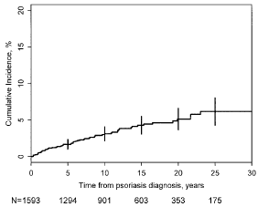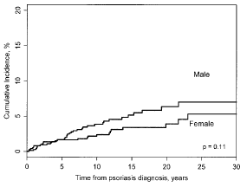
Figure 1: Cumulative incidence of psoriatic arthritis
Source: Wilson (2009)
Males had a higher cumulative incidence of PsA but this was not statistically significant (p = 0.11). Patients with CPP had a higher incidence of PsA but it was also not statistically significant (HR: 1.72 (95%CI: 0.81, 3.63)). Patients with either psoriasis on the scalp, intergluteal/perianal areas, or nail dystrophy had a significantly higher risk of developing PsA. The study did not find higher rates of PsA for later cohorts.(50)
Overall, given the included studies, the estimated prevalence for PsA in patients with CPP is likely to be around 30%. This would put the population estimates for PsA to be between 10,000 and 160,000 people who also have a PASI of 10 or greater.

3.3 PBS utilisation of biologics for the treatment of severe CPP

3.3.1 Method
An analysis of the utilisation of biologics for severe CPP was undertaken using prescription data from the Department of Human Services Supplied Prescriptions Database. Dispensed prescription data for biologics listed on the Pharmaceutical Benefits Scheme (PBS) for severe CPP were exacted for the period from 1 July 2013 to 31 December 2016 based on the date of dispensing. The data were extracted in May 2017. The supplied data file comprised of 119,933 dispensing records.
The PBS dataset used in the analysis contained records for all PBS prescriptions of biologics for severe CPP (Table 8). PBS prescription data does not include private prescriptions or samples provided by industry. Patient-level analyses and counts of patients supplied biologics for CPP were conducted using person specific numbers (non-identifying) in the data. New patients were counted from 1 July 2014 if they had not received a biologic for severe CPP since 1 July 2013. Prevalent patients were all patients who were supplied a biologic for severe CPP during the defined time period.
Table 8: Biologics and item codes used for the extraction of PBS/RPBS prescription data
Biologic | Item Code
Adalimumab | 9425C, 9426D, 9427E, 9428F
Etanercept | 1954W, 1963H, 1964J, 9037P, 9091L, 9429G,  9431J, 9461Y, 9462B
Infliximab | 5758C, 9617E
Ustekinumab | 9304Q, 9305R
Secukinumab | 10425Q, 10494H, 10910F
Note: Ixekizumab was not listed until February 2017 and was therefore not included in the analysis.
The data also included the authority approval restriction from the DHS Authority approvals database. Prescriptions were matched to the authority approval based on the person specific numbers. The authority restriction code was available for 91% of prescriptions.
Patient postcode data from 2016 was used to analyse utilisation by geographical location. Patient postcode from the first biologic prescription they received in 2016 was mapped to ABS Statistical Areas Level 4 (SA4) using the ABS’s Postcode 2016 to Statistical Area Level 4 2016 correspondence table. Postcodes to SA4s mapping was considered appropriate as they are well correlated.(51) Where a postcode area was a part of more than one SA4, it was attributed to the SA4 to which the largest proportion of the postcode corresponded. SA4s have populations of at least 100,000 and metropolitan SA4s have populations of up to 500,000. Whole SA4s aggregate to Greater Capital City Statistical Areas.(52) A small number of postcodes corresponding to post office postcodes were reclassified to the postcode of the suburb in which the post office was located. The 2016 population of SA4s were derived from the ABS Regional Population Growth data for 2016 (March 2017 release). Analyses by geography were age-adjusted to the 2016 Australian population.

Treatment persistence and rates of switching amongst new users
Time-to-event analyses (survival analyses) were performed to analyse the length of time patients spend on continuous treatment with biologics prior to discontinuing treatment or switching to a different biologic. These analyses were performed on a cohort of new users and who had a minimum follow-up of 18 months in the data. This limited the eligible patient cohort to patients who had their first biologic dispensing for severe CPP from 1 July 2014 and 30 June 2015.
The analysis excluded a small number of patients (fewer than five) because they were supplied different biologics for severe CPP on the same day. The cohort analysed for the time-to-event analyses consisted of 778 patients. These patients were followed up for exactly 18 months. Supplementary analyses that followed up patients until the end of the data period (31 December 2016) or the event of interest is presented in Appendix C – ToR 3: PBS utilisation analysis. There was little difference between the two methods. To avoid any bias in cohort comparison due to unequal follow-up, only the results where patients had an equal follow-up of 18 months are presented in the main body.
Figure 2 summarises the eligible patient criteria for the analysis.
Figure 2: Patient cohort flow diagram
Standard prescription coverage days (SCDs) were estimated to calculate the number of days of treatment coverage provided by a prescription for each biologic. SCDs were calculated using the median time-to-refill for each biologic using data for all biologics that were refilled between 1 July 2013 and 31 December 2016 (see Table 9). SCDs were adjusted for stockpiling and switching between biologics
Table 9: Standard prescription coverage days calculated from the prescription data
Biologic | SCDs (days) | 2 x SCDs (days)
Adalimumab | 28 | 56
Etanercept | 29 | 58
Infliximab | 56 | 112
Secukinumab | 25 | 50
Ustekinumab | 85 | 170
Source: DHS Supplied prescriptions database (date of supply), extracted May 2017
DHS = Department of Human Services; DoH = Department of Health; SCD = standard coverage days

Persistence with first biologic
Persistence with first biologic for severe CPP was defined as the length of time patients spend on treatment with their first biologic prior to switching to a different biologic or discontinuing. In this analysis the treatment episode begins at first dispensing and ends when the patient is supplied with a different biologic or had a gap in supply exceeding 2 x SCDs (i.e. discontinuation), which ever event occurred first.
Patients who switched biologics are considered to have ended treatment with their first biologic at the date they were supplied with a different biologic. Patients who had gaps in supply exceeding 2 x SCDs are considered to have ended treatment one SCD after their last dispensing immediately before the gap in supply. Patients who do not switch biologics and do not have gaps in supply exceeding 2 x SCDs are considered to be continuing treatment with their first biologic until the end of follow-up. As follow-up was 18 months, only the patient’s first treatment episode was examined.

Overall persistence with biologics
Overall persistence with biologics was defined as the length of time spent on continuous treatment with biologics. A treatment episode began when the patient had their first dispensing and ended when the patient had gaps in supply exceeding 2 x SCDs. When this occurred, the treatment episode was considered to have ended one SCD after the patient’s last dispensing. The length of each treatment episode was adjusted for stockpiling and switching between biologics. Patients who did not have gaps in supply exceeding 2 x SCDs were considered to be continuing on treatment until the end of follow-up.
Overall continuation was also assessed using authority restriction codes. Patients who started biologic treatment between 1 July 2014 and 30 June 2015 were assessed if they were supplied a biologic with an authority code for initial treatment followed by a biologic with a subsequent authority code for continuing treatment. Patients had to receive a biologic with a continuing authority code within 365 days of their first prescription being dispensed. There were 653 adult patients who started biologics during the aforementioned time period who received a prescription with an initial treatment authority code. These patients are considered ‘assessable’. Patients whose first prescription was for a continuing treatment code, had no authority codes recorded or started treatment under a paediatric authority code were not included. The analysis was conducted on the whole cohort and by the biologic with which patients started treatment.

Treatment holidays
The length of time patients persisted with biologics prior to having a treatment holiday from biologics was examined. Patients were considered to have had a treatment holiday if they had gaps in supply exceeding 2 x SCDs and the patient subsequently recommenced biologics during the 18 month follow-up period.
The length of each treatment holiday was defined as the number of days between the date the patient stopped treatment and the date the patient recommenced treatment. The date a treatment holiday began was the date of the last dispensing immediately prior to the treatment holiday, plus the SCDs provided by the last prescription. Time patients spend on treatment with biologics prior to the treatment holiday was defined as the number of days between the patients’ first dispensing and the estimated date the treatment holiday was commenced.

Switching between biologics
An analysis of treatment switching was undertaken to understand the frequency and timing, of changes in the biologic medicines used to treat CPP. This analysis assumed that there was no co-administration of biologics. This is due to the limited evidence supporting the use of more than one biologic and because co-administration of biologics is not allowed under the PBS restrictions for CPP. Therefore, it was assumed that when patients were supplied with another biologic they had ceased treatment with their previous biologic and had started treatment with the new biologic (i.e. the patient had switched biologic’s).
A time to switching episode begins when the patient first initiates therapy with biologic medicines. The switching episode ends at the date the patient is supplied with a different biologic. Patients who had gaps in supply exceeding 2 x SCDs but did not recommence treatment during the study period were censored one SCDs after their last observed dispensing in the data. This was to avoid misclassifying patients as remaining on treatment when they may have discontinued.

3.3.2 Results

PBS utilisation of biologics for the treatment of severe CPP
Figure 3 presents the number of patients who received biologics for severe CPP from June 2013 to December 2016. The total number of patients receiving biologics for severe CPP increased during this period. The number of new patients starting treatment with biologics each quarter has been relatively consistent since 2014.
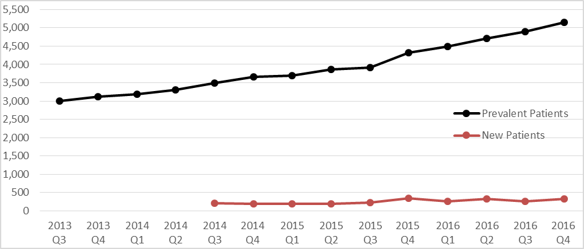
Figure 3: New and prevalent patients receiving biologics for severe CPP 2013-2016
Source: DHS Supplied prescriptions database (date of supply), extracted May 2017
CPP = chronic plaque psoriasis; Q = quarter
Figure 4 presents the number of patients supplied with each biologic for severe CPP by year. The sum of the patients per year in this figure is greater than 100% of patients, as patients who switched biologics during the year can be presented in more than one treatment.
Ustekinumab was the most commonly used biologic, with 46% of patients having had at least one prescription for this biologic in 2016. Adalimumab and secukinumab are the next most commonly used biologics, with approximately 20% of patients having had at least one dispensing for adalimumab and/or secukinumab in 2016. Etanercept and infliximab have low patient numbers, with fewer than 6% of patients having used these biologics in 2016.
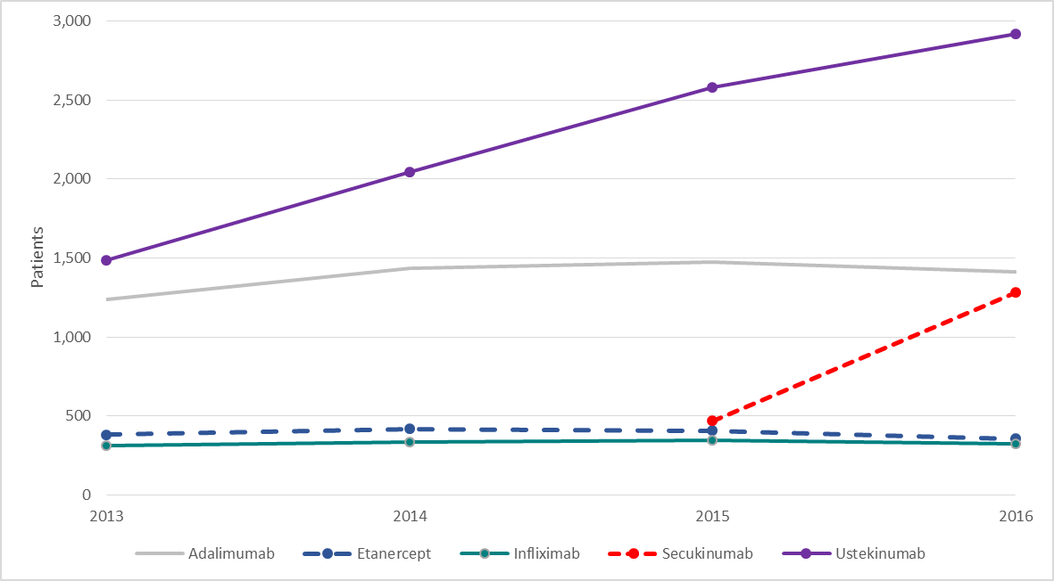
Figure 4: Patients receiving biologics for severe CPP by drug
Source: DHS Supplied prescriptions database (date of supply), extracted May 2017
Note: Secukinumab was listed on the PBS on 1 September 2015.
CPP = chronic plaque psoriasis

Number of prescriptions
Figure 5 shows the total number of prescriptions dispensed for the five biologics listed on the PBS for severe CPP from June 2013 to 31 December 2016. The prescription numbers show a rapid increase in the number of prescriptions for secukinumab since it was PBS-listed in September 2015. Prescriptions for infliximab have remained relatively stable during the period, while prescriptions for adalimumab have decreased slightly since 2015. Prescriptions for ustekinumab have steadily increased since 2013, while prescriptions for etanercept have steadily declined. The total number of prescriptions per quarter continues to increase.
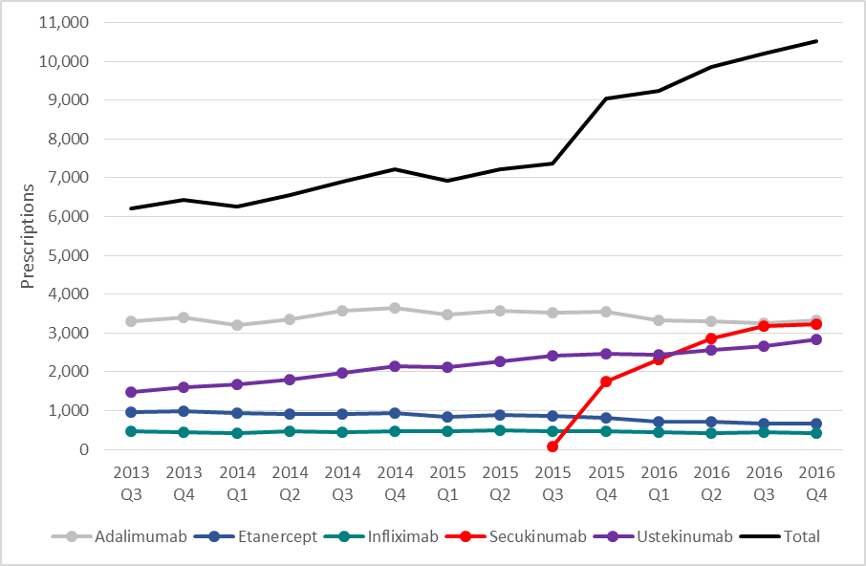
Figure 5: Biologic prescriptions for severe CPP, 2013-2016
Source: DHS Supplied prescriptions database (date of supply), extracted May 2017
Note: Secukinumab was listed on the PBS on 1 September 2015.
CPP = chronic plaque psoriasis

Figure 6 presents the utilisation of biologics for CPP by capital city and latitude. Across the state, and territory capital cities there appeared to be a trend towards higher biologic utilisation in cities further south of the equator. The rate of utilisation in Hobart was three times greater than Brisbane and twice the rate of Sydney. It is unlikely this difference is due to better access to dermatologists in Hobart.

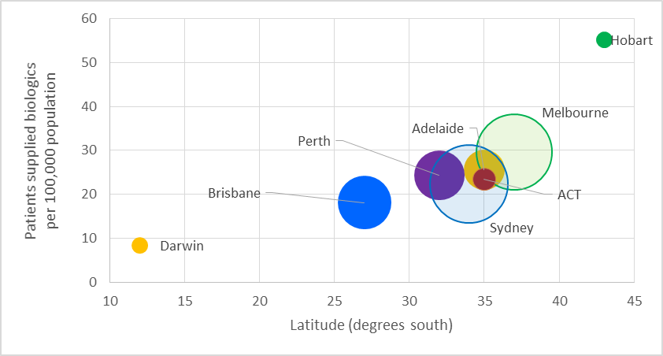
Figure 6: Utilisation by latitude for capital cities (age-adjusted)
Source: DHS Supplied prescriptions database (date of supply), extracted May 2017, ABS Regional Population Growth, Australia (March 2017 release), ABS Postcode 2016 to SA4 2016 Correspondence table.
Note: The size of the circles represent the size of the greater capital city population.
Figure 7 presents the utilisation of biologics for CPP by major centres (excluding capital cities) by latitude. Generally, biologics appeared to be more frequently used in areas that were further south. The rates of biologic use for psoriasis may differ between areas based on the accessibility of dermatologists. Areas where people with severe psoriasis cannot easily access specialist dermatology treatment may have lower rates of biologic use.
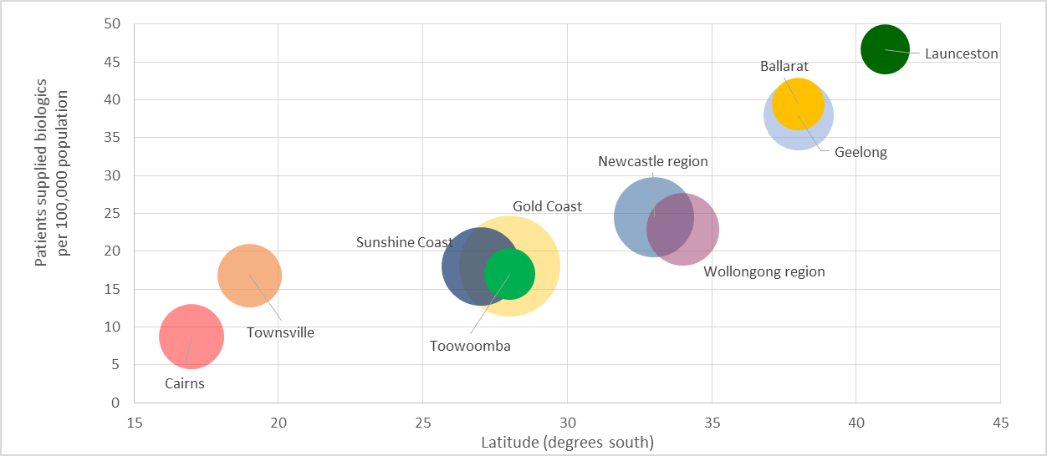
Figure 7: Utilisation by major latitude for major centres (age-adjusted)
Source: DHS Supplied prescriptions database (date of supply), extracted May 2017
In capital cities and major centres, use of biologics appeared to be higher in more southern areas. This may be because psoriasis is more common in areas of Australia that are further away from the equator. This was in line with other research conducted internationally (see 3.2.1 Prevalence of psoriasis in Australia above).

Analysis of expenditure
Table 10 presents the total benefits paid (published prices) for biologics used for CPP per calendar year between 2013 and 2016. Special pricing arrangements apply for some PBS-listed biologics for psoriasis, hence the figures in the table are only indicative of trends.
Total expenditure on biologics for CPP has increased substantially from $79 million in 2014, (the first full year of data) to over $121 million in 2016.
Table 10: Biologic expenditure for severe CPP
Listing years | 2013ª | 2014 | 2015 | 2016
Adalimumab | $11,724,985^{b} | $21,961,118^{b} | $24,103,684^{b} | $24,530,716^{b}
Etanercept | $3,408,964^{b} | $4,667,700^{b} | $5,909,870^{b} | $6,532,959^{b}
Infliximab | $3,698,230 | $5,307,585 | $7,231,884 | $7,357,199
Secukinumab | - | - | $3,205,624^{b} | $20,144,662^{b}
Ustekinumab | $19,358,908^{b} | $47,269,588^{b} | $57,396,604^{b} | $62,457,372^{b}
Total | $38,191,087 | $79,205,991 | $97,847,666 | $121,022,908
Source: DHS Supplied prescriptions database (date of supply), extracted May 2017
ª These figures are for the months July to December only
^{b} Special pricing arrangements

Market share by biologic
Figure 8 presents the market share of each biologic by year. Prescriptions for ustekinumab accounted for over half of total expenditure in each year. Ustekinumab remained the biologic with the largest PBS expenditure in 2016. PBS expenditure on adalimumab, etanercept and infliximab have declined as a proportion of total PBS expenditure on biologics for CPP. Adalimumab expenditure as a proportion of PBS expenditure on CPP biologics has declined from 28% in 2014 to 20% in 2016. Etanercept and infliximab expenditure as a proportion of PBS expenditure on CPP biologics has declined by approximately 10% during the same period. The Secukinumab market has grown to 17% in 2016 since its listing in September 2015.

Figure 8: Market share of biologics by year (stacked)
Source: DHS Supplied prescriptions database (date of supply), extracted May 2017
Note: only data from June to December was available for 2013

Persistence with first biologic for severe CPP on the PBS
Table 11 summarises the number of patients who persisted with their first biologic at 6, 12 and 18 months. Treatment persistence with first biologic was high at 6 months, with 83% (n = 649) of patients having persisted (i.e. stayed treatment without a break) with their first biologic for at least 6 months. At 12 month follow-up, 73% (n = 570) of patients had persisted with their first biologic for at least 12 months. At 18 months follow-up, 61% (n = 476) of patients had persisted with their first biologic for at least 18 months.
Table 11: Persistence with first biologic at 6, 12 and 18 months; n (%) of patients persisting with first biologic for severe CPP
N | 6 months | 12 months | 18 months
778 | 649 (83%) | 570 (73%) | 476 (61%)
Source: DHS Supplied prescriptions database (date of supply), extracted May 2017
CPP = chronic plaque psoriasis

Figure 9 presents the time-to-event curves for the proportion of patients persisting with their first biologic for severe CPP. The figure shows that most patients persisted with their first biologic for at least 6 months. However, as time on treatment increased, persistence rates with first biologic steadily decline.
Figure 9: Persistence with first biologic for severe CPP
Source: DHS Supplied prescriptions database (date of supply), extracted May 2017
CPP = chronic plaque psoriasis

Table 12 summarises the number of patients who persisted with their first biologic at 6, 12 and 18 months follow-up by biologic. Patients who started biologic treatment with etanercept had dramatically lower rates of treatment persistence than patients who had started treatment with other biologics. For example, only 21% of etanercept initiators were continuing with this biologic at 6 months follow-up. In comparison, persistence rates at 6 months were approximately 100% for ustekinumab and infliximab initiators and 77% for adalimumab initiators.
Table 12: Treatment persistence with first biologic at 6, 12, and 18 months by biologic
Biologic | N | 6 months; n (%) | 12 months; n (%) | 18 months; n (%)
Adalimumab | 237 | 181 (77%) | 146 (62%) | 110 (46%)
Etanercept | 75 | 16 (21%) | 12 (16%) | 6 (8%)
Infliximab | 15 | 15 (100%) | 14 (93%) | 10 (67%)
Secukinumab¹ | - | - | - | -
Ustekinumab | 451 | 437 (97%) | 398 (88%) | 350 (78%)
Source: DHS Supplied prescriptions database (date of supply), extracted May 2017
CPP = chronic plaque psoriasis
¹ Secukinumab was listed on listed the PBS schedule on 1 September 2015, which was after the 30 June 2015 cut-off for treatment initiation in this study.

Figure 10 presents the Kaplan Meier curves for the proportion of patients persisting with their first biologic for severe CPP, by biologic. The rates of persistence with first biologic were highest for patients who started treatment with ustekinumab and infliximab and lowest for patients who had started treatment with etanercept. The etanercept group also included children who use episodic treatment.. Patients who started treatment with adalimumab had the second lowest rates of treatment persistence.
Figure 10: Persistence with first biologic for severe CPP by biologic
Source: DHS Supplied prescriptions database (date of supply), extracted May 2017

Table 13 presents the persistence on etanercept as a first biologic for adults and children. Children treated with etanercept are treated episodically. Children can have an initial treatment period of 16 weeks. If they demonstrate an adequate response, they can have a further eight weeks treatment for a total treatment course of 24 weeks. Children can be re-treated within 12 months if they experience a disease flare. After a break of at least 12 months, children have to requalify for initial treatment. There were 22 patients who started etanercept who were aged 17 years or younger when they had their first prescription. The results in presented in Table 13 show that children who started etanercept had higher rates of persistence compare with adults who started etanercept.

Table 13: Treatment persistence with etanercept as a first biologic (adults vs. children)
Patient group | N | 6 months; n (%) | 12 months; n (%) | 18 months; n (%)
Children (<18 years) | 22 | 6 (27%) | 6 (27%) | <6
Adults (18 years and older) | 53 | 10 (19%) | 7 (13%) | < 6
Overall | 75 | 16 (21%) | 13 (17%) | 6 (8%)
Source: DHS Supplied prescriptions database (date of supply), extracted May 2017
CPP = chronic plaque psoriasis

Figure 11 presents the Kaplan Meier curves for the proportion of patients persisting with etanercept as first biologic. The graph shows that children who started etanercept were more likely to continue with etanercept than adults at every point in time.
Figure 11: Persistence with etanercept as a first biologic (adults vs. children)
Source: DHS Supplied prescriptions database (date of supply), extracted May 2017
CPP = chronic plaque psoriasis; yrs = years

Overall persistence with biologics for severe CPP on the PBS
Overall persistence with biologics was high, with 88% of patients having remained on continuous treatment with biologics for at least 6 months. After 12 months 83% of patients were continuing biologic treatment and 80% of patients were continuing treatment at 18 months. These results are presented in Table 14.

Table 14: Persistence with biologics for severe CPP
N | 6 months | 12 months | 18 months
778 | 683 (88%) | 645 (83%) | 619 (80%)
Source: DHS Supplied prescriptions database (date of supply), extracted May 2017
CPP = chronic plaque psoriasis

Table 15 presents the proportion of adult patients who started biologic treatment and received a continuing authority approval within one year of starting biologic treatment. The continuing approval could be for the same biologic or a different biologic. The analysis found that 94% (614/653) of assessable adult patients who started a biologic for CPP received a prescription for continuing treatment. This was higher than the 83% of patients persisting with biologics at 12 months. This may be due to missed doses (and prescriptions), use of lower doses, and the use of intermittent therapy in children.
Table 15: Patients with a continuing authority approval
Group | N | Proportion with continuing authority (n, %)
All assessable patients | 653 | 599 (92%)
Adalimumab | 203 | 188 (93%)
Etanercept | 14 | 11 (79%)
Infliximab | 12 | 10 (83%)
Ustekinumab | 424 | 390 (92%)
Source: DHS Supplied prescriptions database (date of supply), extracted May 2017
Note: Analysis excluded patients who started treatment with a continuing authority code or an authority code for patients aged under 18 years and patients whose prescriptions had no authority codes.
Continuation based on authority approvals for patients who started treatment with etanercept and infliximab was lower than for patients who started adalimumab or ustekinumab. However, there were only a small number of assessable patients who started treatment with etanercept or infliximab.

Treatment holidays from biologic treatment on the PBS
During the 18 month follow-up period, 40 patients (5%) had at least one treatment holiday from PBS subsidised biologics for severe CPP. It was uncommon for patients to have had two or more treatment holidays (<1%). Therefore, this analysis only examined the patient’s first treatment holiday.

Table 16 summarises the median length of time patients spend on biologics prior to having their first treatment holiday and the median duration each treatment holiday lasted. Fewer than five patients had a treatment holiday on infliximab, secukinumab and ustekinumab and are therefore not presented.
Table 16: Median time spent on biologics prior to the treatment holiday and the median duration of the treatment holiday (sub-analysis: patients who had treatment holidays)
Biologic | Number of patients who had a treatment holiday | Median time spent on treatment prior to treatment holiday | Median duration of the treatment holiday
All | 40 | 6 months | 5 months
Adalimumab | 28 | 7 months | 5 months
Etanercept | 8 | 3 months | 5 months
Source: DHS Supplied prescriptions database (date of supply), extracted May 2017
CPP = chronic plaque psoriasis

The table shows that patients who had treatment holidays within the first 18 months of treatment generally spend about 5 months on treatment with biologics prior to taking a treatment holiday. Overall these treatment holidays lasted approximately 5 months. Examining treatment holidays, by the biologic the patient was taking immediately before the treatment holiday, shows that patients who were taking etanercept generally spend less time on treatment prior to having a treatment holiday than patients taking other biologics. These values should be interpreted with caution because the cohort had only 18 months of follow-up. Therefore patients included in the analysis had to stop treatment and recommence treatment during this period. Therefore, the true number and length of treatment holidays was likely to be underestimated in this analysis.
Additionally, it was not possible to determine why the patient had taken a treatment holiday. The patient may have taken a treatment holiday because of drug toxicity, sustained remission of CPP, or for other reasons. However, this could not be determined from the data.
Table 17 summarises the rates of treatment holidays from biologic medicines for severe CPP at 6, 12, and 18 months follow-up. At 6 months follow-up, 3% (n =20) of patients had a treatment holiday. At 12 months follow-up this number increased to 4% (n= 33) and at 18 months follow-up, 5% (n = 40) of patients had a treatment holiday.
Table 17: Number of patients who had a treatment holiday from biologics
N | 6 months | 12 months | 18 months
778 | 20 (3%) | 33 (4%) | 40 (5%)
Source: DHS Supplied prescriptions database (date of supply), extracted May 2017
CPP = chronic plaque psoriasis

The above table also shows that of patients who had treatment holidays, half (n = 20/40) experienced these events within the first 6 months. This suggested treatment holidays most commonly occur within the first 6 months of starting treatment with biologics, when only 18 months of treatment was considered.
Table 18 summarises the rates of treatment holidays at 6, 12, and 18 months follow-up by biologic. Patients were classified according to the biologic they were taking prior to experiencing the treatment holiday or at the end of follow-up. Ustekinumab and secukinumab are not presented due to the small numbers of patients who had treatment holidays.
The table shows that patients taking adalimumab and etanercept were more likely to have had a treatment holidays at 6, 12 and 18 months follow-up than patients taking other biologics.
Table 18: Number (%) of patients who had a treatment holiday by biologic
Biologic | N | 6 months | 12 months | 18 months
Adalimumab | 179 | 14 (8%) | 23 (13%) | 28 (16%)
Etanercept | 67 | 6 (9%) | 7 (11%) | 8 (12%)
Infliximab | 15 | - | - | -
Secukinumab | 89 | - | <5 ¹ | <5 ¹
Ustekinumab | 428 | - | <5 ¹ | <5 ¹
Source: DHS Supplied prescriptions database (date of supply), extracted May 2017
CPP = chronic plaque psoriasis
¹ Patient numbers lower than five were suppressed to protect patient privacy.

Switching between biologic medicines on the PBS
Table 19 summarises the rates switching between biologics for severe CPP at 6, 12, and 18 months follow-up. At 6 months follow-up, 5% (n=36) of the cohort had switched from their first biologic. At 12 months follow-up, this number had increased to 11% (n = 88) and by 18 months follow-up, 22% (171) of patients had switched biologics.
Table 19: Number (%) of patients who switched between biologics for severe CPP
N | 6 month | 12 months | 18 months
778 | 36 (5%) | 88 (11%) | 171 (22%)
Source: DHS Supplied prescriptions database (date of supply), extracted May 2017
CPP = chronic plaque psoriasis

Of the patients who switched biologics, almost half (n = 83/171; 49%) switched between 12 and 18 months after treatment initiation. This suggests that patients tend to remain on treatment with their first biologic for at least 12 months prior to switching to a different biologic. Alternatively, the increased rates of switching observed at 12 to 18 months follow-up could be due to secukinumab being listed on the PBS.
Figure 12 presents the Kaplan Meier curve for the length of time patients spend on treatment with their first biologic prior to switching to a different biologic. Most patients (approximately 75%) continue treatment with their first biologic for at least 18 months.
Figure 12: Length of time spent on treatment with first biologic prior to switching to a different biologic
Source: DHS Supplied prescriptions database (date of supply), extracted May 2017
CPP = chronic plaque psoriasis

Table 20 summarises the rates of switching between biologic for severe CPP at 6, 12, and 18 months by biologic. Patients were classified according to the biologic with which they started treatment.
The table shows patients who had initiated treatment with adalimumab and etanercept had higher rates of switching than patients who had initiated treatment with other biologics.
Table 20: Number of patients who switched between biologics for severe CPP; n (%) patients who switched between biologics for severe CPP
Biologic | N | 6 month | 12 months | 18 month
Adalimumab | 237 | 29 (12%) | 55 (23%) | 83 (35%)
Etanercept | 75 | < 5 | 6 (8%) | 10 (13%)
Infliximab | 15 | - | < 5² | < 5²
Secukinumab¹ | - | - | - | -
Ustekinumab | 451 | < 5² | 26 (6%) | 73 (16%)
Source: DHS Supplied prescriptions database (date of supply), extracted May 2017
CPP = chronic plaque psoriasis
¹ Secukinumab was listed on listed the PBS schedule on 1 September 2015, which was after the 30 June 2015 cut-off for treatment initiation in this study
² Patient numbers lower than five were suppressed to protect patient privacy

Figure 13 presents the Kaplan Meier curves for the length of time patients spend on treatment with their first biologic before switching to different biologic by drug. Patients who started treatment with adalimumab and etanercept had the higher rates of switching than patients who initiated treatment with ustekinumab and infliximab.
Figure 13: Length of time spent on treatment with first biologic prior to switching
Source: DHS Supplied prescriptions database (date of supply), extracted May 2017
Note: Secukinumab was listed on listed the PBS schedule on 1 September 2015, which was after the 30 June 2015 cut-off for treatment initiation in this study

Table 21 summarises the most common patterns of biologic use and switching in the patient cohort. The most common pattern of biologic utilisation was for patients to start and remain on treatment with ustekinumab (n=378; 49%), followed by starting and remaining on treatment with adalimumab (n = 154; 20%) or etanercept (n = 65; 8%).
The three most common patterns of switching were for patients to start treatment with ustekinumab and later switch to secukinumab (n = 53; 7%), followed by starting treatment with adalimumab and later switching to ustekinumab (n = 42; 5%) or secukinumab (n = 27; 3%).
Table 21: Most common biologic sequences for CPP
Rank | Biologic Sequence | n (%)
1 | Ustekinumab only | 378 (49%)
2 | Adalimumab only | 154 (20%)
3 | Etanercept only | 65 (8%)
4 | Ustekinumab -> Secukinumab | 53 (7%)
5 | Adalimumab -> Ustekinumab | 42 (5%)
6 | Adalimumab -> Secukinumab | 27 (3%)
7 | Any 3 biologics | 20 (3%)
8 | Infliximab only | 10 (1%)
9 | Ustekinumab -> Adalimumab | 9 (1%)
10 | Etanercept -> Ustekinumab | 5 (1%)
11 | Infliximab -> Ustekinumab | 5 (1%)
12 | Any 4 or more biologics | <5¹
Source: DHS Supplied prescriptions database (date of supply), extracted May 2017
Note: Values in the table do not add to 100%
¹ Patient numbers lower than five were suppressed to protect patient privacy

3.4 Prior use of non-biologic treatments
The Reference Group considered phototherapy to be the first systemic therapy that is typically used. The clinicians in the group considered that phototherapy results in a decrease in symptoms after six to twelve weeks treatment. Use of phototherapy may be limited by patient comorbidities, such as melanoma. It was noted that some patients were unable to access phototherapy in areas that are far away from a phototherapy service, particularly patients residing in rural or remote areas. Some patients are also unable to use phototherapy because they were unable to fit in the phototherapy box due to obesity, a common comorbidity in patients with psoriasis.
The Reference Group clinicians considered cyclosporin to be an effective treatment but considered that its use was limited by toxicity, particularly renal toxicity. A dose of 2.5 mg/kg daily was considered to be commonly used in practice. Acitretin was considered to have a fast onset of action. The Reference Group clinicians considered that acitretin could not be used for very long, with the six week duration of treatment in the biologic restrictions not commonly used in practice. Acitretin was not considered an appropriate treatment for women of childbearing age. Acitretin was considered a good treatment option for patients with remitting-relapsing forms of psoriasis. The Reference Group clinicians considered that response to methotrexate treatment is evident at 12 weeks. It was noted that the PBS restrictions for biologics required only six weeks treatment, which was considered too short to determine the full effectiveness of methotrexate.
The clinicians on the Reference group noted there may be differences in the use of prior therapies based on the site/s affected by psoriasis. Psoriasis of the palms of the hands and soles of the feet cannot be well treated with topical therapy due to the thickness of the skin. Genital psoriasis also usually cannot be treated with topical therapy. Nail psoriasis is usually on the nail plate, making topical therapy not useful. Methotrexate was also considered not to be useful for nail psoriasis.
The Reference Group noted that the persistence with prior therapies is often lower than observed in clinical trials. Some of the prior therapies, such as phototherapy and topical treatments, can be very time consuming. It was considered, that in practice, prior therapies are used at a lower dose and for a lower duration than in clinical trials.

3.5 Comparison of PBS utilisation of biologics with PBS restrictions, guidelines, and clinical evidence

3.5.1 Comparison of PBS utilisation with PBS restrictions
The majority of patients appeared to be using biologics chronically. Over 18 months follow-up, only 5% of patients had a treatment break.
The PBS restrictions allow patients to fail to achieve a PASI 75 response with three biologicals before they are deemed to have completed the PBS treatment cycle and are not eligible for PBS-subsidised biological treatment. In the group of patients who started biologics between 1 July 2014 and 30 June 2015, fewer than 1% (<5/778) patients had four or more biologics over 18 months follow-up. However, the PBS dispensing data cannot be used to determine whether patients had failed to achieve a PASI 75 response or whether treatment was switched for other reasons. Patients are able to switch to an alternate biologic without having to meet the initial treatment criteria.
Insufficient data were available to assess the proportion of patients who had prolonged treatment breaks, such as the five year break required by the PBS restrictions for patients who have failed to demonstrate treatment with three biologic agents.

3.5.2 Comparison of PBS utilisation with clinical guidelines
Overall continuation with biologics was high, with 80% of patients remained on continuous treatment with biologics at 18 months, either with their first biologic or switching to another one. This was broadly consistent with treatment guidelines that recommend continued treatment if an adequate response is achieved. The definition of an adequate response differed between the guidelines. PBS prescription dispensing data could not be used to verify whether patients used other therapies prior to starting biologics, met psoriasis severity criteria for biologic treatment, or had an adequate response to continue treatment.

3.5.3 Comparison of PBS utilisation with clinical evidence
Table 22 compares the rate of biologic continuation at six months with the proportion of patients who achieved a PAS I75 response from the key clinical trials.

Table 22: Continuation of first biologics compared with trial PASI 75 outcomes
Biologic | PBS continuation  (6 months  ≈ 24 weeks) | PASI 75 response  (time) | PBS continuation  (12 months  ≈52 weeks) | PASI 75 response (time)
Adalimumab | 77% | 67% ª -70%^{b}  (24 weeks) | 62% | 67% ª  (48 weeks)
Etanercept (adults only) | 19% | 44% - 62%  (24 weeks) ^{c} | 13% | -
Infliximab | 100% | 77%- 82%  (24 weeks) ^{d} | 93% | 55%  (50 weeks) ^{e}
Ustekinumab | 97% | ≈80% ^{f}  (24 weeks) | 88% | ≈70% ^{f}  (40 weeks)
Source: DHS Supplied prescriptions database (date of supply), extracted May 2017; effectiveness data from Term of Reference 2
Note: Secukinumab was listed on listed the PBS schedule on 1 September 2015, which was after the 30 June 2015 cut-off for treatment initiation in this study.
PASI 75 = 75% reduction in the Psoriasis Area and Severity Index score
ª Gordon (2012) Cohort D
^{b} Ashina (2010)
^{c} Leonardi (2003) and PRESTA trial
^{d} EXPRESS and RESTORE trials
^{e} Menter (2007) (5mg/kg every 8 weeks dosing)
^{f} Kimball (2012)

The proportion of patients who continue biologic treatment for CPP with ustekinumab (97%) and infliximab (100%) were higher than the proportion of patients in the clinical trials who had a PASI 75 response at both six months and one year. Continuation at six months for infliximab and ustekinumab may be slightly overestimated compared to the other biologics. Patients had to be without an infliximab or ustekinumab prescription for a longer period of time (112 days for infliximab and 170 days for ustekinumab) before they were considered to have stopped treatment (refer to Table 9 in the methods). The proportion of patients who continued etanercept (19%) was substantially lower than the proportion of patients who had a PASI 75 response at 24 weeks in the clinical trials. The proportion of patients who continued adalimumab (77%) was similar to the rates of PASI 75 response in the clinical trials.
The best estimate of the prevalence of severe CPP (PASI > 15) in Australia was 19,223; however, only 5,144 patients were receiving biologics on the PBS. Biologics are PBS-listed for severe psoriasis that is refractory to at least three treatments (phototherapy, methotrexate, cyclosporin and acitretin). Many patients may achieve an adequate response to these therapies and may not need to be prescribed biologicals, which may account for some of this discrepancy. The Reference Group noted many patients can achieve good psoriasis clearance with a combination of phototherapy and topical therapy.
There may be reluctance to use some of the prior therapies due to toxicity. The Reference Group noted that cyclosporin can cause renal toxicity and can cause hypertension which is problematic in many patients with psoriasis who have comorbid metabolic disease. Acitretin is contraindicated in pregnancy and women who may become pregnant within three years of treatment cessation. As a result, acitretin treatment may be considered unacceptable by some women of childbearing age. Difficulty accessing specialist treatment and fulfilling monitoring requirements of some of the prior therapies may result in fewer patients with severe psoriasis being eligible for biologics. Use of biologics on private prescriptions may also contribute to the difference between the estimated prevalence of severe CPP and PBS utilisation of biologics for CPP.

References
1. Quirk CJ. Skin disease in the Busselton population survey. The Medical journal of Australia. 1979;1(12):569-70.
2. Plunkett A, Merlin K, Gill D, Zuo Y, Jolley D, Marks R. The frequency of common nonmalignant skin conditions in adults in central Victoria, Australia. International Journal of Dermatology. 1999;38(12):901-8.
3. Kilkenny M, Stathakis V, Jolley D, Marks R. Maryborough skin health survey: Prevalence and sources of advice for skin conditions. Australasian Journal of Dermatology. 1998;39(4):233-7.
4. Australian Bureau of Statistics. Australian Health Survey, National Health Survey, 2011-12: TableBuilder. Findings based on use of ABS TableBuilder data; 2011-12 [cited 2017 7 June]. Available from: https://secure.abs.gov.au/.
5. Australian Bureau of Statistics. National Health Survey, 2014-15: TableBuilder. Findings based on use of ABS TableBuilder data; 2014-15 [cited 2017 7 June]. Available from: https://secure.abs.gov.au/.
6. Australian Bureau of Statistics. Australian Aboriginal and Torres Strait Islander Health Survey, Detailed Conditions and Other Health Data, 2012-13: TableBuilder. Findings based on use of ABS TableBuilder data; 2012-13 [cited 2017 7 June]. Available from: https://secure.abs.gov.au/.
7. Australian Bureau of Statistics. Estimates and Projections, Aboriginal and Torres Strait Islander Australians, 2001 to 2026: cat.no. 3238.0; 2014 [cited 2017 9 June]. Available from: www.abs.gov.au/ausstats/abs@.nsf/mf/3238.0.
8. Parisi R, Symmons DP, Griffiths CE, Ashcroft DM, Identification, Management of P, et al. Global epidemiology of psoriasis: a systematic review of incidence and prevalence. Journal of Investigative Dermatology. 2013;133(2):377-85.
9. Michalek IM, Loring B, John SM. A systematic review of worldwide epidemiology of psoriasis. Journal of the European Academy of Dermatology & Venereology. 2017;31(2):205-12.
10. World Health Organization. Global Report on Psoriasis. 2016.
11. Danielsen K, Olsen AO, Wilsgaard T, Furberg AS. Is the prevalence of psoriasis increasing? A 30-year follow-up of a population-based cohort. Br J Dermatol. 2013;168(6):1303-10.
12. Tollefson MM, Crowson CS, McEvoy MT, Maradit Kremers H. Incidence of psoriasis in children: A population-based study. Journal of the American Academy of Dermatology. 2010;62(6):979-87.
13. Icen M, Crowson CS, McEvoy MT, Dann FJ, Gabriel SE, Maradit Kremers H. Trends in incidence of adult-onset psoriasis over three decades: A population-based study. Journal of the American Academy of Dermatology. 2009;60(3):394-401.
14. Huerta C, Rivero E, Rodríguez L. Incidence and risk factors for psoriasis in the general population. Arch Dermatol. 2007;143(12):1559-65.
15. Springate DA, Parisi R, Kontopantelis E, Reeves D, Griffiths CEM, Ashcroft DM. Incidence, prevalence and mortality of patients with psoriasis: a U.K. population-based cohort study. Br J Dermatol. 2017;176(3):650-8.
16. Schafer I, Rustenbach SJ, Radtke M, Augustin J, Glaeske G, Augustin M. Epidemiology of psoriasis in Germany--analysis of secondary health insurance data. Gesundheitswesen (Bundesverband der Arzte des Offentlichen Gesundheitsdienstes (Germany)). 2011;73(5):308-13.
17. Merola JF, Li T, Li WQ, Cho E, Qureshi AA. Prevalence of psoriasis phenotypes among men and women in the USA. Clinical and experimental dermatology. 2016;41(5):486-9.
18. Baker CS, Foley PA, Braue A. Psoriasis uncovered – measuring burden of disease impact in a survey of Australians with psoriasis. Australasian Journal of Dermatology. 2013;54:1-6.
19. Mallbris L, Larsson P, Bergqvist S, Vingård E, Granath F, Ståhle M. Psoriasis Phenotype at Disease Onset: Clinical Characterization of 400 Adult Cases. Journal of Investigative Dermatology. 2005;124(3):499-504.
20. Phan C, Sigal ML, Estève E, Reguiai Z, Barthélémy H, Beneton N, et al. Psoriasis in the elderly: Epidemiological and clinical aspects, and evaluation of patients with very late onset psoriasis. Journal of the European Academy of Dermatology and Venereology. 2016;30(1):78-82.
21. Lopez Estebaranz JL, Zarco-Montejo P, Samaniego ML, Garcia-Calvo C, Group PS. Prevalence and clinical features of psoriatic arthritis in psoriasis patients in Spain. Limitations of PASE as a screening tool. European Journal of Dermatology. 2015;25(1):57-63.
22. Norris D, Photiou L, Tacey M, Dolianitis C, Varigos G, Foley P, et al. Biologics and dermatology life quality index (DLQI) in the Australasian psoriasis population. J Dermatolog Treat. 2017:1-6.
23. Theodorakopoulou E, Yiu ZZN, Bundy C, Chularojanamontri L, Gittins M, Jamieson LA, et al. Early- and late-onset psoriasis: a cross-sectional clinical and immunocytochemical investigation. Br J Dermatol. 2016;175(5):1038-44.
24. Papadavid E, Katsimbri P, Kapniari I, Koumaki D, Karamparpa A, Dalamaga M, et al. Prevalence of psoriatic arthritis and its correlates among patients with psoriasis in Greece: results from a large retrospective study. Journal of the European Academy of Dermatology & Venereology. 2016;30(10):1749-52.
25. Papadavid E, Rompoti N, Theodoropoulos K, Katsimbri P, Boumpas D, Rigopoulos D. Data from psoriasis clinic in a Greek university hospital during the first semester of 2016. Journal of the American Academy of Dermatology. 2017;76(6):AB92.
26. Burns T, Breathnach S, Cox N, Griffiths C, (ed). Rook's Textbook of Dermatology. 7th ed: Blackwell Publishing; 2004.
27. Bonigen J, Phan A, Hadj-Rabia S, Boralévi F, Bursztejn AC, Bodemer C, et al. Impact of sex and age on the clinical and epidemiological aspects of childhood psoriasis: Data from a French cross-sectional multicentre study. Annales de Dermatologie et de Venereologie. 2016;143(5):354-63.
28. Pourchot D, Bodemer C, Phan A, Bursztejn AC, Hadj-Rabia S, Boralevi F, et al. Nail Psoriasis: A Systematic Evaluation in 313 Children with Psoriasis. Pediatric Dermatology. 2017;34(1):58-63.
29. Morris A, Rogers M, Fischer G, Williams K. Childhood psoriasis: a clinical review of 1262 cases. Pediatric dermatology. 2001;18(3):188-98.
30. American Academy of Dermatology. Psoriasis (stats and facts) n.d. [cited 9 June 2017]. Available from: https://www.aad.org/media/stats/conditions/psoriasis.
31. Menter A, Gottlieb A, Feldman SR, Van Voorhees AS, Leonardi CL, Gordon KB, et al. Guidelines of care for the management of psoriasis and psoriatic arthritis: Section 1. Overview of psoriasis and guidelines of care for the treatment of psoriasis with biologics. Journal of the American Academy of Dermatology. 2008;58(5):826-50.
32. Griffiths CEM, Barker JNWN. Pathogenesis and clinical features of psoriasis. The Lancet. 2007;370(9583):263-71.
33. Augustin M, Krüger K, Radtke MA, Schwippl I, Reich K. Disease Severity, Quality of Life and Health Care in Plaque-Type Psoriasis: A Multicenter Cross-Sectional Study in Germany. Dermatology. 2008;216(4):366-72.
34. Meeuwis KAP, de Hullu JA, Massuger LFAG, van de Kerkhof PCM, van Rossum MM. Genital psoriasis: A systematic literature review on this hidden skin disease. Acta Dermato-Venereologica. 2011;91(1):5-11.
35. Piaserico S, Gisondi P, Amerio P, Amoruso G, Campanati A, Conti A, et al. Validation and field performance of the Italian version of the psoriatic arthritis screening and evaluation (PASE) questionnaire. Acta Dermato-Venereologica. 2016;96:96-101.
36. Langenbruch A, Radtke MA, Jacobi A, Purwins S, Haack K, Reich K, et al. Quality of psoriasis care in Germany: results of the national health care study “PsoHealth3”. Archives of Dermatological Research. 2016;308(6):401-8.
37. Eder L, Haddad A, Rosen CF, Lee KA, Chandran V, Cook R, et al. The Incidence and Risk Factors for Psoriatic Arthritis in Patients with Psoriasis: A Prospective Cohort Study. Arthritis and Rheumatology. 2016;68(4):915-23.
38. Jenner N, Campbell J, Plunkett A, Marks R. Cost of psoriasis: A study on the morbidity and financial effects of having psoriasis in Australia. Australasian Journal of Dermatology. 2002;43(4):255-61.
39. Singh P, Soyer HP, Wu J, Salmhofer W, Gilmore S. Tele-assessment of Psoriasis Area and Severity Index: A study of the accuracy of digital image capture. Australasian Journal of Dermatology. 2011;52(4):259-63.
40. Urbancek S, Sutka R, Kmecova Z, Salkovska J, Vano I, Rovensky J. Screening of psoriatic arthritis in Slovakia. Journal of the European Academy of Dermatology and Venereology. 2016;30:34.
41. Puig L, van de Kerkhof PCM, Reich K, Bachelez H, Barker J, Girolomoni G, et al. A European subset analysis from the population-based Multinational Assessment of Psoriasis and Psoriatic Arthritis shows country-specific features: results from psoriasis patients in Spain. Journal of the European Academy of Dermatology and Venereology. 2017;31(7):1176-82.
42. Taylor W, Gladman D, Helliwell P, Marchesoni A, Mease P, Mielants H. Classification criteria for psoriatic arthritis: Development of new criteria from a large international study. Arthritis & Rheumatism. 2006;54(8):2665-73.
43. Prey S, Paul C, Bronsard V, Puzenat E, Gourraud PA, Aractingi S, et al. Assessment of risk of psoriatic arthritis in patients with plaque psoriasis: a systematic review of the literature. Journal of the European Academy of Dermatology & Venereology. 2010;24 Suppl 2:31-5.
44. Ágh T, Vokó Z, Heisel O, Chiva-Razavi S, Barbeau M, Szilberhorn L, et al. A systematic literature review of the prevalence of psoriatic arthritis. Annals of the Rheumatic Diseases. 2016;75:657.
45. Ogdie A, Weiss P. The Epidemiology of Psoriatic Arthritis. Rheumatic Diseases Clinics of North America. 2015;41(4):545-68.
46. Spelman L, Su JC, Fernandez-Penas P, Varigos GA, Cooper AJ, Baker CS, et al. Frequency of undiagnosed psoriatic arthritis among psoriasis patients in Australian dermatology practice. Journal of the European Academy of Dermatology & Venereology. 2015;29(11):2184-91.
47. Mease PJ, Gladman DD, Papp KA, Khraishi MM, Thaçi D, Behrens F, et al. Prevalence of rheumatologist-diagnosed psoriatic arthritis in patients with psoriasis in European/North American dermatology clinics. Journal of the American Academy of Dermatology. 2013;69(5):729-35.
48. Hoff M, Gulati AM, Romundstad PR, Kavanaugh A, Haugeberg G. Prevalence and incidence rates of psoriatic arthritis in central Norway: data from the Nord-Trondelag health study (HUNT). Annals of the Rheumatic Diseases. 2015;74(1):60-4.
49. Karreman MC, Weel AEAM, Ven MVD, Vis M, Tchetverikov I, Nijsten TEC, et al. Performance of screening tools for psoriatic arthritis: A cross-sectional study in primary care. Rheumatology (United Kingdom). 2017;56(4):597-602.
50. Wilson FC, Icen M, Crowson CS, McEvoy MT, Gabriel SE, Kremers HM. Incidence and clinical predictors of psoriatic arthritis in patients with psoriasis: A population-based study. Arthritis Care & Research. 2009;61(2):233-9.
51. Australian Bureau of Statistics. Australian Statistical Geography Standard (ASGS) Correspondences: cat.no. 1270.0.55.006; 2016 [cited 2017 9 June]. Available from: http://www.abs.gov.au/websitedbs/D3310114.nsf/home/Correspondences (requested by email).
52. Australian Bureau of Statistics. Australian Statistical Geography Standard (ASGS) 2017 [updated 1 June 2017; cited 2017 9 June]. Available from: http://www.abs.gov.au/websitedbs/d3310114.nsf/home/australian+statistical+geography+standard+%28asgs%29.
53. Hoy D, Brooks P, Woolf A, Blyth F, March L, Bain C, et al. Assessing risk of bias in prevalence studies: modification of an existing tool and evidence of interrater agreement. Journal of Clinical Epidemiology. 2012;65(9):934-9.
54. Chamurlieva M, Korotaeva T, Loginova E. High prevalence of psoriatic arthritis misdiagnoses in psoriasis patients in russian dermatological clinics based on psoriasis epidemiology screening tool (PEST), rheumatological evaluation and the CASPAR Criteria. Annals of the Rheumatic Diseases. 2016;75:355-6.
55. Lebwohl MG, Kavanaugh A, Armstrong AW, Van Voorhees AS. US Perspectives in the Management of Psoriasis and Psoriatic Arthritis: Patient and Physician Results from the Population-Based Multinational Assessment of Psoriasis and Psoriatic Arthritis (MAPP) Survey. American Journal of Clinical Dermatology. 2016;17(1):87-97.
56. Coates LC, Savage L, Waxman R, Moverley AR, Worthington S, Helliwell PS. Comparison of screening questionnaires to identify psoriatic arthritis in a primary-care population: a cross-sectional study. Br J Dermatol. 2016;175(3):542-8.
57. Korman NJ, Zhao Y, Lu J, Tran MH. Psoriasis disease severity affects patient satisfaction with treatment. Dermatology Online Journal. 2015;21(7).
58. Dini V, Martini P, Bellini M, Bagnoni G, Marsili F, Lancia U. Psoriatic arthritis prevalence in the clinical practice of dermatologists in North-West Tuscany centers of excellence: A screening experience. Giornale Italiano di Dermatologia e Venereologia. 2017;152(1):24-7.
59. Edson-Heredia E, Zhu B, Guo J, Maeda-Chubachi T, Lebwohl M. Disease burden and quality of life in psoriasis patients with and without comorbid psoriatic arthritis: results from National Psoriasis Foundation panel surveys. Cutis. 2015;95(3):173-8.
60. Truong B, Rich-Garg N, Ehst BD, Deodhar AA, Ku JH, Vakil-Gilani K, et al. Demographics, clinical disease characteristics, and quality of life in a large cohort of psoriasis patients with and without psoriatic arthritis. Clinical, Cosmetic and Investigational Dermatology. 2015;8:563-9.
61. De Marco G, Cattaneo A, Carrera CG, Gibertini P, Battafarano N, Marchesoni A. The EPIPSOFIRE project: A Preliminary Report. Drug Development Research. 2014;75:S85-S7.

Appendix A – ToR 3: Methods
A systematic literature review was undertaken to identify estimates of the incidence and prevalence of severe CPP (PASI ≥ 15) in the Australian population. The systematic review searched the databases Medline and Embase. The review was performed in two parts. The first aimed to identify existing systematic reviews of the epidemiology of psoriasis and psoriatic arthritis from inception. The search found two systematic reviews of the epidemiology of psoriasis (8, 9) and two systematic reviews of the prevalence of PsA(43), one of which was in abstract form only.(44) These reviews were complete to 2015. The second part of the literature search identified studies published since 2015. The risk of bias of the included studies were assessed using the tool for assessing risk of bias in prevalence studies by Hoy (2012).(53)
The following sources were used:
- Medline
- Embase
The bibliographies of all included studies were searched for any relevant studies not identified in the database searches. The relevant PBS Public Summary Documents were identified and obtained (www.pbs.gov.au). We searched publications from the Australian Bureau of Statistics and the Australian Institute of Health and Welfare for data on psoriasis.

Search strategy
Search strategy: Identification of systematic reviews (Medline OVID and Embase)
- psoriasis.mp. or exp Psoriasis/
- exp Arthritis, Psoriatic/ or psoriatic.mp
- Psorias?s.mp
- epidemiology.mp or epidemiology/
- incidence.mp or incidence/
- prevalence.mp or prevalence/
- 1 or 2 or 3
- 4 or 5 or 6
- 7 and 8
- Systematic review.m-titl.
- 9 and 10
- limit 11 to yr="2007 -Current"
Search strategy: Identification of updated studies (Medline OVID and Embase)
- psoriasis.mp. or exp Psoriasis/
- exp Arthritis, Psoriatic/ or psoriatic.mp
- epidemiology.mp or epidemiology/
- incidence.mp or incidence/
- prevalence.mp or prevalence/
- [16-11-2015]/sd NOT [17-8-2017]/sd
- 1 or 2
- 3 or 4 or 5
- 7 and 8
- 9 and 6
- 1 and 2
- limit 11 to English language and humans

Selection of studies
Relevant studies will be identified by the titles and abstracts and then full papers will be obtained to determine relevance using a priori developed inclusion and exclusion criteria. All papers will be independently appraised by two reviewers (DV & AC) in order to achieve an acceptable level of agreement of eligible papers. Any disagreement between the eligibility and relevance of papers will be adjudicated by a third reviewer (MD).
The key inclusion criteria are:
- Studies examining the epidemiology of psoriasis or patients with both psoriasis and PsA.
- Studies examining the rate of psoriasis treatment
The key exclusion criteria are:
- Studies examining the epidemiology of the following in patients with psoriasis patients with both psoriasis and PsA:
  - other diseases
  - biomarkers
  - genetic markers
- Studies examining the efficacy of a treatment or intervention
- All articles that were searched full text or included in the review were screened for potentially relevant articles
- The AIHW website was searched for literature on 25 May 2017. The Australian Burden of Disease Study 2011 did not include epidemiological estimates but referenced to the AHS 2011-12 and the Jenner 2002 which were included in the report. Australian Burden of Disease Study: impact and causes of illness and death in Aboriginal and Torres Strait Islander people 2011 did not include epidemiology estimates.
- The WHO global report was screened for potential relevant articles.

Appendix B – ToR 3: Epidemiology results

Risk of Bias
Table 23: Risk of bias of included studies
Study | Applicability | Sampling frame | Sample selection | Non-response bias | Direct data collection | Case definition | Instrument validity and reliability | Consistent data collection | Length of prevalence period | Appropriate numerator denominator | Overall risk of bias
ABS NHS  2011-12 | Low | Low | Low | Low | High | Low | High | Low | Low | Low | Low
ABS NHS  2014-15 | Low | Low | Low | Low | High | Low | High | Low | Low | Low | Low
ABS ATSI Health survey  2012-13 | Low | Low | Low | Low | High | Low | High | Low | Low | Low | Low
Augustin (2008) | High | Low | High | Low | Low | Low | Low | Low | Low | Low | Low
Baker (2013) | High | Low | High | High | Low | Low | High | Low | Low | Low | High
Bonigen (2016) | Low | Low | Low | Low | Low | Low | Low | Low | Low | Low | Low
Chamurlieva (2016) | High | Low | High | Low | Low | Low | Low | Low | Low | Low | High
Coates (2016) | Low | Low | High | Low | Low | Low | High | Low | Low | Low | Moderate
Danielsen (2013) | High | Low | Low | Low | Low | Low | Low | High | Low | Low | High
de Marco (2014) | High | Low | High | Low | Low | Low | Low | Low | Low | Low | High
Dini (2017) | High | Low | Low | Low | Low | Low | High | Low | Low | Low | Moderate
Eder (2016) | Low | Low | Low | Low | Low | Low | Low | Low | Low | Low | Low
Edson-Heredia (2015) | High | Low | High | Low | Low | Low | High | Low | Low | Low | High
Hoff (2015) | Low | Low | Low | Low | Low | Low | Low | Low | Low | Low | Low
Huerta (2007) | Low | High | High | Low | High | High | Low | High | Low | Low | High
Icen (2009) | Low | Low | Low | Low | Low | Low | Low | High | Low | Low | Low
Kilkenny (1998) | High | Low | Low | Low | Low | High | High | Low | Low | Low | Moderate
Jenner (2002) | High | Low | High | High | Low | Low | Low | Low | Low | Low | Moderate
Langenbruc (2016) | Low | Low | Low | Low | Low | Low | Low | Low | Low | Low | Low
Lebwohl (2016) | Low | Low | High | High | Low | Low | High | Low | Low | High | Moderate
Lopez (2015) | Low | Low | High | Low | Low | Low | Low | High | Low | Low | Low
Karreman (2017) | Low | Low | High | Low | Low | Low | Low | Low | Low | Low | Low
Korman (2015) | High | High | High | Low | Low | Low | Low | Low | Low | Low | Moderate
Mallbris (2005) | High | Low | Low | Low | Low | Low | Low | Low | Low | Low | Low
Mease (2013) | High | Low | Low | Low | Low | Low | Low | High | Low | Low | Low
Merola (2016) | High | Low | High | Low | Low | Low | Low | Low | Low | Low | Moderate
Morris (2001) | High | Low | High | Low | Low | Low | Low | Low | Low | Low | High
Norris (2017) | High | Low | High | Low | Low | Low | Low | High | Low | Low | High
Papadavid (2016) | High | Low | High | Low | Low | Low | Low | Low | Low | Low | Moderate
Papadavid (2017) | High | Low | High | Low | Low | Low | Low | Low | Low | Low | Moderate
Phan (2016) | Low | Low | Low | Low | Low | Low | Low | Low | Low | Low | Low
Piaserico (2016) | High | Low | High | Low | Low | Low | Low | Low | Low | Low | Moderate
Plunkett (1999) | High | Low | Low | High | Low | Low | Low | Low | Low | Low | Moderate
Pourchot (2017) | Low | Low | Low | Low | Low | Low | Low | Low | Low | Low | Low
Puig (2017) | Low | Low | Low | High | Low | High | High | Low | Low | Low | Moderate
Quirk (1979) | High | Low | High | High | Low | Low | Low | High | Low | Low | Moderate
Rook’s Textbook of Dermatology 7th edition | High | High | High | High | High | High | High | High | High | High | High
Schafer (2011) | High | High | Low | Low | No | Low | Low | Low | Low | Low | Moderate
Singh (2011) | High | Low | High | Low | Low | Low | Low | Low | Low | Low | High
Spelman (2015) | High | Low | Low | Low | Low | Low | Low | High | Low | Low | Moderate
Springate (2017) | Low | Low | Low | Low | High | High | High | High | Low | Low | Moderate
Theodorakopoulou (2016) | Low | Low | Low | Low | High | Low | Low | Low | Low | Low | Low
Tollefson (2010) | Low | Low | Low | Low | Low | Low | Low | Low | Low | Low | Low
Truong (2015) | High | Low | Low | Low | Low | Low | Low | Low | Low | Low | Low
Urbancek (2016) | High | Low | Low | Low | Low | Low | Low | Low | Low | Low | Moderate
Wilson (2009) | Low | Low | Low | Low | Low | Low | Low | Low | Low | Low | Low
Note: Items were considered high risk if insufficient information was available to permit judgement as guided in the tool.
ABS = Australian Bureau of Statistics; ATSI = Australian Aboriginal and Torres Strait Islander; NHS = National Health Survey

Study characteristics
Table 24: Study characteristics
Study | Study type | Recruitment | Inclusion criteria | Exclusion criteria
ABS NHS  2011-12  ABS NHS  2014-15 | National survey | Stratified multistage area sample of private dwellings | - | -
ABS ATSI Health survey  2012-13 | National survey | Stratified multistage sampling. Separately recruited individuals from remote communities. | - | -
Augustin (2008) | Prospective, multicentre, cross-sectional, observational cohort study | - Patient at participating site (private dermatology clinics, hospital outpatient clinics, rheumatology centres)  - Study sites selected for geographic representativeness. Preference to sites with clinical study experience. | - ≥ 18 years  - CPP | - Unable to fill questionnaire  - Participated in epidemiological study  - Non-compliant or uncooperative  - Employees or family members of investigators
Baker (2013) | Cross-sectional multicentre,  studies  (2 surveys) | - Healthcare providers  - Web-based advertisements  - Psoriasis Australia (patient group) | - ≥ 18 years  - psoriasis diagnosis | -
Bonigen (2016) | Cross-sectional,  multicentre  (Chi-Psocar study) | Patients at participating centres | - ≤ 18 years  - psoriasis diagnosis | -
Chamurlieva (2016) | Cross-sectional | Dermatology patients (consecutive) | - ≥ 18 years  - CPP  - No inflammatory arthritis (diagnosed) | -
Coates (2016) | Cross-sectional (screening study) | - Primary care  - Identified through database  - Random selection | - ≥ 18 years  - Psoriasis diagnosis | - Diagnosed with PsA, RA, AS
Danielsen (2013) | Single-centre,  population-based, cross-sectional study | Random selection and whole birth cohort invitation from population database | - Patients in any wave of the study | - ≥ 75 years  - Born after 1977
de Marco (2014) | Cross-sectional | Dermatology patients (consecutive) | - ≥ 18 years  - Psoriasis diagnosis  - Receiving treatment | - Other skin diseases  - PsA diagnosis  - Biologic use
Dini (2017)  (abstract) | Cross-sectional | Dermatology patients (consecutive) | - Psoriasis diagnosis | -
Eder (2016) | Cohort study | Dermatology clinics and phototherapy centres | - Psoriasis (dermatologist confirmed) | - Inflammatory arthritis or SpA
Edson-Heredia (2015) | Cross-sectional | US National Psoriasis Foundation panel (random selection) | - ≥ 18 years  - Psoriasis diagnosis | -
Hoff (2015) | Cross-sectional, population-based | Adult population (all) | - | -
Huerta (2007) | Cohort study (database) | - Included in general practice database  - Enrolled with GP for ≥ 2 yrs  - ≥ 1 yr follow-up | - | - Previous psoriasis diagnosis  - Cancer diagnosis
Icen (2009) | Population-based cohort study | Whole population | - ≥ 18 years | - Previous psoriasis diagnosis
Kilkenny (1998) | Cross-sectional | Random selection (telephone directory) | - ≥ 18 years | -
Jenner (2002) | Cross-sectional | - GP and dermatologist referral  - Psoriasis Association of Victoria | - ≥ 13 years | -
Langenbruc (2016) | Cross-sectional | Dermatology clinics | - ≥ 18 years  - Psoriasis diagnosis | -
Lebwohl (2016) | Cross-sectional, | Random selection (telephone directory) | - ≥ 18 years  - psoriasis diagnosis | -
Lopez (2015) | Cross-sectional, multicentre | Dermatology patients (consecutive) | - ≥ 18 years  - CPP diagnosis  - Clinical record at outpatient clinic | - Recent clinical trial participation
Karreman (2017) | Cross-sectional (screening) | GP referral | - ≥ 18 years  - Psoriasis diagnosis | PsA diagnosis
Korman (2015) | Cross-sectional | Representative health survey | - ≥ 20 years  - Psoriasis (self-reported) | -
Mallbris (2005) | Cross-sectional | - Newspaper advertisements  - Swedish Psoriasis Association  - Healthcare professionals | - ≥ 15 years  - Psoriasis diagnosis (new) | -
Mease (2013) | Cross-sectional | Dermatology patients (consecutive) | - ≥ 18 years  - CPP diagnosis | -
Merola (2016) | Cohort | Health professionals in two cohort studies | - Psoriasis (physician diagnosed) confirmed by screening questionnaire | -
Morris, (2001) | Cross-sectional | Dermatology patients (all referred) | - Children (≤ 15 years)  - psoriasis diagnosis (paediatric dermatologist) | -
Norris (2017) | Cross-sectional | Australian psoriasis registry patients (systemic therapy) | - moderate-to-severe CPP | - Psoriasis mostly on hands, feet, face, nail or genitalia
Papadavid (2016) | Cross-sectional | Dermatology patients (consecutive) | - Psoriasis diagnosis (dermatologist) | -
Papadavid (2017) | Cross-sectional  (abstract only) | Dermatology patients (consecutive) | - Psoriasis diagnosis (dermatologist) | -
Phan (2016) | Cross-sectional, multi-centre | Dermatology patients (consecutive) | - Psoriasis diagnosis (dermatologist)  - Consultation during study period | -
Piaserico (2016) | Cross-sectional, multi-centre | Dermatology patients (consecutive) | - ≥ 18 years  - CPP diagnosis | - Major psychiatric comorbidity  - Autoimmune disorder  - Rheumatoid factor positive  - ≥3 weeks psoriasis treatment  - Pustular or erythrodermic psoriasis
Plunkett (1999) | Cross-sectional | - Random sample (electoral roll)  - Mail and telephone contact | - ≥ 20 years | -
Pourchot (2017) | Refer to Bonigen (2016)
Puig (2017) | Cross-sectional, multinational | Random selection (telephone directory) | - ≥ 18 years | -
Quirk (1979) | Cross-sectional | Not stated | - ≥ 18 years | -
Rook’s Textbook of Dermatolo-gy 7th edition | Not stated | Not stated | Not stated | Not stated
Schafer (2011) | Cross-sectional | Patients with statutory health insurance | - Continuously insured in 2005 | Not stated
Singh (2011) | Cross-sectional (tele -dermatology study) | Outpatient dermatology patients (consecutive) | - Psoriasis diagnosis | -
Spelman (2015) | Cross-sectional (screening study) | - Tertiary dermatology centres  - Dermatologist referral | - ≥ 18 years  - CPP diagnosis | - Diagnosed rheumatological condition  - Clinical trial participation in previous 3 months
Springate (2017) | Longitudinal | - Included in general practice database  - Enrolled with GP practice included in analysis | - All patients in database | -
Theodorako-poulou (2016) | Cross-sectional | Healthcare service recruitment | - ≥ 18 years  - Psoriasis diagnosis | -
Tollefson (2010) | Population-based cohort study | Whole population | - ≥ 18 years | - Pre-existing psoriasis (before 1970)  - Missing medical records
Truong (2015) | Cross-sectional | Healthcare provider referral | - ≥ 18 years  - Psoriasis diagnosis (dermatologist confirmed) | -
Urbancek (2016) | Cross-sectional | Dermatology patients (consecutive) | - Psoriasis diagnosis | -
Wilson (2009) | Population-based cohort study | Whole population | - ≥ 18 years  - Psoriasis diagnosis (clinical records) after 1970 | - Concurrent psoriasis and PsA diagnosis (clinical records)
AS = ankylosing spondylitis; CPP = chronic plaque psoriasis; PsA = psoriatic arthritis; RA = rheumatoid arthritis; SpA = spondyloarthritis

Results
Table 25: Prevalence of psoriatic arthritis (additional studies)
Study  (psoriasis population) | Study location (year) | Risk of bias | N | Proportion of patients  (diagnostic criteria)
Phan (2016) (20) | France (not stated) | Low | 2,210 | 19% (Not stated)
Chamurlieva (2016) (54) | Russia (not stated) | Unclear | 103 | 59% (CASPAR)
Lopez (2015) (21) | Spain (2010-2011) | Low | 375 | 23% (CASPAR and Moll and Wright)
Lebwohl (2016) (55) | USA (2012) | Low | 1,005 | 27% (Includes pts without PsO diagnosis)
Coates (2016) (56) | UK (not stated) | Moderate | 1,494 | 19% (CASPAR - excl imaging and serology)
Urbancek (2016) (40) | Slovakia (2014-2015) | Moderate | 831 | 22% (CASPAR)
Korman (2015) (57) | USA (2012) | Moderate | 366 | 20% (Self-reported in moderate to severe group)
Dini (2017) (58) | Italy (2014-2015) | Moderate | 134 | 24% (Self-reported arthritis)
Piaserico (2016) (35) | Italy (not stated) | Moderate | 298 | 28% (CASPAR)
Edson-Heredia (2015) (59) | USA (2003-2011) | High | 3,532 | 36% (moderate to severe)
Langenbruc (2016) (36) | Germany (2014) | Low | 1,265 | 17% (Clinician assessment - probable or verified)
Truong (2015) (60) | USA (2006-2010) | Low | 598 | 30% (Clinician diagnosed)
Eder (2016) (37) | Canada (2006-2012) | Low | 464 | 11% (CASPAR)
Theodorakopoulou (2016) (23) | UK (2010-2012) | Low | 340 | 25% (Not stated)
Papadavid (2016) (24) | Greece (2011-2013) | Low | 278 | 31% (Moll and Wright)
de Marco (2014) (61) | Italy (2011-2012) | Moderate | 313 | 4% (CASPAR)
Mallbris (2005) (19) | Sweden (2001-3) | Low | 400 | 17% (incidence)
CASPAR = Classification Criteria for Psoriatic Arthritis; excl = excluding; PsO = psoriasis; UK = United Kingdom; USA = United States of America

Appendix C – ToR 3: PBS utilisation analysis

Methods
The results presented in this section relate to the same cohort of patients who were described in the main body (see Section 3.4). However, in these analyses follow-up was not capped at 18 months. Instead, patients were censored at the end of the data collection period, 31 December 2016. The minimum follow-up was still 18 months for all patients in this analysis but some patients had longer follow-up than others (i.e. follow-up ranged between 18 months and 30 months).

Results

Persistence with first biologic for severe CPP on the PBS
Figure 14: Persistence with first biologic for severe CPP
Source: DHS Supplied prescriptions database (date of supply), extracted May 2017
CPP = chronic plaque psoriasis

Figure 15: Persistence with first biologic for severe CPP
Source: DHS Supplied prescriptions database (date of supply), extracted May 2017
CPP = chronic plaque psoriasis

Overall persistence on treatment with biologics
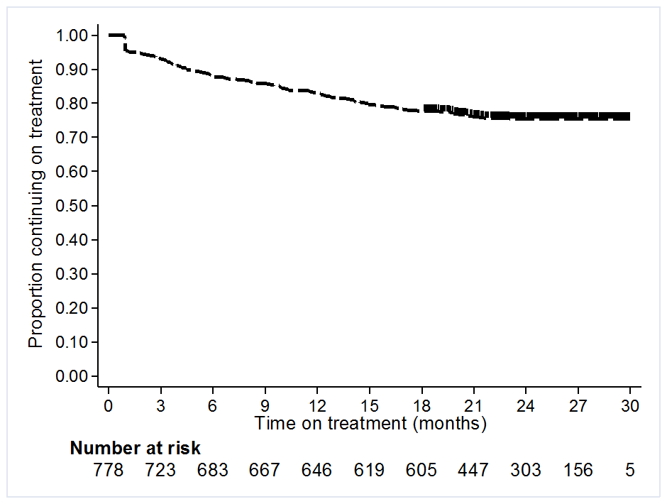
Figure 16: Overall persistence with biologics for severe CPP
Source: DHS Supplied prescriptions database (date of supply), extracted May 2017

Treatment holidays from biologic treatment on the PBS
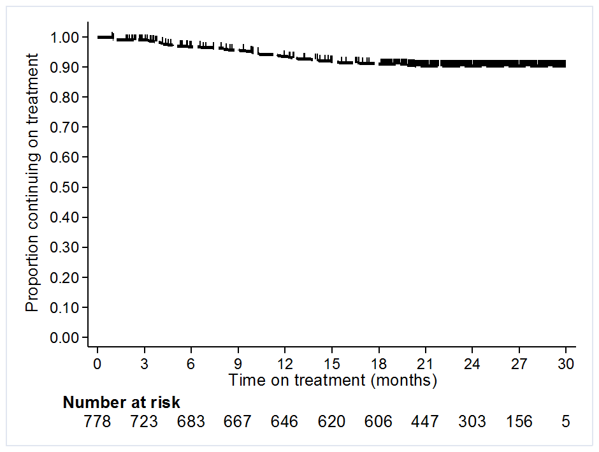
Figure 17: Time spent on treatment with biologics prior to treatment holiday
Source: DHS Supplied prescriptions database (date of supply), extracted May 2017
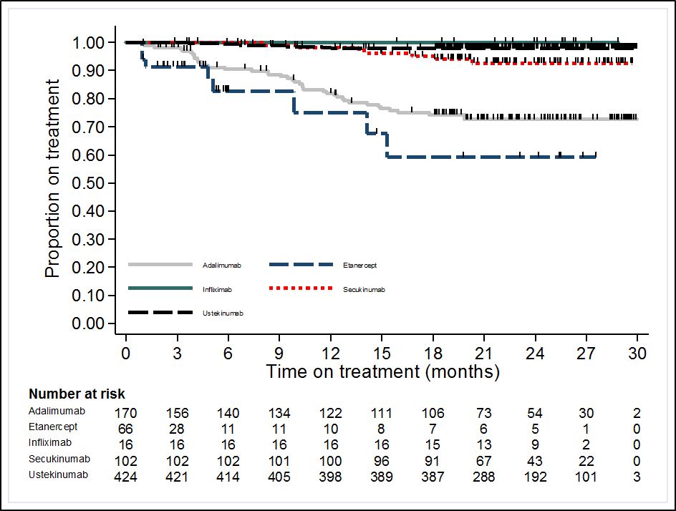
Figure 18: Time spent on treatment with biologics prior to treatment holiday by biologic
Source: DHS Supplied prescriptions database (date of supply), extracted May 2017

Switching between biologic medicines on the PBS
Figure 19: Length of time spent on treatment with first biologic prior to switching to a different biologic
Source: DHS Supplied prescriptions database (date of supply), extracted May 2017
CPP = chronic plaque psoriasis
Figure 20: Length of time spent on treatment with first biologic prior to switching to a different biologic by biologic
Source: DHS Supplied prescriptions database (date of supply), extracted May 2017
CPP = chronic plaque psoriasis

