Pharmaceutical Benefits Scheme Price Disclosure Guidelines

1 Overview 5
2 Summary of Price Disclosure 6
2.1 Key terminology 6
2.2 Price Disclosure 7
3 Roles and Responsibilities 8
3.1 Department of Health 8
3.2 Price Disclosure Data Administrator (PDDA) 8
3.3 Third Party Quality Assurance Provider 9
3.4 Responsible Persons 9
4 Application of Price Disclosure 9
4.1 Medicines subject to Price Disclosure 9
4.2 Combination drugs on F2 10
4.3 Exempt items 10
4.4 Designated Brands 11
5 Price Disclosure Requirements 12
5.1 Annual price disclosure cycles 12
5.2 Submission deadlines 13
5.3 Data preparation 13
5.4 Change of responsible person during a data collection period 14
5.5 Initial data collection period 15
5.6 Ongoing data collection periods 17
5.7 Brands delisted during data collection period 17
5.8 Required data 17
5.9 Inclusion of public hospital supply 18
5.10 Incentives 19
5.11 Discounts and incentives offered for Designated Brands with AEMP of $4 or less 21
5.12 Aligning data to disclosure requirements 22
6 Compliance 23
6.1 Best practice 23
6.2 Non-compliance 24
6.3 Consequences of non-compliance 24
7 Price Disclosure Calculations 25
7.1 Process for determining Weighted Average Disclosed Price (WADP ($)) 25
7.2 Calculation steps 25
7.3 Treatment of data from initial data collection period 29
7.4 Calculation of flow-on price reductions for combination items 29
8 Removal of originator brand data 32
8.1 Overview of originator brand removal 32
8.2 Originator brand data not removed if calculation does not result in a lower price 32
8.3 Determination of an originator brand 33
8.4 Buddy Rule 33
8.5 30-month clock (as applied for data collection periods up to 31 March 2022) 34
8.6 Modified clock for early removal of originator brand data (applied from data collection period commencing 1 April 2022) 34
9 Outcomes of Price Disclosure 37
9.1 Application of price disclosure reductions 37
9.2 Thresholds for application of reductions, including floor price thresholds 37
9.3 Low volume/low discount no reduction items 40
9.4 Brands listing after the end of the data collection period 41
9.5 Reduction in claimed price for brands with a brand price premium 42
9.6 Changed pack sizes after data collection period 42
10 Worked Examples 43
11 Notification of outcomes, Quality assurance, dispute resolution and Ministerial discretion 49
11.1 Notification of outcomes 49
11.2 Quality assurance 49
11.3 Dispute resolution process 49
11.4 Ministerial discretion 49
12 Security of commercial in-confidence material 50
13 History of Price Disclosure 50
14 Definitions 51

Disclaimer
These Guidelines are intended to provide general guidance to responsible persons in relation to price disclosure administered under the National Health Act 1953 (Cth) (the Act) and the National Health (Pharmaceutical Benefits) Regulations 2017 (Cth) (the Regulations).
The Guidelines are not intended to be, and should not be treated as, legal or professional advice, and responsible persons should seek their own legal and professional advice where appropriate.
Nothing in the Guidelines in any way limits the operation of the Act or Regulations or affects or fetters any function or power of the Minister or any other person or body under the Act and Regulations.
Enquiries
For further information or clarification regarding Price Disclosure, please email pricedisclosure@health.gov.au.

Overview
    - Under the Pharmaceutical Benefits Scheme (PBS), the Commonwealth subsidises the cost of brands of pharmaceutical items to Australian residents who hold a Medicare card or overseas visitors from countries with which Australia has a Reciprocal Health Care Agreement.
    - For multi-branded pharmaceutical items the approved ex-manufacturer price (AEMP), which is the base price upon which a PBS subsidy is paid, is periodically recalculated based on information disclosed by responsible persons in relation to the supply of those pharmaceutical items. The price disclosure arrangements are designed to more closely align the AEMP with the average prices those medicines are being supplied for in the market.
    - The legislative requirements for price disclosure are set out in the National Health Act 1953 (Cth) (the Act) and the National Health (Pharmaceutical Benefits) Regulations 2017 (Cth) (the Regulations).
    - These Guidelines are intended to provide guidance to responsible persons regarding their price disclosure obligations, including how to comply with them, and the consequences of non-compliance. These Guidelines also provide details of the price disclosure process, such as how data is collected and processed, how the outcomes of calculations are applied to the prices of relevant pharmaceutical items and what options are available to responsible persons to raise disputes.
    - These Guidelines update and replace the 2016 Price Disclosure Procedural and Operational Guidelines to reflect legislative amendments effective from 1 July 2022, including:
- Introduction of floor prices for designated brands (effective from the October 2022 price disclosure cycle) – see 4.4 – Designated Brands and s99ADHC of the Act.
- Changes to the threshold for applying price disclosure price reductions (effective from the October 2022 price disclosure cycle) – see 9.2 – Thresholds for application of reductions, including floor price thresholds.
- Changes to the timing for removal of originator brands from calculations (effective from the April 2023 price disclosure cycle) – see 8 – Removal of originator brand data.
- Changes to exclusion of supplies to public hospitals within disclosed data (effective from the October 2023 price disclosure cycle) – see 5.9 – Inclusion of public hospital supply.
- Changes to adjusted net revenue calculations (effective from the October 2023 price disclosure cycle) – see 7.2 – Calculation steps – step 3A.

Summary of Price Disclosure

Key terminology
    - Some key terms are listed below. A full glossary is provided at the end of the Guidelines.
      - AEMP is the approved ex-manufacturer price for a pharmaceutical item and is defined in s84(1) of the Act. It is the base price of a brand of pharmaceutical item and forms the basis for subsidies paid under the PBS. The same AEMP will apply for all brands of a pharmaceutical item (see s85C of the Act).
      - Brand is defined in s84 of the Act and means the trade name that a pharmaceutical item is supplied under of if there is no trade name, the name of the person who is or will be the responsible person.
      - Combination item is defined in s84(1) of the Act and means a pharmaceutical item that has a drug that contains at least two other drugs or medicinal preparations, at least one of which is a PBS listed drug.
      - Designated brands are brands of pharmaceutical items which meet one of the criteria in s99ADHC(1) of the Act and receive price protections under s99ADHC.
      - Drug means a drug for which a declaration under s85(2) of the Act is in force. Also referred to as the ‘Legal Instrument Drug’.
      - Exempt item is a pharmaceutical item in F2 that is exempt from price disclosure requirements. Exempt items are determined by the Minister under s84AH of the Act, following advice provided by the PBAC.
      - Floor price is a limitation under s99ADHC(5) of the Act preventing the AEMP of designated brands from being reduced by price disclosure to an amount less than $4. See 4.4 – Designated Brands below.
      - Form means the strength, type of unit, size of unit, formulation, presentation or other descriptor (e.g. 50 mg tablet). Also referred to as the ‘Legal Instrument Form’. See s85(3) of the Act.
      - Manner of administration (MoA) means the route the drug takes to enter the body (e.g. oral, injection). Also referred to as the ‘Legal Instrument MoA’. See s85(5) of the Act.
      - Minister means the Minister for Health and Aged Care and their delegate(s).
      - Pharmaceutical item is defined under s84AB of the Act and is made up of the drug, manner of administration and form.
      - Price disclosure cycle means a data collection period (see 5.5 and 5.6 below), its associated processing period and corresponding reduction day. See 5.1 – Annual price disclosure cycles below.
      - Reduction day means a price disclosure ‘reduction day’ under Division 3B of Part VII of the Act, which is the day on which a price reduction as a result of price disclosure may come into effect.
      - Related brand is defined in s5(1) of the Regulations and means a brand of a pharmaceutical item with the same drug and manner of administration (drug/MoA) as another pharmaceutical item, but does not include exempt items.
      - WADP ($) is the weighted average disclosed price determined under s99ADB(4) of the Act and is calculated in accordance with Division 2 of Part 7 of the Regulations (see 7 – Price Disclosure Calculations below). The WADP ($) may be the reduced AEMP for a brand on each price disclosure reduction day.

Price Disclosure
    - Price disclosure is governed by Part VII, Division 3B of the Act and Part 7 of the Regulations. Price disclosure requirements apply to all brands of a pharmaceutical item that have a drug on F2, unless the brand is an exempt item.
    - Price disclosure arrangements have been in place since 2007 to ensure the prices that patients and the Australian government pay for multi-branded medicines more closely reflect the average prices those medicines are supplied to the market. These arrangements result in price reductions which can occur twice a year.
    - Responsible persons are required to collect and submit data on sales revenue, sales volume, and the value of incentives for each of their brands of pharmaceutical items that are subject to price disclosure. An external service provider (the Price Disclosure Data Administrator (PDDA)) receives the data and performs all calculations on the Department’s behalf. All price disclosure calculations undergo an independent third-party quality assurance check.
    - The PDDA calculates the weighted average disclosed price (WADP ($)) for each brand of a pharmaceutical item based on the disclosed data. A price reduction for a brand may occur if the percentage difference between the current price and the WADP ($) is greater than the prescribed threshold for the brand (see 9.2 to 9.5 below).
    - A price disclosure cycle is 12 months in length and comprises a six-month data collection period, followed by a six-month processing period, ending in a reduction day of 1 April or 1 October. Cycles occur twice a year and overlap, requiring the responsible person of a brand to disclose data every 6 months.

    - The diagram below illustrates the high-level steps in the price disclosure process.
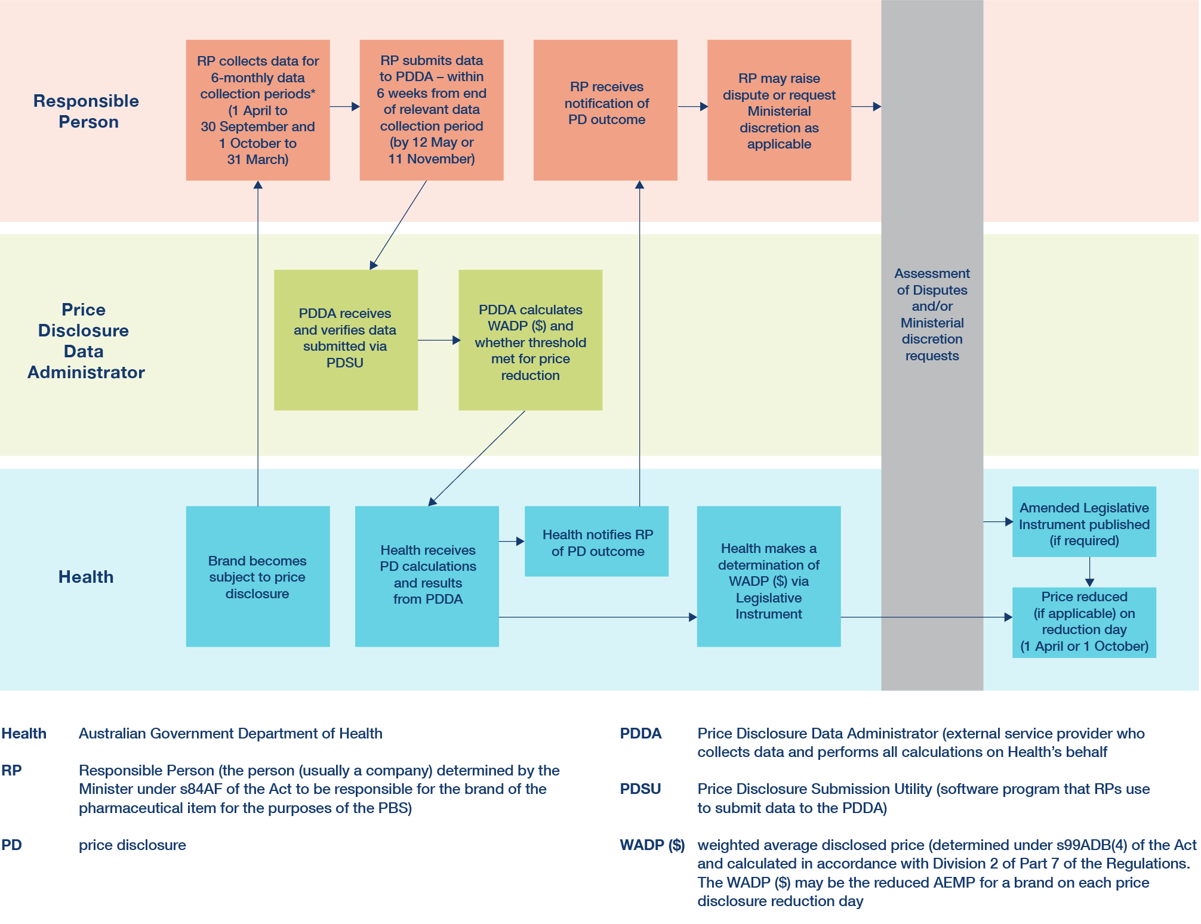
* Initial data collection period may be longer or shorter than 6 months – see 5.5 – Initial data collection period below.

Roles and Responsibilities

Department of Health
    - The Department of Health (Department) is responsible for the administration of the price disclosure arrangements. It outsources some functions to the PDDA and coordinates the exercise of powers under the Act and Regulations that give effect to AEMP reductions. It also administers the Dispute Resolution Process and liaises with members of the public and industry regarding price disclosure concerns.

Price Disclosure Data Administrator (PDDA)
    - The Department has engaged an external service provider (the PDDA) to collect data and perform all calculations on the Department’s behalf. The PDDA is identified in s85(6) of the Regulations.
    - The PDDA provides and maintains the Price Disclosure Submission Utility (PDSU), which is software used by responsible persons to enable the secure transmission of price disclosure data.

    - Responsible persons should contact the PDDA for any queries in relation to the PDSU and data submission requirements. Contact information:
Price Disclosure Data Administrator
Australian Healthcare Associates
Locked Bag 32005
Collins Street East
Melbourne VIC 8003
Telephone: 1300 336 062
Email: admin@pricedisclosure.com.au

Third Party Quality Assurance Provider
    - The PDDA employs the services of an independent third party to conduct quality assurance processes over the disclosed data and resulting calculations.

Responsible Persons
    - The responsible person is the person (usually a company) determined by the Minister under s84AF of the Act to be responsible for the brand of the pharmaceutical item for the purposes of the PBS, and can be found by using the PBS Medicine Search field on the PBS website.
    - The responsible person is legally required to collect and submit data to the PDDA for each of its brands of pharmaceutical items subject to price disclosure.
    - The responsible person will nominate an authorised representative, which is an individual who has legal authority to act on behalf of a responsible person in matters pertaining to the PBS. The authorised representative is the point of contact for correspondence and requests from the Department and the PDDA. The authorised representative has access to the PDSU to submit data on behalf of the responsible person and to sign a declaration electronically when data is disclosed. A responsible person may be represented by more than one authorised representative. Changes to contact information for a responsible person (such as changes to authorised representatives) can be made through the Health Products Portal (HPP).
    - If the responsible person for a brand has changed or will change due to its sale or transfer, the Department must be notified via the PBS Listing team at pbslisting@health.gov.au. This will allow the Minister to determine a new responsible person in a timely manner. See 5.4 – Change of responsible person during a data collection period below.

Application of Price Disclosure

Medicines subject to Price Disclosure
    - All brands of pharmaceutical items containing a drug on the F2 formulary are subject to price disclosure, unless they are exempt items. Once a drug is on F2, all brands of all pharmaceutical items are subject to price disclosure, even if the pharmaceutical items are not all multi-branded.
    - Drugs, not pharmaceutical items, are listed on a formulary. A drug can only be allocated to one formulary at a time. A drug will move to the F2 formulary (and become subject to price disclosure) when it no longer meets the criteria for F1 and is not on the combination drug list. Generally, this occurs when the drug becomes multi-branded (i.e. the first new brand is listed, which is bioequivalent or biosimilar and has the same manner of administration as an existing pharmaceutical item on the PBS).
    - The Department publishes a list of drugs subject to price disclosure on its website and updates the list on the first day of each month to reflect updates to the Schedule of Pharmaceutical Benefits. Responsible persons should refer to the list on the website and will also receive a notification from the PDDA prior to submitting data for each price disclosure cycle.

Combination drugs on F2
    - Combination drugs on F2 are subject to two calculation methods for potential price reductions arising from price disclosure:
      - direct application of the price disclosure calculations to the combination item, based on data disclosed for each brand of the combination item during the data collection period; or
      - flow-on price reductions calculated using the price reduction that will apply to brands of pharmaceutical items containing only component drugs.
Whichever method results in a lower AEMP will be applied. Further detail about how price reductions are flowed-on to combination drugs is provided at 7.4 – Calculation of flow-on price reductions for combination items below.

Exempt items
    - The Minister may determine that certain pharmaceutical items are exempt items under s84AH of the Act. Exempt items are not subject to the price disclosure arrangements. In making a determination under s84AH, the Minister may have regard to any advice from the PBAC that the particular formulation of the pharmaceutical item is suitable for use by a demographic subgroup (e.g. children or geriatric patients) for whom other formulations of the drug are not suitable.
    - A responsible person can seek consideration for a medicine to be determined as an exempt item through a Category 4 submission to the PBAC. Procedural guidance is available on the PBS website, including specific guidance for Category 4 submissions. For further information regarding the process to seek consideration as an exempt item, responsible persons should email pbac@health.gov.au.
    - Once a new bioequivalent or biosimilar brand of an exempt item is listed, the item is removed from the exempt items list and will become subject to price disclosure.
    - A full list of exempt items is published on the Department’s website.

Designated Brands
    - From 1 July 2022, some brands of pharmaceutical items will receive floor price protections under s99ADHC of the Act. These protections will apply to brands which meet one of the following criteria:
      - the drug/MoA of the brand’s pharmaceutical item has been on F2 for at least 42 months and at least 30 months must have passed since the first price disclosure price reduction for any brand of the same drug/MoA (42-month clock) (s99ADHC(1)(a)). A drug/MoA will be taken to have been on F2 for at least 42 months if at the end of the previous data collection period, the drug/MoA has been on F2 for at least 42 months, and on a day at least 42 months before the end of the previous data collection period, the drug/MoA was multi-branded (s99ADHC(6)); or
      - the AEMP of the brand is $4 or less (s99ADHC(1)(b)); or
      - the AEMP of the brand has been increased on and after 1 July 2022 through a new price agreement and a determination is in force in relation to the brand (s99ADHC(1)(c)); or
      - the AEMP of the brand has received a price increase on 1 October 2022 under s104B of the Act (s99ADHC(1)(d)).
    - Brands that meet the above criteria are referred to as ‘designated brands’. There is no difference in requirements to disclose data for designated brands.
    - Designated brands are treated differently to other brands with respect to price disclosure calculations and price reductions:
      - Designated brands with an AEMP of $4 or less are not subject to price reductions under Part VII of the Act unless it is the result of a price agreement.
      - Designated brands with an AEMP of more than $4 will not have their AEMP reduced through price disclosure unless they pass the 30% threshold or 12.5% average test and 10% threshold under s99ADH of the Act.
      - If designated brands are to receive a price reduction under s99ADH, that reduction is limited by a floor price of $4.
      - Brands with an AEMP of $4 or less will have adjusted net revenue calculated on the basis of the volume of the brand sold, multiplied by the average AEMP of the brand for the data collection period.
      - If discounts or incentives are offered for brands with an AEMP of $4 or less, the adjusted net revenue for the responsible person’s brands with an AEMP of more than $4 is reduced by a net revenue adjustment percentage to take into account any discounting of the responsible person’s brands with an AEMP of $4 or less.

Price Disclosure Requirements

Annual price disclosure cycles
    - Price disclosure operates in two overlapping cycles. A full 12 month cycle consists of a six month data collection period, followed by a six month submission and processing period, concluding on either 1 April or 1 October.
April Cycle:
      - Data collection period: 1 April to 30 September
      - Data submission deadline: 11 November
      - Outcomes notified: mid-late December
      - Reduction day: 1 April (12 months from start of data collection period)
October Cycle:
      - Data collection period: 1 October to 31 March
      - Data submission deadline: 12 May
      - Outcomes notified: mid-late June
      - Reduction day: 1 October (12 months from start of data collection period)
    - Price Disclosure Cycles are referred to by the year and month of the reduction date, for example the 2023 April Cycle has a data collection period from 1 April 2022 to 30 September 2022, and a reduction day of 1 April 2023.
    - A diagram illustrating the overlapping price disclosure cycles is below:

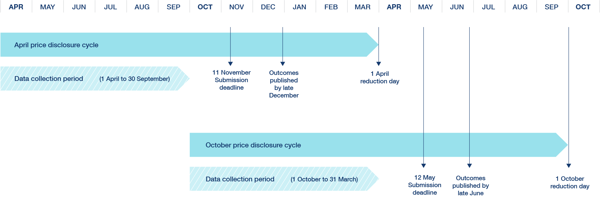

Submission deadlines
    - Responsible persons must submit price disclosure data (including incentives data) to the PDDA by the relevant deadline (12 May or 11 November) for each data collection period. This applies even if they are submitting data for only part of the data collection period. For example, the responsible person for a brand of a pharmaceutical item new to F2 as of 1 June, with a data collection period of 10 months, must submit by 11 November of the current year and 12 May of the following year. Refer to 5.5 – Initial data collection period and 5.6 – Ongoing data collection periods below.
    - Price disclosure data is submitted electronically to the PDDA through the PDSU. Data can be submitted via direct input into the PDSU or upload of a data file (Excel or XML) through the PDSU.
    - Immediately before a responsible person is required to submit data for the first time, the PDDA will provide the PDSU software to the responsible person.
    - The PDSU will be opened in the periods 1 October to 11 November and 1 April to 12 May to allow responsible persons to submit data for their brands. The PDDA will populate the PDSU with a list of brands for each responsible person. If data is only required for part of a data collection period for a brand, the list in the PDSU will indicate the time period that data is required to cover.
    - The Department recommends an early review of the list of brands in the PDSU to ensure it includes all the products for which there is a legal obligation to provide data and responsible persons are encouraged to collate data as early as possible in the data submission period. Although some data may not be available until later in the submission period, an early review will assist to identify the actions required to collate the data by the submission deadline and identify and ameliorate any potential difficulties or delays.
    - The Regulations require strict compliance with the submission deadline and do not provide for the Department to extend the submission deadline. Late disclosure will constitute non-compliance, and penalties may be imposed for such non-compliance under s99ADF and s99ADG of the Act. Further information is at 6 – Compliance below. Non-compliance by a responsible person, whether it be the failure to submit or providing incomplete data, will not prohibit the PDDA from proceeding with the calculation.

Data preparation
    - Responsible persons have final responsibility to:
      - check which of their brands are subject to price disclosure; and
      - collect and submit the required price disclosure data.
    - For each of their brands subject to price disclosure, the responsible person must ensure correct disclosure of:
      - sales revenue;
      - volume of the brand sold (size and quantity of packs sold) for all pack sizes of a brand of pharmaceutical item, including packs of the brand of pharmaceutical item that are not pack quantities in the PBS listing instrument; and
      - apportioning of the value of any incentives relating to the brand (as described at 5.10 – Incentives below).
    - Responsible persons should use their own methodologies for extracting the required data. Responsible persons should ensure that appropriate methodologies for extracting and/or estimating data have been developed and such methodologies are:
      - explicit, rational and defensible;
      - well-documented and maintained as part of the data records; and
      - applied in a consistent manner.
    - Responsible persons are responsible for ensuring that the data collected and submitted for each of their brands in each disclosure cycle is accurate.
    - Responsible persons should keep adequate records to support the data collected and submitted, including relating to the methodologies used and any calculations made to generate the data and the application of the methodologies for each of their brands and in each disclosure cycle. For further details on record keeping requirements see 6 – Compliance below.
    - Data submissions must be accompanied by a declaration electronically signed by the responsible person’s authorised representative as follows:
“I certify, in accordance with the certification procedures that I have caused reasonable reviews of the information to be done. To the best of my knowledge and belief, the information is true, complete and accurate, as of the date it is submitted and in accordance with the National Health (Pharmaceutical Benefits) Regulations 2017.”
    - After the responsible person submits data, the PDDA will send a Submission Confirmation Report to the responsible person’s authorised representative for their records and to allow them to review the data as submitted through the PDSU.
    - If the responsible person identifies an error in the confirmation report, the responsible person must resubmit the data for the relevant brand as soon as possible. Once submitted, the PDDA will repeat the confirmation process.

Change of responsible person during a data collection period
    - Responsible persons are required to disclose data for any period during which they are or were the responsible person for a brand.
    - If there has been a change of responsible person for a brand during a data collection period, the list of brands presented to each responsible person in the PDSU will indicate the time period for which they were each responsible for the brand. Each responsible person will separately submit data for the time period that they were responsible for the brand.
    - If a responsible person transfers commercial responsibility for a brand to another company, both companies must also request that the responsible person for the brand is changed to reflect the transfer.
    - The Department recommends that as soon as both companies are aware of the date on which commercial responsibility will be transferred, they should contact the PBS Listing team at pbslisting@health.gov.au. Changes of responsible person should be notified as soon as possible, to avoid a situation where there is a change of commercial responsibility for a brand before the change of responsible person is effective.

    - The original responsible person retains responsible person status for the brand under s84AF of the Act until a change of responsible person is affected through an amendment to the legislative instrument with details of the new responsible person. These changes can be made on the first day of each month as part of the monthly update to the Schedule of Pharmaceutical Benefits. The new responsible person will not be permitted to submit data on behalf of the original responsible person for the time period before the change of responsible person is affected.
    - If further information about the submission process is required, please contact the PDDA. In the event of a responsible person change please contact the Department per 5.4.4 above.

Initial data collection period
    - Responsible persons must begin collecting data on the start day for a brand under s99ADD of the Act, which is:
      - for new brands containing an F2 drug: the day that the brand is listed on the PBS;
      - for brands of previously exempt items: the day that the pharmaceutical item ceases to be exempt; and
      - for drugs already listed on the PBS: the day that the drug moves to F2.
    - As noted above, ongoing data collection periods are six months long, running from 1 April to 30 September and 1 October to 31 March. The initial data collection period is defined to ensure that a minimum of six months data is provided for the first brand of a drug/MoA that becomes subject to price disclosure. Brands whose start date is the same as the first day of a data collection period will have a six month data collection period. Brands of a drug/MoA that do not have any related brands already subject to price disclosure whose start date falls within a data collection period will have a longer initial data collection period.
    - If there are related brands already subject to price disclosure, then the brand’s initial data collection period will end when the data collection period of the related brand(s) ends. This means that a brand may have an initial data collection period that is shorter or longer than six months, depending on the time remaining in the related brand’s data collection period.
    - The examples below illustrate the different scenarios which can result in a longer or shorter initial data collection period:
      - Brand A is the first brand of a drug/MoA that is subject to price disclosure. Brand A lists on 1 June 2021 and has its initial data collection period ending 31 March 2022. Brand B of the drug/MoA is listed on 1 August 2021 and has its initial data collection period ending 31 March 2022. Both Brand A and Brand B have an initial data collection period longer than six months.
      - Brand C lists on 1 January 2022 and has the same drug/MoA as Brand A and Brand B. The initial data collection period for Brand C will end on 31 March 2022 (the same end date as its related brands, Brand A and Brand B). Brand C has an initial data collection period shorter than six months.
      - Brand D lists on 1 June 2022. Its related brands are providing disclosure for the ongoing standard data collection periods. Brands A, B and C all have data collection periods ending on 30 September 2022. Brand D will have an initial data collection period ending on 30 September 2022 (the same end date as its related brands). Brands A, B and C have standard data collection periods of six months. Brand D has an initial data collection period shorter than six months.
    - If there are no related brands, the end of the brand’s first data collection period is set out in s67(3) of the Regulations:
      - if the start day occurs between 2 April and 1 October—the next 31 March; or
      - if the start day occurs between 2 October and 1 April—the next 30 September.
    - Brands with an initial data collection period that is longer than six months will be required to submit data twice, once for each submission date that corresponds to part of the initial data collection period. For example, a brand with an initial data collection period running from 1 June 2022 to 31 March 2023 will submit data:
      - for the period 1 June 2022 to 30 September 2022 – by 11 November 2022; and
      - for the period 1 October 2022 to 31 March 2023 – by 12 May 2023.
    - The diagram below illustrates how initial data collection periods are matched for new and existing brands subject to price disclosure.
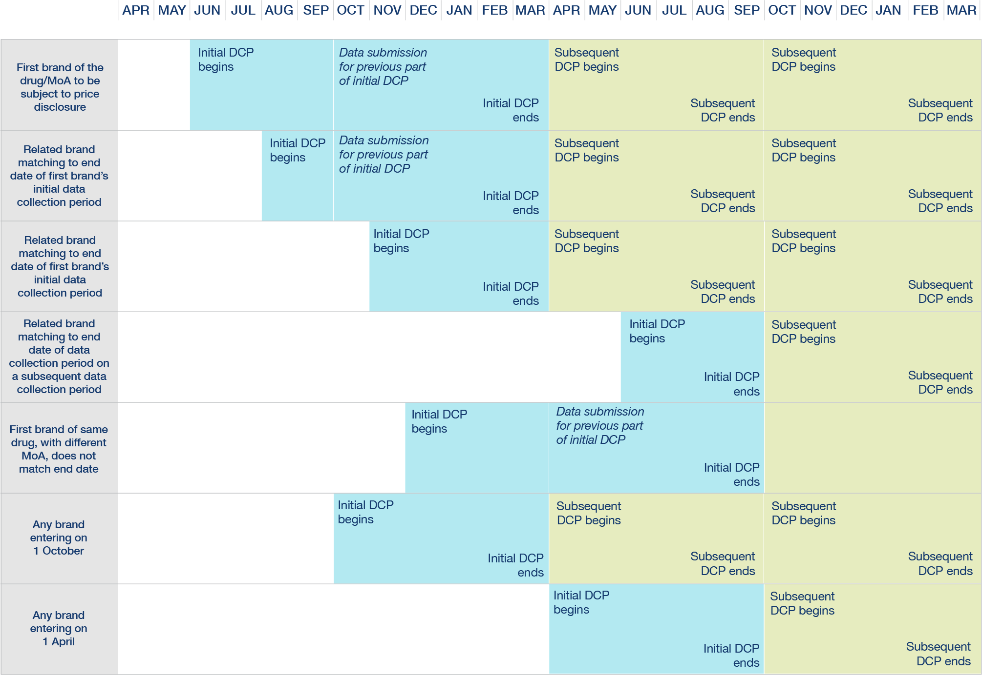
    - For brands newly listed on the PBS, the initial month of data (i.e. for the first month that the brand is listed on the PBS) is removed from the calculations which are performed using the provided data. To assist with this, the initial month of data must be provided separately to the PDDA as part of the data submission. This only applies to brands newly listed on the PBS and does not apply to brands moving from F1 to F2, the combination drug lists or brands of previously exempt items.

Ongoing data collection periods
    - After the initial data collection period, the responsible person is required to collect and submit data for all subsequent data collection periods every six months.
    - Immediately at the end of each data collection period the responsible person commences collecting data for the next data collection period.

Brands delisted during data collection period
    - If a brand is delisted during a data collection period, the responsible person is required to collect and submit data for the period up until the delist date.

Required data
    - In accordance with s85(2) of the Regulations, for each brand subject to price disclosure, the responsible person must collect and submit the following data:
      - the start and end dates of the period to which the information relates;
      - the name of the brand;
      - the name of the responsible person;
      - the name of the drug in the pharmaceutical item;
      - the form of the drug, including its strength;
      - the manner of administration of the form of the drug;
      - the number or quantity of units in a pack (the number of tablets in a pack, for example);
      - the number of packs sold;
      - the revenue from sales of the brand, excluding GST;
      - if any incentive is given in relation to the brand:
        - the kind of incentive; and
        - the value of the incentive, excluding GST.
    - All monetary amounts should be expressed in Australian dollars, rounded to the nearest whole dollar (rounding 50 cents upwards), and exclude GST.
    - The volume of the brand sold must include all pack sizes of the brand, including packs that are not pack quantities in the PBS listing instrument.
    - In some circumstances, data relating to sales to public hospitals must be excluded from the data submitted. Otherwise, all sales of the brand are to be provided, including sales to private hospitals and over the counter PBS items (whether or not they are supplied under the PBS). This is discussed in further detail below.

Inclusion of public hospital supply
    - For data collection periods up to 30 September 2022, public hospital supply will continue to be excluded from the data which is provided by responsible persons.
    - From the data collection period commencing 1 October 2022 onwards, public hospital supply will no longer be routinely excluded from price disclosure data which is provided by responsible persons. From 1 October 2022, if the drug in the pharmaceutical item has been on F2 for at least 42 months at the end of the previous data collection period for the brand, then supply to a public hospital must be included in the data provided. In all other cases, supply to a public hospital is excluded.
    - The diagram below illustrates an example for the inclusion of data on supplies to public hospitals.
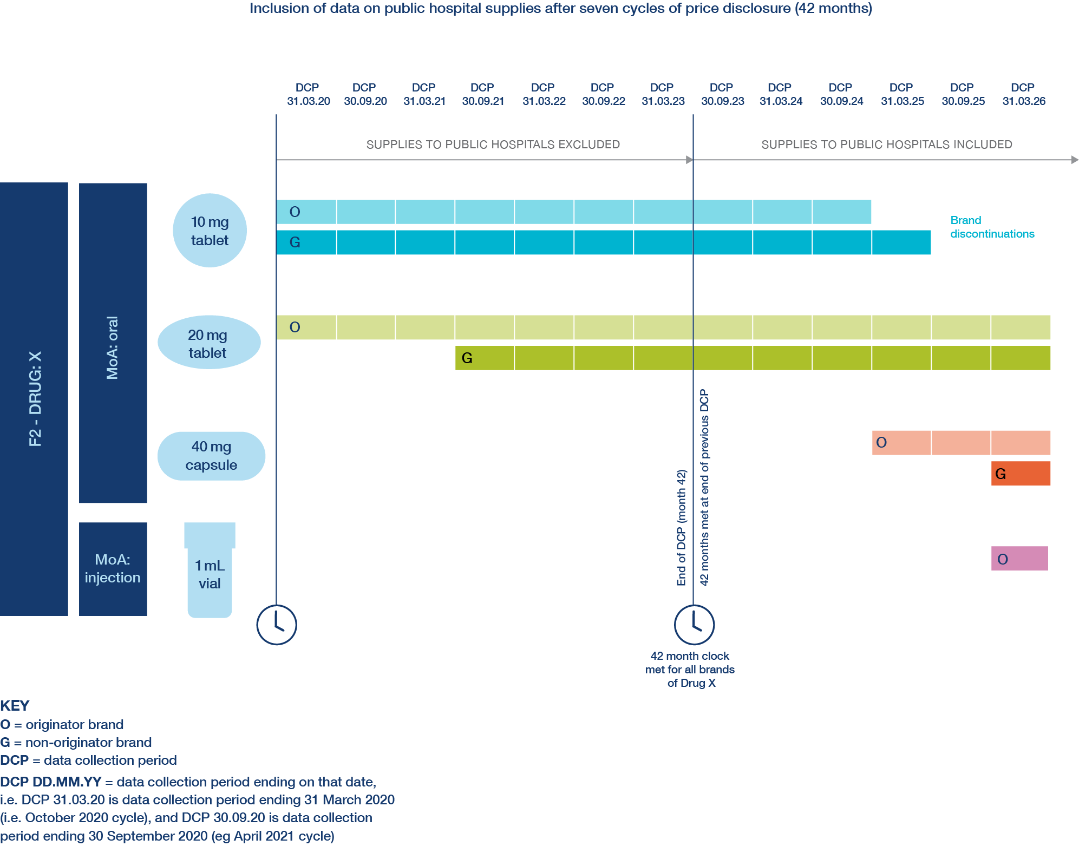
    - ‘Public Hospital’ is defined in the Act, by reference to the Private Health Insurance Act 2007 (Cth). The status of a particular hospital can be found on the Department of Health website.
    - If extraction of public hospital supply data from the rest of the data is not feasible, an estimate may be used. If extraction is complex or an estimate is required, the responsible person must develop an explicit, rational and defensible methodology for the extraction that is maintained as part of the data records and is available upon request by the Department (see 5.3 – Data preparation above and 6.2 – Non-compliance below).

Incentives
    - Responsible persons must provide details of the kind and value (excluding GST) of any incentives given in relation to a brand. An incentive for a brand of a pharmaceutical item is defined in the Regulations to include anything given as an incentive to take supply of the brand (including a delisted brand before it was delisted) whether the incentive is given:
      - before the supply of the brand, but on condition of taking supply; or
      - at, or after, the time of the supply of the brand; or
      - over a period of time; or
      - directly for the brand; or
      - indirectly for the brand (for example, for a group of brands of pharmaceutical items or other products).
    - Responsible persons should consider whether anything which is given to persons or organisations who take supply of products from them, falls within the definition of an incentive.
    - An incentive can be given at any time, directly or indirectly for the brand. An incentive includes anything that is intended to change, or has the effect of changing, the behaviour of purchasers (such as pharmacies, wholesalers, hospitals and other dispensers) of a responsible person’s listed brands of pharmaceutical items.
    - Incentives may be provided indirectly for items other than the brand subject to price disclosure, such as other PBS listed items, non-PBS listed items, over the counter items and/or non-drug products (e.g. make-up, baby care products). Incentives may be provided for multiple items. Incentives may also be provided over a period of time, and the supply of the brand may fall across data collection periods. In each of these instances, it will remain an incentive which is required to be disclosed.
    - The value of any non-monetary incentives should be fairly estimated, having regard to the market value of the incentive. Non-monetary incentives may include, for example, medical equipment, professional services, product displays (including installation of those displays) and attendance at a conference. The full value of the non-monetary incentives should be included. For example, the registration fee for attendance at a conference, as well as the value of any other benefits associated with attendance at the conference, such as additional activities, food and beverages, should be included. The methodology used by responsible persons for estimating any non-monetary incentives must be explicit, rational and defensible, maintained as part of the data records and available upon request by the Department (see 5.3 – Data preparation above).
    - If incentives relate to multiple items, the value of those incentives should be fairly apportioned to each brand for the data collection period and the brands impacted by the incentive must be identified. In many instances an apportionment based upon sales revenue or sales volume will be appropriate. Sales revenue may be appropriate for brands of the same item that have the same AEMP. Sales volume may be appropriate for different brands of different pharmaceutical items that have different AEMPs.
    - If a value or volume-based proportional apportionment is not appropriate, the responsible person may use another method which is appropriate, explicit and rational. The methodology used by responsible persons for apportioning incentives must be explicit, rational and defensible, maintained as part of the data records and available upon request by the Department (see 5.3 – Data preparation above).
    - The following example demonstrates how a responsible person may wish to apportion incentives, which apply to more than one form, across those forms.
EXAMPLE 1 – Incentive Data for Asclepius® oral brands
Revenue-based apportionment
Brand and Form | Incentives that apply to multiple brands and/or forms | Sales revenue
Asclepius tablet 25 mg | To be calculated | $2,245,049
Asclepius tablet 50 mg | To be calculated | $2,254,951
Asclepius (Overall) | $150,000 | $4,500,000
Apportioning the incentives that apply to Asclepius overall to Asclepius tablet 25 mg:
I_{T(Z25)} = I_{T} × | R_{A25} | = $150,000 × | $2,245,049 | = $74,835
I_{T(Z25)} = I_{T} × | R_{T} | = $150,000 × | $4,500,000 | = $74,835
I_{T(A25)} is the Overall Asclepius incentives, apportioned for Asclepius tablet 25 mg
I_{T} is the Total value of overall Asclepius incentives
R_{A25} is the Sales Revenue for Asclepius tablet 25 mg
R_{T} is the Total Sales Revenue of Asclepius

EXAMPLE 2 – Incentive Data for Asclepius® oral brands
Volume-based apportionment
Brand and Form | Incentives that apply to multiple brands and/or forms | Sales volume
Asclepius tablet 25 mg | To be calculated | 400
Asclepius tablet 50 mg | To be calculated | 500
Asclepius (Overall) | $150,000 | 900
Apportioning the incentives that apply to Asclepius overall to Asclepius tablet 25 mg:
I_{T(A25)} = I_{T} × | V_{A25} | = $150,000 × | 400 | = $66,666.67
I_{T(A25)} = I_{T} × | V_{T} | = $150,000 × | 900 | = $66,666.67
I_{T(A25)} is the Overall Asclepius incentives, apportioned for Asclepius tablet 25 mg
I_{T} is the Total value of overall Asclepius incentives
V_{A25} is the Sales Volume for Asclepius tablet 25 mg
V_{T} is the Total Sales Volume of Asclepius

    - Where supply falls across data collection periods, the value of the incentives for each relevant time period must be fairly apportioned. If an incentive is given prior to a brand becoming subject to price disclosure, the incentive must be disclosed if it remains in effect during part or all of the data collection period.
    - If incentives (such as discounts or rebates) have already been deducted from the revenue provided pursuant to s85(2)(i) of the Regulations, those incentives should not be separately disclosed as part of the incentive data provided pursuant to s85(2)(j) of the Regulations. This avoids double-counting of incentives in the calculations which are performed by the PDDA on disclosed data.

Discounts and incentives offered for Designated Brands with AEMP of $4 or less
    - The Commonwealth’s investment into designated brands with an AEMP of $4 or less is designed to support minimum stockholding requirements under Division 3CAA of the Act, and not be passed on by responsible persons as discounts and incentives.
    - If discounts or incentives are provided in relation to brands with an AEMP of $4 or less, they will be apportioned to the responsible person’s brands with AEMPs more than $4, as part of the calculations which are performed in step 3A in s73A of the Regulations to determine the WADP ($).
    - Under s99AEL of the Act, if incentives are offered for brands with an AEMP of $4 or less, the Minister has powers to:
      - delist the brand that incentives have been offered for;
      - delist a brand or brands of any pharmaceutical item of the responsible person;
      - refuse to list a brand or brands of any pharmaceutical item of the responsible person;
      - refuse to declare a legal instrument drug, form, or manner of administration for a brand supplied by the responsible person.
    - In determining whether to exercise such powers, the Minister must have regard to any relevant information that relates to discounts or incentives that was disclosed in compliance with the price disclosure requirements. In addition, the Minister may have regard to:
      - the extent to which the discount or incentive will compromise the responsible person’s capacity to continue to supply the brand of the pharmaceutical item;
      - whether the responsible person will consistently maintain adequate stock levels of the brand of the pharmaceutical item in the future;
      - the extent to which the discount or incentive will compromise another person’s capacity to continue to supply another brand of the pharmaceutical item; and
      - any other matter the Minister thinks is relevant.
    - From 1 July 2023, the Minister may also have regard to whether the responsible person has breached the minimum stockholding requirement in s99AEKB of the Act.
    - In determining whether to exercise the powers under section 99AEL, the Minister may consider whether the discounts or incentives were provided in accordance with contractual arrangements entered into prior to the National Health Amendment (Enhancing the Pharmaceutical Benefits Scheme) Act 2021 (Cth) receiving assent on 13 December 2021 (prior contractual arrangements).
    - To assist the Minister in considering this issue, the responsible person should provide evidence that:
      - the responsible person has not offered discounts or incentives that go above and beyond the prior contractual arrangements; and
      - notwithstanding the discounts or incentives, the responsible person will consistently maintain adequate stock levels of the brand of the pharmaceutical item in the future; and
      - after 1 July 2023, the responsible person has not breached section 99AEKB.
    - In forming a view about the prior contractual arrangements, the Minister is likely to consider whether the responsible person has had an opportunity under their contractual arrangements to update their pricing and cease offering discounts or incentives in relation brands of pharmaceutical items that have an AEMP of $4 or less. Depending on the terms of the contract, such an opportunity might arise, for example, when the contract comes up for renewal or extension, an option is being exercised, or variations to the terms are otherwise negotiated. If an opportunity has arisen to update their pricing, the responsible person should outline what changes have been made to the contractual arrangements after 13 December 2021.
    - Further information about the Minister’s powers is outlined in s99AEL of the Act.

Aligning data to disclosure requirements
    - The data which is collected by the responsible person and provided to the PDDA for sales revenues, incentives and sales volumes must align to the relevant data collection periods.
    - Responsible persons should consider their methods in advance and consider accounting methods that align with the data collection periods if possible, and if not, then be aware of methods to extract the required data to report correctly.
    - The methods used to define sales and to recognise and measure revenue for price disclosure purposes should be consistent with the responsible person’s financial accounting policies.
    - The following example illustrates the importance of:
      - Carefully considering the method used when preparing data for price disclosure purposes.
      - Working out the brands for which submissions will be required early in a submission period. Although some data may not be available until later in the submission period, early checks will assist to identify what is required so that disclosed revenue and incentive information is accurate.
      - Ensuring that accounting methods allow for alignment of incentives to the supply that they relate to, or if that is not possible, then methods have been considered to allow for information to be manually extracted and calculations performed to allow correct reporting of incentives for price disclosure.

EXAMPLE – ‘Stock on hand’ rebate
A ‘stock on hand’ rebate might be paid by a responsible person to a wholesaler following a reduction in the AEMP of a brand.
Over the period 1 October 2022 to 31 March 2023, the responsible person sells 100 packs of the brand to a wholesaler for $10 (after discounts).
A price reduction takes effect on the 1 April 2023 reduction day, resulting in a new lower AEMP of $6.
On 1 April 2023, a wholesaler has 20 packs of the brand in stock purchased at the higher price ($10).
To account for the reduction in stock on hand value, the responsible person issues a stock on hand rebate valued at $80 (20 packs × $4 reduction).
The stock on hand rebate is an incentive which relates to the remaining 20 packs which were supplied in the period 1 October 2022 to 31 March 2023.
There are two methods a responsible person could use to report the incentives:
- an accrual accounting method (stock on hand rebates reported in the period when the sales which are being rebated occurred); or
- a cash accounting method (stock on hand rebates reported in the period when the rebate is paid).
Using a cash accounting method, the responsible person would report:
- volume of 100 and revenue of $1,000 for the data collection period ending 31 March 2023; and
- the value of the stock on hand rebate ($80) is reported for the data collection period ending 30 September 2023, which is not the period when the relevant supply was made.
The timing mismatch results in:
- Revenue in the period 1 October 2022 to 31 March 2023 being inflated because some units, recorded as sold at $10, were effectively sold at $6 when the $4 stock on hand rebate is taken into account.
- Revenue in the period 1 April 2023 to 30 September 2023 being reduced because the stock on hand rebate of $4 (negative revenue) is recorded in this period despite applying to sales prior to 1 October 2022.
Using an accrual accounting method would correctly match the incentive (stock on hand rebate) to the supply that it relates. The responsible person deducts the stock on hand rebate from sales revenue for the period 1 October 2022 to 31 March 2023. Under this approach, the responsible person must rapidly quantify any stock on hand rebates associated with a particular price reduction so the incentive can be disclosed as required within the six-week submission period immediately following the price reduction.

Compliance

Best practice
    - It is expected that responsible persons will operate within an organisational framework and culture which supports compliance.
    - Serious penalties apply for non-compliance with price disclosure requirements. Responsible persons must make themselves aware of their obligations with respect to price disclosure under the Act and Regulations and how these affect their record keeping and reporting requirements.
    - Responsible persons should ensure that appropriate methodologies for extracting and/or estimating data have been developed, documented and applied in a consistent manner (see 5.3 – Data preparation above). A detailed audit trail should be maintained so that data submitted can be traced to the underlying transactional data.
    - The Department may request that a responsible person agree to participate in an audit of their price disclosure data and methodologies. This may involve the Department, the PDDA, or an alternative appointed auditor checking business records against the disclosure statements submitted to the Department. Responsible persons should therefore complete their submissions carefully and keep adequate records to support their submissions.
    - All methodologies, detailed transactional records and any other documents relating to price disclosure must be kept for two years from the end of the price disclosure cycle to which those records relate. For example, records relating to the data collection period 1 April 2023 to 30 September 2023 (2024 April cycle) must be retained until 1 April 2026.

Non-compliance
    - If a responsible person fails to meet its obligations with respect to any aspect of the price disclosure requirements in relation to a supply of a brand of a pharmaceutical item constitutes non-compliance.
    - This may include but is not limited to the following failings:
      - the responsible person did not submit any data when required to do so;
      - the responsible person submitted partial and/or incomplete data;
      - the responsible person submitted inaccurate data; and/or
      - the responsible person submitted all required data, but after the deadline.
    - On identifying a case of non-compliance, the Department will formally notify the responsible person that:
      - non-compliance has occurred;
      - the nature and details of the non-compliance;
      - the action which the Department is asking the responsible person to take and the timeframes for that action; and
      - any action which the Department intends to take and the timeframes for that action.
    - If, before or after the submission deadline, the responsible person becomes aware that it will act or has acted in a non-compliant manner then it should advise the PDDA and the Department immediately in writing. If verbal notification is provided, it should immediately be followed by written confirmation. The Department or the PDDA (acting on behalf of the Department) will then advise the responsible person what course of action the responsible person and Department will need to take to minimise the impact of the non-compliance.

Consequences of non-compliance
    - Non-compliance may constitute a criminal offence, and/or result in action by the Minister under the Act and Regulations. Financial penalties of up to 60 penalty units apply for each offence.
    - Giving false or misleading information is a serious offence. Producing false or misleading documents is also a serious offence.
    - Actions the Minister can take in response to any non-compliance include:
      - delisting from the PBS the brand(s) not providing data and/or any other listed brands of the responsible person; and/or
      - refusal to list new brands of the same responsible person and/or refusal to make declarations or determinations in relation to the pharmaceutical item, where the only listed brand of a pharmaceutical item would be the responsible person’s.
    - The consequences of non-compliance are at the discretion of the Minister. Without limiting the matters that the Minister may take into account in exercising their discretion, relevant matters may include:
      - the number of times the responsible person did not comply with the price disclosure requirements for:
        - the disclosure brand of the disclosure item; and
        - if, in addition to the disclosure brand of the disclosure item, the person was also required to comply with the price disclosure requirements for a brand of a pharmaceutical item—that brand of the pharmaceutical item; and
      - the period in which the non-compliances occurred; and
      - the duration of each non-compliance; and
      - the reasons for the non-compliances; and
      - whether those reasons are, in the Minister’s opinion, reasonable; and
      - any other matter the Minister thinks is relevant.

Price Disclosure Calculations

Process for determining Weighted Average Disclosed Price (WADP ($))
    - For the purposes of price disclosure calculations, medicines are grouped on the basis of drug/MoA. Medicines with the same drug/MoA in any brand and form are referred to as ‘related brands’.
    - Using the disclosed prices, further calculations are performed to give a WADP ($) for each brand within a group of related brands. Calculations are weighted by the volumes being sold for each brand to ensure that the outcomes reflect the market activity of related brands, taking into account the relative volumes of each individual brand.
    - If the difference (if any) between the AEMP and the WADP ($) meets the relevant threshold set out in s99ADH(1)(c) of the Act, on the next reduction day the AEMP of the pharmaceutical item will be reduced to the calculated WADP ($) unless the AEMP on the reduction day (1 April or 1 October in any year) is already the same or lower. Further details of restrictions on the application of price reductions are provided at 9.1 – Application of price disclosure reductions below.

Calculation steps
    - The diagram below illustrates how calculations are performed across a group of related brands. Sections 71 to 81 of the Regulations prescribe the method for determining the WADP ($) of a listed brand of a pharmaceutical item. Calculations are performed in the following sequence:
      - On individual brands of pharmaceutical items (same drug/MoA, same form) (steps 1 to 5); then
      - In a group of all brands of the pharmaceutical item (Steps 7 & 8); then
      - In a group of all related brands (Step 10); then
      - For each individual brand of each pharmaceutical item (Step 11).
    - Steps 1 to 10 calculate the weighted average percentage difference (WAPD (%)) between the prices at which the pharmaceutical items are being sold in the market, and the relevant AEMPs of the various pharmaceutical items which make up the group of related brands. WAPD (%) for the same drug/MoA (WAPD (%)_{drug/MoA}) is used to give a common quantification expressed as a percentage for any difference in price between the market and the relevant AEMPs. Weighting and averaging are part of the calculation process to ensure the calculation result accurately reflects market activity.
    - The average AEMP of each brand in the group of related brands is then reduced by the WAPD (%)_{drug/MoA}, to obtain the WADP ($) for each brand (Step 11).
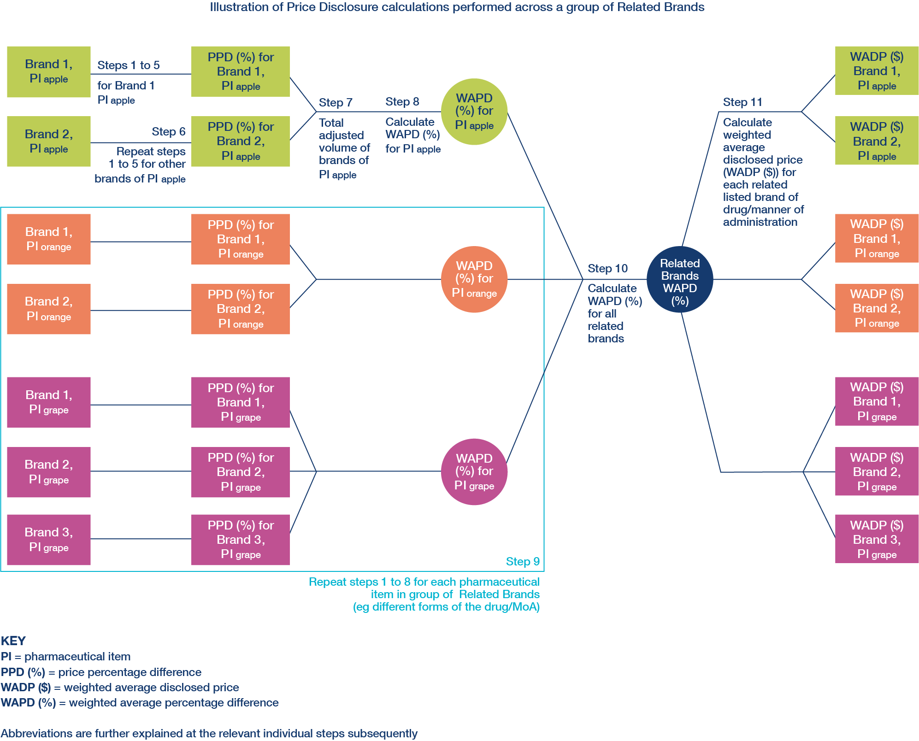
    - Each of the steps in the Regulations are summarised below, however the Regulations remain the definitive source for details of the calculations which are performed.

Step 1 – Net revenue for brand (s71 of the Regulations)
Work out the net revenue for the listed brand of the pharmaceutical item for the data collection period, where net revenue is the sales revenue minus the value of incentives. Pack size information is required for all supplies.
Note: See 7.3 – Treatment of data from initial data collection period below.

Step 2 – Adjusted volume for brand (s72 of the Regulations)
Work out the adjusted volume of the brand expressed as the number of packs and calculated as if the pack size equals the pricing quantity (PQ) on the final day of the data collection period.
Note: See 7.3 – Treatment of data from initial data collection period below.

Step 3 – Average AEMP for brand of the pharmaceutical item (s73 of the Regulations)
Work out the average AEMP of the brand for the data collection period by adding up the AEMP on each price sampling day and dividing that amount by the number of price sampling days. The AEMP is adjusted for any variation in PQ during the data collection period to reflect the PQ on the final day of the data collection period.

Step 3A – Adjusted net revenue for brand (s73A of the Regulations)
This is an additional step which will apply to data collection periods on or after 1 October 2022.
Work out the adjusted net revenue of the brand for the data collection period.
For brands with an average AEMP of $4 or less, the adjusted net revenue is the adjusted volume of the brand multiplied by the average AEMP of the brand.
For brands with an average AEMP of more than $4, the adjusted net revenue is worked out by:
      - Adding up the net revenue of the responsible person’s brands with an average AEMP of $4 or less.
      - Recalculating what the sum of the net revenue would have been if those brands were instead sold for the average AEMP.
      - Subtracting (a) from (b) (but not below zero). If this step gives a negative result, then 0 is the amount used.
      - Calculating the net revenue adjustment percentage (NRAP (%)) by dividing (c) by the sum of net revenue for all of the responsible person’s brands with an average AEMP more than $4 (expressed as a percentage (%) to 2 decimal places).
      - Reducing net revenue for the relevant brand by the NRAP (%).

Step 4 – Disclosed price for brand (s74 of the Regulations)
Work out the disclosed price of the brand for the data collection period by dividing the adjusted net revenue (step 3A) by the adjusted volume (step 2). This gives an amount per unit as sold to market. If this amount is more than the average AEMP, the average AEMP is used for the disclosed price.

Step 5 – Price percentage difference of brand (s75 of the Regulations)
Work out the price percentage difference by subtracting the disclosed price for the brand (step 4) from the average AEMP (step 3) and dividing that amount by the average AEMP (step 3) (expressed as a percentage (%) to 2 decimal places (PPD (%)).

Step 6 – Repeat steps 1 to 5 for each brand of the same pharmaceutical item (s76 of the Regulations)
Calculate the price percentage difference (PPD (%)) by following steps 1 to 5 for each other brand which has been a listed brand during the data collection period. If a brand has delisted, the PQ on the final day is taken to be the PQ of a listed brand of the same pharmaceutical item on the final day (used in step 2), or if there is no listed brand of the same pharmaceutical item on the final day, the PQ of last listed brand of the same pharmaceutical item.

Step 7 – Total adjusted volumes of brands of the same pharmaceutical item (s77 of the Regulations)
Work out the total adjusted volume by adding up the adjusted volumes for each brand of the same pharmaceutical item.

Step 8 – Weighted average percentage difference for the pharmaceutical item (WAPD (%)_{PI}) (s78 of the Regulations)
Work out the WAPD (%) of the brands of the pharmaceutical item (WADP (%)_{PI}) by adding up the adjusted volume (step 2) multiplied by the price percentage difference (step 5) for each brand of the pharmaceutical item and dividing that amount by the total adjusted volume of the brands (step 7) (expressed as percentage to 2 decimal places).

Step 9 – Repeat steps 1 to 8 for each pharmaceutical item with related brands (same drug/MoA, different forms) (s79 of the Regulations)
Work out the WAPD (%) for each brand with the same drug/MoA but a different form by repeating steps 1 to 8.
This allows the calculation of a WAPD (%) for each of the pharmaceutical items in the group of related brands.

Step 10 – Weighted average percentage difference for all related brands (same drug/MoA, any form) (WAPD (%)_{drug/MoA}) (s80 of the Regulations)
Work out the WAPD (%) for the listed brand and all related brands by:
      - Multiplying the total adjusted volume (step 7) by the average AEMP (step 3) for each pharmaceutical item and adding up the results.
      - Multiplying the total adjusted volume (step 7) by the average AEMP (step 3) for each pharmaceutical item and by the weighted average percentage difference (step 8) for each pharmaceutical item and adding up the results.
      - Dividing (b) by (a) (expressed as a percentage to 2 decimal places), to obtain WAPD (%)_{drug/MoA}.

Step 11 – Weighted average disclosed price (WADP ($)) for each related listed brand (same drug/MoA, any form) (s81 of the Regulations)
Work out the WADP ($) by reducing the average AEMP (step 3) for the brand by the WAPD (%)_{drug/MoA} for all related brands (step 10). The WADP ($) is adjusted for any variation in PQ to reflect the PQ on the relevant day (first day of next data collection period).
Note: The calculations are performed with and without the originator brand in some circumstances – see 8 – Removal of originator brand data below. Whichever calculation results in a higher WAPD (%)_{drug/MoA} (and thus a lower WADP ($)) at Step 10 will be used.

Threshold test – Compare WADP ($) for brand (adjusted to same PQ) with AEMP on relevant day (s99ADH(1)(c))
Work out the unadjusted price reduction by calculating the difference between the AEMP and the WADP ($) (step 11) on relevant day, expressed as a percentage of the AEMP.
If the difference exceeds the relevant threshold in s99ADH(1)(c) of the Act, a price reduction will occur on the next price reduction day unless the AEMP on the reduction day is already the same or lower. If the difference is less than the relevant threshold, there is no price disclosure reduction.

Treatment of data from initial data collection period
    - For newly listed brands, if the brand is in its initial data collection period, the initial month of data is not included in the calculations which are performed at steps 1 and 2 of the method for determining WADP ($). The responsible person submits data for the initial month separately to the balance of data. See 5.5 – Initial data collection period above.

Calculation of flow-on price reductions for combination items
    - Combination items on F2 may be subject to two price reduction calculations, with the method that results in a lower AEMP on the reduction day being applied. Combination items on F2 may be subject to a direct price disclosure reduction following the method set out in 7.2 – Calculation steps above.
    - Combination items may also be subject to flow on price disclosure reductions which apply the reduction to the component drug(s) in the combination item following the method outlined in s85A of the Regulations. According to this method, a price reduction in brands of pharmaceutical items containing one or more component drugs will be applied to the proportion of the AEMP of the combination item that has had a price reduction (adjusted for any differences in the quantity or amount, or pricing quantity (PQ)).
    - The formula used to calculate the flow on price reduction for a combination item is:

    - If all components of the combination item are listed on the PBS, then the ‘reduction day component AEMPs’ and ‘day before component AEMPs’ are calculated by adding up the AEMP of all of the ‘listed component items’ on the relevant day (reduction day, or day before). The listed component item is the pharmaceutical item that has:
      - the same listed component drug as the non-combination item;
      - the same manner of administration of the combination item; and
      - the smallest difference in the total quantity or amount of the component drug contained in the quantity or number of units in the PQ compared to the total quantity or amount of the component drug in the PQ of the combination item.
    - The AEMPs are adjusted for any changes in quantity or amount, or PQ.
    - For example, if the combination item contains 125mg of Drug C and has a PQ of 4 tablets and there are three pharmaceutical items that have 50mg, 100mg, and 200mg of Drug C respectively all with a PQ of 5 tablets, the listed component item will be the pharmaceutical item that has 100mg of Drug C x PQ of 5 = 500mg, as this is the closest quantity of Drug C to the amount of Drug C in the combination item (125 mg x PQ of 4 = 600mg).
    - If there is more than one pharmaceutical item with the smallest difference (e.g. both Drug D and E have a 25 mg difference which is the smallest difference), then the pharmaceutical item which is not an exempt item and results in the smallest reduction to the AEMP of the brand of the combination item will be the listed component item.
    - If there is one or more component drugs that are not listed on the PBS:
      - The ‘day before component AEMPs’ is calculated by adding the AEMPs of each of the listed component items (adjusted if necessary), and the non-listed component price. The non-listed component price is calculated by subtracting the AEMPs on the day before the reduction day of the listed component items from the AEMP of the combination item. If the non-listed component price is a negative number, it is assigned $0. For example:
        - For the combination item Yellow+Red where Yellow is listed and Red is not listed and the AEMP for Yellow+Red is $20 and the AEMP for Yellow is $15, the non-listed component price of Red is $20 – $15 = $5.
        - For combination item Green+Blue where Green is listed and Blue is not listed and the AEMP of Green+Blue is $50 and the AEMP for Green is $55, the non-listed component of Blue is taken to be $0 as $50 – $55 results in a negative number.
      - The ‘reduction day component AEMPs’ is calculated by adding the AEMPs of each of the listed component items (adjusted if necessary), and the non-listed component price multiplied by the differential reduction percentage. The differential reduction percentage is the difference between 100% and the percentage by which the AEMP of the listed component has been reduced through a price disclosure reduction or if there are two or more listed component items receiving a reduction, the average of those reductions. For example, if the listed component has been reduced by 40%, the differential reduction percentage is 60% (100% minus 40%). If there are two listed components reduced by 20% and 30% respectively, the differential reduction percentage is 75% (20% plus 30%, divided by 2 = 25%; 100% minus 25% = 75%).
    - Below are examples of the calculation of a flow-on price reduction, and comparison with a direct reduction.

EXAMPLE 1 – Calculation of flow-on reduction (both drugs listed on the PBS)
Scenario 1
F2 combination Drug Red 20 mg + Green 50 mg, with a PQ of 30 and an AEMP of $50 (Drug Red+Green).
- Drug Red has one form listed, 20 mg, with a PQ of 30 and an AEMP of $25.
- Drug Green has one form listed, 50 mg, with a PQ of 30 and an AEMP of $35.

A reduction of 50% applies to Drug Red. This is flowed on to Drug Red+Green as follows:

- The reduction day component AEMPs of Drug Red+Green is $25 * 50% + $25 = $37.50.
- The day before combination item AEMP of Drug Red+Green is $50.
- The day before component AEMPs is $25 + $25 = $50.
- The reduced AEMP for Drug Red+Green is $37.50 x ($50/$50) = $37.50.

Scenario 2
Drug Brown 100 mg + Violet 50 mg, with a PQ of 100 and an AEMP of $100 (Drug Brown+Violet)
- Drug Brown has two forms listed, 50 mg and 200 mg, each with a PQ of 50.
- The closest pharmaceutical item is Drug Brown 50 mg which has an AEMP of $30. This AEMP is adjusted for the form and PQ in the combination item and becomes $30 * 2 * 2 = $120 (to adjust for the strength and PQ differences).
- Drug Violet has one form, 50 mg, with a PQ of 100 and the AEMP is $20.

A 35% reduction is applied to Drug Brown. This is flowed on to Drug Brown+Violet as follows:

- The reduction day component AEMPs of Drug Brown+Violet is $120 * (1 – 35%) + $20 = $98.
- The day before combination item AEMP of Drug Brown+Violet is $100.
- The day before component AEMPs is $120 + $20 = $140.
- The reduced AEMP for Drug Brown+Violet is $98 * ($100/$140) = $70.

EXAMPLE 2 – Calculation of flow-on reduction (combination item with a non-PBS listed component and a PBS listed component)
Scenario 1
F2 combination Drug Orange 20 mg + Purple 50 mg, with a PQ of 30 and an AEMP of $50 (Drug Orange+Purple).

- Drug Orange has three forms listed, 10 mg, 20 mg and 40 mg. All three forms have a PQ of 30.
- The AEMP of Orange 20 mg is $25.
- Drug Purple is not listed on the PBS listed. The non-listed component is $50 – $25 = $25.

A 20% reduction is applied to Drug Orange. This flows on to Drug Orange+Purple as follows:

- The reduction day component AEMPs of Drug Orange+Purple is $25 * (1 – 20%) + $25 * (1 – 20%) = $40.
- The day before combination item AEMP of Drug Orange+Purple is $50.
- The day before component AEMPs is $25 + $25 = $50.
- The reduced AEMP for Drug Orange+Purple is $40 * ($50/$50) = $40.

Removal of originator brand data

Overview of originator brand removal
    - For certain pharmaceutical items, calculations are performed, with and without originator brand data, and the calculation resulting in the lowest new price is applied.
    - A WADP ($) calculation with originator brand data included is known as the ‘originator weighted average percentage difference’ (OWAPD). A WADP ($) calculation with originator brand data removed is known as a ‘generic weighted average percentage difference’ (GWAPD).
    - For the data collection periods up to and including 31 March 2022, GWAPD calculations may be used if the drug/MoA meets both the 30-month clock and the Buddy Rule.
    - From the data collection period commencing 1 April 2022, GWAPD calculations may be used if the drug/MoA meets the Buddy Rule, and the drug has been on F2 for at least 18 months and there has not been a price disclosure price reduction to a related brand or the drug has been on F2 for at least 30 months. The decision tree at the end of 8.6 sets out the application of the new criteria for removal of originator brand data.

Originator brand data not removed if calculation does not result in a lower price
    - The GWAPD calculation will only be considered for determination as the WADP ($) (potential reduced price) if it results in a lower new price than including the originator brand data.

Determination of an originator brand
    - Section 99ADB(6B) of the Act provides that the Minister (or delegate) may determine by legislative instrument that a brand of a pharmaceutical item that has a drug on F2 is an ‘originator brand’. The making of an originator brand determination may be considered upon movement of a drug from F1 to F2. Determination of an originator brand does not necessarily mean that the data for that brand will always be removed from calculations. Details of the criteria for removal are discussed below and at 8.4 to 8.6 inclusive.
    - Not all drugs subject to price disclosure have had an originator brand determined by the Minister or delegate and where there is no determination the removal of originator brand data will not apply.
    - When determining originator brands for drugs that move to F2, the Minister must take into account whether when the brand was listed on the PBS the drug was on the F1 formulary or the combination drug list (CDL). This provides assurance that the general approach will be to consider the brand(s) that move from F1 to F2, as an ‘originator brand’. However, an originator brand is not always required to be determined on movement of a drug to F2 (for example, if it is considered that there is no originator listed on the PBS). In addition, an originator brand may be determined after the drug moves to F2 (for example, if a first new brand of a new manner of administration lists or an originator brand variant lists such as Amoxil and Amoxil Forte).

Buddy Rule
    - Originator brand data will only be removed if on the first day of each month in the data collection period where an originator brand is listed, a non-originator brand of that pharmaceutical item is also listed. The non-originator brand can be different from month to month. This is the case even if the drug/MoA meets the other criteria for removal of originator brand data.
    - The diagrams below illustrate the application of the Buddy Rule for different forms/strengths of the same drug/MoA. “O” denotes the Originator brand. “G”, “J” and “H” denote different non-originator brands.
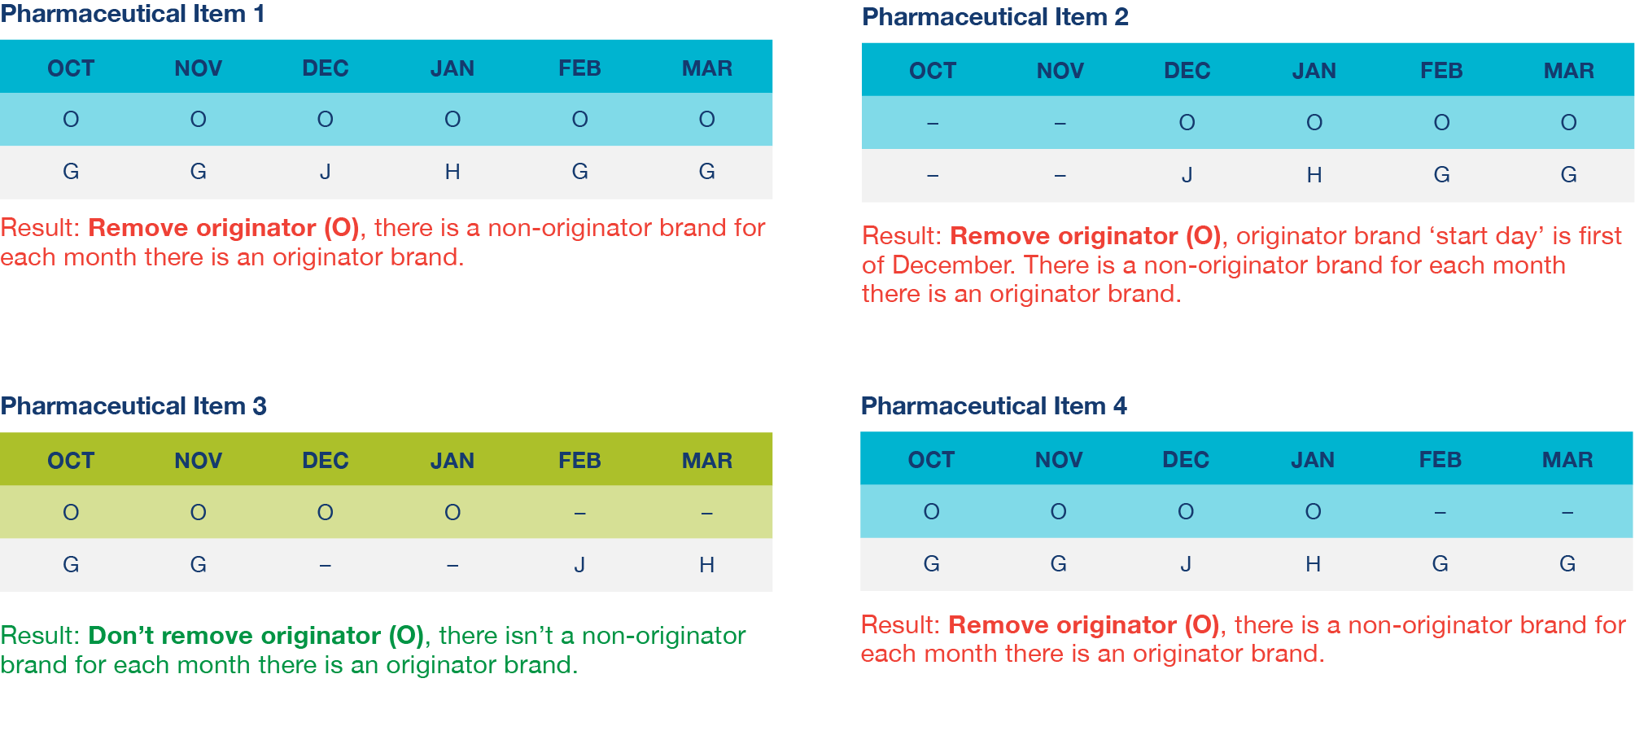

30-month clock (as applied for data collection periods up to 31 March 2022)
    - A drug/MoA is assessed against the clock criteria at the end of the previous data collection period, not the current data collection period for which data is being submitted.
    - To meet the 30-month clock (also known as the ‘remove originator clock’), both of the following criteria must be satisfied:
      - at the end of the previous data collection period, the drug in the brand has been on F2 for at least 30 months (s84(1)(b) Regulations); and
      - on a day at least 30 months before the end of the previous data collection period, (s84(1)(c) Regulations):
(i) there was a related brand that had the same pharmaceutical item as, or was bioequivalent or biosimilar to, the brand; or
(ii) there were two or more related brands that had the same pharmaceutical item as or were bioequivalent or biosimilar to each other.
    - The diagram at 8.6.6 provides a demonstration of the 30-month clock as well as the modified clock for early removal of originator brand data which is discussed at 8.6.

Modified clock for early removal of originator brand data (applied from data collection period commencing 1 April 2022)
    - Amendments made to the Regulations apply to the data collection period commencing 1 April 2022 (which corresponds to the 1 April 2023 reduction day). The amendments under the modified s84(1)(b) provide for removal of originator brand data if:
      - the drug in the brand has been on F2 for at least 18 months at the end of the previous data collection period and the brand and related brands have not been subject to a price disclosure price reduction; or
      - the drug in the brand has been on F2 for at least 30 months at the end of the previous data collection period.
    - As with the 30-month clock above, a drug/MoA is assessed against the clock criteria at the end of the previous data collection period, not the current data collection period for which data is being submitted. While 18 or 30 months may be reached during a data collection period, the clock status which may trigger a GWAPD calculation will not change until the next data collection period.
    - To meet the modified clock, the criteria in s84(1)(c) of the Regulations, which is described at 8.5.2(b) above must also be met, taking into consideration whether the 18-month or 30-month clock applies.
    - It is possible that a brand will satisfy the criteria in paragraph 8.6.1 above such that originator brand data is removed for the cycle(s), and the brand and related brands receive a price reduction prior to the brand having been on F2 for 30 months, such that early removal of originator brand data does not apply on the next cycle. The brand will then be eligible for originator brand data to be removed from the calculations again once the brand has been on F2 for at least 30 months.

    - In the diagram below:
      - The drug/MoA (Drug X, oral) is multi-branded when it moves to F2, hence the multi-branded modified clock starts on the same day that the F2 modified clock starts. In this example originator data may be removed 30 months later as a price disclosure reduction to a related brand has occurred within 18 months.
      - The drug/MoA (Drug X, injection) is not multi-branded when it moves to F2. The multi-branded modified clock starts two years later after a bioequivalent brand is listed. Originator data may be removed after 18 months of the start of the clock as a price disclosure reduction to a related brand has not occurred within 18 months.
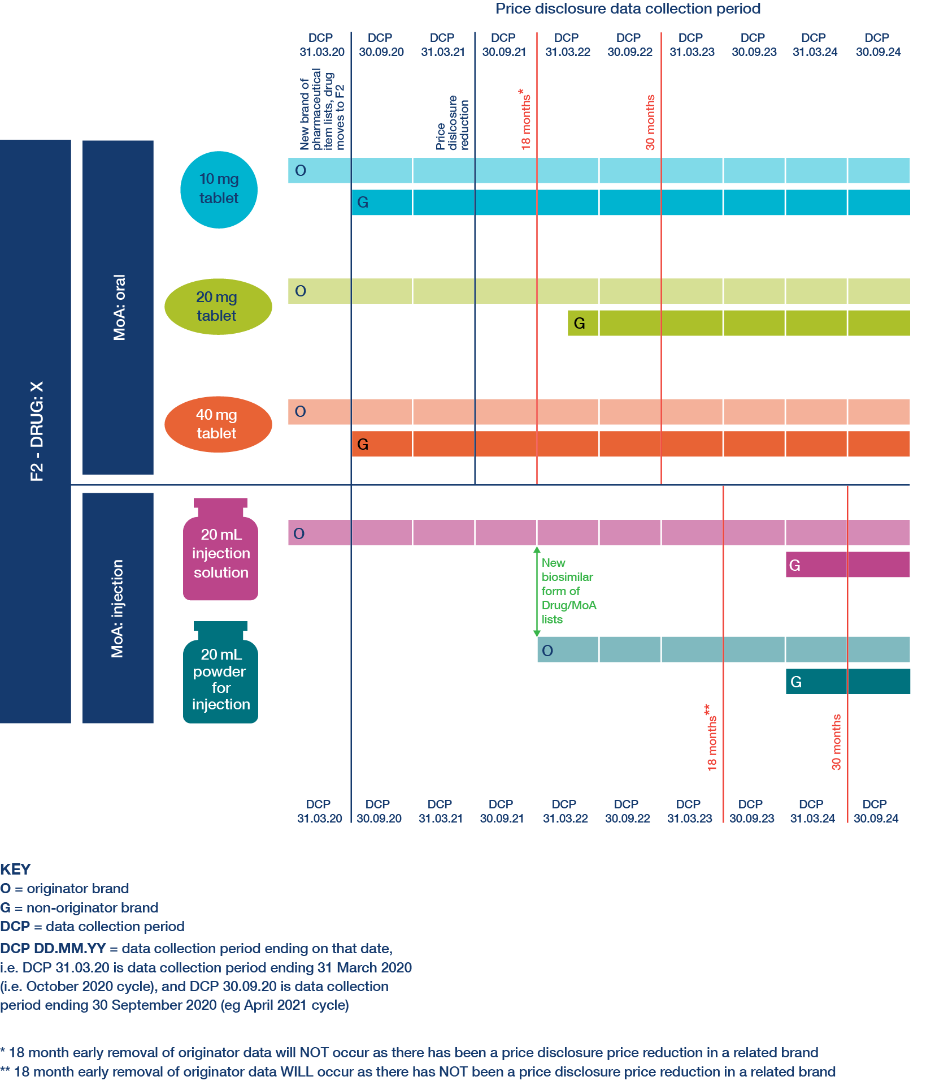
    - The diagram below sets out the decision making process to apply the criteria set out in s84(1)(a)-(c) and s84(3) of the Regulations for removing originator brand data from the data collection period commencing 1 April 2022.
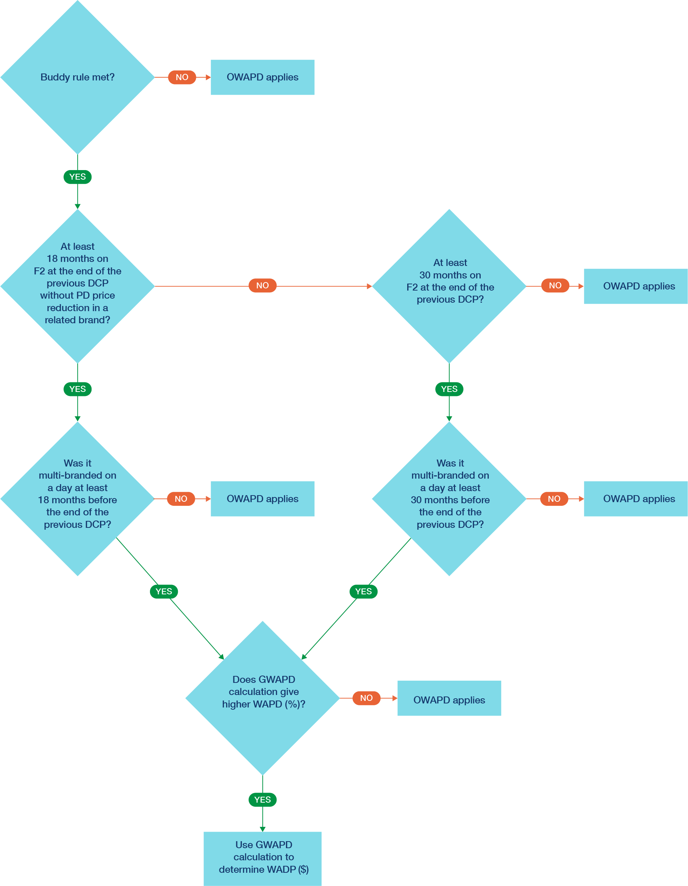

Outcomes of Price Disclosure

Application of price disclosure reductions
    - Subject to the following provisions, price disclosure reductions will apply the calculated WADP ($) on the reduction day if the discounting threshold is met and if any of the following do not apply:
      - No change if it would result in a higher price – if application of the price disclosure outcome would result in an increase to the AEMP on the reduction day (e.g. because there has been a lower price offered since the end of data collection) then there will be no price disclosure related change to the AEMP.
      - Floor price protections – for designated brands with an AEMP of $4 or less, no further price reductions apply. For designated brands with an AEMP more than $4, price reductions are capped at a floor price of $4 and will be reduced to $4 instead of a lower price that might otherwise apply.
      - Low-volume/low discount items – if a brand comprises nor more than 10% of the total adjusted volume of the group of related brands, and the weighted average percentage difference for brands of the pharmaceutical item is not more than 3%, it will not receive a price reduction.

Thresholds for application of reductions, including floor price thresholds
    - Subject to the floor price protections for designated brands and the low volume/low discount protections, if the difference between the applicable AEMP and the WADP ($) meets the relevant threshold, then a price reduction will occur on the next reduction day. The relevant thresholds are set out in s99ADH(1)(c) of the Act and are as follows:
      - For brands that are not designated brands– 10%;
      - For designated brands with an AEMP of more than $4 – 30%; or
      - For designated brands with an AEMP of more than $4, if there has been discounting averaging at least 12.5% over the last 3 data collection periods including the one for which calculations are performed and there has not been a price reduction under s99ADH of the Act – 10%.

    - The diagram below sets out the application of s99ADH of the Act:
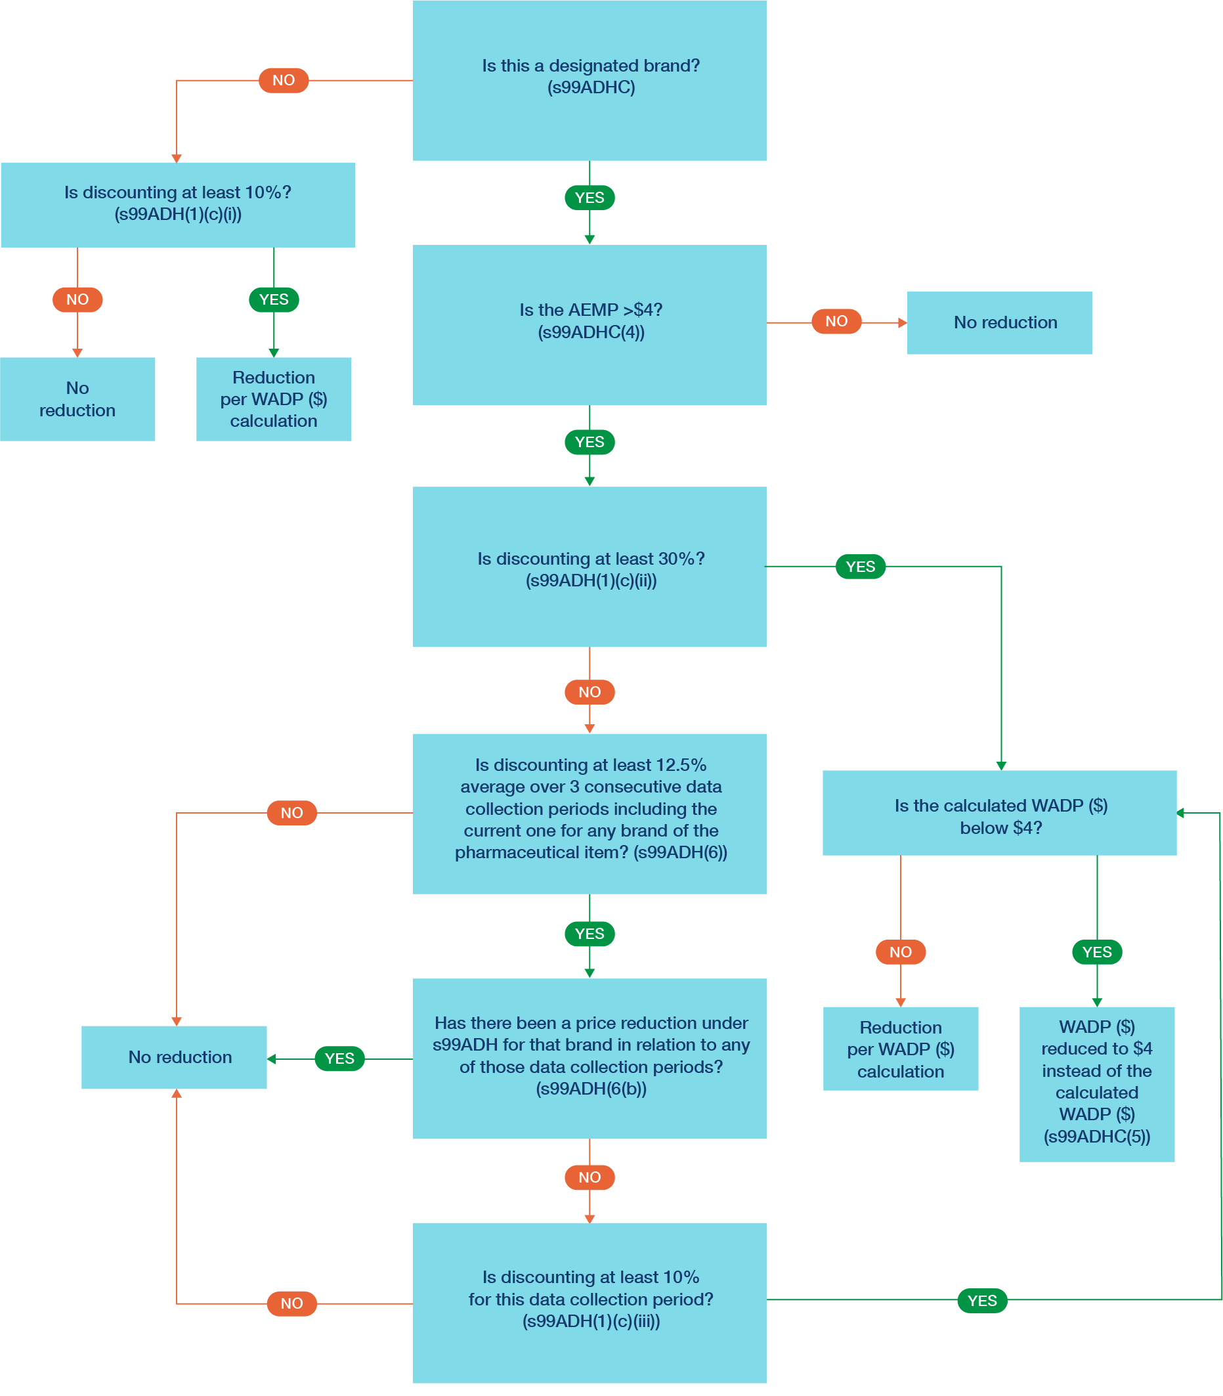

EXAMPLE 1
Brand A is a designated brand because it was subject to a price increase on or after 1 July 2022 and the Minister made a determination under s99ADHC(2) of the Act. Brand A currently has an AEMP of $20. The discounting in the current cycle is 11%. The discounting in the two previous cycles was 16% and 12% respectively and the brand did not take a reduction in either of those cycles.
Following the flow diagram above:
- The brand is a designated brand
- The AEMP is more than $4
- The discounting is not at least 30% in the current cycle
- The average discounting over the last three consecutive cycles is (16% + 12% + 11%) / 3 = 13%, which is at least 12.5%
- There was no price reduction in the previous two cycles
- Discounting in the current cycle is at least 10%
- The new WADP ($) will be $20 * (1 – 11%) = $17.80, which is more than $4
A price disclosure reduction will apply and the new AEMP for Brand A will be $17.80.
EXAMPLE 2
Brand B is a designated brand because it meets the 42-month clock criteria. Brand B currently has an AEMP of $5. The discounting in the current cycle is 25%. The discounting in the two previous cycles was 29% and 15% respectively and the brand did not take a reduction in either of those cycles.
Following the flow diagram above:
- The brand is a designated brand
- The AEMP is more than $4
- The discounting is not at least 30% in the current cycle
- The average discounting over the last three consecutive cycles is (29% + 15% + 25%) / 3 = 23%, which is at least 12.5%
- There was no price reduction in the previous two cycles
- Discounting in the current cycle is at least 10%
- The new WADP ($) will be $5 * (1 – 25%) = $3.75 which is less than $4
A price disclosure reduction will apply and the new AEMP for Brand B will be $4.00.

Low volume/low discount no reduction items
    - Section 82 of the Regulations provides for certain pharmaceutical items with low volume and low discounting to be given a WADP ($) of the applicable AEMP rather than the WADP ($) calculated in accordance with the method prescribed in ss71 to 81 of the Regulations, even where other items with the same drug/MoA take a reduction.
    - The criteria for brands of a pharmaceutical item to not take a reduction, despite others with the same drug/MoA taking a reduction, are set out in s82 of the Regulations and are as follows:
      - the ‘total adjusted volume’ for the pharmaceutical item worked out in step 7 is more than zero and not more than 10 per cent of the aggregated total adjusted volumes for all pharmaceutical items with the same drug/MoA;
      - the WAPD (%)_{drug/MoA} calculated across all brands of the pharmaceutical item in step 8 is no more than 3%;
      - there is not a related brand which is bioequivalent or biosimilar to which
9.3.2(a)-(b) immediately above applies; and
      - there is no advice from the PBAC provided under s101(3) of the Act that the pharmaceutical item ‘does not provide a significant improvement in efficacy or a reduction in toxicity over alternative therapies’.
    - For brands of a pharmaceutical item that meet the criteria in 9.3.2 above, their WADP ($) is taken to be their applicable AEMP (usually the current price), rather than the reduced price that would normally be determined.
EXAMPLE
Drug/MoA | Form | Brand | Brand Volume | Drug/MoA volume | Volume of the brand is more than 0% but less than 10% of the Drug/MoA volume– Yes/No | Brand discount less than 3% - Yes/No | Advice received from PBAC about significant improvement | Outcome
Purple/Oral | Tablet 20mg | A | 95,000 | 275,000 | No – brand makes up 35% of the Drug/MoA market | No - 29.24% | No | Reduction applies
Purple/Oral | Tablet 20mg | B | 160,000 | 275,000 | No – brand makes up 58% of the Drug/MoA market | No - 29.24% | No | Reduction applies
Purple/Oral | Capsule 20mg | B | 20,000 | 275,000 | Yes – brand makes up 7% of the Drug/MoA market | Yes - 2.69% | Yes the PBAC has advised that Purple Oral Capsule 20mg provides an improvement in efficacy over alternative therapies | No reduction applied due to low volume/low discount criteria

Brands listing after the end of the data collection period
    - Any new brands of existing pharmaceutical items that are listed on the PBS after the data collection period ends and before the reduction day will have their AEMP reduced to the AEMP of the existing brand on the reduction day in accordance with s99ADHA of the Act. No specific notice of a reduction is provided to responsible persons for these new brands, however the reduction to the existing brand is published on the PBS website.
    - Any new pharmaceutical items that list after the data collection period (e.g. a new strength) will have a WADP ($) calculated. Notices of these reductions will be provided to responsible persons.
    - Section 69 of the Regulations provides special rules to obtain values for some elements in the WADP ($) calculations for new pharmaceutical items so they can be treated equally with their related brands. The relevant sections of the Regulations are:
      - AEMP on relevant day – s69(3);
      - Data collection period – s69(4);
      - AEMP on price sampling day – s69(5).
    - A new pharmaceutical item listed after the relevant day (first day of the data collection period), will not have an ‘AEMP on relevant day’ for the purposes of WADP ($) calculations. Section s69(3) of the Regulations provides a method to calculate an ‘AEMP on relevant day’ which takes into account any changes that would have been made to the AEMP of the brand if it had been listed on the relevant day. This adjustment is done by taking the AEMP of the brand on the day it was actually listed and subtracting any increases and adding any decreases that would otherwise have occurred had the brand been listed in the period starting on the relevant day and ending immediately before when the brand was actually listed. If a brand lists on the relevant day (first day of the next data collection period), an adjustment of its AEMP for the relevant day is not required.
    - For the purposes of determining the WADP ($) of a new pharmaceutical item:
      - a brand is deemed to have had a data collection period under s69(4) of the Regulations beginning on the earliest day for which the data collection period commenced for a related brand and ending on the day before the relevant day;
      - the AEMP on each price sampling day is deemed under s69(5) of the Regulations to be the AEMP of the listed brand on its start day, less any increases and plus any decreases, that would otherwise have occurred had the brand been listed in the period starting on the price sampling day and ending immediately before the brand was actually listed.
    - As brand data will not have been collected during the data collection period for a new brand of a new pharmaceutical item, these steps permit an average AEMP to be worked out in step 3 for the purposes of calculating a WADP ($).

Reduction in claimed price for brands with a brand price premium
    - Some brands have a claimed price which is higher than the AEMP. The claimed price is determined by the Minister and usually results in patients paying an out-of-pocket amount as a brand price premium, a special patient contribution or a therapeutic group premium.
    - Where there is a price disclosure price reduction in the AEMP of a brand with a claimed price, the claimed price will automatically be reduced by a percentage proportional to the reduction in the AEMP, using the formula in s99ADH(4) of the Act:
In the formula:
      - AEMP = the AEMP on the day before the reduction day.
      - AAEMP = the price in the WADP Determination.
An example calculation is provided below.
EXAMPLE 1 – Calculating a new brand price premium for Price Disclosure
Relevant prices for Brand X:
- AEMP = $7.20
- AAEMP = $6.19
- Current claimed price = $10.90
Using the formula:
$7.20 | – | $6.19 | x | 100 | = | 14.03% (reduction percentage)
 | $7.20
New claimed price = $10.90 – 14.03% = $9.37
The new claimed price for Brand X is $9.37

Changed pack sizes after data collection period
    - If the PQ of a pharmaceutical item changes after the relevant day (i.e. the day after the end of the data collection period), then the AEMP applying on the reduction day will be adjusted to reflect the new PQ. The PQ may change, for example, due to the smallest pack size increasing due to the delisting of the existing smallest pack size or increase due to the listing of a new pack size that is smaller than the existing pack sizes.

    - The example below demonstrates how this adjustment would be made.
EXAMPLE – Apportioning if pricing quantity changes
Working out the AEMP on the reduction day
Asclepius tablet 25 mg has a PQ of 20 tablets on the relevant day (i.e. day after the last day of the data collection period).

The WADP ($) for the PQ is $20.

A new pack size of 10 lists after the relevant day.

Asclepius tablet 25 mg has a new PQ of 10 tablets applicable on the reduction day.

The following formula is applied to calculate the new price on the reduction day for the new PQ:

WADP ($) | x | New pricing quantity | = | AEMP on reduction day
Old pricing quantity

$20 (Asclepius 25mg) | x | 10 | = | $10.00
20

Worked Examples
EXAMPLE – Calculating the WAPD (%) and WADP ($) for a brand, with and without originator brand data
Brands A, B, C and D used in this example are pharmaceutical items with the same drug/MoA. Brands A and B are brands of one pharmaceutical item, and Brands C and D are brands of another pharmaceutical item.

Pharmaceutical item #1:
A GWAPD calculation applies to the 10 mg tablet form with a PQ of 50. The AEMP on each price sampling day of 6 months and on the relevant day is $10.
Step | Brand A (originator)  Responsible Person 1 | Brand B (generic)  Responsible Person 2
1) Net revenue for brand  excluding initial month | Brand A revenue ($372,000)  Incentives ($93,000)  Revenue – incentives  = 372,000 – 93,000  = $279,000 | Brand B revenue ($360,000)  Incentives ($64,800)  Revenue – incentives  = 360,000 – 64,800  = $295,200
2) Adjusted volume for brand | Volume supplied (62,000)  Pack size (25)  PQ (50)  Adjust volume to final day pricing quantity of 50:  = 62,000 * 25 / 50  = 31,000 | Volume supplied (40,000)  Pack size (50)  PQ (50)  No adjustment required:  = 40,000
3) Average AEMP (av.AEMP) for brand | = (10 + 10 + 10 + 10 + 10 + 10) / 6  = $10
3A) Adjusted net revenue for brand | a) Net revenue for the responsible person’s brands with AEMP of$4 or less (volume supplied * av. AEMP)  = $0  NRAP cannot be calculated as there are no brands with an AEMP of $4 or less.  Adjusted net revenue  = $279,000 | a) Net revenue for the responsible person’s brands with AEMP of $4 or less (volume supplied * av. AEMP)  = $0  NRAP cannot be calculated as there are no brands with an AEMP of $4 or less.  Adjusted net revenue  = $295,200
4) Disclosed price for brand | = 279,000 / 31,000  = $9.00 | = 295,200 / 40,000  = $7.38
5) Price % difference of brand | = (10 - 9) / 10  = 10.00% | = (10 - 7.38) / 10  = 26.20%
6) Repeat steps 1 to 5 for each brand | Above calculations completed.
7) Total adjusted volumes of brands of same PI (adj. vol) | Originator brand data is included in calculations for this step and following, i.e. Brands A and B.  = 31,000 + 40,000  = 71,000 (OWAPD) | Originator brand data is excluded in calculations for this step and following, i.e. Brand B.  = 40,000 (GWAPD)
8A) WAPD (%)_{PI} (OWAPD) (% to 2 decimal places) | Brand A (step 2 * step 5)  + Brand B (step 2 * step 5)  / step 7  = (31,000 * 0.1) + (40,000 * 0.262) / 71,000  = 19.13%
8B) WAPD (%)_{PI} (GWAPD) (% to 2 decimal places) |  | Brand B (step 2 * step 5)  / step 7  = (40,000 * 0.262) / 40,000  = 26.20%
9) Repeat steps 1 to 8 for each pharmaceutical item with related brands | See calculations for pharmaceutical item #2 below.
Low volume/low discount no reduction | Total adjusted volume for brands of the pharmaceutical item:  71,000/187,500 = 37.87% > 10%  WAPD (%)_{PI} = 19.13% > 3%  s82 of the Regulations does not apply
Pharmaceutical item #2:
A GWAPD calculation applies to the 5 mg tablet form with a PQ of 50. The AEMP on each price sampling day in the data collection period and on the relevant day is $7.
Step | Brand C (originator)  Responsible Person 1 | Brand D (generic)  Responsible Person 3
1) Net revenue for brand  excluding initial month | Brand C revenue ($292,000)  Incentives ($64,240)  Revenue – incentives  = 292,000 – 64,240  = $227,760 | Brand D revenue ($520,000)  Incentives ($83,200)  Revenue – incentives  = 520,000 – 83,200  = $436,000
2) Adjusted volume for brand | Volume supplied (73,000)  Pack size (25)  Adjust to PQ (50)  = (73,000 * 25) / 50  = 36,500 | Volume supplied (80,000)  Pack size (50)  = 80,000 (no adjustment required)
3) Average AEMP (av.AEMP) for brand | = (7 + 7 + 7 + 7 + 7 + 7) / 6  = $7.00
3A) Adjusted net revenue for brand | a) Net revenue for the responsible person’s brands with AEMP of $4 of less (volume supplied * av. AEMP)  = $0  NRAP cannot be calculated as there are no brands with an AEMP of $4 or less.  Adjusted net revenue  = $227,760 | a) Net revenue for the responsible person’s brands with AEMP of $4 or less (volume supplied * av. AEMP)  = $0  NRAP cannot be calculated as there are no brands with an AEMP of $4 or less.  Adjusted net revenue  = $436,800
4) Disclosed price for brand | = 227,760 / 36,500  = $6.24 | = 436,800 / 80,000  = $5.46
5) Price % difference of brand | = (7 – 6.24) / 7  = 10.86% | = (7 – 5.46) / 7  = 22.00%
6) Repeat steps 1 to 5 for each brand | Above calculations completed.
7) Total adjusted volumes of brands of same PI (adj. vol) | Originator brand data is included in calculations for this step and following, i.e. Brands C and D.  = 36,500 + 80,000  = 116,500 (OWAPD) | Originator brand data is excluded in calculations for this step and following, i.e. Brand D.  = 80,000 (GWAPD)
8A) WAPD (%)_{PI} (OWAPD) (% to 2 decimal places) | Brand C (step 2 * step 5)  + Brand D (step 2 * step 5)  / step 7  = (36,500 * 0.1086) + (80,000 * 0.22) / 116,000  = 18.51%
8B) WAPD (%)_{PI} (GWAPD) (% to 2 decimal places) |  | Brand D (step 2 * step 5) / step 7  = 80,000 * 0.22 / 80,000  = 22.00%
9) Repeat steps 1 to 8 for each pharmaceutical item with related brands | No other pharmaceutical items with related brands. Proceed to Step 10.
Low volume/low discount no reduction | Total adjusted volume for brands of the pharmaceutical item:  116,500/187,500 = 62.13% > 10%  WAPD (%)_{PI} = 18.51% > 3%  s82 of the Regulations does not apply

Drug/MoA OWAPD:
The WAPD (%)_{drug/MoA} is calculated for the parent drug/MoA of the 5 mg and 10 mg tablet forms with a PQ of 50 and including the Originator brand. The WADP ($) per PI and unadjusted price reduction are tested with a 10% threshold in this example.

The brands listed for this drug/MoA are not designated brands with a floor price.

Neither pharmaceutical item satisfies the criteria under s82 of the Regulations, and the WADP will be tested against the threshold.
Step | Pharmaceutical item #1  Brands A and B | Pharmaceutical item #2  Brands C and D
10) WAPD (%)_{drug/MoA} (OWAPD) | Sum of total adjusted volume * average AEMP per PI.  = (71,000 * 10) + (116,500 * 7)  = 1,525,000 (X)  Sum of total adjusted volume * average AEMP * WADP(%)_{PI} (OWAPD).  = (71,000 * 10 * 0.1913) + (116,500 * 7 * 0.1851)  = 466,897 (Y)  X / Y  = 466,897 / 1,525,000  = 30.61%
11) WADP ($) for each brand | Av.AEMP – WAPD (%)_{drug/MoA}:  = 10 * (1 – 0.3061)  = $6.94 | Av.AEMP – WAPD (%)_{drug/MoA}:  = 7 * (1 – 0.3061)  = $4.86
10% threshold and test | (Relevant day AEMP – WADP ($)) / relevant day AEMP  = (10 – 6.94) / 10  = 30.61% (exceeds 10%) | (Relevant day AEMP – WADP ($)) / relevant day AEMP  = (7 – 4.86) / 7  = 30.61% (exceeds 10%)

Drug/MoA GWAPD:
The WAPD (%)_{drug/MoA} is calculated for the parent drug/MoA of the 5 mg and 10 mg tablet forms with a pricing quantity of 50 and excluding the Originator brand. The WADP ($) per PI and unadjusted price reduction are tested with a 10% threshold in this example.

The brands listed for this drug/MoA are not designated brands with a floor price.

Neither pharmaceutical item satisfies the criteria under s82 of the Regulations, and the WADP will be tested against the threshold.
Step | Pharmaceutical item #1  Brands A and B |  | Pharmaceutical item #2  Brands C and D
10) WAPD (%)_{drug/MoA} (GWAPD) | Sum of total adjusted volume * average AEMP per PI.  = (40,000 * 10) + (80,000 * 7)  = 960,000 (X)  Sum of total adjusted volume * average AEMP * WADP(%)_{PI} (GWAPD).  = (40,000 * 10 * 0.262) + (80,000 * 7 * 0.22)  = 228,000 (Y)  X / Y  = 228,000 / 960,000  = 23.75%
11) WADP ($) for each brand | Av.AEMP – drug/MoA WAPD:  = 10 * (1 – 0.2375)  = $7.63 | Av.AEMP – drug/MoA WAPD:  = 7 * (1 – 0.2375)  = $5.34
10% threshold and test | (Relevant day AEMP – WADP ($)) / relevant day AEMP  = (10 – 7.63) / 10  = 23.75% (exceeds 10%) | (Relevant day AEMP – WADP ($)) / relevant day AEMP  = (7 – 5.34) / 7  = 23.75% (exceeds 10%)
OUTCOME:
The WADP ($) is calculated with both OWAPD and GWAPD calculations, with the calculation resulting in the higher reduction effective on the reduction day. This is often the GWAPD calculation but can be the OWAPD calculation, as is the case in this example.

The adjusted AEMP for brands A, B, C, and D based on OWAPD calculations will appear in Schedule 1 of the WADP Principal Determination published in advance of the reduction day.
Step | Pharmaceutical item #1  Brands A and B | Pharmaceutical item #2  Brands C and D
Adjusted AEMP & unadjusted price reduction (OWAPD) | $6.94, or 30.61%. | $4.86, or 30.61%.
Adjusted AEMP & unadjusted price reduction (GWAPD) | $7.63, or 23.75%. | $5.34, or 23.75%.

Notification of outcomes, Quality assurance, dispute resolution and Ministerial discretion

Notification of outcomes
    - Outcomes of the April cycles are determined in mid to late December and outcomes for the October cycles are determined in mid to late June. Outcomes are published on the Price Disclosure webpage shortly after the determination is made. The Department will email responsible persons notifying that outcomes have been published and advising of the deadline for lodging a dispute or Ministerial discretion request with the Department (see 11.2 – Dispute resolution process below).
    - Indicative prices that set out price to pharmacy and the Dispensed Price per Maximum Quantity or Amount (DPMQ or DPMA) are published a month later.
    - Any amendments to the determination required to be made due to new brands listing or as a result of disputes will be published in February for April cycles and August for October cycles.

Quality assurance
    - There are a number of safeguards in place to ensure both the quality of data which is submitted for price disclosure purposes, and the accuracy of the resulting calculations and outcomes, including combination flow-on reductions.
    - Data collection and calculations (with the exception of combination flow-on reductions) have been outsourced to an independent service provider, the PDDA. The PDDA is Australian Healthcare Associates Pty Ltd. Data submissions are made through a highly secure software environment (the PDSU) which allows for responsible persons to submit, review and check the status of data.
    - The PDDA performs data analysis checks on data submissions to identify anomalies and possible discrepancies.
    - All price disclosure calculations undergo quality assurance checks by an independent third party. The independent third party reviews the system processes used by the PDDA to maintain data submissions and calculate the WADP, including recalculations for a sample of pharmaceutical items to verify the PDDA calculations.

Dispute resolution process
    - If responsible persons have any concerns regarding the outcome of a price disclosure cycle, they may formally lodge a dispute with the Department.
    - If a dispute is lodged with the Department, it will be investigated and resolved internally by the Department in accordance with the dispute resolution process detailed in the Price Disclosure Dispute Resolution Process Guidance Material available on the PBS website.

Ministerial discretion
    - Under section 99ADHB of the Act, the Minister has discretionary powers not to apply or apply a reduced flow-on price disclosure reduction. Please refer to the Ministerial Discretion Guidance Material for Statutory Price Reductions for further information about making a request to the Minister for the exercise of Discretion.

Security of commercial in-confidence material
    - The Department and the PDDA consider sales and incentive information submitted by responsible persons to be commercial-in-confidence and recognise responsible persons’ expectations that commercial-in-confidence information will be protected from inadvertent, unintended or improper disclosure.
    - The PDSU is a secure means to provide data to the PDDA. All communication is via https and is internally encrypted with a Public Key Infrastructure (PKI) encryption certificate which is unique to each responsible person. Data is stored on a secure server and transmitted securely.
    - In accordance with its legal responsibilities the Department and the PDDA will treat all information received from the responsible person as confidential and will not disclose that information to any person except where the confidential information:
      - is required, or authorised, to be disclosed by law, (including disclosure within the Department and its contractors for administration of the PBS, or for court proceedings);
      - must be disclosed to the Department’s solicitors, auditors, insurers, advisers or Commonwealth Ombudsman;
      - is reasonably necessary for the enforcement of the criminal law or for the protection of public revenue;
      - is generally available to the public.

History of Price Disclosure
    - Price Disclosure for PBS listed medicines was introduced as part of PBS reforms in 2007.
    - Initially price disclosure only applied to a drug listed on the now defunct F2A formulary after a new brand of an existing pharmaceutical item listed on the PBS. Compliance with price disclosure was mandatory for responsible persons of these new brands, and was voluntary for responsible persons of brands already listed on the F2A formulary. More details about the original price disclosure arrangements are available at:
www.pbs.gov.au/info/industry/pricing/disclosure.
    - Under the first extension of price disclosure, known as Expanded and Accelerated Price Disclosure (EAPD), from 1 December 2010 all brands of non-exempt pharmaceutical items containing F2 drugs became subject to price disclosure provisions. More details about price disclosure under EAPD are available at: www.pbs.gov.au/info/industry/pricing/eapd. EAPD operated with the following timelines:
      - The data collection period for regular ongoing cycles was 12 months followed by a 6-month processing period.
      - The main cycle covered most medicines subject to the arrangements and had a potential reduction day on 1 April each year.
      - Two supplementary cycles occurred each year for some drugs and MoAs new to price disclosure, with potential reduction days on 1 August and 1 December each year. After their first supplementary cycle, medicines merged into the main cycle.
    - The last reduction under EAPD occurred on 1 August 2014.
    - Further amendments to price disclosure were made under the Simplified Price Disclosure (SPD) reforms in 2014. The first price disclosure reductions based on the SPD modifications occurred on 1 October 2014, based on information submitted for data collection periods ending 31 March 2014.
    - In 2015, the PBS Access and Sustainability package included the following amendments to price disclosure:
      - Price disclosure reductions in component ingredient drugs were applied to F2 combination items as a flow-on reduction, where this resulted in a lower price than direct application of price disclosure to the F2 combination item. Previously only single-branded combination items on the CDL received flow-on reductions.
      - Removal of originator brands from WADP calculations for medicines listed on the F2 formulary for three years or more where this resulted in a lower adjusted price.
      - Certain pharmaceutical items not to take a price disclosure reduction despite other pharmaceutical items with the same drug/MoA taking a reduction, under what is known as the ‘low volume/low discount’ criteria.
    - In 2018, an amendment was made to the Act to introduce a 30% threshold for medicines listed on the F2 formulary for 4.5 years or more instead of the standard 10% threshold. This threshold change was intended to ensure the viability of medicines that have been through two price disclosure calculations with originator brand data removed. This is generally after being subject to price disclosure for the equivalent of seven cycles.
    - Amendments to the Act and the Regulations from 1 July 2022 have resulted in the following changes to price disclosure:
      - The introduction of a floor price for designated brands with an AEMP of more than $4, restricting any price reduction to $4 instead of any lower price that would otherwise apply.
      - The early removal of originator brand data from WADP ($) calculations for medicines listed on the F2 formulary for 18 months or more where a medicine has not previously had a price disclosure reduction and where this results in a lower adjusted price.
      - Expansion of the brands to which the 30% threshold applies to, with all designated brands with an AEMP more than $4 now subject to the threshold.
      - Addition of a 12.5% average price reduction test across three successive cycles without a price disclosure reduction and 10% threshold in the current cycle for designated brands, which were previously assessed against a 30% threshold.
      - The inclusion of public hospital supply data for pharmaceutical items that have been on F2 for at least 42 months at the end of the previous data collection period.

Definitions
    - Act: National Health Act 1953 (Cth).
    - AEMP: is the approved ex-manufacturer price for a pharmaceutical item and is defined in s84(1) of the Act. It is the base price of a brand of pharmaceutical items and forms the basis for subsidies paid under the Pharmaceutical Benefits Scheme. The same AEMP will apply for all brands of a pharmaceutical item (see s85C of the Act).
    - Authorised Representative: an individual who has company authority to enter into price agreements, submit price disclosure data and otherwise deal with the Minister, the Department of Health and its delegates in relation to the responsible person’s brands of pharmaceutical items.
    - Average AEMP (av.AEMP): the average of the AEMP for brands of a pharmaceutical item in each month of the data collection period calculated in step 3 (s73 of the Regulations).
    - Brand: is defined in s84 of the Act and means the trade name that a pharmaceutical item is supplied under or if there is no trade name, the name of the person who is or will be the responsible person.
    - Combination Drug List (CDL): an administrative list which sets out the single-brand combination drugs that meet the criteria in s85AB of the Act (i.e. are not on formularies (F1 or F2)).
    - Combination item: is defined in s84(1) of the Act and means a pharmaceutical item that has a drug that contains at least two other drugs or medicinal preparations, at least one of which is a PBS listed drug.
    - Data collection period: is defined in s67 of the Regulations. Further information about the initial data collection period for a brand is at 5.5 – Initial data collection period above. Subsequent data collection periods run from 1 October to 31 March and from 1 April to 30 September.
    - Data submission period: the period ending approximately 6 weeks after the end of each data collection period. For the period ending 31 March, data is to be submitted by 12 May. For the period ending 30 September, data is to be submitted by 11 November. If either date falls on a weekend or a day that is a public holiday for the whole of a state or Territory, data submission is required on the next business day.
    - Designated brands: are brands of pharmaceutical items which meet one of the criteria in s99ADHC(1) of the Act and receive price protections under s99ADHC of the Act.
    - Drug: means a drug for which a declaration under s85(2) of the Act is in force. Also referred to as the ‘Legal Instrument Drug’.
    - Exempt item: is a pharmaceutical item in F2 that is exempt from price disclosure requirements. Exempt items are determined by the Minister under s84AH of the Act, following advice provided by the PBAC.
    - F1: U Formulary 1, which contains drugs that are determined by the Minister under s85AB or s99AEJ of the Act or prescribed in the Regulations to be on F1 (see s84AC of the Act). Generally this will be drugs that:
• have only one brand of each form and strength listed on the PBS;
• are not considered to be bioequivalent or biosimilar to any brands of pharmaceutical items; and
• are not in a therapeutic group with a drug on the F2 formulary.
    - F2: U Formulary 2, which contains drugs that are determined by the Minister under s85AB of the Act or prescribed in the Regulations to be on F2 (see s84AC of the Act). F2 contains all drugs (excluding single brand combination drugs) that do not meet the criteria for F1, i.e.:
• multi-branded pharmaceutical items; and
• drugs which are in therapeutic groups with drugs that have multiple brands.
    - Floor price: is a limit on the reduction of the AEMP of the designated brands to an amount less than $4 under s99ADHC of the Act. See 4.4 – Designated Brands above.
    - Form: means the strength, type of unit, size of unit, formulation, presentation or other descriptor (e.g. 50 mg tablet). Also referred to as the ‘Legal Instrument Form’. See s85(3) of the Act.
    - Incentive: is defined in s5(1) of the Regulations. See 5.10 – Incentives above.
    - Manner of administration (MoA): means the route the drug takes to enter the body (e.g. oral, injection). Also referred to as the ‘Legal Instrument MoA’. See s85(5) of the Act.
    - New Brand: a brand newly listed on the PBS.
    - Originator Brand: under s99ADB of the Act the Minister (or delegate) may determine by legislative instrument that a brand of a pharmaceutical item that has a drug on F2 is an ‘originator brand’. See 8 – Removal or originator brand data above.
    - PBS: The Pharmaceutical Benefits Scheme which is provided under Part VII of the Act.
    - Pharmaceutical Benefits Advisory Committee (PBAC): an independent expert body established under s100A of the Act and appointed by the Minister under s100B of the Act, to provide advice to the Government about pharmaceutical benefits. Members include doctors, health professionals, health economists and consumer representatives. For more information, see the PBS website.
    - Pharmaceutical item: is defined under s84AB of the Act and is made up of the drug, manner of administration and form.
    - Price disclosure cycle: means a data collection period (see 5.5 and 5.6 above) plus its associated processing period and corresponding reduction day. See 5.1 – Annual price disclosure cycles above.
    - Price Disclosure Data Administrator (PDDA): the external service provider who conducts data collection and performs all calculations on the Department’s behalf. See 3.2 – Price Disclosure Data Administrator (PDDA) above.
    - Price Disclosure Submission Utility (PDSU): software provided by the PDDA and used by responsible persons for the secure transmission of price disclosure data.
    - Pricing quantity (PQ): is defined in s84AK of the Act and means the lowest pack quantity specified in the PBS listing instrument for any brand of each pharmaceutical item.
    - Processing period: the six-month period following the data collection period and leading up to the reduction day.
    - Reduction day: means a ‘reduction day’ under Division 3B of Part VII of the Act, which is the day on which a price reduction as a result of price disclosure may come into effect.
    - Regulations: National Health (Pharmaceutical Benefits) Regulation 2017 (Cth).
    - Related brand: is defined in s5(1) of the Regulations and means a brand of a pharmaceutical item with the same drug and manner of administration (drug/MoA) as another pharmaceutical item, but does not include exempt items.
    - Relevant day: the day after the end of the period in respect of which the WADP ($) of the brand of the pharmaceutical item is determined.
    - Responsible person: the person (usually a company) determined by the Minister under s84AF of the Act to be responsible for the brand of the pharmaceutical item under the PBS. See 3.4 – Responsible Persons above.
    - Start day: see 5.5 – Initial data collection period above.
    - The Department: The Australian Government Department of Health.
    - Therapeutic group: are determined by the Minister under s84AG of the Act, following advice provided by the PBAC.
    - Unadjusted Price Reduction: is defined in s99ADB(1) and means the difference between the applicable AEMP of the brand of the pharmaceutical item and the WADP ($) determined for the brand of the pharmaceutical item, expressed as a percentage of the applicable AEMP. See 9.2 above.
    - WADP ($): is the weighted average disclosed price determined under s99ADB(4) of the Act and is calculated in accordance with Division 2 of Part 7 of the Regulations (see 7 – Price Disclosure Calculations above). The WADP ($) may be the reduced AEMP for a brand on a reduction day.
    - WAPD (%): is the weighted average percentage difference and is calculated in accordance with ss78 and 80 of the Regulations.

All information in this publication is correct as at 30 September 2022

Amendments made by the National Health Amendment (Enhancing the Pharmaceutical Benefits Scheme) Act 2021 (Cth) (Amendment Act) and the National Health (Pharmaceutical Benefits) Amendment (2021 Measures No. 1) Regulations 2021 (Cth) (Amendment Regulations) respectively.
See ss99ADA, 99ADC and 84AH (‘Exempt items’) of the Act.
Further information regarding incentives is provided at 5.10 – Incentives below.
s99ADD of the Act.
s99ADA of the Act.
s99ADH of the Act.
s99ADHB of the Act.
s99ADH(3) of the Act.
If the PBAC is of the opinion that the following circumstances exist in relation to a pharmaceutical item, under s101(4AB) of the Act the PBAC must advise the Minister: is of the opinion that the following circumstances exist in relation to a pharmaceutical item: (a) the listed drug in the pharmaceutical item represents suitable therapy for a particular patient population; (b) the pharmaceutical item is suitable for use by a particular subgroup of that population because of either or both of the form and manner of administration of the drug in the item; (c) no other pharmaceutical item that has that drug is suitable for use by that subgroup because of either or both of the form and manner of administration of the drug in that other item;
The Minister may make this determination under s99ADHC(2) by notifiable instrument.
Details of those restrictions are provided at: - Step 3A of 7.2 Calculation steps - 9.2 – Thresholds for application of reductions, including floor price thresholds
s99ADHC(4) of the Act provides for reductions of designated brands as a result of a price agreement or under s99ADH(c)(ii) or (iii). Section 99ADH(c)(ii) and (iii) only apply to brands with an AEMP of more than $4 (s99ADH(1)(c)(ii) and (iii)).
ss99ADHC(4)(b), 99ADH(1)(c)(ii) and (iii).
s99ADHC(5) of the Act and see 9.1 – Application of price disclosure reductions below.
s73A Regulations and see 7.2 – Calculation steps below.
Calculated per s73A Regulations.
s85(9)(a) Regulations. If 11 November is a weekend or public holiday, the data is due on the next business day.
s85(9)(b) Regulations. If 12 May is a weekend or public holiday, the data is due on the next business day.
This may occur, for example, if a brand is listed on F2 or ceases to be exempt part-way through a data collection period.
National Health (Listing of Pharmaceutical Benefits) Instrument 2012.
s67(2) Regulations.
‘Initial month’ is defined in s5 of the Regulations as follows: “for a brand of a pharmaceutical item that was not a listed brand immediately before the brand’s start day, means the first month of the brand’s first data collection period.”
s85(4) Regulations.
s67(4) Regulations.
Incentives are dealt with in more detail at 5.10 – Incentives below.
s85(5) Regulations.
Over the counter medicines are Schedule 2 and Schedule 3 medicines per the TGA scheduling system. Over the counter medicines can only be purchased from a pharmacy, and may also require advice from a pharmacist. Over the counter items may be listed on the PBS in addition to being available over the counter.
s85(2) Regulations.
s85(2A) Regulations (as amended by the National Health (Pharmaceutical Benefits) Amendment (2021 Measures No. 1) Regulations 2021 (Cth)).
s85(2)(j) Regulations.
s85(3) Regulations.
s99ADF of the Act.
Criminal Code Act 1995, Division 137 of the Criminal Code.
s99ADG(2)(a) of the Act.
s99ADG(2)(b) of the Act.
s99ADG(2)(c) and (d) of the Act.
s99ADG(2)(d) of the Act.
s99ADG(3) of the Act
See 9.2 – Thresholds for application of reductions, including floor price thresholds below.
A day is a price sampling day if it is the first day of a calendar month for each month and within either (i) the data collection period of the brand, or (ii) the data collection period for another brand of the same pharmaceutical item, whichever period commenced earlier (s68 Regulations).
Round this number, per s84AI of the Act.
s84 Regulations.
‘Relevant day’ is defined in s99ADB of the Act to mean the day after the end of the period in respect of which the weighted average disclosed price of the brand of the pharmaceutical item is determined.
s99ADH(3) of the Act.
s99ADHB of the Act. This section of the Act does not include exempt items.
s85A(2) Regulations.
s85A(3) Regulations.
s85A(4) Regulations.
s84(1)(b) Regulations, as in effect up to data collection period ending 30 September 2022.
s84(1)(a) Regulations, see detail at 8.4 – Buddy Rule below.
s84(3) Regulations.
Data collection period corresponds to the 1 October 2022 reduction day.
See 9.1.1(b) above.
See 9.3 – Low volume/low discount no reduction items below.
‘Applicable AEMP’ is defined in s99ADB of the Act as the AEMP of the brand on the relevant day, being the day after the end of the data collection period.
If the 10% threshold is met, price reductions will occur for all forms and strengths of a drug that have the same manner of administration for which a weighted average percentage difference (WAPD (%)) equal to or greater than 10% has been calculated.
s82 Regulations.
s99ADB(3B)(a) and (b) of the Act, s69 Regulations.
i.e. the day after the end of the data collection period.
WADP ($) will be the same for each brand of the same pharmaceutical item, although it is calculated separately for each brand.
Until 1 December 2010, the Minister could determine drugs for the F1, F2A, or F2T formularies, the latter two containing multi-branded drugs. Drugs on the F2A and F2T formularies merged into a single F2 formulary from 1 December 2010 onwards.

