THE PHARMACY DIABETES SCREENING TRIAL (PDST) – AN UPDATE
Research Team (USYD) –Ines Krass, Bernadette Mitchell, Frances Wilson, Kate Luckie Research Team (Deakin University) – Kevin McNamara, Rob Carter, Sophy TF Shih, Vincent Versace, Peta Trinder, Mohammadreza Mohebbi
Pharmacy Guild of Australia –Erica Vowles, Fiona Mitchell, Maja Ajdukovic

Presentation Overview

• Recap on PDST trial

• Pharmacy recruitment

• Pharmacy activity in diabetes screening prior to commencing PDST

• Pharmacist training evaluation

• Pharmacist feedback

• Consumer feedback

Sixth Community Pharmacy Agreement Pharmacy Diabetes Screening Trial

▪Funded by the Australian Government Department of Health, and developed in partnership with The Pharmacy Guild of Australia, The University of Sydney and Deakin University.

▪Aims to test the comparative clinical and cost effectiveness of three models of a pharmacy-based opportunistic risk assessment, screening and referral service for type 2 diabetes in a previously undiagnosed population.

The PDST uses clustered randomised controlled design where geographic clusters of pharmacies are the unit of randomisation and screening participants are the unit of analysis

Hypotheses

Primary
The addition of either an HbA1c POC test (Group B) or a scBGT POC test (Group C) to the AUSDRISK™ assessment will be associated with a statistically significant increase in the proportions of newly diagnosed T2DM cases compared with AUSDRISK™ alone (Group A).

Secondary
Groups B and C will be associated with a statistically significant increase in the proportions of those who take up referral with the GP, are newly diagnosed with prediabetes, i.e., IFG or IGT, and are newly diagnosed with either diabetes or pre-diabetes compared with Group A.

Evaluation summary
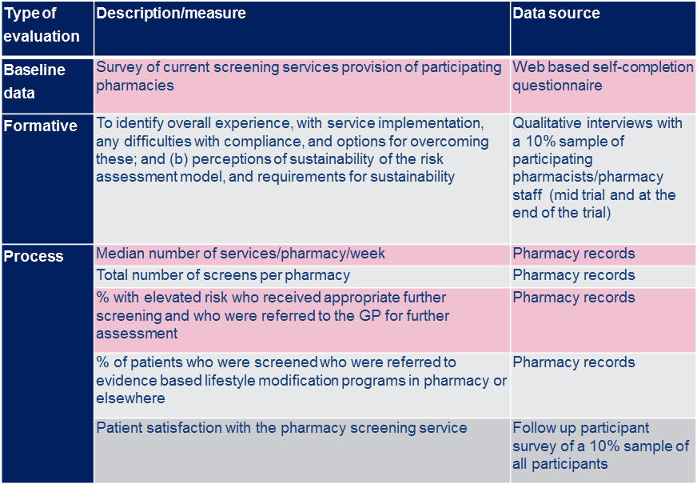

Evaluation summary (cont)
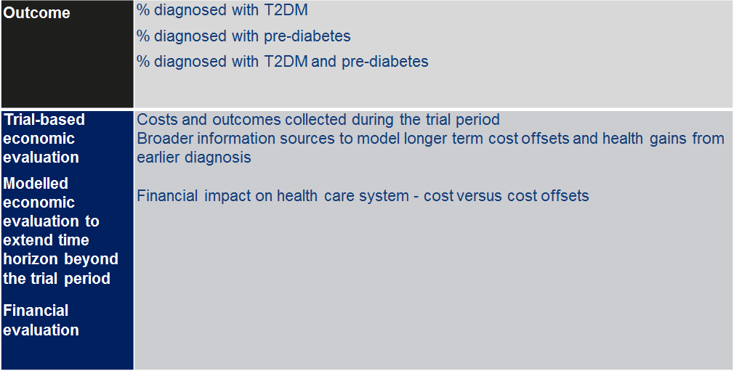

Pharmacy recruitment
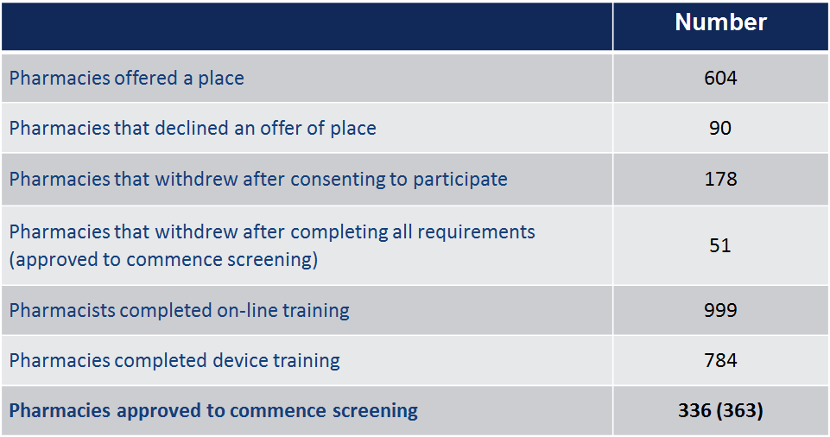

Pharmacy Recruitment (n=336)
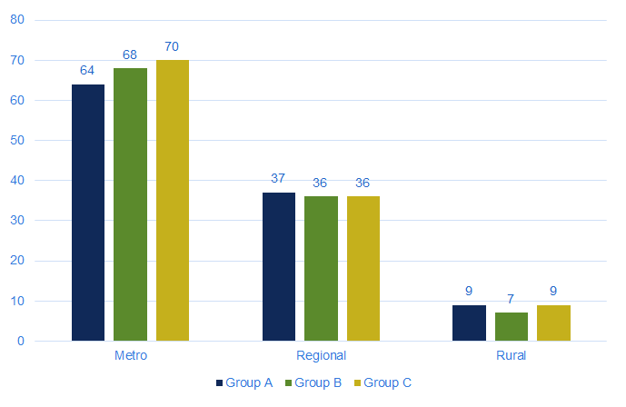

Pharmacies met Recruitment Target (n=113)
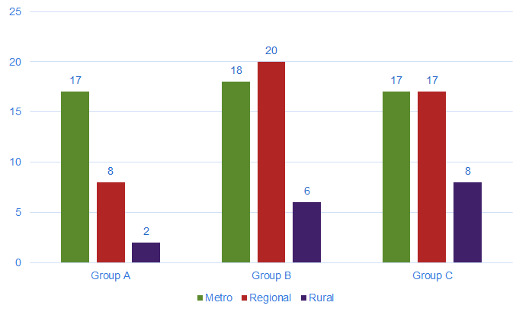

BASELINE SURVEY

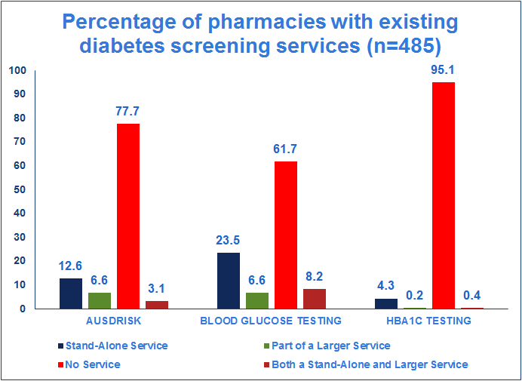

TRAINING REQUIREMENTS

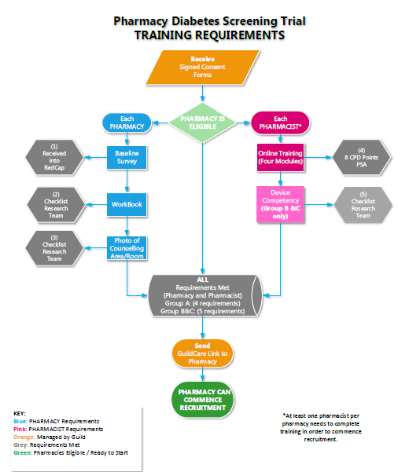

Guild Academy – Online Training Evaluation

RESULTS

Eight hundred and seventy five (n=875) pharmacists completed the online training and evaluation to mid November 2017 (Group A: 303, Group B: 277, and Group C: 295).
• 84% found the online learning course experience easy to use
• 94% felt that the activity was “mostly” or “very” relevant to their practice
• 90% expressed a high level of satisfaction with the online training course
• 89% agreed that it achieved the learning objectives

Qualitative feedback
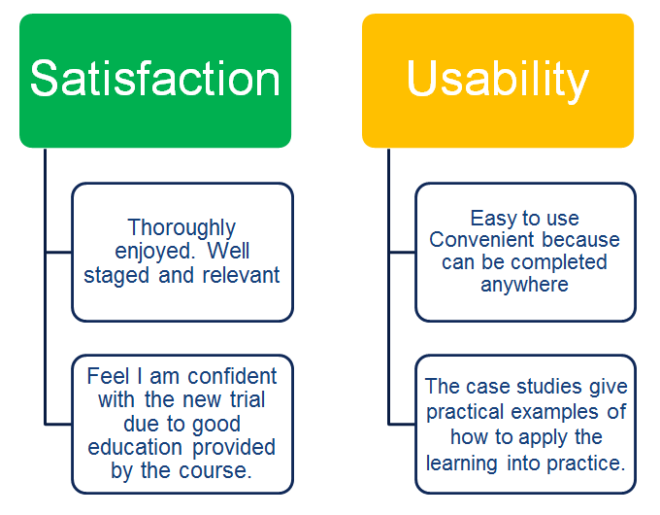

PATIENT RECRUITMENT

Recruitment Distribution by Region
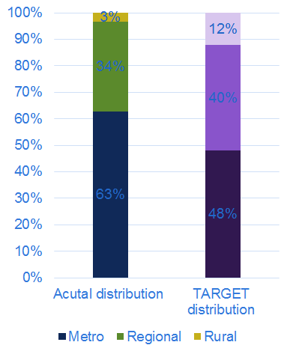

Recruitment Distribution by Gender and Age (n=14189)
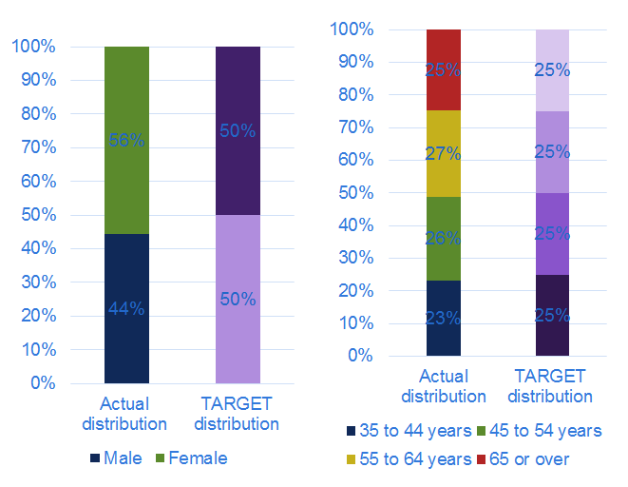

AUSDRISK Categories
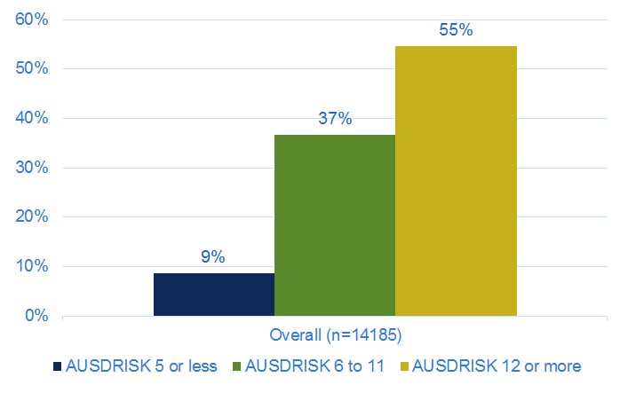

Pharmacist Feedback

Method
• Maximum variation sampling to recruit potential PDST pharmacists PDST for an end of trial telephone interview.
• Two groups, –based on target number of screenings for each area stratification – metropolitan (96 screenings), regional (80 screenings), and rural (24 screenings).
• High-performing - they reached their target in the given timeframe of the trial:
• Low-performing if completed a third or fewer screenings relative to the target.
• Stratified, by areas (metropolitan, regional, and rural), AND Group: (Group A, Group B and Group C), and state and territory

Results –Characteristics of Participants
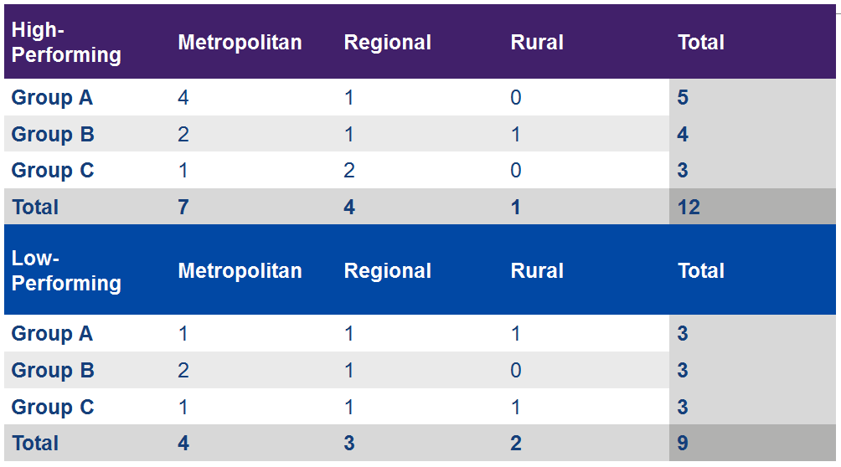

Pharmacists’ perspectives on the PDST

Overall Experience
(The) long term vision of… (my) pharmacy… (is) continuing being more patient focused and increased customer service. Less behind the counter and more out… Offering services that people might want to as well, cholesterol, warfarin testing, things like that. Like BP testing, the Medchecks. (PharmID_176)
It was quite a positive experience … It was a good way to engage with patients on a more clinical level.. It was something that pushed us to...offering further services to patients (PharmID_355)
I thought it was quite well set up, the protocol was easy to follow and the Guildcare was easy to follow (PharmID_299)

Facilitators
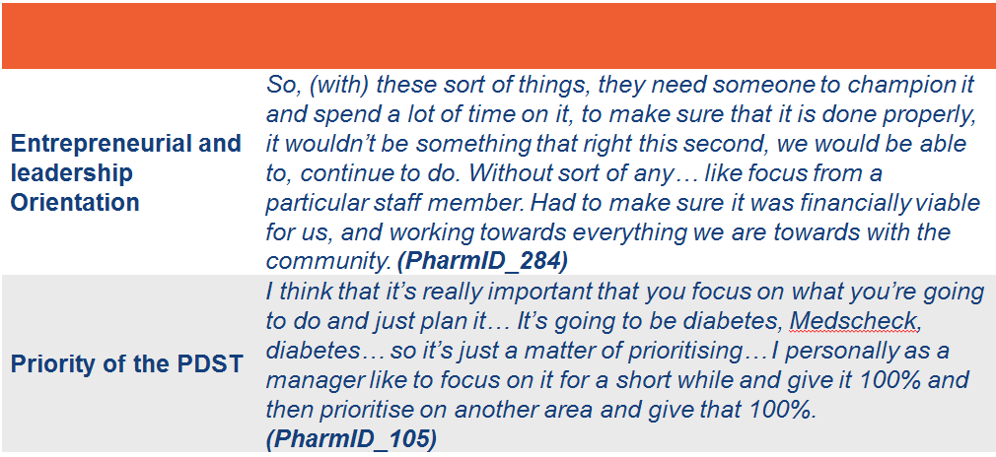

Facilitators
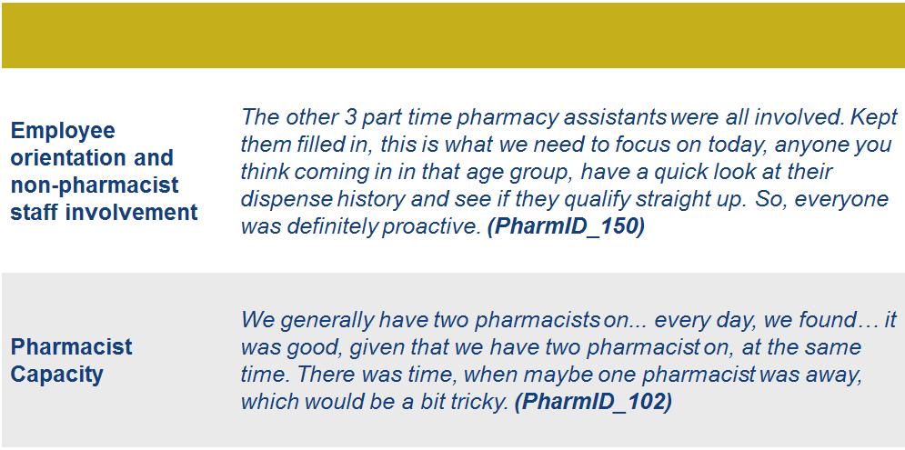

Barriers
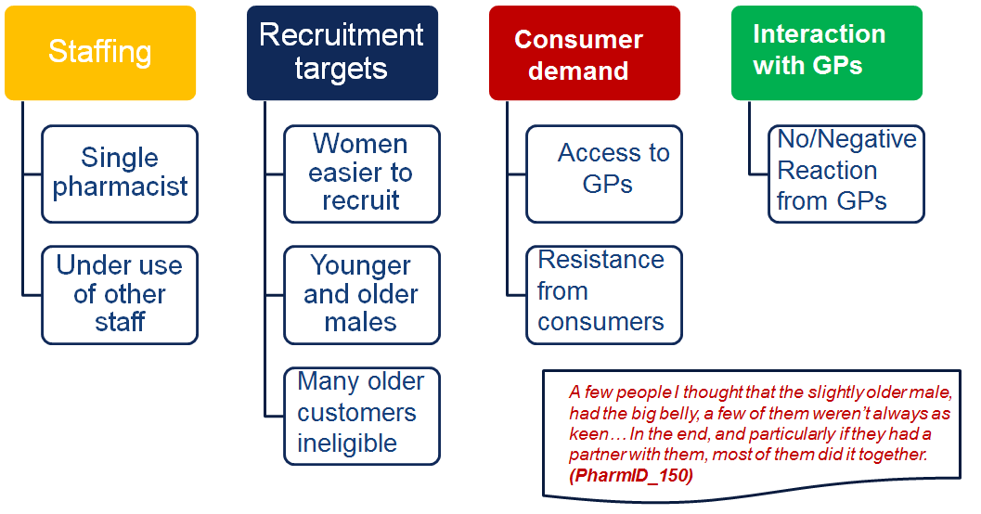

CONSUMER FEEDBACK

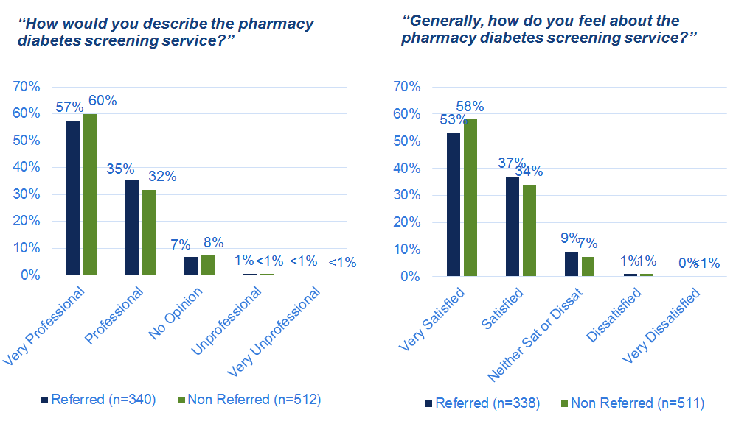
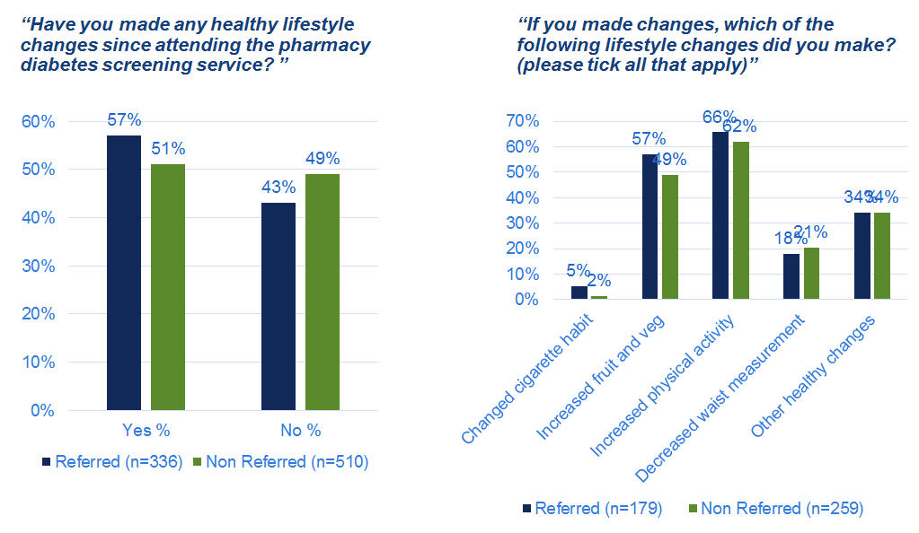
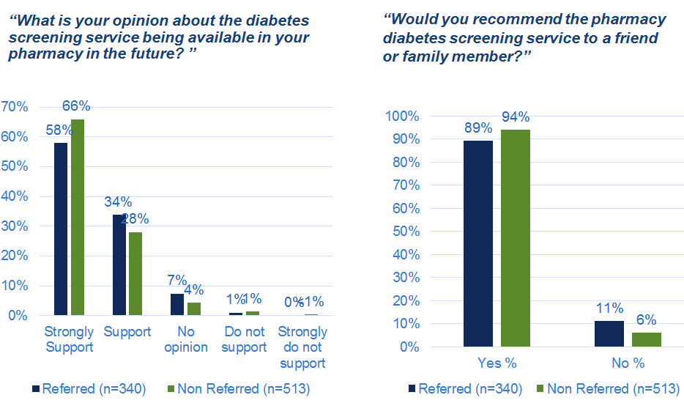

Consumer feedback
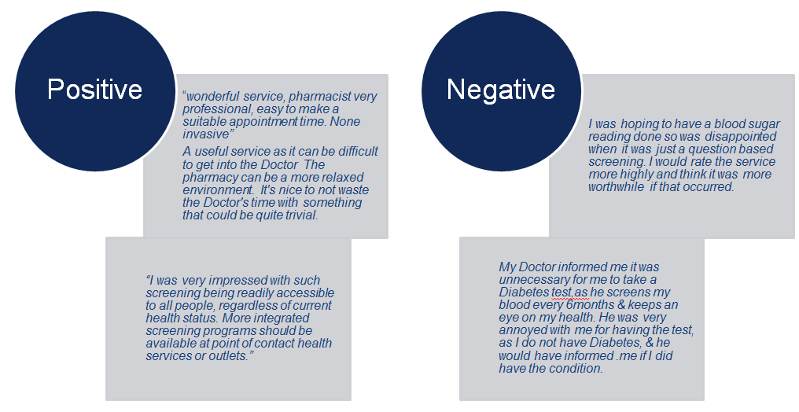

Summary

➢ Pharmacists generally positive about delivering diabetes screening in community pharmacy

➢ Success depended on local population demographics of the pharmacy clientele, access to other primary care services (GPs), leadership of the pharmacy champion and capacity of the pharmacy to prioritise and deliver the screening

➢ Consumers were generally very supportive of the pharmacy diabetes screening service

➢ Higher withdrawal rates pharmacies in the Risk Assessment only arm of the trial AS well as lower screening rates

➢ Current activity is focused on follow-up with consumers and GPs to determine outcomes of the screening

