Aboriginal and Torres Strait Islander Medication Review Service:

A Feasibility Study

Or

The IMeRSe Study

Acknowledgement of Country

Griffith University acknowledges the people who are the traditional custodians of the land we meet on today, pays respect to Elders, past, present and emerging, and extends that respect to other Indigenous Australians



The IMeRSe Feasibility Study

Improve medication management, health and wellbeing for Aboriginal and Torres Strait Islander people through a strengths based, collaborative and culturally appropriate pharmacy service.

Why does the research have to be done?

- In Australia, people living in the community can have medicines reviews with a pharmacist in a community pharmacy or in their home
- We know that medication reviews help people stay well and out of hospital
- But research has found that Indigenous people do not access medication reviews for many reasons
- talking to a pharmacist in a pharmacy or at home may not be culturally safe it doesn't involve anyone from their Aboriginal Health Service
- only a GP can refer someone
- there is no follow-up with the pharmacist to check-in on how things are going
- lack of integration between the pharmacy and the health service geographic isolation

Where will the research be conducted?

➢This study will be run in 9 sites (both ACCHSs and other models) and their associated community pharmacies (up to 23)
- 2 start-up sites to pilot all aspects of service, recruitment, data collection etc

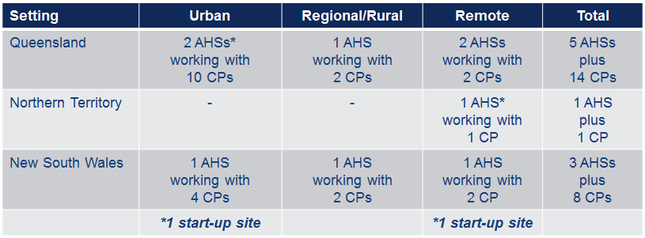

What does this research aim to achieve?

As a pharmacy service IMeRSe aims to:

➢Promote health and wellbeing by optimising an individual’s medication management through a culturally responsive medication review service

- delivered by community pharmacists
- integrated with Aboriginal Health Services as part of holistic care

➢Enhancing existing services in an integrated and beneficial way and

➢Support capacity building in pharmacists and Aboriginal Health Services staff

Who is leading the research?
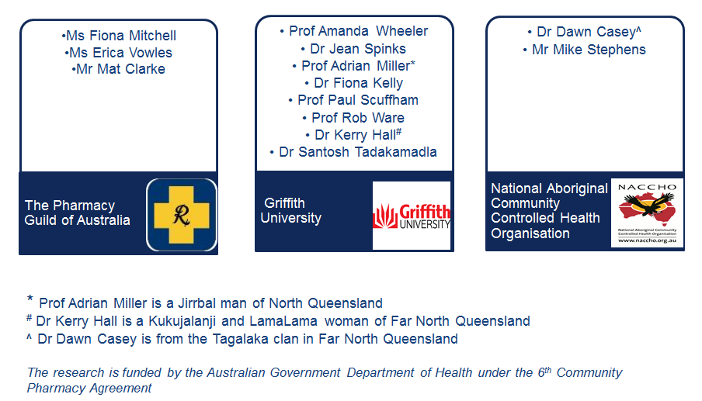

IMeRSe Indigenous Governance

• Assoc Prof Ray Lovett, Chair Epidemiologist, Australian National University, Canberra
• Prof Roianne West
Director, First Peoples Health Unit, Griffith University
• Dr Carmel Nelson
Director of Clinical Services, Institute for Urban Aboriginal and Torres Strait Islander Health, South East Queensland
• Dr Christine Connors
General Manager Primary Health Care, Northern Territory Department of Health
• Mr Daniel Williamson
Manager, Aboriginal and Torres Strait Islander Health Unit, Queensland Health

How is this research being done?

➢For each site the research team will:
- Connect and support partnerships between the AHS and their local community pharmacies
- Train pharmacists to deliver IMeRSe and provide ongoing mentoring to pharmacy staff
- Train and support an AHS staff member(s) to be the Study Coordinator
- Ask AHS staff and the local community to welcome the pharmacists and talk with them about local community protocols and health issues
➢For IMeRSe to be effective it is essential that strong working relationships are fostered between AHS staff and community pharmacy staff and between pharmacists and consumers

Who can participate in this research?

➢Up to 540 AHS consumers can participate
➢Any pharmacy staff, AHS nurses, doctors, health workers, or family members and patients can talk to the Study Coordinator about someone they see having problems with their medicines who:
- is older than 18 years
- has been treated at the AHS at least 3 times in the last 2 years
- uses the local pharmacies participating in the study
- has a chronic illness or is pregnant or had a baby in the last 2 years

What does IMeRSe look like?
M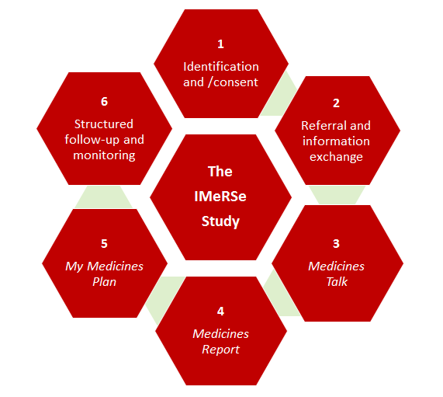

Who is involved in delivering IMeRSe?

Four distinct roles are required to successfully deliver IMeRSe:

1. AHS staff member nominated and trained to be the Study Coordinator*
2. Community pharmacists (supported by other pharmacy staff)
3. Aboriginal health worker (AHW) or nominated AHS staff*
4. General practitioners (GPs)

*There may be some cross-over in these roles

How is this research being done?

➢Each AHS will recruit a total of 60 consumers to participate
➢First, the Coordinator will talk with consumers about what is involved in the study. If they consent they will complete questionnaires together about their health, their medicines, treatment satisfaction and beliefs, adherence, and their wellbeing
- Coordinator collects data on laptop/tablet (paper only as back-up or participant preference)
- questionnaires include Apps developed or validated for Indigenous people such as
- the Growth and Empowerment Measure (GEM) designed to measure empowerment and growth within the person, their family and their community
- the Kessler psychological distress scale
- this may take about an hour

How is IMeRSe delivered?

➢Then the Coordinator will arrange a time for the participant to talk with the pharmacist and their AHW about their medicines, and make plans to sort out problems and taking their medicines better (Medicines Talk)

- appointment booked directly into pharmacist calendar in Guildcare NG
- Medicines Talk will be at a place that the participant chooses with a support person if they want (i.e. at AHS, home, pharmacy or somewhere they are comfortable)
- AHW or other nominated AHS staff member attends
- the Medicines Talk will use the Stay Strong Plan, an App developed for Indigenous people
- strengths based, motivational interviewing, problem solving & solution focused
- promotes behavior change after review of social connections, individual strengths & stressors, & setting goals
- this will take about an hour
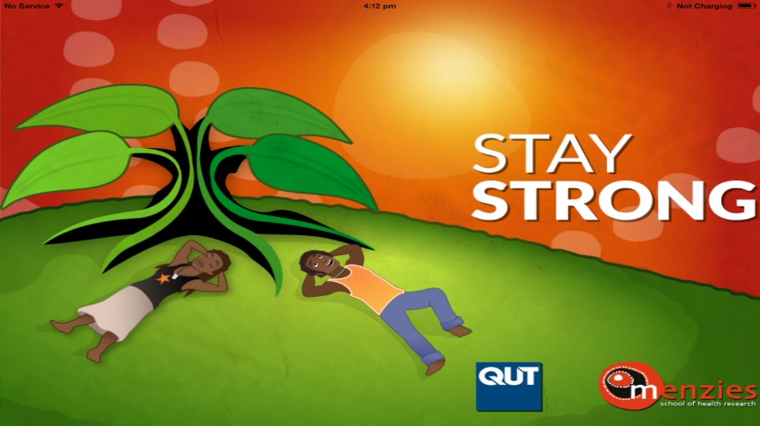

Summary
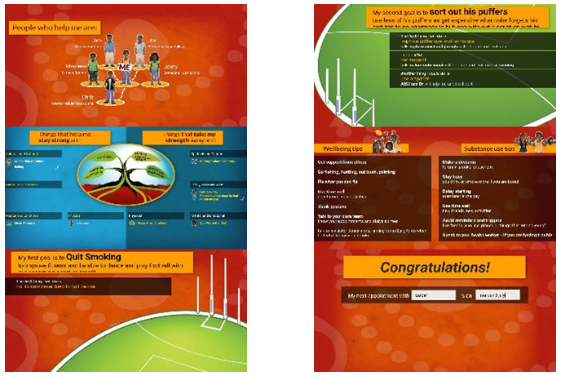

Goal setting
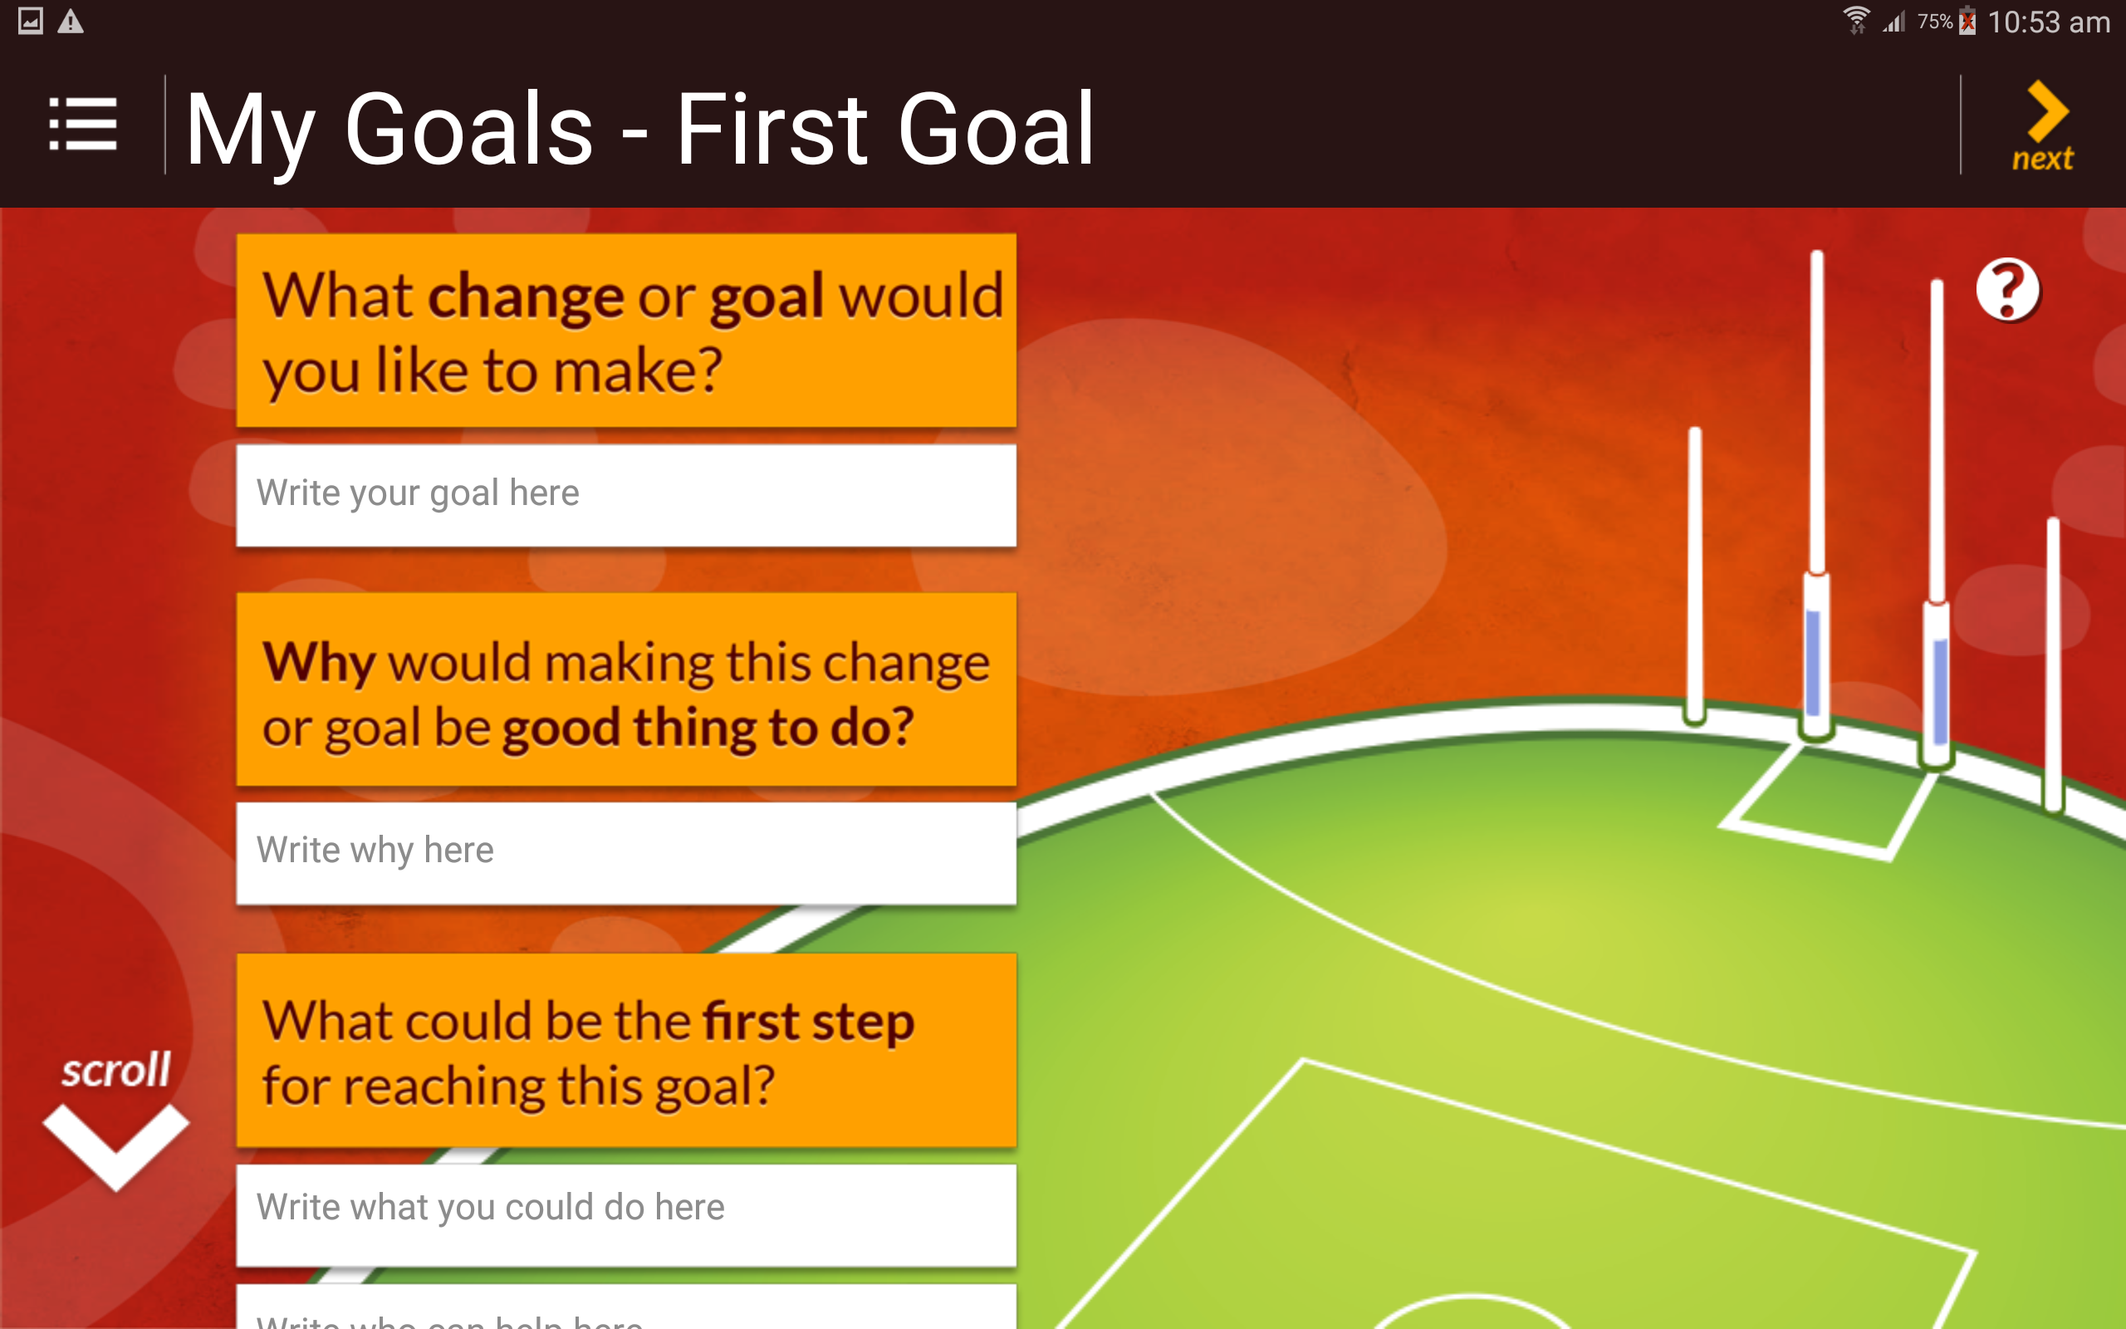

IMeRSe online
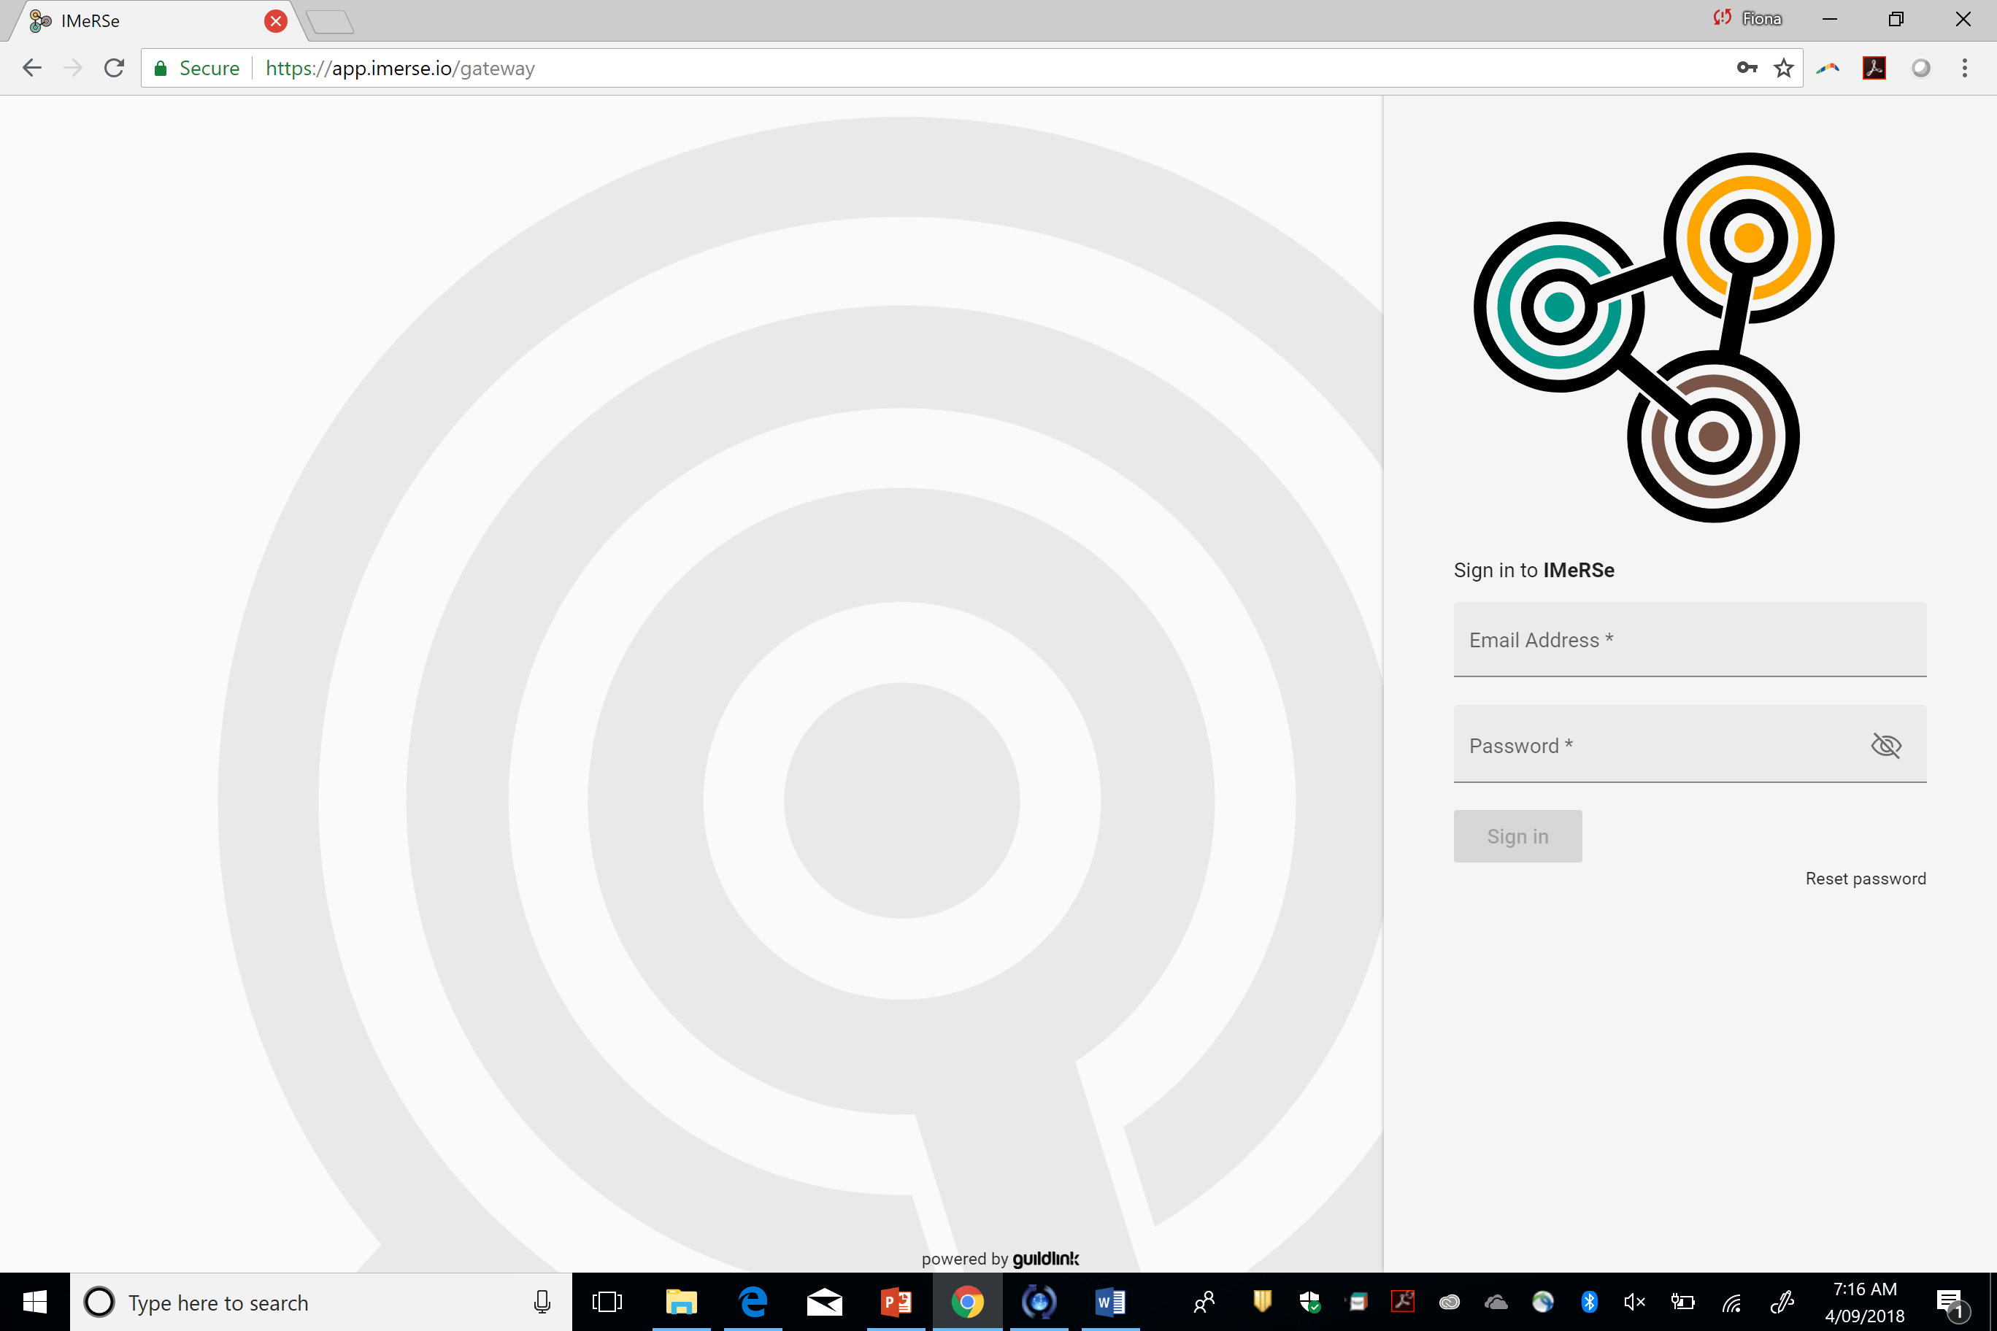

Pharmacy training
- Training focuses on
- awareness and understanding of Indigenous health and cultural issues
- skills and confidence to communicate effectively
- building/strengthening interpersonal and interprofessional relationships
- administrative components of IMeRSe delivery
- Online pre-training module building cultural awareness (2 hours)
- Face-to-face workshop focused on cultural responsiveness, communication and IMeRSe delivery (8 hours)
- includes role plays using Stay Strong Plan
➢Onsite welcome and local training at AHS and IMeRSe implementation in pharmacy (6 hours)
➢Ongoing mentoring by pharmacist and Aboriginal nurse and trainer

How is IMeRSe delivered?

- Pharmacist then prepares the Medicines Report in a purpose-built IMeRSe module of Guildcare NG that is accessible by AHS staff (GP & Coordinator) to facilitate exchange of shared information
- GP then prepares the medication management plan (My Medicines Plan) together with the participant and other AHS staff
- accepts, amends or rejects recommendations from Medicines Report & generates My Medicines Plan in Guildcare which is uploaded into medical record and printed for participant
- The pharmacist and AHW will continue to check-in with participants over the next 6 months to help them with any ongoing problems with their medicines
- appointments & follow-up documented in Guildcare & shared with AHS

How is this research being done?

  - At 6-months the Coordinator and participant will complete the questionnaires together again about their health, their medicines, and well-being (approximately one hour)

  - AHS staff, consumer participants and pharmacy staff will be invited to give feedback in an interview about IMeRSe so that we can improve it

  - We will invite each AHS, local community and pharmacy staff to talk about the research findings with us at the end of the study

Expected research outcomes
- Primary outcome
- Difference in cumulative incidence rate of serious medication-related problems (MRPs) in the 6-months after IMeRSe introduction compared with the 6-months prior (MRPs will be a pre-specified list tested and refined in start-up phase)
- Secondary outcomes
- Difference in psychological & social empowerment (GEM)
- Difference psychological distress (Kessler-10)
- Difference in potentially-preventable medication-related hospitalisations
- Difference in treatment satisfaction, beliefs about medicines and adherence
- Difference in healthcare resource use – MBS items, PBS items, Section 100, PBS CTG, laboratory tests and hospitalisations
➢Acceptability and feasibility outcomes
- recruitment, retention, acceptability with IMeRSe & training, choice of outcome measures, feasibility of primary outcome measures
- to inform future RCT
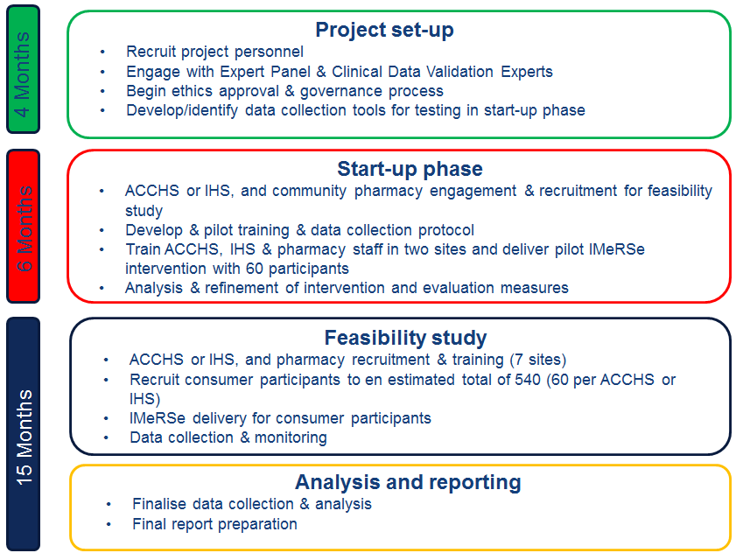

Research engagement and progress

- 8/9 Aboriginal Health Services enrolled
- Brisbane, Tennant Creek, Rockhampton, Cooktown, Bowen, Brewarrina, Gunnedah, Nowra
- Pharmacists from 23 community pharmacies trained
- 2 start-up sites trained and underway (May)
- Inala (SE Brisbane) working with 5 community pharmacies
- Anyinginyi (Tennant Creek) working with 1 community pharmacy
- 18 participants currently enrolled
- 5 Medicines Talks booked (7 additional referrals consent and enrolment)
- 7 Medicines Talks completed with participant, pharmacist & AHW
- 3 Medicines Reports in progress or completed by pharmacist –
- 2 Medicines Plans under review or completed by GP
- and 1 Follow-up completed by pharmacist & participant

Expected benefits of IMeRSe
- Health and population:
- Avoid MRPs & potentially preventable medication-related hospitalization
- More effective use of healthcare services
- Improved quality use of medicines
- Aboriginal and Torres Strait Islander participants
- Improved health and wellbeing
- Ownership of health and relationships with health pharmacists
- Improved understanding and use of medicines
- Pharmacies as safe health spaces
- AHS and pharmacies
- Improved relationships
- Efficiencies in service delivery

Participant feedback and acceptance of IMeRSe

“This is an important service and I would like it to continue as a valuable service” [Participant (Community Elder)]

“This is an important service to educate people about their health and medications, more research like this is needed.” [Participant (Community Elder)]

“A service like this should have been happening years ago, it is important and everyone needs to know about it.” [Participant]

Provider feedback and acceptance of IMeRSe
“The Community are proud of their health service, they trust it and feel as if they own it and because of this they feel as if they own IMeRSe, therefore they are willing to participate” [IMeRSe Coordinator]

“I have found the entire IMeRSe process simple to use, engages the pharmacist. It is an amazing opportunity to connect with the Indigenous community and provide a culturally appropriate health service. The patient greatly appreciated the fact that the review was tailored to their needs and gained a lot more from the review than they otherwise might have. It was a very valuable experience for both myself and the patient” [Pharmacist]

“GPs are often resistant to getting feedback about their own work, their own prescribing, but my first medication review outcomes have been very useful and informative. Packing confusion, OTC confusion, reducing complexity in medication timings, have all been corrected.” [GP]

Questions? www.griffith.edu.au/imerse

Thank You

